RESCUE BREATHER® POCKET VENTILATOR

When seconds count...Be prepared for any breathing emergency!
 | 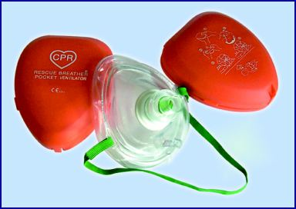

When a breathing emergency arises, you can breathe easier knowing that the O-Two Systems Rescue Breather® CPR Pocket Ventilator provides the rescuer with a safe and effective means to perform life saving mouth-to-mouth resuscitation while offering maximum protection for both the rescuer and the patient. The Rescue Breather® CPR | Pocket Ventilator comes standard with a low-resistance one way valve, disposable 3M FiltreteTM filter, protected oxygen inlet, head strap and carrying case. The replaceable 3M FiltreteTM filter ensures optimum bacterial protection, yet minimum airway resistance and snaps securely into a groove channel in the mask.
Features:
- Transparent Universal Mask can be used on Adults, Children and Infants
- Standard 15mm fitting allows the mask to be used with Bag-Valve-Mask Resuscitators
- Replaceable, Clear one way valve with standard 15mm fitting
- Separate Replaceable 3M Filtrete™ filter
- Oxygen Inlet
- Head strap
- Compact Carrying Case
- Latex Free
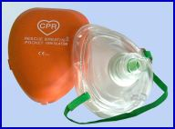
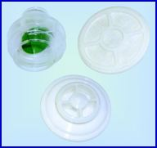
Ordering Information:
01PV1500-CS
O-Two Systems Rescue Breather® CPR Pocket Ventilator c/w Headstrap, Oxygen Inlet, 3M FiltreteTM Filter in Clamshell Hard Case. (Case/12)
01PV1505-CS
Replacement One Way Valves (Pkg. 10)
01PV1510-CS
Replacement 3M Filtrete™ Filter (Pkg. 10)

