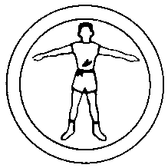 PERSONAL FITNESS
Merit Badge Requirements

If meeting any of the requirements for this merit badge is against the Scout’s religious convictions, it does not have to be done if the boy’s parents and the proper church officials state in writing that:
* To do so would be against religious convictions.
* The parents accept full responsibility for anything that might happen because of such exemption. They release the Boy Scouts of America from any responsibility.

1)
A) Before you try to meet any other requirements, have your health-care provider give you a thorough examination using the Scout medical examination form. Describe the examination. Tell what questions you were asked about your health. Tell what health or medical recommendations were made and report what you have done in response to the recommendations. Explain the following:
1) Why physical exams are important
2) Why preventative habits are important in maintaining good health
3) Diseases that can be prevented and how
4) The seven warning signs of cancer
5) The youth risk factors that affect cardiovascular fitness in adulthood
B) Have an examination made by your dentist. Get a statement saying that your teeth have been checked and cared for. Tell how to care for your teeth.

2) Explain to your merit badge counselor verbally or in writing what personal fitness means to you, including:
A) Components of personal fitness
B) Reasons for being fit in all components
C) What it means to be mentally healthy
D) What it means to be physically healthy and fit
E) What it means to be socially healthy. Discuss your activity in the eight areas of healthy social fitness
F) What you can do to prevent social, emotional, or mental problems

3) With your counselor answer and discuss the following questions:
A) Are you free from all curable diseases? Are you living in such a way that your risk of preventable diseases is minimized?
B) Are you immunized and vaccinated according to the advice of your health-care provider?
C) Do you understand the meaning of a nutritious diet and know why it is important for you? Does your diet include foods from all four groups?
D) Are your body weight and composition what you would like them to be and do you know how to modify it safely through exercise, diet, and behavior modification?
E) Do you carry out daily activities without noticeable effort? Do you have extra energy for other activities?
F) Are you free from habits relating to nutrition and the use of alcohol, tobacco, drugs, and other practices that could be harmful to your health?
G) Do you participate in a regular exercise program or recreational activities?
H) Do you sleep well at night and wake up feeling refreshed and energized for the new day?
I) Are you actively involved in the religious organization of your choice, and do you participate in their youth activities?
J) Do you spend quality time with your family and friends in social and recreational activities?
K) Do you support family activities and efforts to maintain a good home life?

4) Explain the following about physical fitness:
A) The components of physical fitness
B) Your weakest and strongest component of physical fitness
C) The need to have a balance in all four components of physical fitness
D) How the components of personal fitness relate to the Scout Laws and Scout Oath

5) Explain the following about nutrition:
A) The importance of good nutrition
B) What good nutrition means to you
C) How good nutrition is related to the other components of personal fitness
D) The three components of a sound weight (fat) control program

6) Before doing requirements 7 and 8, complete the aerobic fitness, flexibility, muscular strength, and body composition tests as described in the Personal Fitness merit badge pamphlet. Record your results and identify those areas where you feel you need to improve.

Aerobic Endurance Test
Record your performance on one of the following tests:
A) Run/walk as far as you can in nine minutes
B) Run/walk one mile as fast as you can

Flexibility Test
Using a sit-and-reach box constructed according to specifications in the merit badge pamphlet, make four repetitions and record the fourth reach. This last reach must be held for 15 seconds to qualify.

Muscular Strength Test
You must use the sit-up test and EITHER the pull-up or push-up test.
A) Sit-ups. Record the number of sit-ups done correctly in 60 seconds. The sit-ups must be done in the form explained and illustrated in the merit badge pamphlet.
B) Pull-ups. Record the total number of pull-ups completed consistent with the procedures presented in the merit badge pamphlet.
C) Push-ups. Record the total number of push-ups completed consistent with the procedures presented in the merit badge pamphlet.

Body Composition Test
Have your parent, counselor, or other adult take and record the following measurements:
A) Circumference of the right upper arm, midway between the shoulder and the elbow, with the arm hanging naturally and not flexed.
B) Shoulders, with arms hanging by placing the tape two inches below the top of the shoulder and around the arms, chest, and back during breath expiration.
C) Chest, by placing the tape under the arms and around the chest and back at the nipple line during breath expiration.
D) Abdomen circumference at navel level (relaxed).
E) Right thigh, midway between the hip and the knee.
*If possible, have the same person take the measurements whenever they are recorded.

7) Outline a 12-week physical fitness program using the results of your physical fitness tests. Be sure your program incorporates the endurance, intensity, and warm-up guidelines discussed in the Personal Fitness merit badge pamphlet. Before beginning your exercises, have the program approved by your counselor and parents

8) Complete the physical fitness program you outlined in requirement 7. Keep a log of your fitness program activity (i.e., how long your exercised; how far your ran, swam, or biked; how many exercise repetitions you completed; your exercise heart rate; etc.). Repeat the aerobic fitness, muscular strength, and flexibility tests every two weeks and record your results. After the 12th week, repeat all four tests, record your results, and show improvement in each one. Compare and analyze your pre-program and post-program body composition measurements. Discuss the meaning and benefit of your experience.

9) Describe your long-term plans regarding your personal fitness.

Worksheet Created by: Rob Greenland – 245 East 925 South – Layton, Utah 84041 – robgreenland@juno.com
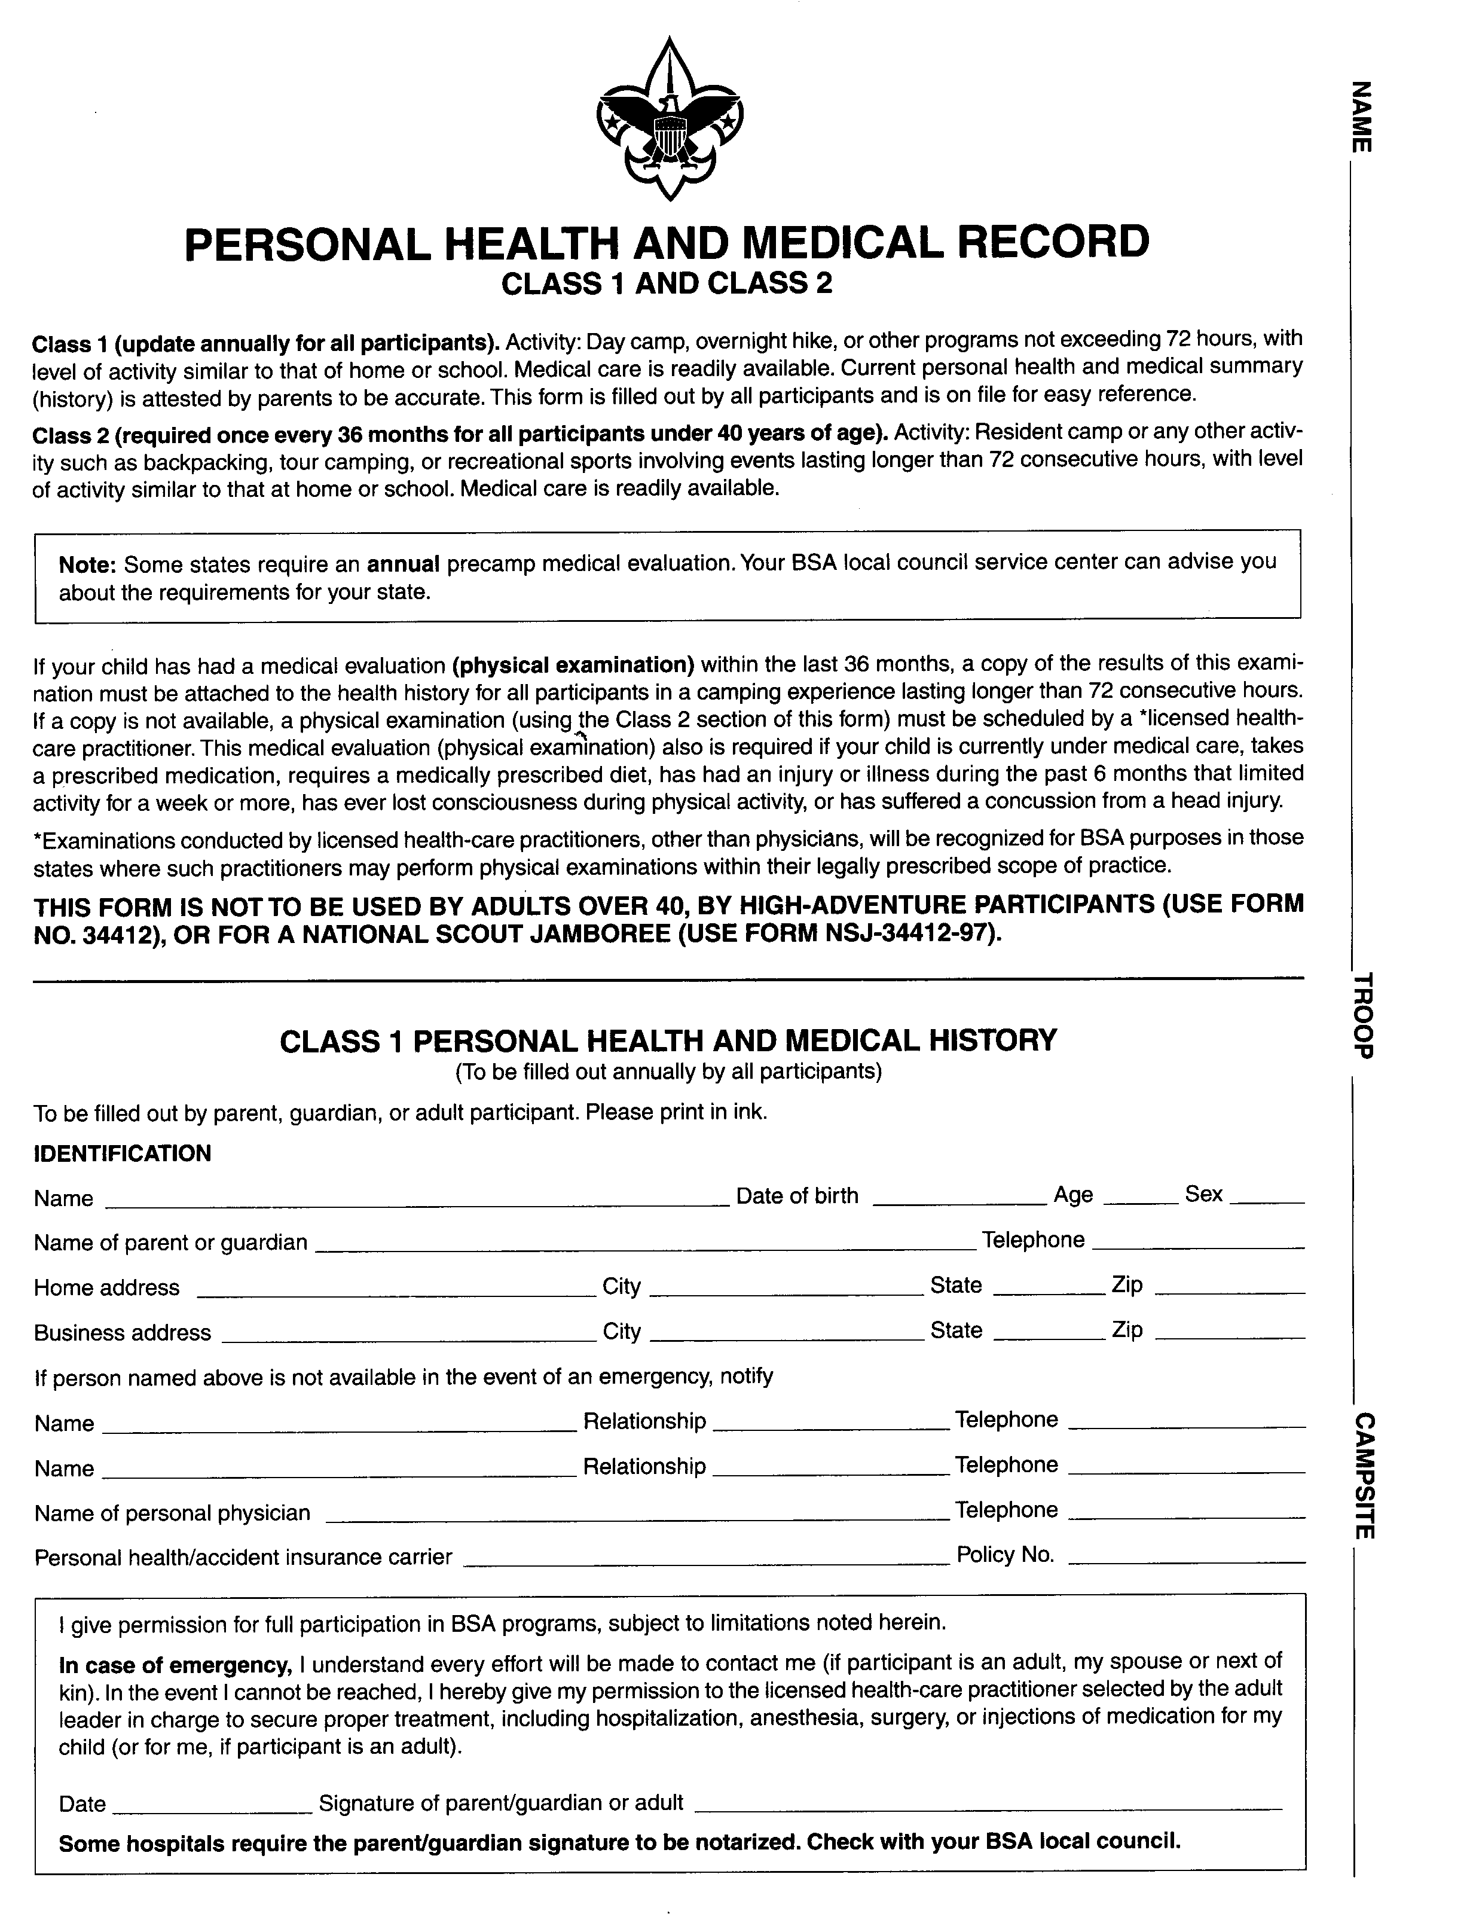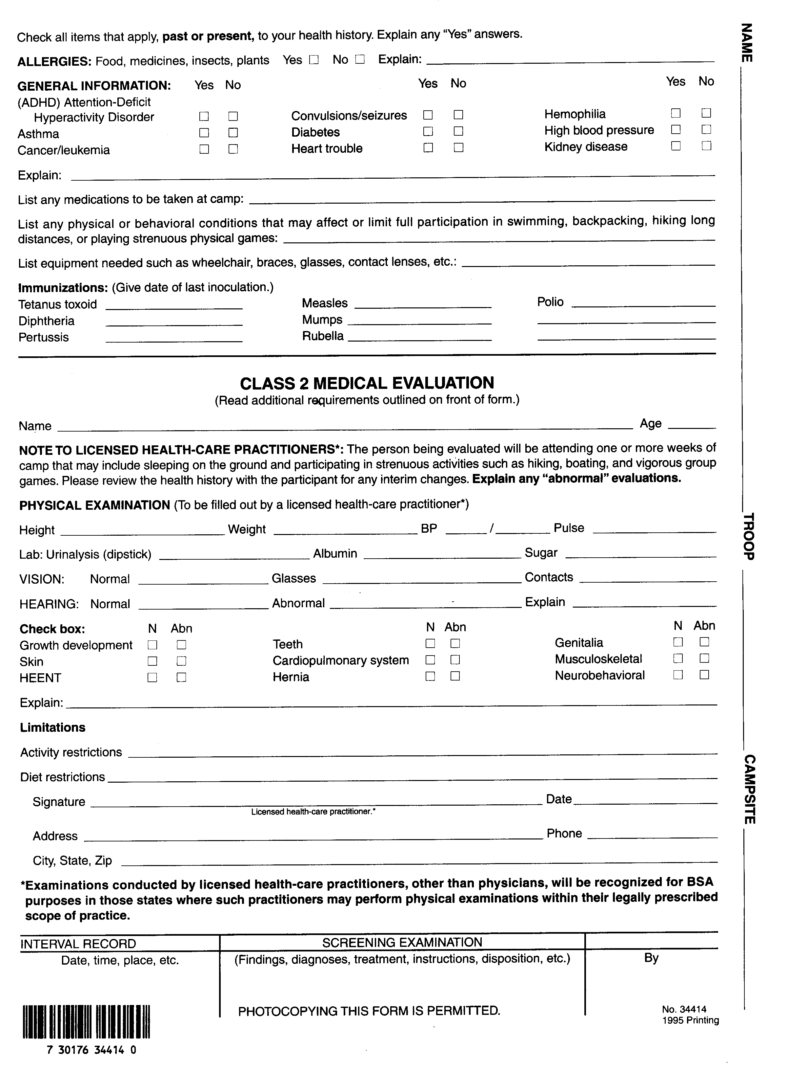RequiRequirement 1

Before you try to meet any other requirements, have your health-care provider give you a thorough examination. He/she is to use the Scout medical examination form. A copy of the form is attached to this document, but you may want to obtain an original copy.

Describe your examination: ____________________________________________________________________________________
_________________________________________________________________________________________________________________________________________________________________________________________________________________________________________________________________________________________________________________________________

What questions were you asked about your health? __________________________________________________________________
_________________________________________________________________________________________________________________________________________________________________________________________________________________________________________________________________________________________________________________________________

What recommendations did your doctor make? _____________________________________________________________________
_________________________________________________________________________________________________________________________________________________________________________________________________________________________________________________________________________________________________________________________________

What have you done about the above recommendations? _____________________________________________________________
_________________________________________________________________________________________________________________________________________________________________________________________________________________________________________________________________________________________________________________________________

Why are physical exams important? ______________________________________________________________________________
_________________________________________________________________________________________________________________________________________________________________________________________________________________________________________________________________________________________________________________________________

Why are preventative habits important in maintaining good health? _____________________________________________________
_________________________________________________________________________________________________________________________________________________________________________________________________________________________________________________________________________________________________________________________________

What diseases can be prevented and how? _________________________________________________________________________
______________________________________________________________________________________________________________________________________________________________________________________________________________________
___________________________________________________________________________________________________________

What are the seven warning signs of cancer:

____________________ ____________________ ____________________ ____________________

____________________ ____________________ ____________________

What are some of the youth risk factors that affect cardiovascular fitness in adulthood? _____________________________________
______________________________________________________________________________________________________________________________________________________________________________________________________________________
___________________________________________________________________________________________________________

__ Have an examination made by your dentist.

__ Get a statement saying that your teeth have been checked and cared for.

Tell how to care for your teeth: _________________________________________________________________________________
___________________________________________________________________________________________________________
___________________________________________________________________________________________________________

Requirement 2

Explain to your merit badge counselor verbally or in writing the following:

What does personal fitness mean to you: __________________________________________________________________________
___________________________________________________________________________________________________________
___________________________________________________________________________________________________________

Components of personal fitness: ________________________________________________________________________________
___________________________________________________________________________________________________________
___________________________________________________________________________________________________________

Reasons for being fit in all components: __________________________________________________________________________
___________________________________________________________________________________________________________
___________________________________________________________________________________________________________

What it means to be mentally healthy: ____________________________________________________________________________
___________________________________________________________________________________________________________
___________________________________________________________________________________________________________

What it means to be physically healthy and fit: _____________________________________________________________________
___________________________________________________________________________________________________________
___________________________________________________________________________________________________________

What it means to be socially healthy: _____________________________________________________________________________
___________________________________________________________________________________________________________
___________________________________________________________________________________________________________

What are several healthy social traits: ____________________________________________________________________________
___________________________________________________________________________________________________________
___________________________________________________________________________________________________________
What can you do to prevent social, emotional, or mental problems: _____________________________________________________
___________________________________________________________________________________________________________
___________________________________________________________________________________________________________

Requirement 3
With your counselor answer and discuss the following questions. Do not write anything here. Check off each topic after discussion.

__ Are you free from all curable diseases?
__ Are you living in such a way that your risk of preventable diseases is minimized?
__ Are you immunized and vaccinated according to the advice of your health-care provider?
__ Do you understand the meaning of a nutritious diet and know why it is important for you?
__ Does your diet include foods from all four groups?
__ Are your body weight and composition what you would like them to be and do you know how to modify it safely through
exercise, diet, and behavior modification?
__ Do you carry our daily activities without noticeable effort?
__ Do you have extra energy for other activities?
__ Are you free from habits relation to nutrition and the use of alcohol, tobacco, drugs, and other practices that could be harmful?
__ Do you participate in a regular exercise program or recreational activities?
__ Do you sleep well at night and wake up feeling refreshed and energized for the new day?
__ Are you actively involved in the religious organization of your choice, and do you participate in their youth activities?
__ Do you spend quality time with your family and friends in social and recreational activities?
__ Do you support family activities and efforts to maintain a good home life?

Requirement 4

Explain the following about physical fitness:

What are the components of physical fitness? ______________________________________________________________________
______________________________________________________________________________________________________________________________________________________________________________________________________________________
___________________________________________________________________________________________________________

What is your weakest component of physical fitness? ________________________________________________________________
___________________________________________________________________________________________________________
___________________________________________________________________________________________________________

What is your strongest component of physical fitness? _______________________________________________________________
___________________________________________________________________________________________________________
___________________________________________________________________________________________________________

What is the need to have a balance in all four components of physical fitness? ____________________________________________
___________________________________________________________________________________________________________
___________________________________________________________________________________________________________
___________________________________________________________________________________________________________

How do the components of personal fitness relate to the Scout Laws and Scout Oath?_______________________________________
___________________________________________________________________________________________________________
___________________________________________________________________________________________________________
___________________________________________________________________________________________________________

Requirement 5

Explain the following about nutrition:

What is the importance of good nutrition? _________________________________________________________________________
___________________________________________________________________________________________________________
___________________________________________________________________________________________________________
___________________________________________________________________________________________________________

What does good nutrition mean to you?___________________________________________________________________________
___________________________________________________________________________________________________________
___________________________________________________________________________________________________________
___________________________________________________________________________________________________________

How is good nutrition related to the other components of personal fitness? _______________________________________________
___________________________________________________________________________________________________________
___________________________________________________________________________________________________________
___________________________________________________________________________________________________________

Explain the three components of a sound weight (fat) control program: __________________________________________________
___________________________________________________________________________________________________________
___________________________________________________________________________________________________________
___________________________________________________________________________________________________________

Requirement 6
Before doing requirements 7 & 8, complete the aerobic fitness, flexibility, muscular strength, and body composition tests as described in the Personal Fitness merit badge pamphlet. Use the attached PRE-PROGRAM Test Results Record to record your results and identify those areas where you feel you need to improve.

Physical Fitness Tests

Aerobic Fitness Tests
Record your performance on one of the following tests:
A) Run/Walk as far as you can in nine minutes
B) Run/Walk one mile as fast as you can

Flexibility Test
Using a sit-and-reach box constructed according to specifications in the merit badge pamphlet, make four repetitions and record the fourth reach. This last reach must be held for 15 seconds to qualify.

Muscular Strength Test
You must use the sit-up test and EITHER the pull-up or push-up test.
A) Sit-ups. Record the number of sit-ups done correctly in 60 seconds. The sit-ups must be done in the form explained and illustrated in the merit badge pamphlet.
B) Pull-ups. Record the total number of pull-ups completed consistent with the procedures presented in the merit badge pamphlet.
C) Push-ups. Record the total number of push-ups completed consistent with the procedures presented in the merit badge pamphlet.

Body Composition Tests
Have your parent, counselor, or other adult take and record the following measurements:
A) Circumference of the right upper arm, midway between the shoulder and the elbow, with the arm hanging naturally and not flexed.
B) Shoulders, with arms hanging by placing the tape two inches below the top of the shoulder and around the arms, chest, and back during breath expiration.
C) Chest, by placing the tape under the arms and around the chest and back at the nipple line during breath expiration.
D) Abdomen circumference at navel level (relaxed).
E) Right thigh, midway between the hip and the knee.
*If possible, have the same person take the measurements whenever they are recorded.

PRE-PROGRAM Test Results Record

Name ________________________________ Age: _____ Date: __/__/__ Body Weight: _____

Use this form to record your physical fitness test results before beginning your physical fitness program.

Aerobic Endurance Tests
Record your time or distance after completing one of the options

Nine minute run/walk: 1st Distance: __________
One mile run/walk: 1st Time: __________

Flexibility Test
Record your fourth reach distance after holding for 15 seconds.

Reach Distance: __________inches

Muscular Strength Test
Record the number of sit-ups correctly completed in 60 seconds

Sit-Ups: __________

Record the number of Pull-Ups OR Push-Ups completed according to the procedures in the merit badge pamphlet. Circle the option you chose for this requirement

Push-Ups Pull-Ups

Total: __________ Total: __________

Body Composition Test
Record your measurements below

A) Circumference of the right upper arm, midway between the shoulder and the elbow, with the arm hanging naturally and not flexed.

Measurement: __________

B) Shoulders, with arms hanging by placing the tape two inches below the top of the shoulder and around the arms, chest, and back during breath expiration.

Measurement: __________

C) Chest, by placing the tape under the arms and around the chest and back at the nipple line during breath expiration.

Measurement: __________

D) Abdomen circumference at navel level (relaxed).

Measurement: __________

E) Right thigh, midway between the hip and the knee

Measurement: __________

Requirement 7

Outline a 12-week physical fitness program using the results of your physical fitness tests. Be sure your program incorporates the endurance, intensity, and warm-up guidelines discussed in the Personal Fitness merit badge pamphlet. Before beginning your exercised, have the program approved by your counselor and parents.

You will need to tailor your program to fit your needs and meet your goals. When designing your fitness program, do not over commit yourself to a program that is beyond your physical capabilities.

To help you outline your physical fitness program consider the following points and questions.

* What physical activities do you enjoy doing? * What physical activities do you want to include in your program
* Will you exercise daily? * Will you exercise every other day?
* How much time do you have on a daily basis for exercise? * How long will your exercise sessions last each time?
* What equipment and/or facilities will you need for your fitness program? (gym, pool, bike, proper shoes for running, etc.)
* Do you have access to the equipment and/or facilities that you will need for your physical fitness program?
* Are there any financial issues that need to be addressed within your program? (pool passes, gym memberships, etc.)
* Do you have someone that you can exercise with? (Remember: never swim without a buddy!)

Use the area below to outline your physical fitness program.

Requirement 8

_____ Complete the physical fitness program you outlined in requirement 7. If you would like, you can use the attached exercise log to keep a log of your fitness program activity (i.e., how long your exercised; how far your ran, swam, or biked; how many exercise repetitions you completed; your exercise heart rate; etc.) OR, you can design and use a chart of your own.

_____ Repeat the aerobic fitness, muscular strength, and flexibility tests every two weeks. You can use the TWO WEEK record of fitness chart to record your results. The chart is located at the bottom of the Exercise Log.

_____ After the 12th week, repeat all four tests, record your results, and show improvement in each one. Use the attached POST PROGRAM test results record to record your results.

Complete the following after you have completed all other requirements.

Compare and analyze your pre-program and post-program body composition measurements. What do they tell you? Did you improve in the areas that you identified earlier? ____________________________________________________________________
___________________________________________________________________________________________________________
___________________________________________________________________________________________________________
___________________________________________________________________________________________________________
___________________________________________________________________________________________________________
___________________________________________________________________________________________________________
___________________________________________________________________________________________________________

Discuss the meaning and benefit of your experience: ________________________________________________________________
___________________________________________________________________________________________________________
___________________________________________________________________________________________________________
___________________________________________________________________________________________________________
___________________________________________________________________________________________________________
___________________________________________________________________________________________________________
___________________________________________________________________________________________________________

TWO WEEK Record Of Fitness

POST-PROGRAM Test Results Record

Name ________________________________ Age: _____ Date: __/__/__ Body Weight: _____

Use this form to record your physical fitness test results after completing your physical fitness program.

Aerobic Endurance Tests
Record your time or distance after completing one of the options

Nine minute run/walk: 1st Distance: __________
One mile run/walk: 1st Time: __________

Flexibility Test
Record your fourth reach distance after holding for 15 seconds.

Reach Distance: __________inches

Muscular Strength Test
Record the number of sit-ups correctly completed in 60 seconds

Sit-Ups: __________

Record the number of Pull-Ups OR Push-Ups completed according to the procedures in the merit badge pamphlet. Circle the option you chose for this requirement

Push-Ups Pull-Ups

Total: __________ Total: __________

Body Composition Test
Record your measurements below

A) Circumference of the right upper arm, midway between the shoulder and the elbow, with the arm hanging naturally and not flexed.

Measurement: __________

B) Shoulders, with arms hanging by placing the tape two inches below the top of the shoulder and around the arms, chest, and back during breath expiration.

Measurement: __________

C) Chest, by placing the tape under the arms and around the chest and back at the nipple line during breath expiration.

Measurement: __________

D) Abdomen circumference at navel level (relaxed).

Measurement: __________

E) Right thigh, midway between the hip and the knee

Measurement: __________

