

SUMMER 2002 PROJECT REPORT

CLUSTER COMPUTING: DEVELOPMENT OF A BEOWULF LINUX CLUSTER TO ACHIEVE A SUPERCOMPUTER PERFORMANCE FOR NASA’s LAND INFORMATION SYSTEM (LIS)

SUBMITTED TO:

Dr. Dillard Menchan,
Equal Opportunity Program Office, NASA Goddard Space Flight Center
Code 120, Greenbelt, MD 20771

Dr. Joan S. Langdon,
Director, Summer Institute in Engineering and Computer Applications (SIECA)
Department of Computer Science
Bowie State University
Bowie, MD 20715

STUDENT: Uttam Kumar Majumder
MENTOR: Dr. Christa Peters-Lidard

COLLEGE: The City College of New York
MAJOR: Computer Science & Engineering
CLASS LEVEL: Lower Senior
NASA CODE: 974 / Hydrological Sciences

PROGRAM: SIECA (UG) Intern 2002
HOST: NASA & Bowie State University

CLUSTER COMPUTING: DEVELOPMENT OF A BEOWULF LINUX CLUSTER TO ACHIEVE A SUPERCOMPUTER PERFORMANCE FOR NASA’s LAND INFORMATION SYSTEM (LIS)

(A Grand Challenge Application in the Earth, Space, Life, and Microgravity Sciences)

Christa D. Peters-Lidard, Uttam K. Majumder

Abstract

Supercomputers are extremely fast computers that can perform gigantic amount of computational task within a second. Since supercomputers are very expensive, they are accessible principally by national labs, large companies, and universities. However, the demand for this huge computing engine is widespread. The rise in parallel computing and distributed computing in late 90’s and today’s super fast microprocessor, memory, and network technology introduced an alternative solution. Using cluster computing, we can achieve near supercomputer performance on affordable and regularly available PCs or workstations. This has motivated the development of a LINUX cluster for NASA’s Land Information System (LIS) that require massively parallel computation. This paper depicts the implementation of LIS LINUX cluster.

- Introduction

Knowledge of land surface water, energy, and carbon conditions are of critical importance to real-world applications such as agricultural production, water resource management, and flood, weather, and climate prediction. This has motivated the development of a pilot Land Data Assimilation Systems (LDAS) which integrates remotely-sensed and model-derived land surface data in a 4-Dimensional Data Assimilation framework. However, to fully address the land surface research and application problems, climate prediction problem, and other critical water and carbon cycle applications, LDAS must be implemented globally at very high resolution (1 km), and these predictions must be available to end users for use in various applications using a user-friendly, freely available, system independent, portable interface. This has motivated the development of Land Information System (LIS). The eventual computational requirements of this LIS are estimated to be 1000 times larger than the current North American 1/8 degree LDAS, which itself is significantly limited by software and hardware engineering. The LIS will provide knowledge of land surface water, energy, and carbon conditions for use in critical real-world applications and Earth System Modeling in a near real time.

Due to very high resolution and near real time need of land surface information, the use of scalable parallel computing technology is critically important and relevant. The LIS Linux cluster will consist of 192 computing nodes and 8 IO nodes to perform parallel computation.

- LIS LINUX Cluster Design

The cluster consists of 192 computing nodes and 8 IO nodes, interconnected with a gigabit Ethernet switch and 8 fast Ethernet switches.
The 192 computing nodes are divided into 8 sub-clusters, with 24 nodes in each sub-cluster, interconnected with fast Ethernet via one of the 8 24-port fast Ethernet switches. The switch for each sub-cluster has a gigabit uplink. The 8 sub-clusters are further interconnected with gigabit Ethernet by plugging the uplinks in the 24-port gigabit switch.

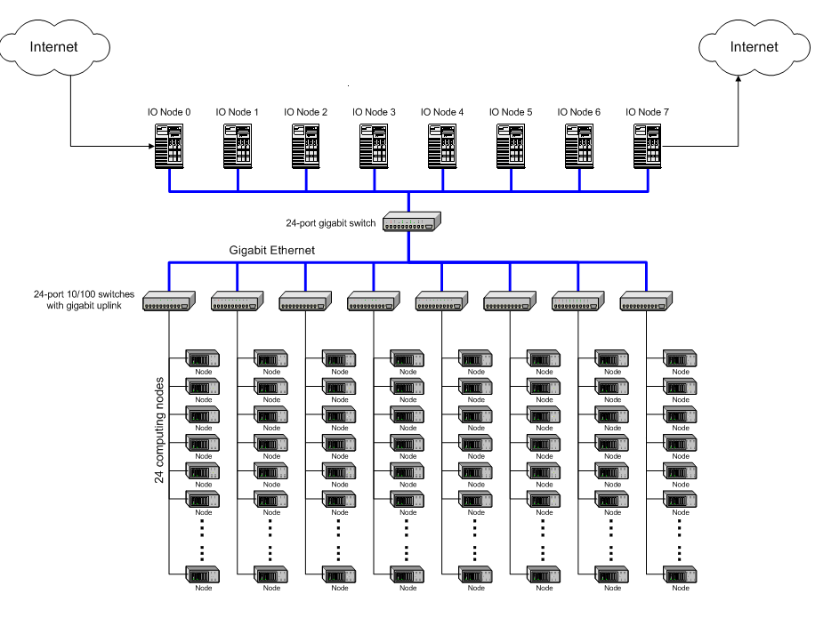
FIGURE 1: LIS LINUX Cluster Physical Architecture

The 8 IO nodes are interconnected and connected to the computing nodes by plugging into the same gigabit switch. There are 8 more gigabit ports unused on the gigabit switch for future addition of either IO nodes or computing sub-clusters.

The use of 8 sub-clusters and 8 IO nodes is mainly for the segregation of network traffic resulting from non-local file IO operations, and for the spreading of data storage so each IO node does not have to deal with single big files. So in average each IO node will only need to serve the IO requests of 24 computing nodes, and only store 1/8 of the output information, which makes the output volume manageable.

The 8 IO nodes share 4 external Promise RAID systems for file storage, with a total capacity of about 5 TB. Each computing node has an internal IDE hard drive of 80 GB. The computing nodes will boot from network via bootp or DHCP, and load the operating system image from one of the IO nodes. Therefore, we do not need to keep a copy of the OS image on their local disks.

- LIS Cluster Hardware Specification

IO Nodes:

ITEM | DESCRIPTION | QUANTITY
CPU | Athlon XP 2000 (1.7 GHz) for servers w/Fan/ Heatsink | 16, Dual CPU Each IO node
Motherboard | TYAN THUNDER K7X MTHRBD | 8
Memory | Kingston KVR266X72RC25/1024 1GB REG SDRAM DDR 168 DIMM PC2100 | 16, 2G each IO node
NIC | Gigabit NIC | 10,Node 0 and 7 w/2 NICs
Case / Power | Antec SX 1240 SOHO FILE SERVER CASE 12BAY | 8
CD-RW | Plextor 24/10/40A PLEXWRITER INT EIDE DRIVE | 8
Floppy | TEAC 1.44MB 3.5" DRIVE W/MNTNG KIT | 8
SCSI Ext. RAID | Promise UltraTrak100 TX8 16MB cache U2-SCSI (compatible w/ U160 SCSI on MB) | 4
Storage | 160 GB IDE HDD | 32

Computing Nodes:

ITEM | DESCRIPTION | QUANTITY
CPU | AMD Athlon XP 1800 (1.5 GHz) | 200
Motherboard | Biostar M7VKQ | 200
Memory | Kingston 512 MB SDRAM | 200
NIC | Built in | 0
Case / Power | Antec | 200
Storage | 80GB IDE HDD | 200

Networking:

ITEM | DESCRIPTION | QUANTITY
GB Switch | Netgear GS524T 24-port Gigabit switch | 1
FE Switch | 48 port 100/10 switch w/2 Gb uplinks | 4
Cable | Cat-5 UTP

- Installing Linux

Before installing Linux OS, we were required to set up the BIOS of each computing nodes and record the MAC address from the BIOS reading. Since we don’t need CD-ROM drive or Floppy drive for computing nodes, we use the procedure of automatic installation of Linux OS from a centralized server to a fresh node (the client /computing node) over the network without using a floppy drive or CD-ROM on the client node.

4.1 Hardware environment:
The computing node uses a Biostar M7VKQ motherboard with a built-in Ethernet adapter using RTL8139 chipset, an AMD Athlon XP 1800+ CPU, and a Maxtor 81.9G hard drive. The Ethernet adapter supports Intel UNDI PXE 2.0. The server uses the same hardware configuration as the client with an additional CD-ROM for the initial installation of software on the server.

4.2 Software environment:
Software: RedHat 7.2 distribution of Linux 2.4.7-10.

4.3. References to install Linux over Network:
http://www.stanford.edu/~alfw/PXE-Kickstart/PXE-Kickstart.html
http://syslinux.zytor.com/

- LIS Cluster Hardware Monitoring (LM_Sensors)

LM_Sensors provides essential drivers for monitoring the temperatures, voltages, and fans of Linux systems. It contains drivers for sensor chips and I2C and SMBus masters. It also contains text-based tools for sensor reporting, and a library for sensors access called 'libsensors'. It also contains tools for sensor hardware identification.

To monitor the hardware status of the computing nodes, a set of Linux hardware monitoring drivers has been installed to each computing node. We install i2c-2.6.3 and lm_sensors-2.6.3.

5.1 Environment:
Hardware: Biostar M7VKQ with VIA VT82C686 chipset and a CPU of
AMD Athlon(tm) XP 1800+.
Software: RedHat 7.2 distribution of Linux 2.4.7-10. Customized
installation with kernel development package to get the kernel
source tree.

5.2 Download the software:
Two packages needed: i2c and lm_sensors.
http://secure.netroedge.com/~lm78/archive/lm_sensors-2.6.3.tar.gz
http://secure.netroedge.com/~lm78/archive/i2c-2.6.3.tar.gz
tar xvfz i2c-2.6.3.tar.gz
tar xvfz lm_sensors-2.6.3.tar.gz

5.3 Compile and run

- LIS Cluster Wake-On-LAN

Wake-on-LAN technology allows to remotely power on a computer or to wake it up from sleep mode. By remotely triggering the computer to wake up and perform scheduled maintenance tasks, we do not have to physically visit each computer on the network.

Wake on LAN works by sending a wake-up frame or packet to a client machine (computing node) from a server machine (IO node). The Wake on LAN network adapter installed in the client receives the wake-up frame and turns on. The scheduled tasks then begin.
To use Wake-on-LAN technology, we need a Wake-on-LAN network adapter, Wake-on-LAN enabled motherboard, and remote management software. The Wake-on-LAN network adapter continually monitors the network looking for wake-up frames. The adapter must have a constant power source in order to boot up, which is usually from a special power supply that delivers a certain amount of power continually.
The Wake-on-LAN adapter also decodes the wake-up frame to determine if it is a wake-up. The key to determining a wake-up frame is if the media access control (MAC address) address is repeated 16 times without breaks or interruptions.
To request a job to any one of the computing nodes, we use the Wake-On-LAN feature of the Biostar mainboard.

6.1. Environment:
Test machine hardware: Biostar M7VKQ with built-in RTL8139 NIC chipset.
RTL8139 supports WOL.
Software: ether-wake.c, from http://www.scyld.com/expert/wake-on-lan.html.

6.2 Compile and run under a RedHat Linux 7.2 with 2.4.7-10, to be used as the wake up server for waking the test machine. The wake-up server and the test machine were connected via a Linksys hub with Cat5 cables.

6.3 BIOS setup:

6.3.1 Start from the BIOS main menu of the M7VKQ, then pick
"Power Management Setup" ==> "Wake Up Events" ==> "PowerOn by PCI Card"
and turn the option to "Enable".

6.3.2 "Power Management Setup" ==> "Wake Up Events" ==> "Wake Up On LAN/Ring",
and turn the option to "Enable" too.
It is important to note that to enable WOL, both options have to be enabled. Only enabling "Wake Up On LAN/Ring" will not work.

- LIS Linux Cluster MPICH Installation

MPI (Message Passing Interface) allows to run a program into a number of processes running in multiple instruction / multiple data (MIMD) fashion. Each of the processes in an MPI Program is independent with a separate and unshared address space. Data is communicated between processes by explicit invocation of MPI procedures send () and receive (). MPI is a portable message passing standard that runs both on tightly coupled massively parallel processors and on networks of workstations.

Installing MPICH1.2.4:
7.1 Download
ftp ftp.mcs.anl.gov
get pub/mpi/mpich.tar.gz
7.2 Install
tar xvfz mpich.tar.gz
compile and run
- LIS Cluster Parallelization Scheme

At the beginning of the simulation, whole job (in our case land area) will be split into about 10, 000 pieces as an unfinished job. The IO nodes/queen nodes will keep a table of three types of jobs: unfinished jobs, finished jobs, and jobs-fetched. Each computing node comes to its corresponding IO node to fetch a piece from it and starts working on it. The IO node then moves the fetched jobs to the jobs-fetched table and starts a timer for each fetched job.
If a computing node finishes the job before it’s corresponding IO node’s timer runs out, this piece of job is regarded as finished job. Then, the IO node moves this job from fetched table to finished table. The computing node become ready to fetch another job until the unfinished table is empty. If a computing node can’t complete the fetched job within its IO node’s timer specific amount time, the IO node assumes that corresponding computing node may have crashed or slow and moves that timed-out job from the fetched table to the unfinished job table so that other computing nodes can fetch that job.

FIGURE 2: Flowchart for parallel computing of computing nodes

FIGURE 3: Parallel computing control flowchart (left) and parallelization scheme (right) of an IO node.

- Conclusion

Cluster computing is increasingly becoming the platform for many scientific and engineering applications. Low cost, scalability, and generality of Linux clusters provide a wide array of opportunities for new domains of application. Some of those applications are Databases, Web Servers, Dynamic Interactive Simulation, Virtual Reality, Image Processing, Process Control, Artificial Intelligence, and Genetic Programming. Some of these applications can be developed using existing hardware and software technology. Others require development of new software technology.

ACKNOWLEDGEMENTS

The authors would like to thank the investigators of LIS project, LIS team, and all anonymous references for their valuable information and suggestions that was very important to write the technical content and the presentation of the article.

REFERENCES

T. L. Sterling, J. Salmon, D. J. Becker, and D. F. Savarese. How to Build a Beowulf. The MIT Press, 1999.

T. Sterling. Beowulf Cluster Computing with Linux. The MIT Press, 2001.

Y. Tian. LIS Software Design Document. http://lis.gsfc.nasa.gov, 2002.

“Installation of the Slave Nodes”, www.scyld.com

“The Beowulf Project”, www.beowulf.org

“Highly-parallel Integrated Virtual Environment”, http://newton.gsfc.nasa.gov/thehive

Christa D. Peters-Lidard: Dr. Christa D. Peters-Lidard received the B.S. degree in Geophysics and Mathematics from the Virginia Polytechnic Institute and State University (Virginia Tech) in 1991, and the M.A. and Ph.D. degrees in Civil Engineering and Operations Research from Princeton University, New Jersey, in 1993 and 1997 respectively.
She was an Assistant Professor of School of Civil and Environmental Engineering, Georgia Institute of Technology. Currently she is a Research Scientist at Hydrological Sciences Branch at NASA/Goddard Space Flight Center. She leads research projects focusing on comparisons between modeled and remotely sensed soil moisture and the application of high performance computing and communications technologies in a global Land Information System. Her primary research objectives are measurement of water and energy fluxes via field experiments and remote sensing, modeling land-atmosphere interactions using coupled hydrological models, and understanding the space-time structure of precipitation, evapotranspiration, and soil moisture. Among her numerous past projects include “Practical Parallel Computing Strategies with Application to Air Quality and Cross-Media Models” (Sponsor: U.S. EPA), "Radar-Based Rain Gage Network Design for the Catskill Mountains"(Sponsor: NYC DEP), "Parallel Coupled PBL-Hydrology Modeling Techniques for Assimilating Remote Sensing Data into a Mesoscale Meteorology Model"(Sponsor: U.S. EPA). She is a member and technical reviewer of American Geophysical Union and a member of American Meteorological Society. She is the Co-PI of NASA’s Land Information System (http://lis.gsfc.nasa.gov).

Uttam Kumar Majumder: Uttam K. Majumder is an undergraduate, lower senior, attending at The City College of The City University of New York, majoring in Computer Science and Engineering.
He is currently working as a summer intern at Hydrological Sciences Branch of NASA/Goddard Space Flight Center in LIS cluster computing project. He is a student member of Association for Computing Machinery (ACM) and The Institute of Electrical and Electronics Engineers (IEEE). His research interests include multicast routing algorithms, network protocols, parallel and distributed computing, image and signal processing, computer graphics. He is the President of the Student Chapter of ACM at City College (http://www.geocities.com/ukmccny).

 NASA’s Goddard Space Flight Center (GSFC), code 974, Greenbelt, MD 20771 e-mail: cpeters@hsb.gsfc.nasa.gov
 The City College of New York, Student Member, ACM / IEEE e-mail:ukmccny@acm.org

