

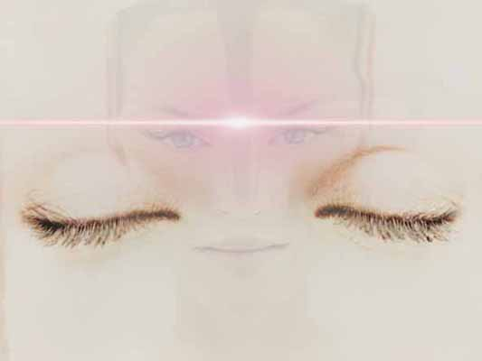



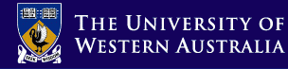
ALL ARE WELCOME – FREE EVENT
FOR RESERVATION CONTACT:
uwa_sai@yahoo.com
www.geocities.com/uwa_sai

FJ Clark Lecture Theatre
Queen Elizabeth II Medical Centre
Monash Avenue-Verdun St (Carpark), Nedlands.

Buses: 23,24,25,97,98,99,103,104
Sunday, 21st March 2004
3.50 to 8.00 p.m

Gazals
Bhajans
Gospel
Aramaic songs
Keertans
*Performances will be in various languages including
FRENCH, SANSKRIT, ARABIC, PUNJABI, URDU, GREEK AND ARAMAIC.

Join the university to explore the universality of music!

STUDY, ACT & INSPIRE GROUP OF UWA presents

RHYTHMS

International Music Appreciation Evening

