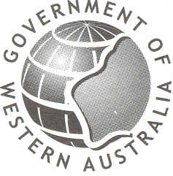
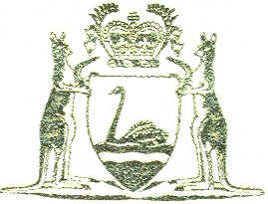
Premier of Western Australia

1 3 JAN 2004

….MUSIC OF THE SOUL 2004

“…….Celebrating Harmony Week is a simple and powerful way of highlighting Australia's rich cultural diversity. Here in Western Australia, one of the most culturally diverse places in the world, cultural and ethnic diversity is an inherent and defining characteristic of our society. The State Government is proud to support initiatives like yours that promote community harmony and value the contribution of the many cultures that form the fabric of our society.

I am sure that your musical event will foster harmony as you perform songs inspired by thoughts of peace and understanding which represent the many cultures that make up our community……”

My best wishes for the Music of the Soul 2004 performances.

DR GEOFF GALLOP MLA
PREMIER
MINISTER FOR CITIZENSHIP AND MULTICULTURAL INTERESTS

www.premier.wa.gov.au

