Preface
I am glad that the Draft Kuala Lumpur Structure Plan 2020 has been succesfully prepared in line with the provisions of the Federal Territory (Planning) Act 1984. City Hall Kuala Lumpur strives to improve the quality of living, working and business environment so as to make Kuala Lumpur, A World-Class City that benefits its people, entrepeneurs, business mean and visitors.
The Draft Kuala Lumpur Structure Plan 2020 is the blueprint that will guide the development of Kuala Lumpur for the next 20 years. The Plan with its two-pronged approach, outlines the goals, strategies and policies towards achieving the vision as well as identifies ways to minimise or solve issues and problems faced by the citizens. Hopefully, the Plan will be useful for all those who are involved in the planning and development of Kuala Lumpur.
A good plan is less meaningful unless it is succesfully implemented and the implementation of th ePlan will not be succesfl without the support of the citizens. In this respect, it is my greatest hope that all stakeholders such as the private sector, non-govermental organisations, community-based organisations, government agencies, professional bodies, institutions of higher learning and the general public will participate by giving your views and comments on the proposals contained in the Draft Kuala Lumpur Structure Plan 2020.
Together we make Kuala Lumpur a better city, A Worl-Class City.
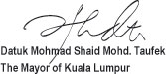
Introduction
The preparation of the Kuala Lumpur Structure Plan 2020 is undertaken in the conviction that most of the policies of the 1984 Kuala Lumpur Structure Plan (KLSP 1984) have been rendered obsolete by developments in recent years. Since the KLSP 1984 was adopted, Kuala Lumpur has undergone a period of unprecedented economic boom and rapid changes. Some of the major developments that have taken place were not anticipated in the structure plan. Development such as the Multimedia Super Corridor (MSC), the Kuala Lumpur International Airport (KLIA) at Sepang and the transfer of federal government administrative functions to Putrajaya are anticipated to stimulate and influence future changes and growth. With globalisation gathering pace, Kuala Lumpur will encounter more challenges within a new international development era. The nation’s capital should be made ready for a competitive international role in the world of the 21st Century. In the light of changes in the recent past and anticipated changes in the near future, it is timely to prepare a new structure plan for Kuala Lumpur.
The Federal Territory (Planning) Act 1982 (Act 267) is the legal basis for the preparation of the new plan. Section 10(1) of the said Act, stipulates:
‘At any time after a structure plan for the Federal Territory comes into effect, the Commissioner may submit to the Minister and shall if sodirected by the Minister, submit to him within a period specified in the direction, proposals for such alteration, addition, revision or replacement in whole or in part to the plan as appear to the Commissioner to be expedient or as the Minister may direct as the case may be’.
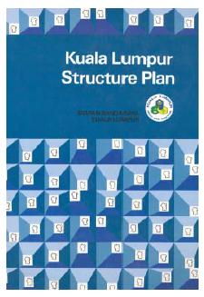
Photo: 1.1: ... most of the policies of the 1984 Kuala Lumpur Structure Plan have been rendered obsolete by developments in recent years.
What Is PSKL
THE DRAFT PLAN
The Draft Kuala Lumpur Structure Plan 2020 (the Draft Plan) contains the vision, goals, policies and proposals to guide the development of Kuala Lumpur (the City) over the next 20 years. It does not contain proposals for detailed physical planning for any specific area. Detailed physical proposals shall be relegated to a subsequent stage of the development plan, that is, the local plan.
The Draft Plan contains details of all the relevant separate components that make up the City, that is, its economic base and population, land use and development strategies, commerce, tourism, industry, transportation, infrastructure and utilities, housing and squatters, community facilities, urban design and landscape, environment and special areas. These components, though discrete parts, are inter-related and mutually contingent. Policies and proposals for each of these components are therefore, directed towards their composition into an integrated whole, that is, the efficiently functioning, progressive and felicitous city.

What Is PSKL
PUBLIC PARTICIPATION
The Commissioner (the Mayor of Kuala Lumpur), in accordance with Section 7 of the Act 267, has obtained the Minister’s consent to publish a public notice of the Draft Kuala Lumpur Structure Plan 2020 in the Gazette and local newspapers. The public may inspect and submit written objections to the Draft Plan within a period of not less than one (1) month from the date of publication of the notice.
The Minister shall appoint a Public Hearing Committee to hear, consider and report objections to the Draft Plan. Upon conclusion of the hearing, the Committee shall submit a report to the Mayor within a reasonable period not later than six (6) months or such extended period as the Minister may allow, the Mayor shall consider the report, make any amendments and submit the revised Draft Plan together with the report of the Committee to the Minister not later than three (3) months from the date of receipt of the report or such extended period as allowed by the Minister. The Minister shall under Section 8 of the Act 267 approves it or approves it with modifications or returns it to the Mayor for further consideration or rejects the revised Draft Plan.
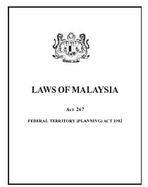
Photo: 1.2: The Commissioner in accordance with Section 7 of the Act 267 has obtained the Minister’s consent to publish a public notice
When the Minister has approved the revised Draft Plan, the Mayor shall give public notice of the approval in the Gazette and in local newspapers. The public notice shall indicate the place where copies of the approved structure plan may be inspected or purchased. The structure plan shall be deemed to have come into force on the date of publication of the public notice in the Gazette.

The International and National Context of Growth
Section

2.1 INTRODUCTION
Being the premier city and the capital of a nation with a highly trade oriented economy that aspires to be fully developed by the year 2020, Kuala Lumpur’s vision, goals, functions and growth must be seen both from the national and the broader global perspective, especially within the context of development of the Asia Pacific Region.
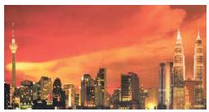
Photo 2.1: ... the premier city and the capital of a nation with a highly trade oriented economy ...

The International and National Context of Growth
Section

2.2 THE GLOBAL TREND

2.2.1 The Globalisation Process
The decline in trade barriers, the vast improvements in transportation and communication systems and networks over the last few decades have enhanced the volume of international trade in goods and services. Accompanying these are the enhanced international mobility of human resources, short and long-term capital and the growth in the number, strength and influence of transnational companies. The world economy has consequently become more integrated and global in nature. Major economic activities especially manufacturing have become more dispersed globally as processes within the production chain of increasingly more complex consumer and capital goods move to places that offer the best competitive advantage.
The global dispersion of production and marketing activities of transnational companies requires the global dispersal of management, control and support. This is achieved by the establishment of regional headquarters/offices in strategically located cities which can offer suitable infrastructure, supporting services, living environment and other ancillary activities. Many cities that have assumed an important role by providing a base for the efficient conduct of international business have attained the status of ‘Global’ or ‘World’ cities. Examples of top ranked global city are London, New York, Paris and Tokyo. Others that play more of a regional or subglobal role within the Asia Pacific Region (refer Figure 2.1) are cities such as Hong Kong, Singapore and Sydney.

2.2.2 The Knowledge-Based Economy
In addition to the globalisation trend, another factor that is and will influence the growth of the nation and that of Kuala Lumpur is the increase in the importance of the knowledge-based economic activities especially those relating to the development of information and communication technology (ICT).
Industries that generate knowledge such as research and development in biotechnology, computer software, multimedia applications, new technology for the computer and other hardware and industries that process, distribute and manage information such as educational institutions, telecommunication and Internet systems, advertising and professional services are the key drivers of the Knowledge-Based Economy (K-Economy)
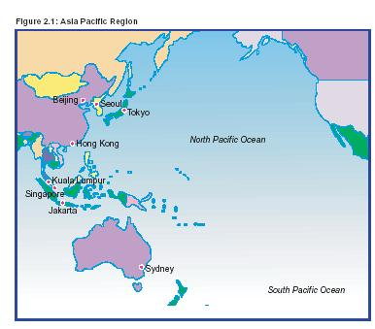

2.2.3 Agenda 21
Agenda 21, a comprehensive programme for action relating to sustainable development, was adopted at the United Nations Conference on Environment and Development (the Earth Summit) in Rio de Janeiro in 1992. A fundamental tenet of Agenda 21 is that development must be sustainable, that is, it must be able to meet the needs of the current generation without compromising the ability of future generations to meet their own needs. The strategy of sustainable development is one, by which communities seek economic development approaches that benefit the local environment and, at the same time, enhance the quality of life.
Local Agenda 21 grew out of Agenda 21 and is aimed at forging a partnership between local authorities and the public they serve, so that they may work together to plan and care for their surroundings within the context of sustainability.

2.3 The National Perspective
Vision 2020 identifies globalisation as one of the major underlying ‘mega trends’ which Malaysia must follow in order to ensure a sound basis for economic development, a view further emphasised by the Third Outline Perspective Plan (OPP3, 2001-2010) and Second Industrial Master Plan (1996-2005). While Kuala Lumpur may not aspire to join the top rank of global cities within the foreseeable future, as the nation’s premier city, it must adopt a strong global orientation.
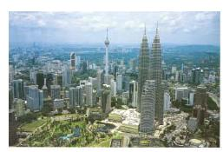
Photo 2.2: Kuala Lumpur together with the Kuala Lumpur Metropolitan Region is already being prepared to play a global role.
Industries and services that have a high export potentia are those which are needed to provide the impetus towards globalisation. High technology and high skilled industries, together with finance, transportation, tourism, business, information and professional services, shopping and other commercial activities, are the principal components of the nation’s economy, which must be developed to a level well beyond where it is now. In this respect, Kuala Lumpur being the premier city must play the leading role.
Kuala Lumpur together with the Kuala Lumpur Metropolitan Region (KLMR) (refer Figure 2.2) is already being prepared to play a global role. The KLIA is being promoted as a regional hub for air travel while concerted efforts are being made to develop Port Klang as a major trans-shipment port for Malaysia and the region. Similarly the development of the MSC, together with the continuous and progressive liberalisation of the trade and finance sectors, reinforces the aim of giving Kuala Lumpur and the KLMR a greater global orientation.

The International and National Context of Growth
Section

2.4 THE SUB-NATIONAL CONTEXT

2.4.1 The Klang Valley Region
The growth of the city of Kuala Lumpur must also be seen from the narrower sub-national perspective. At the time of the KLSP 1984, the Klang Valley Region was the sub-national context within which the growth of Kuala Lumpur was determined. However, major new developments outside it, in particular the KLIA, Putrajaya and Cyberjaya, have rendered the concept of the Klang Valley Region as a sub-national planning entity far less relevant.

2.4.2 The Kuala Lumpur Metropolitan Region
A more appropriate term of reference for Kuala Lumpur’s sub-national context is the Kuala Lumpur Metropolitan Region (KLMR). The KLMR refers to the entire Klang Valley Region as originally defined by the Klang Valley Study (1972) together with much of the Kuala Langat district and the remaining part of the Sepang district where the KLIA is located. It covers a total area of approximately 4,000 square kilometres, which is about 40 percent larger than the size of the Klang Valley Region of 2,843 square kilometres.
The KLMR is one large urban entity which incorporates the complete range of urban functions. However, it is important to distinguish between Kuala Lumpur, which is an administrative unit and the much larger KLMR which represents the total urban entity within which Kuala Lumpur is located and functions in many ways as the nucleus of the KLMR. Kuala Lumpur’s role, status and specific functions within the overall KLMR must be defined within the context of the wider total urban entity.
Similarly, in view of their symbiotic relationship, the planning of Kuala Lumpur must take full account of developments in the KLMR as a whole.
Since the KLSP 1984, the other urban centres in the Klang Valley Region, notably Petaling Jaya, Shah Alam and Subang Jaya, have grown at a rate that far outstrips that of the City. There has been strong in-migration to the KLMR outside Kuala Lumpur from all over the country and net out-migration from Kuala Lumpur into residential areas located outside the City. In the year 2000, the population of Kuala Lumpur was approximately 1.42 million compared to 4.30 million for the whole of the KLMR, a population distribution pattern not envisaged by the KLSP 1984.
As the MSC, especially Putrajaya and Cyberjaya grow, so will the proportion of the total built-up area in the KLMR compared to Kuala Lumpur. This decline in the relative size of Kuala Lumpur, in terms of population and built-up area, underlines the importance of defining the functions of the Kuala Lumpur within the context of the KLMR.

2.4.3 The Multimedia Super Corridor
The most important development within the KLMR that will have the most profound implication on the growth, function and development policies and strategies for Kuala Lumpur is the development of the Multimedia Super Corridor (MSC). This constitutes a 50 kilometre long and 15 kilometre wide corridor that begins from the KLIA in the south to Bukit Jalil in the north.
The MSC contains two ‘smart cities’, Putrajaya and Cyberjaya. Putrajaya is the new federal government administrative centre of Malaysia. Cyberjaya is the location of multimedia industries, a research and development centre, a multimedia university and operational headquarters for multinational companies wishing to direct their worldwide manufacturing and trading activities using multimedia technology. In addition an ‘Airport City’ is to be developed at Salak Tinggi.
Putrajaya and Cyberjaya together are projected to have a population of 500,000 by year 2020. The impact of the MSC is expected on employment and population. The principal outcome of the MSC will be a faster growth of jobs and population for KLMR and for the country as a whole. The growth in global activities is likely to mean a faster migration rate of foreigners especially of those with specialised skills. The City’s activities will be stimulated by the development within the MSC via consumption and production linkages and the growth in the export of services.
While the successful development of the MSC is likely to see a net increase in the job growth within Kuala Lumpur, this in itself is no guarantee that rapid out-migration from the City will ceased. An effective policy to induce more people, especially those in the higher income and skill categories, to live within the City is necessary to minimise or reverse net out-migration.
The global orientation and ‘world-class’ status of the MSC is vital in determining the vision and orientation for the future development of the City and the entire KLMR.
The International and National Context of Growth
Section

2.5 THE FUNCTIONS OF KUALA LUMPUR IN RELATION TO THE KUALA LUMPUR METROPOLITAN REGION
Kuala Lumpur’s principal functions will be redefined as a consequence of the MSC, the relocation of federal government administrative functions to Putrajaya and the wide range of city functions and activities that are now part of the KLMR. Furthermore, as the proportion of builtup land area and population of Kuala Lumpur declines in relation to that of the entire KLMR, the role of Kuala Lumpur is likely to be increasingly specialised. The City must focus on developing its strengths in the top-end service and manufacturing industries to enable them to operate within larger market catchments on an international, national and sub-national scale.
The core urban functions will continue to be located within the city centre of Kuala Lumpur. Thus the headquarters of transnational companies, the top end hotels and shopping outlets, recreational and entertainment centres will be located in the city centre, as will specialised training facilities, professional services and specialist medical services. In addition, Kuala Lumpur will also be a focus for the development of knowledge-based and high valueadded manufacturing industries.
As the capital of the nation, Kuala Lumpur will continue to house the major religious institutions and cultural facilities such as art galleries, museums, theatres and libraries. Befitting their international and national status, these institutions and facilities must be enhanced considerably.
Figure 2.3 illustrates a ‘functional pyramid’ for the KLMR with more specialised urban functions towards the apex of the pyramid, which represents Kuala Lumpur, and more general functions towards its base, representing the remainder of the KLMR.
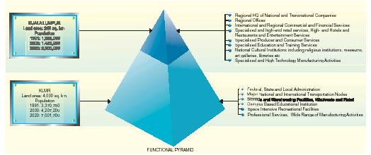
Figure 2.3: Function of Kuala Lumpur in relation to the Kuala Lumpur Metropolitan Region

Vision and Goals of Kuala Lumpur
Section

3.1 INTRODUCTION
n order to reach the population of 2.2 million in the year 2020, a population growth rate that is faster than that attained in the last decade needs to be achieved. Measures must be implemented to attract more people to live in the City.
Policies:
EC 9: CHKL shall implement measures to reverse the declining population growth rate in order to achieve a population of 2.2 million by the year 2020.
There is a need to increase the residential population of the City Centre not only to optimise the infrastructural investment, but also with a view to making the City Centre a more vibrant and dynamic place which can attract local and international businesses.
EC 10: CHKL shall implement measures to attract more people to live in the City Centre.
The increase in the population of the aged and the growth of expectations for a better standard of living require that greater attention be given to the needs of the aged in terms of the quality and range of accommodation and other facilities.
EC 11: CHKL shall take into consideration the needs of the aged population in all aspects of planning and development.
Vision and Goals of Kuala Lumpur
Section

3.2 THE DEVELOPMENT VISION FOR KUALA LUMPUR
The vision for Kuala Lumpur that is consistent with the national vision is:
KUALA LUMPUR - A WORLD - CLASS CITY
The vision of ‘A World-Class City’ encapsulates the ambition to make Kuala Lumpur a city that will assume a major global or sub-global role for the benefit of all its inhabitants, visitors and investors. Kuala Lumpur will strive to establish the highest quality living, working and business environment benchmarked against the best in the world. This is necessary if it is to attract and retain national and international investors as well as skilled and professional workers, both local and foreign.
As a world-class city, Kuala Lumpur must also ensure that the infrastructure, environment, city management and cultural, social and community facilities meet the highest expectations of the majority of its residents, visitors and investors.
The four principal constituents of a world-class city are a world-class working environment, a world-class living environment, a world-class business environment and a world-class governance.
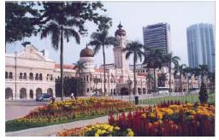
Photo 3.1: Kuala Lumpur, being the premier city of the nation, must contribute strongly to the attainment of the ideal embodied within Vision 2020.

3.2.1 A World-Class Working Environment
There should be a wide range in the choice of jobs and career opportunities together with good training facilities. Convenient and efficient transportation services offering minimum commuting time and cost together with good communication services and infrastructure are important considerations. Workplaces should be well equipped and provide a pleasant working environment and there should be well-developed supporting institutions such as libraries and information services as well as childcare facilities for working mothers.

3.2.2 A World-Class Living Environment
There should be a wide range in the choice of jobs and career opportunities together with good training facilities. Convenient and efficient transportation services offering minimum commuting time and cost together with good communication services and infrastructure are important considerations. Workplaces should be well equipped and provide a pleasant working environment and there should be well-developed supporting institutions such as libraries and information services as well as childcare facilities for working mothers.

3.2.3 A World-Class Business Environment
There should be a wide range in the choice of jobs and career opportunities together with good training facilities. Convenient and efficient transportation services offering minimum commuting time and cost together with good communication services and infrastructure are important considerations. Workplaces should be well equipped and provide a pleasant working environment and there should be well-developed supporting institutions such as libraries and information services as well as childcare facilities for working mothers.

3.2.4 A World-Class City Governance
A world-class city governance is necessary to ensure that all the ingredients that go to make up a world-class working, living and business environment are provided, sustained and continuously upgraded so as to keep pace with the best in the world. A world-class city governance is essentially one oriented towards an efficient and equitable use of available financial, organisational and human resources. Dedication, innovation, creativity and integrity are qualities of good governance that ensure the provision and maintenance of the best possible working, living and business environments.

3.3 GOALS
In order to achieve the vision of A World-Class City, five goals are identified:
Goal 1: To enhance the role of Kuala Lumpur as an international commercial and financial centre.
For Kuala Lumpur to become a world-class city, it must enhance its existing strengths and position itself as a commercial and financial centre able to compete at a regional and international level. Kuala Lumpur must also reinforce its status as the nation’s capital by becoming a major centre for the K-Economy and taking a lead role in implementing government policies.
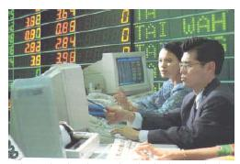
Photo 3.2: ... the City must enhance its existing strengths and position itself as a commercial and financial centre able to compete …
The City leads the nation in the high-end service industries. To orientate itself globally, these service industries together with manufacturing industries that are compatible with its urban status, such as skilled and technology intensive manufacturing and knowledgebased industries must be developed as important export industries.
In addition, Kuala Lumpur must seek to attract the regional headquarters of transnational companies operating on a global or sub-global scale by promoting itself as a competitive location in Asia Pacific Region and developing its support services and infrastructure to a level that is commensurate with the best in the world.
Goal 2: To create an efficient and equitable city structure.
For Kuala Lumpur to realise its vision as A World-Class City, it is important that the commercial and financial goal is achieved efficiently and also in a manner that benefits all members of the City’s community. Development must be balanced in such a way that the overall configuration of land use is optimised without compromising societal needs or adversely affecting the existing natural and built environment.
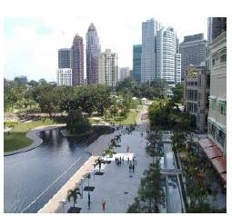
Photo 3.3: Development must be balanced … without compromising societal needs or adversely affecting the existing natural and built environment.
Good transportation and other communication linkages within the City and externally to the rest of the country and the world are also essential ‘enabling factors’ in the attainment of Goal 1. Public transportation plays an important part in the achievement of this goal by enabling greater flexibility and freedom of movement. Other infrastructure, utilities and facilities must be equitably distributed to ensure that they are accessible to all citizens.
Goal 3: To enhance the city living environment.
The City must be functional, liveable, and impart a sense of community and belonging. In addition, it must also provide a clean, healthy, safe and caring environment that caters to the needs of all. The City needs a wide range of employment and business opportunities,
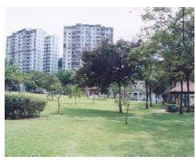
Photo 3.4: The City must be functional, liveable, and impart a sense of community and belonging. education, training, sufficient quality housing for all income groups and well designed, easily accessible social, sports and recreational facilities. It is of great importance to ensure that the needs of future generations are not compromised by decisions or developments related solely to present day issues.
Goal 4: To create a distinctive city identity and image.
In a world where globalisation has led to certain homogeneity in the appearance and character of major cities across the world, it is imperative that Kuala Lumpur seeks to define its own distinctive identity reflective of its tropical climate and multi ethnic population. This should be manifested in the built and natural environment and the everyday way of life of the City’s inhabitants as well as the various forms of cultural expression. The image of a tropical garden city is appropriate implying as it does the need to moderate the climate by providing shade from the sun and shelter from the rain.
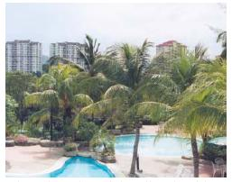
Photo 3.5: … to define its own distinctive identity reflective of its tropical climate and multi ethnic population.
These can be achieved by using a combination of natural elements such as trees and physical ones such as buildings.
The distinctive way of life in Kuala Lumpur, which stems in part from the ethnic and cultural diversity of its people and also from the blending of aspects of those cultures, should be jealously guarded and given greater expression. Culture and the arts should also be nurtured and promoted both as tourist products and factors in enhancing the overall quality of life for the City’s residents.
Goal 5: To have an efficient and effective governance.
The importance of good governance is of central importance in the achievement of the goals, strategies and policies set out in the Plan. This requires a commitment to the qualities of good governance as set out in the Habitat Agenda, namely transparency, responsibility, accountability and the adoption of just, effective and efficient administrative practices.
Transparency can be accomplished through sharing of a common vision, active and meaningful participation of all stakeholders and the free flow of information. Citizen and customer-oriented policies need also to be adopted as a means of improving the authority’s responsiveness to the needs of its citizens.
Effectiveness and efficiency are also key elements of good governance which the authority must improve through management innovation, capacity building, outsourcing, benchmarking, human resources development and networking. Processes and institutions must be reengineered to produce results that meet the needs of the City and its population while making the best use of resources.
Vision and Goals of Kuala Lumpur
Section

3.4 CONCLUSION
The vision and goals for Kuala Lumpur have been formulated with the aim of creating a sustainable city. City Hall Kuala Lumpur (CHKL) shall ensure that the planning of the City shall strike a balance between physical, economic, social and environmental development. Local Agenda 21 shall be adopted to encourage citizen participation towards creating a sustainable society. This is in line with government policies of implementing sustainable development strategies as stipulated in the Habitat Agenda of the Rio Declaration.

Economic Base and Population
Section

4.1 Introduction
In so far as Kuala Lumpur is the capital of the nation, its economic catchment encompasses the entire country. The present range of human activities in the City, its infrastructure and buildings, its parks and monuments, its spectrum of social, spiritual, recreational and entertainment facilities, and its concentration of governmental and non-governmental institutions, are manifestations of the City’s function as the capital of the nation. With the relocation of federal government administrative functions to Putrajaya, some diminution of this role is likely to be felt, but the City will remain the economic and business centre of the country.
At the same time, Kuala Lumpur forms part of the KLMR, a region that is the most industrialised and, economically the fastest growing in the country. Furthermore, the building of the KLIA at Sepang, the creation of the MSC, which includes Putrajaya and Cyberjaya, and the expansion of Port Klang have reinforced the national and international economic significance of the City.
As an international business centre, Kuala Lumpur vies with such cities as Singapore, Bangkok, Manila and Hong Kong for primary position in the Asia Pacific Region.
In realising its vision to become A World-Class City, Kuala Lumpur must address the regional, national and international perspectives, embrace the opportunities presented and define its specific role.

4.2 EXISTING SITUATION AND ISSUES

4.2.1 Economic Base
The Gross Domestic Product (GDP) for Kuala Lumpur (at purchasers’ value in 1987 prices) has increased from RM21,157 million in 1995 to RM25,968 million in 2000, an average annual growth rate of 4.2 percent. Malaysia’s GDP average annual growth rate during the same period was 4.7 percent (refer Table 4.1).
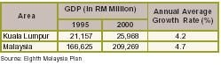
Table 4.1: Gross Domestic Product (GDP), 1995 - 2000
The per capita GDP for Kuala Lumpur during the period 1995 to 2000 rose from RM22,799 to RM30,727, an average annual growth rate of 6.1 percent. The per capita GDP for Kuala Lumpur was more than twice that of the national average (refer Table 4.2).
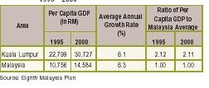
Table 4.2: Per Capita Gross Domestic Product (GDP), 1995 - 2000

4.2.2 Employment
(i) Existing Situation
The total current employment in Kuala Lumpur is estimated at around 838,400. The economic structure of Kuala Lumpur and the entire KLMR in terms of broad sectoral distribution of employment is given in Table 4.3.
The tertiary or service sector forms the largest component of employment in Kuala Lumpur representing about 83.0 percent of the total compared to 71.0 percent in the KLMR. Based on the Eighth Malaysia Plan, it is estimated that Kuala Lumpur accounts for the major portion or 58.0 percent of the service sector jobs within the KLMR. The tertiary sector comprises finance, insurance, real estate & business services, wholesale & retail trade, restaurant & hotel, transport, storage & communication, utilities, personal services and government services.
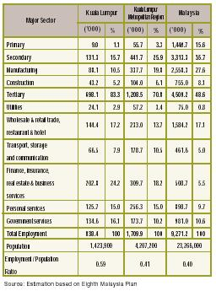
Table 4.3: Distribution of Employment by Major Sector in Kuala Lumpur, KualaLumpur Metropolitan Region and Malaysia, 2000
The secondary sector, which comprises manufacturing and construction, represents only 16.0 percent of employment in Kuala Lumpur compared to 26.0 percent in the KLMR.
The employment to population ratio in Kuala Lumpur is higher at 59.0 percent compared to 41.0 percent in the remainder of the KLMR and 40.0 percent in the country as a whole.
(ii) Issues
The manufacturing component of employment has declined to 10.5 percent of total employment in 2000 from 16.8 percent in 1980 (refer Table 4.1 KLSP 1984), leading to a reduction in the range of employment opportunities in the manufacturing sector.
• Decline in employment in the manufacturing sector

4.2.3 Population
(i) Existing Situation
The total current employment in Kuala Lumpur is estimated at around 838,400. The economic structure of Kuala Lumpur and the entire KLMR in terms of broad sectoral distribution of employment is given in Table 4.3.
The tertiary or service sector forms the largest component of employment in Kuala Lumpur representing about 83.0 percent of the total compared to 71.0 percent in the KLMR. Based on the Eighth Malaysia Plan, it is estimated that Kuala Lumpur accounts for the major portion or 58.0 percent of the service sector jobs within the KLMR. The tertiary sector comprises finance, insurance, real estate & business services, wholesale & retail trade, restaurant & hotel, transport, storage & communication, utilities, personal services and government services.
Table 4.3: Distribution of Employment by Major Sector in Kuala Lumpur, KualaLumpur Metropolitan Region and Malaysia, 2000
The secondary sector, which comprises manufacturing and construction, represents only 16.0 percent of employment in Kuala Lumpur compared to 26.0 percent in the KLMR.
The employment to population ratio in Kuala Lumpur is higher at 59.0 percent compared to 41.0 percent in the remainder of the KLMR and 40.0 percent in the country as a whole.
(ii) Issues
The manufacturing component of employment has declined to 10.5 percent of total employment in 2000 from 16.8 percent in 1980 (refer Table 4.1 KLSP 1984), leading to a reduction in the range of employment opportunities in the manufacturing sector.
• Decline in employment in the manufacturing sector

4.3 OBJECTIVES
In order to create an economic framework for the City which will enable it to achieve its vision to be A World-Class City, CHKL aims to:
• Enhance the City’s global and regional economic role as a leading centre of the Knowledge-Based Economy;
• Attain a strong and well diversified economic base;
• Integrate with and complement the activities within the Multimedia Super Corridor; and
• Attain an optimum population size and distribution.
Economic Base and Population
Section

4.4 Employment and Population Target
Kuala Lumpur needs to attain employment and population sizes that are optimum in relation to its economic activities, land resources, infrastructure and community facilities. To this end, an employment of 1.4 million and a population of 2.2 million are targeted for the year 2020 (refer Table 4.6).
Table 4.6: Population and Employment 2000 - 2020
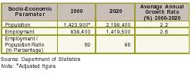

4.5 POLICIES AND PROPOSALS

4.5.1 Economic Base and Employment
a) A Leading Centre Of The Knowledge-Based Economy
Being part of MSC, Kuala Lumpur can anticipate that it will attract many multinational and local enterprises involved with information and communication technology.
Policies:
EC 1: CHKL shall implement measures to develop Kuala Lumpur as a centre of the Knowledge-Based Economy.
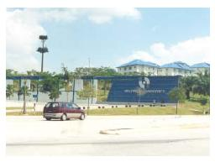
Photo 4.2: ... Kuala Lumpur as a centre of the Knowledge-Based Economy.
b) An International Commercial & Financial Centre
To enhance the role of Kuala Lumpur as an international commercial and financial centre, it is important for the City to enhance its attractiveness to international businesses.
Policies:
EC 2: CHKL shall implement measures to attract international organisations and business entities.
c) An Attractive Tourist Destination
In Kuala Lumpur, as in other major cities, the tourism sector plays an important part in its economic life, providing income, employment and expanding business opportunities. The tourism industry requires a very wide range of services and facilities, provides employment across all sectors of the population and helps to diversify the City’s economy. The potential of tourism sector therefore must be developed and promoted as a major economic generator.
Policies:
EC 3: CHKL shall develop and promote tourism as an important economic sector.
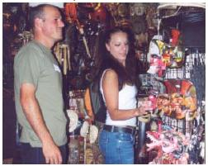
Photo 4.3: The tourism industry requires a verywide range of services and facilities, provides employment …
d) An International Shopping Centre
Enhancing and developing Kuala Lumpur as an international shopping centre is based on a sound foundation as Kuala Lumpur is already the premier shopping centre of the country.
Modern retail formats including mega malls, duty-free shopping outlets and discount stores have been developed which have enhanced the attractiveness of Kuala Lumpur as a shopping centre. Building on its wide variety of shopping facilities, Kuala Lumpur has the opportunity to become an international ‘shopping paradise’.
Policies:
EC 4: CHKL shall enhance and develop Kuala Lumpur as an international shopping centre.
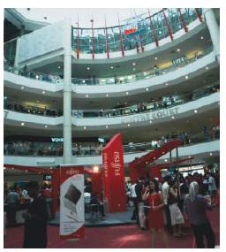
Photo 4.4: … Kuala Lumpur has the opportunity to become an international ‘shopping paradise’.
e) A Major Meeting, Incentives, Convention And Exhibition Centre
Business and conference tourism has expanded in recent years and is becoming a very important component of the industry. As a strategy in developing the tourism sector, more state-of-the-art Meeting, Incentives, Convention and Exhibition Centre (MICE) facilities will be provided. In addition, there shall be concerted efforts among the government and nongovernmental organisations to organise and host international MICE events in Kuala Lumpur.
Policies:
EC 5: CHKL shall promote the development of MICE facilities and encourage the holding of international events in the City.
f) A Dynamic Cultural and Entertainment Centre
Culture and entertainment not only help to make an attractive living environment but can also be developed as important economic goods in their own rights. Cities like London, New York, Sydney and Frankfurt have succeeded in making music, theatre and art as viable commercial activities and by such success are very attractive to international tourists and investors. Within the context of the overall KLMR, Kuala Lumpur continues to serve as the principal cultural and entertainment centre where the best restaurants, nightclubs, theatres, concert halls and art galleries are located.
To make Kuala Lumpur an international centre for culture and entertainment, it is pertinent to build upon its multi-racial, multi-religious and multi-cultural character providing a wide variety of cuisine, forms of cultural expression and types of entertainment. The anticipated influx of expatriates to Kuala Lumpur and the rest of the KLMR in response to the various development strategies and programmes, will also provide a stimulus for increasing the variety of cultural and entertainment facilities in the City.
Policies:
EC 6: CHKL shall encourage and facilitate the development of cultural and entertainment facilities.
g) A Regional Educational and Health Centre
Education and health services are becoming increasingly important economic activities and are being promoted aggressively as major commercial services for the local and export markets. To promote the development of educational and health services, more and improved facilities need to be provided.
Policies:
EC 7: CHKL shall encourage, promote and facilitate the development of education and health as commercial services.
h) A Revitalised Manufacturing Sector
In order to provide a balance in the City’s economic base, a strong manufacturing component must be retained. Existing and new manufacturing industries that meet the criteria of being clean and non-polluting industries shall be selectively retained or encouraged. In step with the development of the MSC, knowledgebased industries including those concerned with software development need to be promoted without neglecting traditional industries that are skill intensive.
Policies:
EC 8: CHKL shall facilitate the restructuring and sustenance of the manufacturing sector in favour of knowledge-based and high skills industries.
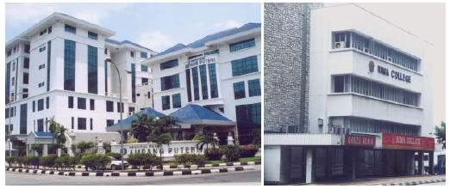
Photo 4.5: Education and health services are becoming increasingly important economic activities and are being promoted aggressively as major commercial services for the local and export markets.

4.5.2 An Optimum Population
n order to reach the population of 2.2 million in the year 2020, a population growth rate that is faster than that attained in the last decade needs to be achieved. Measures must be implemented to attract more people to live in the City.
Policies:
EC 9: CHKL shall implement measures to reverse the declining population growth rate in order to achieve a population of 2.2 million by the year 2020.
There is a need to increase the residential population of the City Centre not only to optimise the infrastructural investment, but also with a view to making the City Centre a more vibrant and dynamic place which can attract local and international businesses.
EC 10: CHKL shall implement measures to attract more people to live in the City Centre.
The increase in the population of the aged and the growth of expectations for a better standard of living require that greater attention be given to the needs of the aged in terms of the quality and range of accommodation and other facilities.
EC 11: CHKL shall take into consideration the needs of the aged population in all aspects of planning and development.

INCOME AND QUALITY OF LIFE
Section

5.1 Introduction
Quality of life encompasses the fulfilment of all human needs such as a satisfactory standard of material life, health, education, security, the satisfaction of living in a clean environment as well as the enjoyment of the aesthetic and the spiritual. In short, it relates to the general well being of the populace. For governments, including a city government like CHKL, the responsibility in bringing about a high quality of life is in ensuring that, inter alia, the necessary infrastructure of utilities and amenities, the institutions of social organisation and a governance that permits an acceptable level of individual expression and choice, are in place. For the individual, a prerequisite of a good quality of life is an adequate income, sufficient to permit access to the facilities that the City can provide.
To achieve a world-class status, it is incumbent on Kuala Lumpur to provide a high quality of life for its population, both in terms of the facilities that the City can offer and in the creation of a framework within which all residents can have equitable access to its facilities.
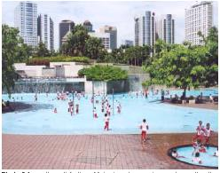
Photo 5.1: … the satisfaction of living in a clean environment as well as the enjoyment of the aesthetic and the spiritual.

5.2 EXISTING SITUATION AND ISSUES

5.2.1 Household Income
a) Average Income
The average monthly household income for Kuala Lumpur has increased from RM3,371 in 1995 to RM4,105 in 1999. Compared with the national average of RM2,472 in 1999, Kuala Lumpur’s average household income is higher by 66.0 percent.
The average annual growth rate of household income for Kuala Lumpur for the period 1995 - 1999 was 5.0 percent which is slightly lower than the national average of 5.2 percent (refer Table 5.1).
Table 5.1: Average Monthly Household Income, 1995-1999
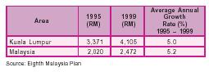
b) Indirect Income Indicators
In terms of indirect income indicators such as car and motorcycle ownership, Table 5.2 shows that Kuala Lumpur has 985.7 cars and motorcycles per 1,000 population in 2000 compared to 421.9 per 1,000 population for Malaysia as a whole. This indicates that the ownership rate of motor vehicles in Kuala Lumpur is twice that of the national average (refer Table 5.2).
Table 5.2: Indirect Income Indicators, 1995-2000
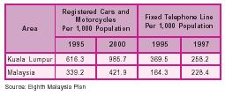
Photo 5.2: ... 23.5 percent of Kuala Lumpur households earned more than RM5,000 ...
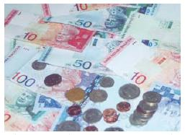
In terms of telephone lines, although the figures indicate a reduction in the number of telephone lines per 1000 population from 1995 to 1997, the actual usage of telephones in Kuala Lumpur has increased, in the form of mobile telephones.
c) Income Distribution
(i) Existing Situation
Figure 5.1 indicates the comparison between Kuala Lumpur and Malaysia in terms of household income distribution. The relative affluence of the residents of Kuala Lumpur is evidenced by the fact that 23.5 percent of Kuala Lumpur households earned more than RM5,000 per month compared to 9.8 percent for Malaysia as a whole. However, 8.1 percent of households in the City earned less than RM1,000, which would place them in a category that is unable to afford even a low cost house.
Figure 5.1: Household Income by Class, Kuala Lumpur and Malaysia, 1999
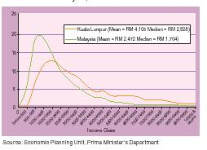
(ii) Issues
• A sizeable proportion of the population falls intothe low income group.
d) Poverty Level
(i) Existing Situation
The poverty level in Kuala Lumpur has increased from 0.5 percent in 1995 to 2.3 percent in 1999, although this is still low compared to national average of 7.5 percent (refer Figure 5.2).
The poverty level does not, however, take into consideration the higher costs of living in the City. The national poverty line figure for a household income of RM510 (at 1997 prices) should be adjusted to the more
realistic figure of RM750 for Kuala Lumpur. At this adjusted division line, the incidence of poverty in Kuala Lumpur does not differ greatly from the national average of around 7.5 percent.
Figure 5.2: Incidence of Poverty 1995-1999
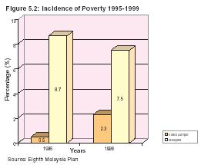
(ii) Issues
• Increase in the number of urban poor.

5.2.2 Other Components of the Quality Of Life
The Quality of Life Survey 1998 measured the satisfaction level of Kuala Lumpur’s residents with respect to a number of specific facilities and services. More than 40 percent of Kuala Lumpur residents faced difficulty in getting to their work place on time owing to traffic congestion.
Around 20 percent of residents were not satisfied with the provision of various public services and community facilities in their areas.
There was generally a high level of dissatisfaction with respect to the road maintenance, bus services, street cleaning services and garbage disposal.
There was widespread concern among the public with the level of pollution of rivers, noise, air and destruction of forests. There were concern regarding safety and security as well as vandalism in some areas of the City.
A more recent perception survey carried out by the Economic Planning Unit confirmed the above findings. It further revealed a high level of dissatisfaction in respect of accessibility to cultural and recreational facilities and the low level of social interaction and integration in the City.
Despite the dissatisfaction with certain aspects of life in the City expressed in the survey, the majority of people in Kuala Lumpur, irrespective of income or skill level, stated their preference to live in Kuala Lumpur rather than any where else. This indicates a sense of identity and pride in their City. All respondents agreed that they have achieved some degree of upward mobility in all aspects of their lives - socially, economically and in terms of job security.
(i) Issues
• Dissatisfaction with certain infrastructure, utilities, services. community and cultural facilities.

INCOME AND QUALITY OF LIFE
Section

5.3 OBJECTIVES
In line with the vision of A World-Class City, the objectives related to income and quality of life are to:
• Raise the overall income level especially those of the low income group;
• Provide opportunities and facilities for residents to attain economic and social progress; and
• Provide a clean, pleasant and safe living environment and access to high quality community and cultural facilities as well as public services that are supported by efficient infrastructure.
to raise funds to finance productive investments in education, business or acquisition of better properties.
INCOME AND QUALITY OF LIFE
Section

5.4 POLICIES AND PROPOSALS

5.4.1 Household Income
Household income includes both earned and unearned income. ‘Unearned’ income includes rental income (or imputed rental income of owner-occupied houses) and capital gain from property ownership. This is an important factor in the improvement of income and net worth of low income households. As property values increase with the growth of the economy and of the City, the income and net worth of property owning low income households increases. Home ownership shall be the main aim of the City’s low cost housing programmes so that owner-occupiers can enjoy capital gains from their properties. Owners of low cost housing should be permitted to mortgage or sell their properties to realise the capital gains if they so desire. This will enable those in the lower income group
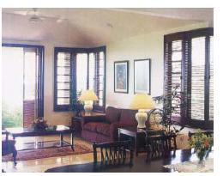
Photo 5.3: Home ownership shall be the main aim of the City’s low cost housing programmes so that owner-occupiers can enjoy capital gains from their properties.
Policies:
IC 1 : CHKL shall implement measures to increase the ‘unearned’ income component of the net worth of low income households.
Some parts of the City, especially the Malay Reservation Areas, traditional kampungs, new villages and dilapidated areas, have low property values even though they are strategically located. Measures shall be taken to realise the full potential of these areas.
IC 2 : CHKL shall facilitate the development of the Malay Reservation Areas, traditional kampungs, new villages and dilapidated areas.
Development of the Malay Reservation Areas, traditional kampungs and new villages is discussed in Chapter 16.0: Special Areas.

5.4.2 Social Programmes
To further assist the low income group and urban poor, CHKL shall provide financial, organisational and expert assistance through its social programmes to raise the income and improve the quality of life. Programmes to support and develop business initiatives for this group shall be encouraged.
Policies:
IC 3 : CHKL shall promote and expand social programmes for low income communities and the urban poor.
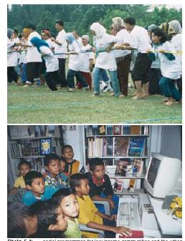
Photo 5.4: ... social programmes for low income communities and the urban poor.

5.4.3 Other Components of the Quality of Life
a) Improvement of Public Services
Good access to high quality public, social and cultural facilities will contribute a great deal to the improvement of the quality of life of the City’s residents. CHKL can provide good governance by recruiting the participation of residents in the improvement of their living environment.
Policies:
IC 4 : CHKL shall, in coordination with the relevant authorities and agencies and with the involvement of the public, ensure the provision of high quality public services.
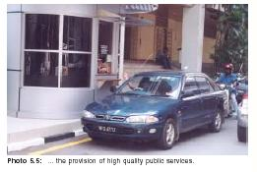
Photo 5.5: ... the provision of high quality public services.
b) Enhancement of the local environment
There is a reservoir of support from Kuala Lumpur residents as suggested by their expressed pride in and sense of belonging to their City.To capitalise on this and to enhance the living environment, a ‘self-managed community’ concept could be introduced where the residential communities themselves manage and improve their own areas with CHKL providing support in terms of training, materials and expertise.
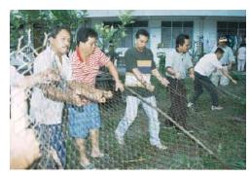
Photo 5.6: ... a ‘self-managed community’ … manage and improve their own areas …
Policies:
IC 5 : CHKL shall adopt the ‘self-managed community’ concept and promote its implementation in selected residential areas.

LAND USE AND DEVELOPMENT STRATEGIES
Section

6.1 INTRODUCTION
The development strategies for the next 20 years are focused on the vision for Kuala Lumpur to become a World-Class City. The strategies are also firmly grounded on the direction and accomplishments of the KLSP 1984 that set the framework for the structure and present growth patterns of Kuala Lumpur. The physical shape of Kuala Lumpur, the distribution of land uses, the new growth areas, infrastructure developments especially roads and rail systems are all directly attributable to the policies and strategies set out in the KLSP 1984.
The population base of Kuala Lumpur is set to increase from 1.4 million to 2.2 million over the next 20 years. Within the context of a city that is already well-developed new strategies that optimise limited land resources need to be devised. This Plan is part of the ongoing evolution of the City and the development strategies set out here form the basis for the planned spatial development of Kuala Lumpur as well as guiding the formation of sectoral policies up to the year 2020.
The strategies are all encompassing and cover every aspect of the City fabric from spatial and infrastructural development to urban design and the less tangible qualities of the City experience that shape and mould people’s perception of the City and their place within it.

LAND USE AND DEVELOPMENT STRATEGIES
Section

6.2 EXISTING SITUATION AND ISSUES

6.2.1 Land use 1984-2000
Table 6.1 indicates the existing land uses by sector while Table 6.2, 6.3 and 6.4 indicate the changes in land use between 1984 and 2000. The land use specialisation index in Table 6.2, 6.3 and 6.4 indicates the relative importance of a particular land use in relation to the City as a whole for each of the planning units designated in the KLSP 1984 (refer Figure 6.1).
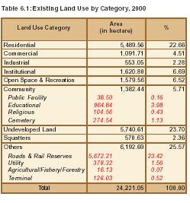
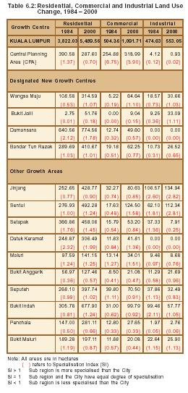
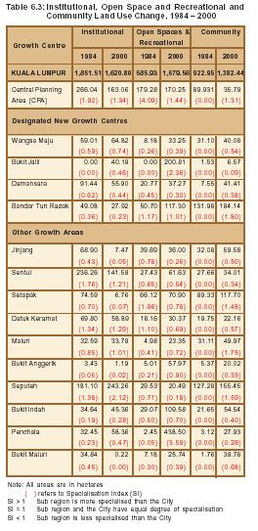
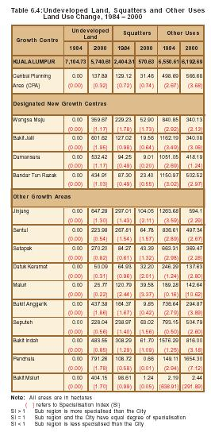
a) Residential
(i) Existing Situation
Residential land use increased from 3,822.03 hectares to 5,489.56 hectares between 1984 and 2000 and is the largest land use component in the City. The majority of increases in residential land use have been in the growth areas of Wangsa Maju and Bandar Tun Razak, whereas Bukit Jalil has yet to establish its residential base. Major established residential land use areas are in Damansara, Bukit Indah, Setapak and Sentul.
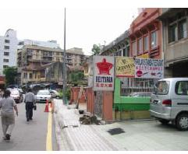
Photo 6.1: ... residential land use in the City Centre has declined significantly ...
However, residential land use in the City Centre has declined significantly between 1984 and 2000 and now accounts only for 26.4 percent of the total residential land use in 1984.
(ii) Issues
• Decline in residential land use in the City Centre; and
• Slow growth of residential land use in Bukit Jalil.
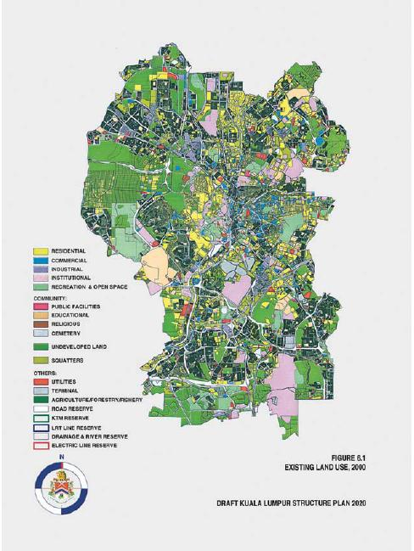
b) Commercial
(i) Existing Situation
Commercial land use growth has been significant, increasing by 116.5 percent from 504.36 hectares to 1,091.71 hectares between 1984 and 2000. Although there has been some dispersal of commercial land over Kuala Lumpur as a whole, the City Centre continues to be by far the most important commercial location in Kuala Lumpur accounting for 25.2 percent of the current total commercial land use.
The growth areas of Wangsa Maju and Bandar Tun Razak have had respectable increase in commercial land use which is in accordance with the objectives of the KLSP 1984. However, Damansara has had moderate growth in commercial land use and Bukit Jalil has only developed marginally. It is significant that of the four growth areas, only Wangsa Maju has a specialisation index in respect of commercial land use greater than 1.0. There has however, been significant growth in commercial land use outside the designated growth areas, in particular in Sentul, Bukit Indah, Jinjang and Seputeh.
(ii) Issues
• Preponderance of commercial land use in the City Centre; and
• Commercial growth outside the designated growth areas.
c) Industrial
(i) Existing Situation
The industrial component of land use is relatively minor and has increased from 474.63 hectares in 1984 to 553.05 hectares in 2000. Most of the industrial land use is distributed in Jinjang, Sentul, Bukit Indah and Maluri, which all grew during the period. Industrial land use also grew in the new growth areas of Wangsa Maju and Bandar Tun Razak and there has been a significant increase in Bukit Jalil because of the Malaysia Technology Park.
Many of the older industrial areas are in a dilapidated state, for example, Chan Sow Lin and areas along Jalan Klang Lama.
(ii) Issues
• Dilapidated industrial areas.
d) Institutional
(i) Existing Situation
Institutional land use which includes government land and military reserve land has decreased by 12.5 percent from 1,851.51 hectares in 1984 to 1,620.80 hectares in 2000 and currently accounts for 6.7 percent of the total land use. Most of this land is located in Sungai Besi Military Camp, Sentul (Batu Cantonment), Seputeh (TUDM Sungai Besi Air force Base), MINDEF and the federal government complexes at Jalan Duta and Mahameru Highway.
The majority of federal government offices has been and will continue to be relocated to Putrajaya and consequently a significant quantity of government office buildings and land will become vacant.
(ii) Issues
• Future use of buildings and lands formerly occupied by federal government offices.
e) Open Space and Recreational
(i) Existing Situation
Open space land use includes the major metropolitan parks, other public and private open spaces for recreational and sports facilities, incidental and community open spaces and as well as forest reserves.
Total open space land use has increased significantly by 169.6 percent from 585.93 hectares in 1984 to 1,579.56 hectares in 2000, although there has been a steady decline in public open space in the City Centre largely because of conversion to other uses.
Major open spaces in the City Centre comprise the public open spaces of Taman Tasik Perdana, Bukit Nanas and the Kuala Lumpur City Centre Park (KLCC) totalling 301.04 hectares. Penchala contains the largest amount of open space totalling 485.93 hectares comprising mainly the Bukit Kiara Botanical Garden, Bukit Kiara Equestrian Park, Kiara West Valley Park, Kuala Lumpur Golf and Country Club (KLGCC) and Malaysia Civil Service Golf Club. The development of the National Sport Complex, International Park, Botanical Park and Berjaya Golf Course at Bukit Jalil, together with the metropolitan park of Taman Tasik Permaisuri at Bandar Tun Razak have contributed to the significant increases in open space in these growth areas.
However, open space only represents 6.5 percent of total land use, and the amount that is available as public open space is even less when private open spaces such as golf courses are excluded.
(ii) Issues
• Decline in open space in the City Centre; and • Shortage of public open space.
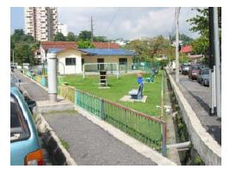
Photo 6.2: Shortage of public open space.
f) Community
(i) Existing Situation
Total community land use, which includes land for cemeteries and public, educational and religious facilities stands at 1,382.44 hectares or 5.7 percent of total land use. The four main tertiary institutions;
Universiti Malaya, Universiti Teknologi Malaysia, Kolej Tunku Abdul Rahman and Universiti Kebangsaan Malaysia occupy the great majority of land use in this category, together with several large tracts of centralised cemetery areas, particularly in Seputeh, Bandar Tun Razak and the City Centre.
Many of the local centres in older residential areas have been developed without adequate provision of community facilities such as community halls, markets, mosques, cemeteries and libraries. Consequently, there are some difficulties in finding sites for these facilities that are easily accessible to the residential population.
(ii) Issues
• Shortage of suitable sites for community facilities.
g) Undeveloped Land
(i) Existing Situation
Undeveloped land includes vacant land, dilapidated areas and ex-mining land. The total amount of undeveloped land now stands at 5,740.61 hectares or 23.7 percent of total land use. However, much of this land occurs in small pockets that do not lend themselves to large-scale development.
Kuala Lumpur has almost exhausted its supply of government owned green-field sites. The new growth areas are well established and the remaining undeveloped land is held under private ownership.
(ii) Issues
• Shortage of undeveloped land.
h) Squatters
(i) Existing Situation
Squatters land consists of residential, commercial and industrial squatters and presently occupies approximately 570.63 hectares or 2.4 percent of total land use.
(ii) Issues
• Issues relating to squatters are covered in Chapter 12.
i) Other Uses
(i) Existing Situation
Other uses consists of infrastructural and utilities reserves, agricultural, fishery and forestry land as well as land occupied by bus and rail terminals.
There has been a 5.5 percent decline in this category of land use from 6,550.61 hectares to 6,192.69 hectares between 1984 and 2000. However, there has been an increase in road reserve land due to the major road building programmes implemented as a consequence of the KLSP 1984. There has also been some increase in the rail reserve land because of the Light Rapid Transit systems (LRT), but this has not been significant because the systems have made use of existing river and rail reserves. The overall decrease in this category of land use is mainly attributable to the conversion of agricultural, fishery and forestry land to commercial and residential land use.
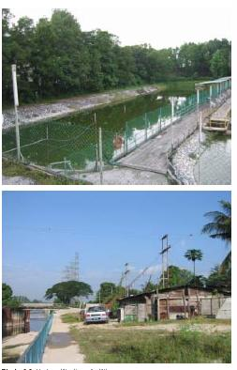
Photo 6.3: Under utilisation of utility reserves.
A large portion of the land that has been set aside as utility reserves, especially for electricity transmission lines are under-utilised.
(ii) Issues
• Under utilisation of utility reserves.

6.2.2 Land Availability
a) Unstable Areas
Unstable areas consist of undeveloped land, squatter areas and areas occupied by longhouses. These areas do not have any established use or permanent structures and can be developed immediately or in the near future.
b) Potential Development Land
In addition to the land available for development categorised as unstable areas, there is also land which has the potential for development. These are lands that presently have an established usage which will no longer be required, as in the case of land occupied by former federal government offices and government quarters.
There is also land which is in need of upgrading and partial redevelopment such as the Malay Reservation Areas, traditional kampungs and new villages. However, any intervention in these areas may cause disruption to the established communities and therefore, the amount of potential land for development will be a small proportion of the total area covered by these settlements.
c) Committed Land Available for Development
(i) Existing Situation
Committed development includes projects for which Development Order has been issued or approvals in principle have been granted. The total area of committed land is 7,298.17 hectares of which residential and commercial development accounts for 2,566.19 hectares.
It is not anticipated that all committed projects, which are primarily residential or commercial developments, will be built, as the supply of building units coming onto the market will depend on a favourable economic climate. It is assumed that a significant number of those for which Development Order have been issued or that have been granted approval in principle, may not proceed at all. In addition, CHKL will need to review committed private developments in the light of the development strategies. Special attention will be paid to committed commercial developments particularly those in the City Centre.
d) Net Available Land
The total net available land for development is estimated at 5,227.40 hectares, which is the total of the unstable areas, potential land for development and committed land available for development. This is summarised in Table 6.5.
Table 6.5: Net Available Land
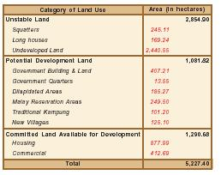
LAND USE AND DEVELOPMENT STRATEGIES
Section

6.3 Evaluation of The Achievement of The KLSP 1984 Development Strategy
The KLSP 1984 development strategy was based on the concept of a hierarchy of urban centres in order to achieve balanced growth across the City. Whilst the Central Planning Area (the City Centre) would still maintain its role and function as the business and commercial core of Kuala Lumpur, four new growth areas were proposed - Wangsa Maju, Bandar Tun Razak, Bukit Jalil and Damansara to decentralize future housing and employment. Each growth area was to be self sufficient in terms of residential population and employment opportunities. Planned populations in the range of 120,000 to 140,000 people were to be complemented by employment of between 72,000 to 90,000 workers. In parallel, local centres throughout the City would be consolidated to service neighbourhood populations. It was envisaged that a direct benefit of this strategy would be the increased use of public transport and reduction in private vehicle usage in the City Centre. Large tracts of undeveloped land within the City provided the opportunity to develop the new growth areas.

6.3.1 General
i) Existing Situation
The present population of Kuala Lumpur stands at 1.4 million although the KLSP 1984 had anticipated a population of 2.2 million by the year 2000. Many people have chosen to locate out of the City because of the availability of more affordable housing in the other urban and suburban areas in the KLMR. Employment targets have also not been met as new employment opportunities have arisen outside the City.
ii) Issues
• Population and employment targets as projected in KLSP 1984 have not been achieved.

6.3.2 Central Planning Area (CPA)
i) Existing Situation
The strategy to relieve some of the pressures on the CPA by directing more growth to the new growth areas has not been entirely successful. Commercial development has continued to increase while residential development and open space have both declined significantly. Land for commercial use has been mainly obtained due to the rezoning of residential lands and some open spaces. As a consequence of the intensification of commercial development in the CPA and the out-migration of the residential population, private vehicle commuting into the CPA has increased, thus putting additional pressure on the road infrastructure.
ii) Issues
• Decline in residential component;
• Increase in commercial component; and
• Reduction in public open spaces.

6.3.3 New Growth Areas
i) Existing Situation
The strategy to accelerate development of the growth areas of Wangsa Maju, Bandar Tun Razak, Bukit Jalil and Damansara has been a qualified success. Three of these growth areas, Wangsa Maju, Bandar Tun Razak and Damansara have reached maturity and, except for their district centres, have achieved their planned targets.
However, Bukit Jalil is in the early stages of growth with respect to residential, cultural, high-tech industrial development and its district centre has yet to be properly developed. None of the growth areas have fully achieved their intended status of becoming self-sufficient townships.
ii) Issues
• Slow development of district centres at Wangsa Maju and Bandar Tun Razak; and
• Slow progress of development at Bukit Jalil.

6.3.4 Existing Development Areas
i) Existing Situation
Development strategies for the remainder of Kuala Lumpur were directed at providing sufficient land to accommodate mainly retail services and local level public services for the immediate population. The strategies have met with only limited success and some areas suffer from the under provision of conveniently accessible utilities and facilities. Existing centres have not consolidated into neighbourhood or district service centres as development has favoured new centres at the expense of upgrading older and established residential areas.
ii) Issues
• Uneven distribution of utilities and facilities; and
• Development has favoured new areas at the expense of upgrading older established residential areas.

6.3.5 Transportation
i) Existing Situation
The KLSP 1984 set out a comprehensive transportation strategy aimed at promoting bus and rail public transportation as well as providing a comprehensive road network to disperse traffic away from the CPA. The LRT system, which was a central element of the public transport strategy, has been successfully completed and the road network has almost been completed virtually unchanged from the original proposals.
However, the primary objective of achieving a significant modal shift from private to public transportation has not been achieved mainly because of the lack of integration between land use planning and the rail-based public transport network and between the various modes of public transportation.
ii) Issues
• Lack of integration between land use planning and rail-based public transport network; and
• Lack of integration between the various modes of public transportation.

LAND USE AND DEVELOPMENT STRATEGIES
Section

6.4 DEVELOPMENT STRATEGIES

6.4.1 General
The development strategies that have been developed are firmly founded on the principles and successes of the KLSP 1984. It is essential that these principles are maintained since much of the planned and implemented infrastructure of the City; its roads, railways and others utilities are already in place.
Additional initiatives, however, have been integrated into the Plan in order to make it more effective, more responsive to the modern day needs of the City and its inhabitants and to inject a new dynamism.
The strategy of balanced growth across the City, a fundamental principle of the KLSP 1984, will be maintained and the hierarchy of urban centres consisting of the CPA and the four new growth areas will be retained and refined. Measures shall be introduced to consolidate these centres and enhance their amenity value to the community as well as to extend the functions of urban centres and improve accessibility. To reinforce these measures, a strong emphasis shall be placed on integrating development and public transportation strategies.
Strategies are introduced which are directed towards improving the living environment of the City to a level commensurate with that available in other world-class cities. These shall include the enhancement of the natural and built environment and the quality of housing and working environment. Better sports, recreational, entertainment, cultural and community facilities shall be provided and complemented by an integrated transportation system and high quality infrastructure.
New strategies shall also be implemented to initiate projects that will stimulate the economic life of the City and promote its image as an international commercial and financial centre. Due to the lack of sizeable greenfield sites available for development, these projects will build on the strengths of existing developed areas or make use of dilapidated areas requiring revitalisation.
Ten development strategies that will guide development policies for the next 20 years are summarised below:
• Enhance the working, living and business environment of the City Centre;
• Designate and develop International Zones;
• Designate and implement Comprehensive Development Areas (CDAs);
• Encourage and facilitate the development of Malay Reservation Areas, traditional kampungs and new villages;
• Initiate and implement the redevelopment of blighted areas;
• Ensure complete and integrated city linkages;
• Provide priority and incentives to development in areas around transit terminals;
• Ensure the functional distribution of centres and facilities;
• Consolidate the development and enhance the environment of stable areas; and
• Consolidate the development and enhance the environment of major entry points.
These strategies and their underlying principles are described in greater detail below (refer Figure 6.2 and Figure 6.3).
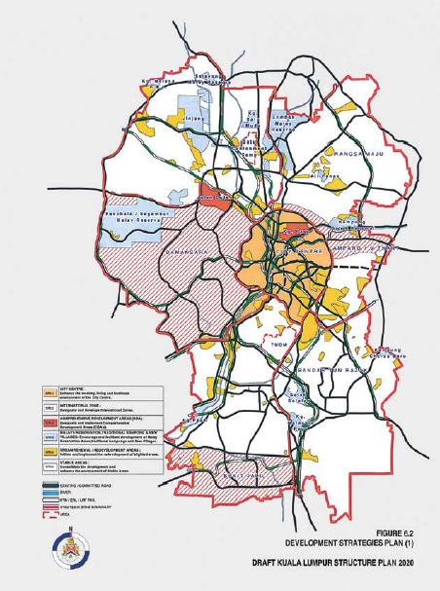
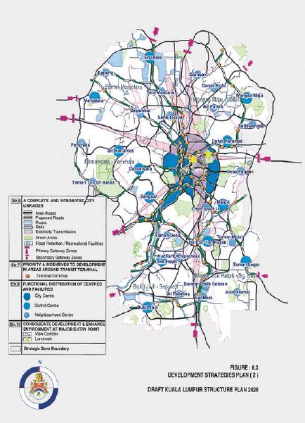
.

6.4.2 Enhance The Working, Living and Business Environment of The City Centre
The City Centre, formerly known as the Central Planning Area in the KLSP 1984 is the heart of the City. Recent facilities have been developed in the areas between KL Sentral and Telecom Tower have facilities that perform some of the commercial functions of the City Centre such as hotels, offices, shopping centres and a regional transportation hub catering to international and regional markets. In this respect this area can be considered part of the City Centre as it now performs a number of functions which are complementary transportation hub catering to international and regional markets. In this respect this area can be considered part of the City Centre as it now performs a number of functions which are complementary.
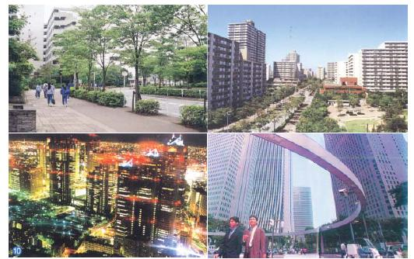
Photo 6.4: This strategy aims to create a complete living inner city environment that provides the very best business and working environment together with a
vibrant commercial and entertainment centre.
The City Centre is the focus of local, national and international attention and, for many, defines the image of Kuala Lumpur. More than any other part of the City, it epitomises its aspirations and those of its inhabitants and the success of its vision for Kuala Lumpur to be A World-Class City will be judged in no small part by the extent to which the City Centre can be seen to have embodied its realisation. This strategy aims to create a complete living inner city environment that provides the very best business and working environment together with a vibrant commercial and entertainment centre.
Particular emphasis shall be placed on attracting more people to live in the City Centre. This will reduce dependence on private transport, as more people will be able to travel directly to work either on foot or by public transport. A consequence of this strategy will be to create an increased liveliness in the City Centre as more people populate its streets outside the normal business periods and commercial and entertainment enterprises benefit from the increased residential market.
In order not to exacerbate problems of oversupply of commercial spaces in the City Centre as well as to encourage greater dispersal of commercial spaces to the other urban centres, the KLSP 1984 strategy of maintaining only moderate growth in the City Centre shall be continued. Land uses which are no longer in keeping with the projected role of the City Centre as an international commercial and financial centre shall be reviewed and relocated, thus releasing more land for commercial and residential uses and also forcompatible non-commercial use that can improve the living environment of the City Centre.
A greater diversity of economic activity shall be encouraged in the City Centre particularly in the fields of tourism, healthcare and higher education. This diversification will help to expand the City’s revenue base and reduce its susceptibility to fluctuations in certain commercial sectors.
The City Centre needs to be reintegrated and connections restored. Pedestrian movement in particular shall be given priority over private vehicular traffic and comprehensive pedestrian networks shall be created affording comfortable and convenient access to transportation nodes and activity centres so as to reduce reliance on private transport.
Urban design guidelines shall be developed and progressively implemented throughout the City Centre which will ameliorate the living environment, create or regenerate connections, both physical and experiential, and develop a unique and discernible identity for the City. Streetscapes shall be harmonised and plazas and pocket parks introduced to add texture and continuity to the external environment of the City Centre.

6.4.3 Designate and Develop International Zones
A world-class city must be able to attract the highest calibre of expertise, both local and overseas, to live as well as work in the City. Contiguous zones that contain activities that are of international relevance and appeal and which also incorporate an attractive living environment shall be developed to providing the highest quality facilities in terms of housing, education, shopping, recreation and entertainment. The quality of existing utilities and facilities shall be improved and upgraded, and existing institutions enhanced to cater for the international market as well as to benefit the local residents.
In addition to being high quality residential districts, the International Zones shall also be developed as high-end employment centres specialising in ICT or high skills technology. Commercial activities that cater to the needs and tastes of the international market shall be encouraged and precincts which specialise in international cuisine and culture shall be designated and developed.
Three areas have been designated zones of international relevance and appeal namely Damansara, Ampang/U-Thant and Bukit Jalil. Each zone will be able to provide its own uniquely attractive living environment to appeal to the differing requirements of international residents from the well established and exclusive lowrise residences of Damansara to the new high rise condominiums of Bukit Jalil.
The eastern part of Damansara and western part of Jalan Ampang/Jalan U-Thant shall complement the activities of the City Centre, providing established high quality living environments conveniently accessible to the central business district. The southern zone at Bukit Jalil shall serve as a bridge between the City and the MSC high tech areas to the south. The character of each zone shall be developed so as to preserve and enhance their own individual locational strengths and existing character and amenity.
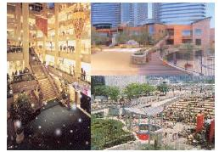
Photo 6.5: ... an attractive living environment shall be developed to providing the highest quality facilities in terms of housing, education, shopping, recreation and entertainment.

6.4.4 Designate and Implement Comprehensive Development Areas
As the premier city of the nation, Kuala Lumpur will be the torchbearer for Malaysian industry and entrepreneurship, and new initiatives shall be implemented that reinforce the national development plans.
Two major Comprehensive Development Areas (CDAs) have been identified which will showcase and provide an impetus for the promotion and development of Malaysian industry and commerce. The two CDAs are Kampong Baru, the Malay Reservation Area in the heart of the City Centre, and the federal government complexes at Jalan Duta to the west of the City Centre. The CDAs shall be comprehensively planned and developed as integrated mixed developments comprising residential, commercial and industrial uses and will include utilities and facilities that are commensurate with their residential populations. Each of the CDAs shall also be served by transit terminals that will be connected to key activities in the area and around which district centres shall be developed.

6.4.5 Encourage and Facilitate the Development of Malay Reservation Areas, Traditional Kampungs and New Villages
While pursuing its vision to be ‘A World-Class City’, it is essential that Kuala Lumpur does not lose sight of its unique character and cultural heritage. In particular, the Malay Reservation Areas (MRAs), traditional kampungs and new villages, besides being of great historical importance in the development of Kuala Lumpur and the nation, also preserve a cultural continuum by maintaining traditional customs and ways of life.
However, these areas were created under circumstances that are no longer relevant to their present urban context. The layout, pattern of land ownership and basic infrastructural provision reflect their original land use as predominantly agricultural smallholdings. Consequently, these areas are characterised by poor infrastructure and a deteriorating urban fabric that lags far behind the rest of the City. In order to make sure that these areas can survive and contribute to the life of the City, measures need to be taken to encourage and facilitate residential and commercial developments.
Community facilities shall be upgraded and basic infrastructure improved by upgrading utility services, drainage and the road systems. New development in these areas shall reflect the values of their respective communities. For example, in order to encourage continuity in the residential communities, the concept of extended family housing shall be developed.
Innovative ways shall be devised to encourage entrepreneurship and bring prosperity to the areas. Commercial activities will be encouraged that emphasise the development and promotion of traditional goods, crafts and cottage industries in tandem with the development of modern products, services and trades that benefit the communities.
Homestay and agro-tourism in particular could well appeal to both domestic and international tourists who wish to experience a taste of traditional ways of life. CHKL shall encourage and assist in the development of tourist support facilities, as well as in tourist promotion both locally and internationally.
Categories of buildings, areas and sites that deserve to be conserved shall be extended to include those that have a particular historical or cultural significance within the context of their community. Similarly, architectural motifs reflecting ethnic and cultural character shall be encouraged for new developments and in streetscape projects. Landscaping shall also make use of indigenous trees and plants that are especially evocative of Malaysia’s location and tropical environment.
These areas have traditionally had a strong sense of identity and community and efforts shall be made to encourage collective development undertaken by the community which are of mutual benefit to the participants and, ideally, the community as a whole. As these close knit communities best understand their own needs, it is desirable that the impetus for development comes from them. CHKL shall facilitate the establishment of community corporations to direct and coordinate development. Expertise and assistance shall be provided to expedite the progress of development and infrastructural improvement.

6.4.6 Initiate and Implement the Redevelopment of Blighted Areas
Some areas of the City have, as a natural consequence of urban growth and decay, become dilapidated. Due to patterns of land ownership, large-scale redevelopment in most cases would be difficult and therefore a longerterm approach, which aims at a gradual regeneration without essentially changing the characteristics of these areas, is to be adopted.
CHKL shall prepare long-term comprehensive development plans and guidelines which will be implemented over a period of time. Improvement to basic infrastructure such as roads, utilities and drainage shall be the initial priority and, as opportunities present themselves, improvements to other amenities and community facilities shall also be implemented. These measures will combine to help regenerate dilapidated areas and encourage more private redevelopment to take place within proper planning and urban design guidelines.
Some of these areas are among the oldest parts of the City and contain buildings and sites that are of historical and cultural significance. These shall be identified in the comprehensive development plans and designated to be conservation areas. Other areas that have clear redevelopment potential could provide opportunities to cater for future urban needs that require public intervention. These too shall be identified and designated as part of the comprehensive development plans.
The guidelines will emphasize the unique characteristics of each of the areas and ensure that development will be compatible with the surrounding areas. The manner in which the comprehensive development plans and guidelines are implemented will ensure that the character and image of each area is retained and enhanced.
A phased urban renewal and development programme based on the comprehensive development plans shall be devised and implemented for each of the identified areas.

6.4.7 Ensure Complete and Integrated City Linkages
A world-class city of the 21st century must be one which is fully connected and integrated both physically and perceptually.
Of prime importance is physical connectivity in the form of a transportation system that enables the efficient movement of people and goods within and around the City. The existing road and rail transportation networks are comprehensive and well established and need now to be completed and integrated. The railway transport network in the City comprises the Projek Usahasama Transit Ringan Automatik (PUTRA) and Sistem Transit Aliran Ringan (STAR) light rapid transit systems, Keretapi Tanah Melayu (KTM) commuter rail services together with the Express Rail Link (ERL) and the monorail or People Rapid Transit (PRT) system. This comprehensive rail network will shortly be completed linking the City Centre to the major centres within Kuala Lumpur, other neighbouring urban centres, Putrajaya and KLIA.
A comprehensive bus network shall be developed which is flexible and user responsive and which is properly integrated with the rail network. Pedestrian networks shall be established with particular emphasis on the City Centre and other areas that provide connections to major transit nodes and activity centres. The increased convenience and flexibility of these measures will help to redirect people towards increased usage of public transportation with less reliance on private transportation.
Essential utilities such as electricity, water, sewerage and drainage shall be upgraded and comprehensively provided throughout the City. Together with the utility companies and agencies, CHKL shall ensure that these utilities are integrated and coordinated with one another and with future development plans. ICT infrastructure, which has become an essential utility of the 21st century, shall be incorporated into all new developments in the City, and upgrading of existing areas shall be encouraged.
Linking together green spaces will encourage a diversity of flora and fauna to permeate into the heart of the City as well as helping to improve air quality and providing amenity to the citizens of Kuala Lumpur. The green network initiated by the KLSP 1984 shall be fully realised, linking major open spaces such as metropolitan parks, forestry reserves and lakes together with other open spaces such as cemeteries and golf courses by means of landscaped road, river, rail and utility reserve corridors.
Visual and perceptual linkages shall also be developed so as to improve the imageability of the City and to make it easier to orientate oneself within it. Views of the City skyline shall be accentuated from various critical parts of the City and especially at its ‘gateway’ arrival points. Sites shall also be identified for future planned landmark building to further enhance the City skyline and facilitate orientation within and around the City.
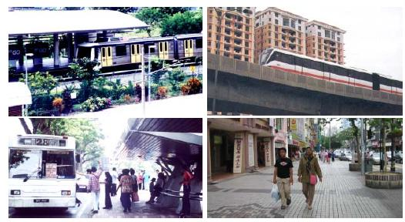
Photo 6.6: ... the form of a transportation system that enables the efficient movement of people and goods within and around the City.

6.4.8 Provide Priority and Incentives to Development in Areas Around Transit Terminals
To reinforce the strategy of providing complete and integrated transport linkages, more intensive development near to transit terminals shall be actively promoted.
Mixed-use development incorporating high-density residential, high plot ratio commercial as well as community and business facilities shall be encouraged, thus greatly reducing reliance on private transportation by making accessibility flexible and convenient. Bus services shall be closely integrated with rail terminals and interchange facilities provided to facilitate fast, convenient and efficient transport. Pedestrian and traffic linkages, both within and from outside these zones, shall be improved to provide more convenient access to the transit terminals.
Park-and-ride facilities shall be provided at interchanges on the perimeter of the City Centre, encouraging more people to use public transportation to access the City Centre. To further discourage private car usage in the City Centre, measures shall be introduced to reduce car parking provision and increase car parking charges. Other traffic restraint measures such as restricted zones and area licensing schemes shall be considered.
By locating major community facilities near to major transit terminals, the effective catchment populations can be greatly increased, consequently permitting the consolidation and optimisation of the usage of resources and facilities. Community facilities that are relevant to this strategy would be community centres, libraries and health facilities.

6.4.9 Ensure the Functional Distribution of Urban Centres and Facilities
A prime concern of the City must be that its urban centres and facilities are distributed in such a way that they are easily accessible to the majority of its population. To this end, a clear hierarchy of urban centres comprising the City Centre, district centres and neighbourhood centres shall be defined. Appropriate functions and facilities shall be determined for each genre of centre according to their location, accessibility and catchment area or population (refer Table 6.6). Existing centres shall be consolidated and upgraded to meet the requirements of the local community.
Table 6.6: Hierarchy and Functions of Urban Centres
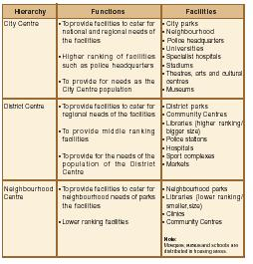
District centres shall be designated that are located at or close to LRT or KTM rail stations and development at these centres shall be intensified so that they benefit a greater number of people. Improved public transport accessibility shall be provided to existing district centres that do not have convenient rail-based terminals and the feasibility of extending the rail network to serve these centres shall be examined. Neighbourhood centres shall, as far as is possible, be located at or close to LRT or KTM rail stations and development at these centres shall also be intensified.
Community facilities shall be distributed and integrated into the various types of urban centre according to their intended catchment population. Larger and more sophisticated facilities such as public libraries that benefit from the consolidation of resources shall be distributed to district centres that are well served by public transport. Other smaller facilities such as local play areas and football fields that need to be more closely associated with residential neighbourhoods shall be distributed to the neighbourhood centres. Facilities that shall be ubiquitously provided such as ‘corner shops’, local play areas and neighbourhood watch booths should be associated with local centres.

6.4.10 Consolidate the Development and Enhance the Environment of Stable Areas
Much of Kuala Lumpur is virtually fully developed. Three of the four growth areas identified in the KLSP 1984; Wangsa Maju, Damansara and Bandar Tun Razak are now well established while other areas of the City have also stabilised and established their own distinct characters.
Some new highway projects have adversely affected the configuration of certain areas. Pedestrian and traffic patterns have become dislocated and communities disrupted as a consequence. In some cases, this has led to a physical and social degeneration of the areas. Plans shall be drawn up to reconfigure these areas in order to help to regenerate and revitalise them.
Elsewhere, development has occurred without due regard for the adequate provision of community facilities, utilities or, in some cases, infrastructure. A programme will be implemented to ensure that all areas are equipped with basic infrastructural needs and have access to proper, up-to-date and well-maintained facilities.
In order to maintain a stable and sustainable city structure, a strategy shall be implemented which builds on the existing strengths of stable developed areas and improves their overall environment. This strategy will be one of minimal intervention sufficient to consolidate the fabric of these areas in order to improve cohesiveness and repair anomalies or shortcomings. Existing land uses in these stable areas shall be maintained and incompatible land uses eliminated. The intrinsic characteristics of stable areas in terms of their geophysical and built environment will be analysed and opportunities exploited to enhance their existing character and identity.
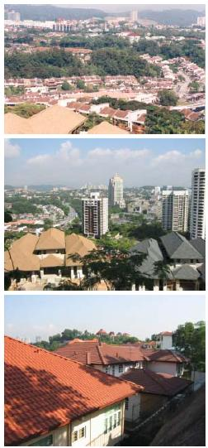
Photo 6.7: ... builds on the existing strengths of stable developed areas and improves their overall environment.

6.4.11 Consolidate the Development and Enhance the Environment of Major Entry Points
Kuala Lumpur is surrounded on all sides by suburban development and townships that blur the definition of its boundaries. This urban sprawl together with a lack of planning consistency on either side of the City boundary has diluted its image and often diminished or compromised Kuala Lumpur’s planning intentions.
Gateway zones shall be established at the primary and secondary entry points at the City boundary. The primary gateway zones will be those where the city perimeter intersects the major access roads into the City and from where views of the City skyline and landmarks are visible. These zones shall be emphasised so that they are consciously perceived as the main points of arrival at the City and project the image of Kuala Lumpur as the nation’s prime commercial and financial centre as well as its high quality living and working environment. At all gateway zones, there shall be a clear definition between elements that are outside and those that are inside the city boundary.
Depending on the physical characteristics and function of each of the gateway zones, an appropriate development character, scale and typology will be determined. In order to heighten the sense of arrival, utilities and facilities shall be provided for visitors, and incompatible land uses that do not help in the proper definition of these zones shall be eliminated. CHKL shall also endeavour, with the cooperation of the relevant local authorities, to ensure that developments outside the City that abut its boundary harmonise with and complement developments inside the boundary.

LAND USE AND DEVELOPMENT STRATEGIES
Section

6.5 The Key Plan
The ten principal strategies are translated into more specific spatial strategies across the City. The two key diagrams that form part of this document illustrate the citywide strategies outlined in the previous section:
• Development Strategies Plan 1:
Illustrates strategies relating to the City Centre, International Zones, Comprehensive Development Areas, Malay Reservation Areas, traditional kampungs and new villages, blighted areas and stable areas (refer Figure 6.2).
• Development Strategies Plan 2:
llustrates strategies relating to the distribution of urban centres and facilities, green networks, road and rail networks, transit terminal nodes and the enhancement of the main City entry points (refer Figure 6.3).
To develop the spatial strategies in further detail as well as to provide greater focus, the City has been divided into six strategic zones whose boundaries align with major road, rail and river corridors. Chapter 17 Strategic Zones describes in greater detail how the development strategies contained in this chapter as well as the sectoral policies outlined in subsequent chapters are applied in respect of the Strategic Zones. The six zones are identified below:
• The City Centre (previously the CPA)
• Wangsa Maju - Maluri
• Sentul - Menjalara
• Damansara - Penchala
• Bukit Jalil - Seputeh
• Bandar Tun Razak - Sungai Besi
The basic planning parameters for each strategic zone for year 2020 are shown in Figure 6.4.
Figure 6.4: Population and Employment by Strategic Zone, 2020
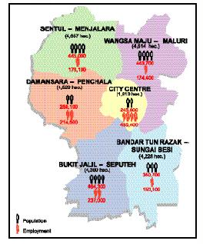

COMMERCE
Section

7.1 INTRODUCTION
An integral part of the vision to make Kuala Lumpur into A World-Class City is to enhance its position as an international commercial and financial centre. Commerce is the driving force behind a city’s economy. It is the creator of wealth, the principal provider of jobs as well as a primary impetus for development and renewal. To be able to attract major multi-national companies to base their regional operations in Kuala Lumpur will bring great rewards to the City and to the nation as a whole.
In order to achieve its goal, Kuala Lumpur must first address the demands of the K-Economy, which is one where innovative ideas and new technologies are the key ingredients of wealth creation. Kuala Lumpur will benefit from the proximity of the MSC, by being able to draw on and complement its knowledge-based enterprises. The City will also be able to maximise the benefits of this relationship by providing complementary high-end services in finance, shopping, entertainment, housing, education and recreation.
CHKL must also provide for an efficient and equitable city structure which best distributes commercial spaces so that all parts of the City have access to appropriate facilities according to their needs. The people of the City should be properly served with conveniently accessible shopping facilities irrespective of their location. Similarly, CHKL will need to satisfy the needs of local businesses, as well as those of the multi-national companies, so that they will be able to obtain affordable office space in areas which satisfy their organisational and staffing needs.

COMMERCE
Section

7.2 EXISTING SITUATION AND ISSUES

7.2.1 Commercial Overview
Existing Situation
The estimated total commercial floor space in the KLMR is 64 million square metres of which 66 percent is located within Kuala Lumpur.
There has been a trend towards the decentralisation of office space from Kuala Lumpur to the KLMR. Between 1991 and 1997, the percentage share of purpose-built office spaces in Kuala Lumpur to that of the whole of the KLMR declined from 95 percent to 80 percent. Similarly, between 1995 and 1998, the amount of commercial complex retail floor space situated in Kuala Lumpur declined from 57 percent to 50 percent of the total for the KLMR.
The major components of commercial floor space in Kuala Lumpur are offices, shopping, hotels and service apartments and other services. Figure 7.1 shows the existing and committed commercial floor space by status and components, while Table 7.1 shows the existing and committed floor space by status and strategic zone. Commercial floor space increased by 277 percent between 1980 and 2000, while employment in the commercial sector increased by 82 percent over the same period to stand at 698,100 in 2000. On the whole, the major components of the commercial services sector have experienced substantial growth in recent years. There has been a decline in the relative amount of commercial floor space in the City Centre compared to the whole of Kuala Lumpur, from 66.3 percent in 1980 to 47.2 percent in 2000.
(ii) Issues
Despite the growth of office and retail space outside the City and the City Centre, there is still an overconcentration of commercial floor space in the City Centre.
• Over-concentration of commercial development in the City Centre.
The supply of commercial floor space in 2000 exceeded demand with vacancy rates in the office and retail sectors running at 23 percent and 30 percent respectively. Based on the demand trend for commercial floor space over the last two decades the current overhang and incoming supply of office and retail floor space are expected to be fully utilised by 2005.
• Overhang of office and retail floor space
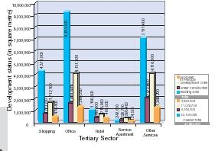
Figure 7.1: Existing and Committed Commercial Floor Space by Status and Components, 2000
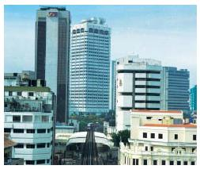
Photo 7.1: ... there is still and over-concentration of commercial floor space in the City Centre.
Table 7.1: Existing and Committed Commercial Floor Space by Status and Strategic Zone, 2000
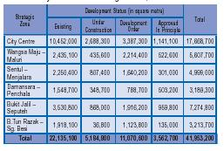

7.2.2 Office Buildings
(i) Existing Situation
Figure 7.2 shows the distribution of existing office areas in Kuala Lumpur. CHKL has been implementing Intelligent Building Guidelines which are applied to all new office buildings in Kuala Lumpur. Included in the guidelines are requirements for Building Management Systems, incorporation of ICT infrastructure and energy conservation measures. Consequently, there is already a sizeable stock of office buildings in Kuala Lumpur of a very high standard.
(ii) Issues
There is a significant quantity of older office buildings, including those vacated by the relocation of government offices to Putrajaya, which are deficient in basic ICT facilities.
• Many of the older office buildings in Kuala Lumpur are obsolete and lacking basic ICT facilities.
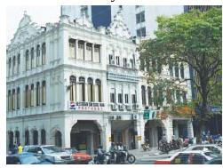
Photo 7.2: There is a significant quantity of older office buildings which are deficient in basic ICT facilities.

7.2.3 Shopping
(i) Existing Situation
Figure 7.3 shows the distribution of existing shopping areas in Kuala Lumpur. The emergence of hypermarkets for convenience shopping and mega malls for general and recreational shopping on the outskirts of the City has started to change the pattern of retail development in Kuala Lumpur. Shophouses, the more traditional form of local shopping, are becoming less relevant as people prefer the convenience, air-conditioned comfort and wider variety of goods available in the large shopping complexes.
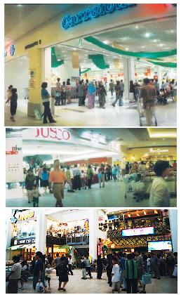
Photo 7.3: The emergence of hypermarkets for convenience shopping and mega malls for general and recreational shopping on the outskirts of the city h a s s t a r t e d t o change the pattern of retail development in Kuala Lumpur.
(ii) Issues
There is a phenomenon of unsuccessful shopping complexes in Kuala Lumpur. The failure of some complexes is principally due to poor accessibility, insufficient catchment, unattractive design, and the lack of proper market and financial studies.
• Failure of some shopping complexes.
The traditional shopping areas in the City Centre have largely been superseded by the emergence of large-scale shopping malls in various parts of the City. As a consequence, there is no longer a clearly defined major shopping area or spine within the City Centre.
• Lack of a dominant shopping spine.
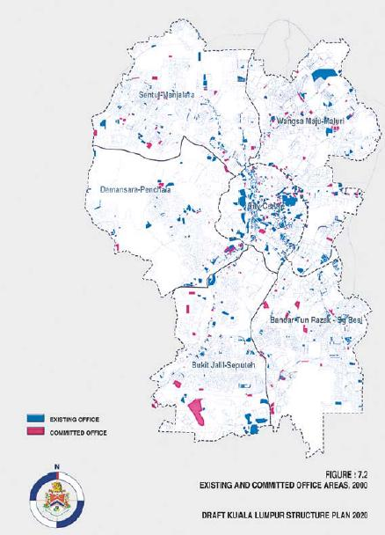

7.2.4 Hotels and Service Apartments
(i) Existing Situation
The existing situation and issues pertaining to hotels is covered in Chapter 8: Tourism. With the recent growth of the expatriate community in Kuala Lumpur, service apartments have gained in popularity. The majority of these are located in the City Centre, Seputeh, Bukit Indah and Sentul. As Kuala Lumpur develops as an international commercial and financial centre, it is anticipated that more expatriate businessmen will be living in the City and that there will consequently be an increased demand for service apartments.
(ii) Issues
• Increasing demand for service apartments.

7.2.5 Other Services
(i) Existing Situation
‘Other services’ consist of mainly institutional, recreational, MICE and storage facilities as well as exhibition halls, auditoriums, theatres, restaurants, gymnasiums, cinemas and concert halls. Most of these services are located in office and hotel buildings and shopping complexes.
The distribution of these facilities is still very much centralised with about 44 percent of the floor space located in the City Centre. The rest are distributed almost evenly across the other strategic zones.

7.2.6 Hawkers and Petty Traders
(i) Existing Situation
The informal sector plays an important role in the socioeconomic life of the City. Hawkers are effective and efficient economic agents in the distribution of goods and services. They help to keep the cost of living in the City low by providing food and other consumer items at affordable prices and widen consumer choice. Besides being a source of livelihood for the thousands of people who are involved in the informal sector, hawkers have also become part of Malaysia’s cultural heritage.
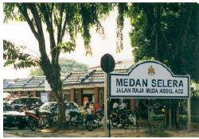
Photo 7.4: Hawkers are effective and efficient economic agents in the distribution of goods and services.
CHKL has been successful in encouraging the development of hawker areas, small entrepreneurs and petty traders. In 2000, there were 35,120 licensed hawkers operating in Kuala Lumpur mainly at markets, night markets, kiosks, secured stalls and ‘attachments outside buildings’. Most of them sell food and drinks, clothes, plastic items and books. Figure 7.4 shows the distribution of hawkers and petty traders.
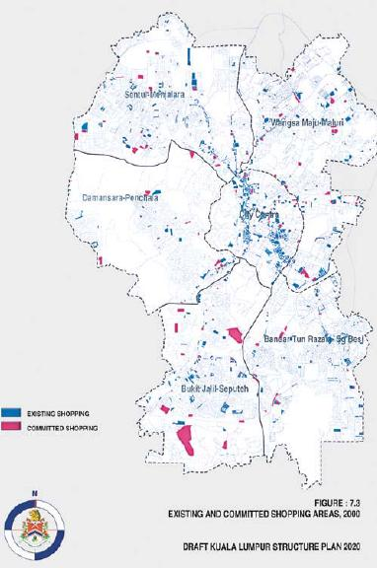
(ii) Issues
A few new permanent hawker centres have been established intended to relocate hawkers. However unsuitable relocation premises for hawkers in terms of accessibility, catchment, comfort and inadequate support facilities are factors that have contributed to the failure of some hawker centres, resulting in hawkers re-establishing their businesses in their original location.
• Unsuitable relocation premises for hawkers.
There are still not enough regulated areas and facilities to cater for the existing hawkers in the City. This has resulted in hawkers operating in places that are not suitable for hawking, which has given rise to other problems such as the obstruction of traffic and sanitation problems related to the standard of hygiene and waste disposal.
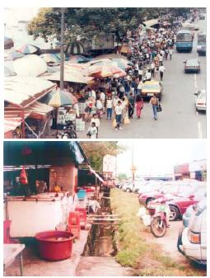
Photo 7.5: ... hawkers operating in places that are not suitable for hawking ...
• Insufficient number of regulated areas and facilities for hawkers.
About 65 percent of the hawker centres are located in the City Centre. There is a lack of hawker centres in some high-density residential areas, for example, Jinjang and Wangsa Maju as well as in industrial areas.
• Lack of hawker centres outside the City Centre.
In year 2000 there were 6,000 unlicensed hawkers in Kuala Lumpur which operate at various unrecognised locations such as within road and river reserves and underneath road flyovers. This has an adverse effect on traffic movement and creates an unsightly appearance and unhygienic conditions.
• Sizeable number of unlicensed hawkers.

COMMERCE
Section

7.3 OBJECTIVES
In order to enhance Kuala Lumpur’s role as an international commercial and financial centre, CHKL aims to:
• Promote Kuala Lumpur as a choice location for international organisations and business entities to establish their regional offices and headquarters;
• Create a technologically advanced city especially in the fields of building technology and design as well as information and communication technology; and
• Enhance the City Centre as an international shopping and entertainment centre.
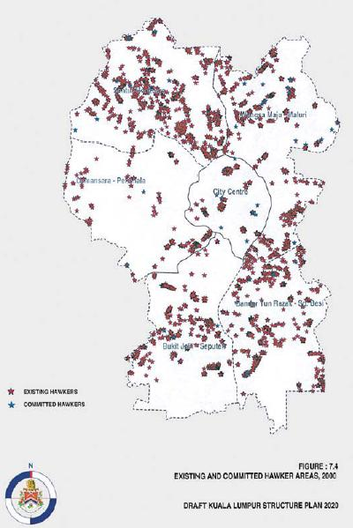
In order to create an efficient and equitable city structure, CHKL aims to:
• Ensure the functional distribution of centres tofacilitate the availability of commercial services and facilities in convenient locations for the population.

COMMERCE
Section

7.4 POLICIES AND PROPOSALS

7.4.1 Business and Finance
a) An International Commercial and Financial
Centre
Based on ten cities in the Asia Pacific region (1995-1997), Kuala Lumpur ranked as the fifth cheapest location for establishing multi-national companies. The average annual costs of maintaining an office in Kuala Lumpur was about 24 percent of the costs in Singapore or 22 percent of those in Hong Kong. Net prime office space rental rates were also much lower than those in Singapore, Hong Kong, Bangkok and Sydney. In terms of price competitiveness, therefore, Kuala Lumpur is well placed to become an international commercial and financial centre and CHKL intends to capitalise on this potential.
Fostering and maintaining business links with other major cities in the region and worldwide is an important factor in expanding opportunities for local businessmen as well as helping to raise Kuala Lumpur’s profile and international awareness of its potential. Building business partnerships with other cities within Asia Pacific region and worldwide will help to promote businesses in Kuala Lumpur.
To promote Kuala Lumpur overseas, a business development body shall be set up to coordinate the various aspects of commercial development in the City. The body will promote business activities and market Kuala Lumpur as an international commercial and financial centre by disseminating information on the facilities available, regulations and formalities for setting up businesses and the estimated operating costs of doing business in Kuala Lumpur.
Policies:
CO 1: CHKL shall set up a business development body to coordinate the various aspects of commercial development in the City, promote business activities and market Kuala Lumpur as an international commercial and financial centre.
In order to maintain a character for the City Centre and the Comprehensive Development Areas consistent with the vision of Kuala Lumpur, the types of businesses and commercial enterprises in these areas should be compatible with and supportive of the City’s status as an international commercial and financial centre.
CO 2: CHKL shall ensure that the types of commercial activities undertaken within the City Centre and Comprehensive Development Areas are compatible with the goal of making Kuala Lumpur an international commercial and financial centre.
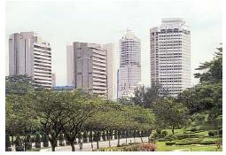
Photo 7.6: The types of businesses and commercial enterprises especially in the City Centre should be compatible with and supportive of its international commercial and financial role.
b) Home-Office Businesses
The technologies associated with the K-Economy are leading to a growth in home-office businesses. There are many benefits for individuals, businesses and administrative bodies in this trend as overheads are lower and demands on the City’s infrastructure, particularly the transportation network, are reduced.
However, present planning control regulations do not permit businesses to be conducted from residential properties. To encourage the growth of home-office businesses, planning control guidelines and regulations shall be reviewed.
Policies:
CO 3: CHKL shall encourage the development of home-office businesses.
c) Provision of an Enabling Infrastructure
While cost competitiveness is an important factor, it is not by itself sufficient to attract international businesses to locate their regional offices in the City. For Kuala Lumpur to achieve the status of a world-class city, there must be the enabling infrastructure such as prime office space, a world-class communication network, a wide range of specialised business services, a qualified labour pool and educational and training facilities as well as efficient national and international transport networks.
An essential part of the enabling infrastructure is the plentiful supply of office buildings which are fully equipped with the latest technologies and ICT infrastructure. Planning control guidelines will be implemented with regards to the integration of ICT infrastructure into new office and hotel developments and the refurbishment of existing commercial buildings to incorporate ICT infrastructure will be encouraged.
Policies:
CO 4: CHKL shall ensure that the enabling infrastructure is adequately provided so that Kuala Lumpur may attain the status of an international commercial and financial centre.

7.4.2 Shopping
a) Shopping Zones
Shopping development in Kuala Lumpur is in transition and appears therefore to be dislocated and haphazard. A sense of order needs to be established so that shopping areas or zones rather than shopping complexes become the focus of retail activity.
There are shopping areas known for special retail items such as electronic components along Jalan Pasar, computer accessories in Imbi Plaza, garment accessories in San Peng, sewing accessories in Jalan Masjid India that need to be formally recognised as specialised shopping precincts. A variety of shopping zones, which identifies and enhances the character of certain shopping areas, shall be established.
Policies:
CO 5: CHKL shall designate a variety of shopping zones in Kuala Lumpur.
b) World-Class Shopping Precinct
A main shopping spine will be established in the City Centre as a world-class shopping precinct with a national and international reputation.
Policies:
CO 6: CHKL shall designate areas in the City Centre to form a premiere shopping spine and determine appropriate strategies to develop the area to attract major national and international retailers.

7.4.3 Hotels and Commercial Apartments
Policies relating to hotels are covered in Chapter 8: Tourism.
As the number of international businesses locating in Kuala Lumpur increases, sufficient service apartments must be provided in convenient locations to cater for the needs of expatriate businessmen.
Policies:
CO 7: CHKL shall ensure that there is adequate provision of commercial apartments with convenient access to the main business areas.

7.4.4 Hawkers and Petty Traders
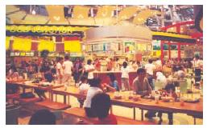
Photo 7.7: CHKL requires the private sector to provide hawker premises within mixed-used complexes.
CHKL shall continue to regulate hawker activities and ensure that adequate premises are provided for them. Sufficient hawker premises must be made available so as to limit the expansion of unlicensed hawkers. CHKL requires the private sector to provide hawker premises within mixed-use complexes. In addition CHKL will continue its policy of rehousing street side hawkers in properly designed hawker centres where all associated facilities can be provided in a hygienic environment.
Policies:
CO 8: CHKL shall monitor the provision of hawker premises and develop additional premises where required.
CO 9: CHKL shall require private sector commercial developments to incorporate hawker premises.
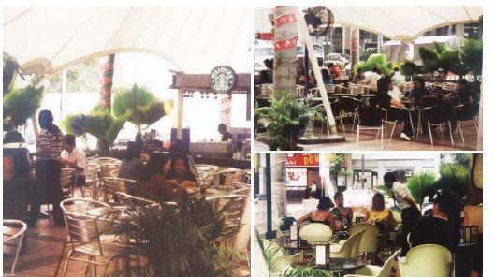
Photo 7.8: ... all associated facilities can be provided in a hygienic environment.

7.4.5 Balanced Commercial Development
Photo 7.7: CHKL requires the private sector to provide hawker premises within mixed-used complexes.
CHKL shall continue to regulate hawker activities and ensure that adequate premises are provided for them. Sufficient hawker premises must be made available so as to limit the expansion of unlicensed hawkers. CHKL requires the private sector to provide hawker premises within mixed-use complexes. In addition CHKL will continue its policy of rehousing street side hawkers in properly designed hawker centres where all associated facilities can be provided in a hygienic environment.
Policies:
CO 8: CHKL shall monitor the provision of hawker premises and develop additional premises where required.
CO 9: CHKL shall require private sector commercial developments to incorporate hawker premises.
Photo 7.8: ... all associated facilities can be provided in a hygienic environment.

COMMERCE
Section

7.5 FUTURE REQUIREMENTS
There are a number of issues that may affect future employment in the commercial sector. These include the performance of the national economy and the growth of urban centres and activities outside Kuala Lumpur.
Projected future requirements are based on employment figures for the targeted residential population of 2.2 million by the year 2020. The distribution of commercial facilities reflects the strategy of moderate growth in the City Centre and a more even distribution over the other strategic zones according to their residential populations.
Projected hawker requirements are distributed evenly over the six strategic zones.
Figure 7.5: Projected Hawker Stalls Requirement by Strategic Zone, 2020
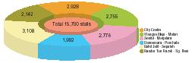
Table 7.2: Projected Commercial Floor Space Requirement, 2020
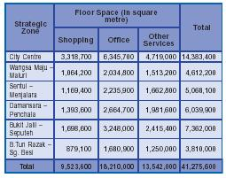

TOURISM
Section

8.1 INTRODUCTION
As with other major cities, tourism plays an important part in the economic life of Kuala Lumpur, providing income, employment, and expanding business opportunities. The tourist industry is very wide ranging in the services and facilities it requires, and provides employment across all sectors of the population
Tourism brings other less obvious but no less important benefits to the people of Kuala Lumpur. By virtue of catering to a population base larger than the City itself, a wider range of shopping, entertainment, recreational, and cultural facilities can be supported. Tourism can also help to provide the impetus and financial justification for measures that benefit the residents of the City such as conservation, beautification and pedestrianisation projects, as well as the hosting of special events and festivals principally aimed at attracting tourists.
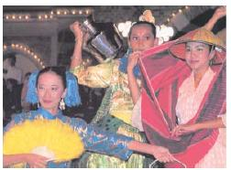
Photo 8.1 ... build on its multi-racial, multi-religious and multi-cultural society to create for itself a distinctive identity and image.
Kuala Lumpur also benefits from exposure. Foreign visitors gain a greater understanding and appreciation of the culture and achievements of the City and its people. The impressions that are taken back to their home countries can do much to raise the profile of the City and the country.
Kuala Lumpur has much to offer as a tourist destination. It is climatically congenial, with a uniquely tropical character and has a developed infrastructure and services sector with a wide range of tourist attractions, shopping, entertainment, hotel, and conference facilities. The City can also build on its multi-racial, multireligious and multi-cultural society to create for itself adistinctive identity and image. CHKL aims to maximise these inherent strengths to make Kuala Lumpur into an attractive international tourist destination.

TOURISM
Section

8.2 EXISTING SITUATION AND ISSUES

8.2.1 Tourism Marketing and Promotion
(i) Existing Situation
The promotion of Malaysia as a tourist destination is mainly pursued by the Malaysia Tourism Promotion Board’s (MTPB) overseas offices, jointly with tour operators, airlines and national tourism offices. Promotion includes sales missions, advertising in the media, participating in international tourism events and exhibitions and the hosting of journalists, foreign travel writers and travel agency personnel.
Besides the marketing and promotion of Kuala Lumpur by the MTPB, promotion is also being undertaken by CHKL and the Kuala Lumpur Tourist Association (KLTA), which is an association made up of all companies involved in the tourism industry.
In the year 2000, the Kuala Lumpur Tourism Council (KLTC) whose Chairman is the Mayor of Kuala Lumpur was set up, which will, in close coordination with the MTPB and business organisations such as the KLTA, be responsible for the marketing and promotion of Kuala Lumpur.
(ii) Issues
There is an inadequate level of market promotion of the City compared to other major tourist cities. In some international tourist destinations, there are city or regional based tourist boards heavily promoting the destination backed up by a mature tour and travel industry, hoteliers, national and regional airlines and business organisations.
• Inadequate marketing and promotion of Kuala Lumpur.

8.2.2 Tourist Arrivals, Expenditure and Average Length of Stay (ALS)
(i) Existing Situation
Despite the economic crisis of 1998, tourist arrivals in Malaysia increased from 6,210,900 in 1997 to 10,221,600 in 2000. This was due mainly to intensified promotion of inbound tourism, the hosting of major international conferences and sporting events such as the Formula One race at Sepang. Total visitor receipts rose markedly from RM4.5 billion in 1990 to RM17.3 billion in 2000. Tourist arrivals and receipts to Malaysia are shown in Table 8.1.
In addition, the number of domestic tourists visiting the City from various parts of the country increased from 2,493,100 in 1997 to 2,803,300 in 2000. Foreign tourist arrivals also increased from 3,536,300 in 1997 to 3,946,900 in 2000. The average length of stay (ALS) of tourists in Malaysia in 2000 was 5.88 nights and about 1.6 nights in Kuala Lumpur. By comparison, the ALS in
the United Kingdom in 1997 was over 8.7 nights and a regional destination such as Thailand has an ALS of around 7.0 nights. The ALS of tourists from Singapore, which is the largest single generator of tourist arrivals and receipts, is generally very short.
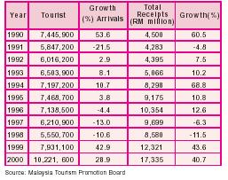
Table 8.1:Tourist Arrivals and Receipts in Malaysia, 1990 - 2000
(ii) Issues
• Short average length of stay of tourists.

8.2.3 Tourism Resources
a) General
(i) Existing Situation
Kuala Lumpur has a wide diversity of resources suitable for tourism although these are at varying degrees of development or attractiveness. Some resources are long established and positioned well, while others have been more recently developed or are not yet oriented strongly for tourism. Similarly some are more attractive or more accessible than others. Indisputably, Kuala Lumpur has resource and locational advantages, which are supportive of, or important to, the development of a viable tourism industry. Figure 8.1 shows the distribution of tourism products in Kuala Lumpur.
(ii) Issues
Tourist resources are not easily accessible, coherent, well linked for pedestrian movement or supported by services such as restaurants and related shopping. Although Kuala Lumpur has a diverse range of actual or potentially significant tourism resources, the present ‘total tourism product’, being the whole spectrum of tourism services, is inadequate and segmented.
• Inadequate and segmented product development.
b) Cultural - Heritage Attractions
(i) Existing Situation
Architecturally, Kuala Lumpur has retained a number of historic buildings and areas that are highly evocative of its past. The Dataran Merdeka and the buildings that surround it, together with the Railway Station and the old shophouse areas provide lasting images of the original city. More recently, buildings like the KL Tower and the Petronas Twin Towers at the KLCC provide images of a city that is thoroughly modern, while firmly in touch with its cultural roots.
There are a number of modern cultural facilities for the performing arts, including musical and cultural performances. These theatres and concert halls not only provide venues for performing arts by both Malaysian and international artistes to be showcased but also add to the cultural vibrancy of the City. CHKL is also active in promoting and providing support to local cultural groups.
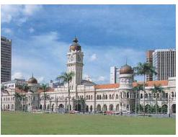
Photo 8.2: Architecturally, Kuala Lumpur has retained a number of historic buildings and areas that are highly evocative of its past.
(ii) Issues
A large number of tourists are interested in purchasing art works, handicrafts, costume accessories and souvenirs but the market in Malaysia is not as well developed as those elsewhere in the region. Given traditional skills in silverware, brassware, pewterware, ‘songket’ weaving, beadwork, woodcarving and batik printing, the potential does exist for expanding this segment of the industry.
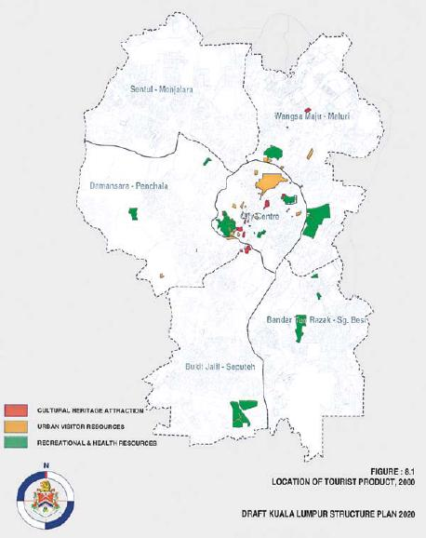
The Royal Selangor pewter factory in Setapak, where tourists can watch skilled craftsmen fabricate artefacts and souvenirs, provides the best example of industrial tourism in Kuala Lumpur. However, with the exception of the Infokraft Handicraft Centre and Craft Cultural Complex, there are relatively few other outlets for traditional handicrafts and souvenirs.
• Inadequate promotion of traditional handicraft and souvenir industries.

Photo 8.3: Given traditional skills in silverware, brassware, pewterware, ‘songket’ weaving, beadwork, woodcarving and batik printing, the potential does exist for expanding this segment of the industry.
c) Shopping, Dining and Entertainment
(i) Existing Situation
Kuala Lumpur is emerging as a price-competitive shopping destination of international quality. Besides the many shopping centres in the City, new retail formats including hypermarkets, mega malls, duty-free shopping outlets and discount stores have been developed.
In addition, there are also the more traditional shophouses, the night markets and the farmers’ markets which are significant tourist resources. The night markets in particular are of great interest to tourists as they give an insight into the traditional Malaysian way of life. Similarly, the shophouse streets, particularly those in the older part of the City, retain the flavour of a bygone era.
(ii) Issues
General issues relating to shopping activities are detailed in Chapter 7: Commerce.
Kuala Lumpur has a wide variety of restaurants and dining places serving local and international cuisine. Other than a few isolated areas, some of which are outside the City Centre, there is a lack of a clearly identifiable dining and entertainment area in the City Centre.
• Lack of a clearly identifiable dining and entertainment area in the City Centre.
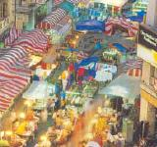
Photo 8.4: The night markets in particular are of great interest to tourists as they give an insight into the traditional Malaysian way of life.
d) Recreational Attractions
(i) Existing Situation
Sports facilities have undergone a transformation in Kuala Lumpur with the development of world-class facilities at the National Sports Complex at Bukit Jalil. In addition, the City possesses a wide array of other sports facilities for badminton, cycling, hockey, golf, tennis, basketball, netball, soccer, squash, gymnastics, athletics, swimming, equestrian and lawn bowling. A world-class Formula One motor racing circuit near the KLIA at Sepang has also greatly enhanced the potential for sports tourism.
There are a number of parks containing attractions of interest to tourists such as the Butterfly Park, Bird Park and Orchid Garden at Taman Tasik Perdana. Taman Tasik Titiwangsa, which contains a large lake, has a floating restaurant and offers activities such as horse riding and boating.
(ii) Issues
General issues relating to recreational activities are detailed in Chapter 13: Community Facilities. Despite the number of world-class sporting venues in Kuala Lumpur, the facilities are under-utilised.
• Under-utilisation of major sporting venues.
e) Health and Education
(i) Existing Situation
Health tourism is not a new phenomenon. Countries like Australia, Singapore and United States of America have gained a reputation for having world-class facilities and services which emphasise fitness, health, rehabilitation and recuperation. There is the potential for Malaysia to become a competitive health tourism destination. Health tourist arrivals to Malaysia, primarily from Indonesia,
Brunei and Singapore, numbered 175,000 in 2000, an increase of 127 percent from 1999. As the standard and facilities of private health care are high and costs are relatively low compared to Singapore and Brunei, Malaysia can expect to attract more visitors utilising its health care services.
Apart from the government-run general hospital, there are several private medical specialists centres including the National Heart Institute in the City. In addition to providing general health services, the public and private hospitals offer a wide range of specialist surgery and treatment.
Kuala Lumpur also has advantages stemming from the high concentration of educational institutions located within its boundaries, providing a wide range of courses. Such public institutions include the University of Malaya, the University of Technology Malaysia and the Medical
Faculty of the University Kebangsaan Malaysia. There are also a large number of private colleges, including the University Tun Abdul Razak and Tunku Abdul Rahman College, in and around Kuala Lumpur providing a wide range of courses which attract students from all over Malaysia as well as from other countries.
(ii) Issues
Despite the proliferation of educational and health facilities and services, they have not been properly promoted and marketed as tourist products.
• Inadequate promotion of educational and health tourism industries.

8.2.4 Tourism Facilities and Infrastructure
a) Hotels
(i) Existing Situation
Between 1996 and 2000, the total number of hotel rooms in Kuala Lumpur increased by 12.18 percent from 16,510 to 26,144. Table 8.2 shows the number of hotel of hotel rooms according to their development status.
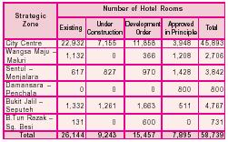
Table 8.2: Existing and Committed Hotel Rooms by Strategic Zone, 2000
The majority of hotels are in the size category of 300 rooms and above. Figure 8.2 and Table 8.3 indicate the existing distribution and size of hotels in the City.
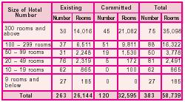
Table 8.3: Existing and Committed Hotels by Size, 2000
The average occupancy rate (AOR) of hotels in Kuala Lumpur dropped by 15.3 percent from 76.2 percent in 1995 to 60.9 percent in 2000. The decline in AOR affected all size categories of hotels, with the largest decline being 28.6 percent for hotels in the size category of 50-99 rooms as shown in Figure 8.3.
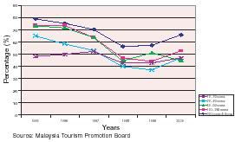
Figure 8.3: Hotel Average Occupancy Rate in Kuala Lumpur,
(ii) Issues
There is very little variety in the type of accommodation on offer to serve the diverse requirement and budgets of foreign and domestic tourists.
• Insufficient variety of types of tourist accommodation.
b) Meetings, Incentives, Conventions and Exhibitions
(i) Existing Situation
Business and conference tourism has expanded in recent years and is becoming a very important component of the industry. MICE participants and business tourists are high yield tourists, usually spending more per day than leisure tourists. The MICE industry generates income for many related business activities including the hospitality sector, airlines, freight forwarders, contractors and suppliers of exhibition materials and entertainment.
The number of MICE events and participants has been growing steadily in recent years and receipts generated from MICE in Malaysia in 2000 amounted to RM1,164.7 million, almost 7 percent of total tourism revenue for that year. Within Kuala Lumpur, the main MICE facilities are at MALTRADE (Malaysia External Trade Development Corporation) in Jalan Duta and the Putra World Trade Centre, while the Bukit Jalil Sports Complex contains one of the premier convention and exhibition centres in the region. Additional convention and exhibition space is being developed at the KLCC Convention and Exhibition Centre. Other major facilities in the KLMR include the Sunway Lagoon Convention Centre, the Mines Wonderland and the Subang International Trade and Exhibition Centre.
(ii) Issues
There is still a shortage of MICE facilities in Kuala Lumpur and facilities need to be upgraded to be able to compete with other major MICE destinations.
• Facilities for MICE need to be increased, upgraded and promoted.
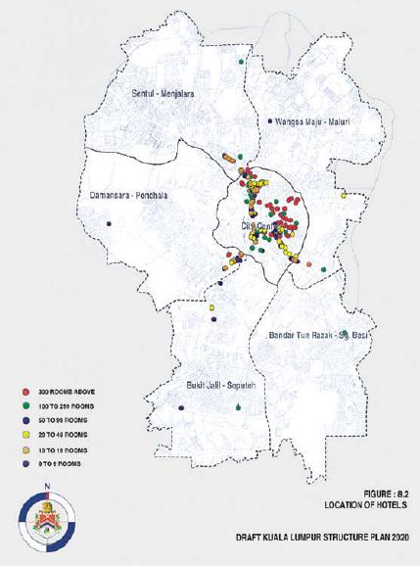

8.2.5 Tourism Support Services and Facilities
a) Support Services
(i) Existing Situation
In order for the tourism industry to function effectively, strong tourism supporting services and facilities such as travel and tour agencies, tour guides, tourist information centres and manpower training are necessary.
There are major tourist information centres in the City as well as at the main gateway airports. Further information is made available by CHKL and the private sector including hoteliers as well as tour and travel companies. The Malaysia Tourism Centre (MTC) at Jalan Ampang is the biggest one stop information centre in Malaysia. This centre houses the tourist information complex which includes an exhibition hall, amphitheatre, audio-visual room, information counter, restaurant, souvenir shop and travel services counters.
(ii) Issues
However, there remain deficiencies especially in comparison with mature international tourist centres where there is a wealth of information made available in airports, coach stations, rail stations, hotels, in free magazines and by generally well informed, highly knowledgeable guides.
Market promotion needs to be able to rely on up-to-date data but the search costs of acquiring relevant, reliable and timely information are high.
• Lack of timely information and high search costs.
Although signage in the City has improved, there remain weaknesses in the provision of directional signage to some tourism destinations and interpretation panels at key attractions, as well as in the availability of comprehensive, up-to-date road maps.
• Inadequate directional signage and other information on tourist sites.
Some tourist ‘front liners’ including taxi drivers, tour bus guides and staff at key transportation gateways are not well informed about the City’s tourist attractions.
• Lack of knowledge about tourist attractions amongst tourist ‘front liners’.
b) Support Facilities
(i) Existing Situation
The Government has initiated a national programme to provide facilities such as themed lighting, pedestrian walkways, public toilets and landscaping in tourist areas and attractions. CHKL is in the process of implementing this programme throughout Kuala Lumpur.
(ii) Issues
At present, however, some sites still lack adequate facilities for tourists and there is a need for a critical mass of attractions supported by related support services.
• Insufficient support facilities for tourists.
c) Accessibility
(i) Existing Situation
Public transportation and taxi services are in need of improvement. The Departing Visitors’ Survey (1999) of the MTPB indicated there were visitor complaints concerning poor transportation services and difficulties in getting taxis and other forms of public transportation. The PRT, which will connect the main hotel and shopping belt to the LRT system, will be completed in 2003 and will help to alleviate some of these problems.
General issues relating to public transportation are outlined in Chapter 10: Transportation.
(ii) Issues
Currently, there are accessibility problems to some of Kuala Lumpur’s tourist destinations due to traffic congestion on a number of major routes particularly during peak hours. In addition, on-going construction activities and the high level of private car usage add to pedestrian’s problems in making journeys on foot from one site to another.
General issues relating to pedestrianisation are detailed in Chapter 14: Urban Design and Landscape.

TOURISM
Section

8.3 OBJECTIVES
To enhance the role of Kuala Lumpur as an international commercial and financial centre, CHKL aims to:
• Develop Kuala Lumpur as an attractive international tourist destination; and
• Increase the average length of stay (ALS) to 3.0 by the year 2010.
To create a distinctive city identity and image, CHKL aims to:
• Create a city which conserves the best of its environmental, architectural and cultural heritage and which offers a rich blend of both the modern and traditional;
• Promote culture and the arts, sports, education and health in the City as tourist products and as factors in enhancing the overall quality of life; and
• Create a tropical garden city sensitive to its natural environment and appropriate to its tropical regional location.

TOURISM
Section

8.4 POLICIES AND PROPOSALS

8.4.1 Tourism Marketing and Promotion
Of immediate importance is the preparation of a comprehensive tourism marketing plan for Kuala Lumpur, which will identify strategies for tourism development and promotion. The plan will cover all aspects of the tourism market, and the preparation of an annual tourism calendar. Activities in the City that complement major international events in Malaysia shall be encouraged and promoted.
All necessary support shall be provided to KLTC for it to effectively market and promote Kuala Lumpur. This will include adequate funding for projects and campaigns and the development of facilities and attractions aimed at expanding and diversifying the tourism base.
Policies:
TO 1: CHKL shall, together with the Kuala Lumpur Tourism Council, market and promote tourism in Kuala Lumpur.
TO 2: CHKL shall, together with the Kuala Lumpur Tourism Council, develop tourist products aimed at expanding and diversifying the tourism base.

8.4.2 Development of Tourism Resources
a) General
The principal tourism development proposals have been based on an analysis of the resource and market strengths, weaknesses and development potential of Kuala Lumpur and the KLMR. A zonal approach for tourism development, promotion and operation shall be implemented with the City Centre as its core, focusing on shopping, MICE, culture, entertainment, dining, health and education. Key areas within the other four strategic zones will focus on more specific tourism activities. Bukit Jalil-Seputeh will focus on sports and MICE, Wangsa Maju-Maluri on industrial tourism,
Damansara-Penchala on education and agro-tourism and Bandar Tun Razak-Sungai Besi on eco-tourism. Figure 8.4 illustrates the principal proposals and tourism functions of the City Centre and the other strategic zones.
Policies:
TO 3: CHKL shall implement a zonal approach to tourism development in the City.
b) Cultural - Heritage Attractions
Tourists want to be able to gain insights into the history, tradition and culture of the people whose countries they visit. CHKL in concert with the private sector shall continue to support local groups and artistes, whose performances reflect Malaysian culture and tradition.
The private sector has a vital part to play in promoting the tourism industry by providing facilities, services and activities. The private sector should be encouraged to provide more facilities such as museums, art galleries, theatres and concert halls that complement CHKL policies and efforts to promote cultural activities in the City. Furthermore programmes should be devised to ensure that these facilities are optimally utilised.
The historic urban core in the City Centre is a precious tourism resource which encapsulates much of the history of Kuala Lumpur and the nation. In order to maximise its potential, it shall be designated as the Cultural Heritage Centre of the nation.
General policies regarding conservation are covered in Chapter 14: Urban Design and Landscape.
Policies:
TO 4: CHKL shall designate the historic urban core as the main cultural heritage centre of the nation and diversify the cultural infrastructure so as to ensure there is a critical mass of attractions.

8.4.3 Shopping, Dining and Entertainment
A main shopping spine in the City Centre shall be developed and promoted as a world-class shopping precinct. In addition, as a means of promoting locally made and/or locally designed products to Malaysians and tourists alike, dedicated plazas or malls shall be developed within specialised shopping precincts. Such ‘Product Plazas’ would be popular, as prices for goods should be more competitively priced than imported goods of equivalent quality.
General policies relating to shopping are detailed in Chapter 7: Commerce.
There is a great opportunity to maximise the tourist potential of existing shopping, dining and entertainment facilities in Kuala Lumpur through more effective promotion of the City as an international shopping, dining and entertainment destination. To satisfy the expectations of international tourists, standards of cleanliness and hygiene should commensurate with world-class standards.
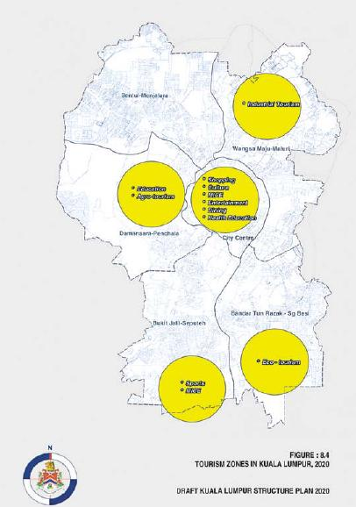
Policies:
TO 5: CHKL shall, together with the Kuala Lumpur Tourism Council, coordinate with the private sector to promote Kuala Lumpur as an international shopping,
dining and entertainment destination.
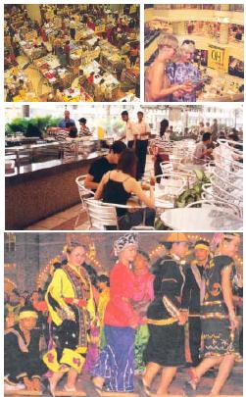
Photo 8.5 ... promotion of the City as an international shopping, dining and entertainment destination.

8.4.4 Recreational Attractions
Measures are being implemented to improve the quality and range of recreational activities, including the provision of more parks and sports facilities. These improvements, although primarily intended for the benefit of the residents of Kuala Lumpur, will also act as tourist attractions.
General policies relating to recreational activities are detailed in Chapter 13: Community Facilities. Eco-tourism and agro-tourism are increasingly being promoted as a means of protecting the natural environment that might otherwise be under the threat of development. The Bukit Anggerik forest reserves, the ridges of Bukit Gasing and Bukit Dinding together with other undeveloped hill sites such as part of Sungai Penchala, present opportunities for the development of eco-tourism and agro-tourism.
Policies:
TO 6: CHKL shall develop eco-tourism and agrotourism opportunities in forestry reserves and other green areas.
The sports facilities at Bukit Jalil and other world-class sporting venues in the City present considerable potential for the hosting of major regional and national sporting events which could attract local and international tourists. Many of the major sport complexes can also be used as venues for other kinds of tourist related events such as trade fairs and concerts.
TO 7: CHKL shall, together with the Kuala Lumpur Tourism Council and other relevant authorities and agencies, promote major sporting complexes as venues for international sports and other events.
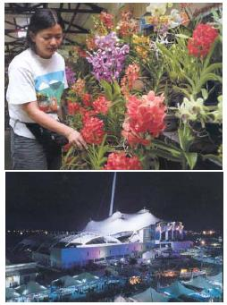
Photo 8.6: Measures are being implemented to improve the quality and range of recreational activities, including the provision of more parks and sports facilities.

8.4.5 Health and Education
There is an opportunity to capitalise on the tourism potential of the major concentration of medical and educational facilities in the City, particularly those with well packaged programmes aimed at attracting overseas clientele.
Policies:
TO 8: CHKL shall, together with the Kuala Lumpur Tourism Council and medical and educational organisations, develop and promote educational and health-care tourism.
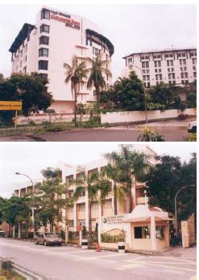
Photo 8.7: ….opportunity to capitalise on the tourism potential of the major concentration of medical and educational facilities in the City.

8.4.6 Tourism Facilities and Infrastructure
INFRASTRUCTURE
a) Hotels
As tourism to Kuala Lumpur develops and diversifies, there is a need for the hospitality industry to have more accommodation modes such as bed and breakfast accommodation and boutique hotels. Budget hotels, youth hostels and educational campus facilities to cater for youth travel and the student holiday market, should also be encouraged.
Policies:
TO 9: CHKL shall promote the diversification of accommodation modes.
b) Meetings, Incentives, Conventions and Exhibitions
To maximise the potential for MICE tourism, Kuala Lumpur should be vigorously promoted as a MICE destination and additional MICE facilities must be developed.
Competition amongst MICE destinations is keen and success depends on the standard of facilities on offer and the availability of nearby attractions and collateral activities. To increase the attractiveness of Kuala Lumpur’s MICE facilities, they need to be continually upgraded to keep abreast of the best international standards and supporting tourist attractions should be developed near to MICE facilities.
Policies:
TO 10: CHKL shall promote Kuala Lumpur as an international meetings, incentive, conventions and exhibition centre and encourage the development of suitable
facilities.
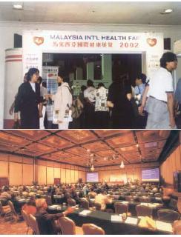
Photo 8.8: ... Kuala Lumpur should be vigorously promoted as a MICE destination ...

8.4.7 Tourism Support Services and Facilities
a) Support Services
Sourcing and maintaining up-to-date tourist information is essential in nurturing the tourist industry particularly when looking to attract overseas visitors who may have little knowledge of the City or the country.
Supporting s ignage and other information systems for tourists need to be improved. More interpretation panels for key attractions such as heritage buildings should also be installed.
Policies:
TO 11: CHKL shall, together with the Kuala Lumpur Tourism Council, coordinate with ther relevant agencies and the private sector to develop supporting information systems for tourists.
Skills training in the tourism sector needs to be increased in order to ensure that it is ready to meet the emerging and changing needs of the visitor market.
TO 12: CHKL shall, together with the Kuala Lumpur Tourism Council, provide training programmes and support information for tourist front liners.
b) Support Facilities
An expanding tourism industry will place added demands for facilities in existing tourist attractions, including additional toilets and parking spaces for tour coaches, taxis and rental cars. Other support facilities like restaurants and souvenir shops will also need to be provided or upgraded and maintenance procedures in popular tourist attractions should be reviewed in the light of increased tourist traffic.
Policies:
TO 13: CHKL shall, together with the Kuala Lumpur Tourism Council, coordinate with other relevant authorities and agencies to ensure that all major tourist and cultural attractions are provided with high quality and well maintained facilities.

TOURISM
Section

8.5 FUTURE REQUIREMENTS
The tourism industry is in part dependent on a number of external factors such as the domestic and international economic situation, which can affect projections in the short to medium term. However, based on long-term trends, Kuala Lumpur anticipates an average annual increase in tourists of approximately 3 percent per annum over the next 20 years.
Projected future requirements for hotel floor space is based on the projected growth of tourist arrivals and an ALS of 3.0 nights in the year 2010. The distribution of hotel facilities reflects the continuing role of the City Centre as the tourism hub and the increased emphasis on sports and MICE tourism in the Bukit Jalil-Seputeh strategic zone.
Table 8.4: Projected Hotel Requirement, 2020
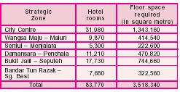

INDUSTRY
Section

9.1 INTRODUCTION
The industrial sector in Kuala Lumpur is undergoing a transformation as the City, in tandem with the MSC, takes the lead in moving Malaysia into the K-Economy. Large scale manufacturing industries that used to be the industrial mainstay of the City are no longer relevant to its new role as an international commercial and financial centre.
Although industry now plays a relatively minor role in the economy of the City compared to the commercial sector, an industrial component will be necessary to service the population of Kuala Lumpur and provide support services to commercial enterprises in the City and the KLMR. In addition, CHKL aims to bring about an industrial renaissance that will revitalise the City’s industrial sector by encouraging industries that are clean and requiring a highly skilled labour force, in particular those at the forefront of the new technologies. R&D and higher skills training are essential components in this shift of emphasis towards knowledge-based industrial development, as is the need to adopt a more integrated approach towards industrial development. As part of this strategy, and in order to enhance the City’s living environment, emphasis must be placed on the renewal of the older industrial areas of Kuala Lumpur and the eradication of illegal and polluting industries.

INDUSTRY
Section

9.2 EXISTING SITUATION AND ISSUES

9.2.1 Industrial Sector Development
a) Manufacturing Sector
(i) Existing Situation
Between 1984 and 1998, industrial land use grew by 19 percent from 579.5 hectares to 690.2 hectares. Industrial land use represented approximately 2.4 percent of total land use in 1998. Manufacturing constituted about 66 percent of the total number of industrial establishments with service related industries accounting for the rest. Fabricated metal products, paper, paper products, foundries, printing and publishing make up the majority of manufacturing establishments while motor vehicle repairs, storage and warehousing predominate in the service related industries. The larger manufacturing establishments are tending to relocate outside of Kuala Lumpur mainly because of the scarcity and high cost of land in the City.
(ii) Issues
Despite the decline in manufacturing, there is still a sizeable manufacturing component in Kuala Lumpur. A large number of these industries are incompatible industries that do not comply with current regulations.
• Incompatible manufacturing industries.
b) Service Industries
(i) Existing Situation
Service industries, which include motor vehicle repairs, storage facilities and warehousing, are necessary to serve the City’s population who cannot rely entirely on such services outside its boundary.
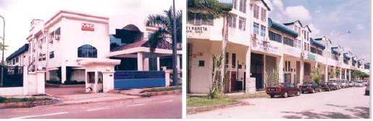
Photo 9.1: Service related industries, which include motor vehicle repairs, storage facilities and warehousing, are necessary to serve the City’s population ...
(ii) Issues
Although these industries such as motor vehicle repair workshops are clustered together in many locations throughout the City, they are widely dispersed and lack adequate infrastructure and facilities. In many cases these industries have not been properly planned for and some are illegal. Many are located in between residential areas and shophouses causing disturbance to the local community, pollution and traffic congestion.
• Service industries are scattered in nature and cause pollution and traffic congestion.
As vehicle ownership has increased, so has the demand for motor repair workshops and other related auto services. While some of these establishments are located in industrial areas, others are located in commercial areas. The provisions of the Use Classes Rule allow for industrial establishments under 200 square metres or with fewer than 20 machines to occupy commercial premises. As a result, motor repair workshops and other industries not compatible with their surroundings often occupy shophouses in commercial areas.
• Use Classes Rule does not prevent incompatible industries from locating in commercial areas.
c) Inter-industrial Linkages
(i) Existing Situation
More than 90 percent of the industrial establishments in the City are small in size. On average the land area occupied per establishment is only 0.24 hectares. Approximately 8 percent of the industrial establishments in Kuala Lumpur are more than 30 years of age and about 36 percent are owned by single entrepreneurs. The vast majority of these small-scale industries operate independently with virtually no inter-industrial linkages.
(ii) Issues
• Weak inter-industrial linkages.
d) Unrationalised Industries
(i) Existing Situation
The majority of manufacturing industries operating in Kuala Lumpur are related to the manufacture of machinery, plastics, foundries and printing. Only about 61 percent of existing manufacturing industries are operating in approved industrial areas.
(ii) Issues
Approximately 28 percent of the existing manufacturing industrial establishments are located in commercial buildings within designated commercial land use areas. Of these establishments, a substantial number violate the floor space conditions stipulated in the CHKL operational guidelines. Another 11 percent are located in residential areas mainly in Jinjang, Bukit Indah and Bukit Jalil.
• Industries occupying commercial buildings or located in residential areas.
Several industrial areas are located very close to the river systems, especially those in Jinjang, Bukit Indah and Chan Sow Lin. This causes problems relating to environmental control and management in respect of garbage and industrial waste disposal, blockages to water flow and cleanliness.
• Inappropriate location of polluting industries close to river systems.
There are also industries which operating without licenses and licensed industries squatting on government land mainly alongside rivers and major highways.
• Industrial squatters on government land.

9.2.1 Industrial Areas
a) Condition of Industrial Areas
(i) Existing Situation
Figure 9.1 and Table 9.1 indicate the distribution of existing and committed industrial areas in Kuala Lumpur. About 80 percent of the existing manufacturing establishments are located in Bukit Indah, Jinjang, Bukit Anggerik, Chan Sow Lin, Sentul, Bandar Tun Razak and Seputeh while the majority of existing service related industrial establishments are located in Jinjang, Bukit
Anggerik and Sentul. The majority of industrial land use is located in Jinjang, Bukit Indah, Maluri and Bukit Jalil.
Table 9.1: Existing and Committed Industrial Floor Space by Status, 2000
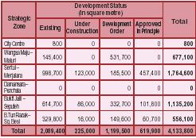
Since 1984, relatively few new industrial estates have been developed. A notable exception is the Technology Park Malaysia in Bukit Jalil which covers about 290 hectares and which is being developed in three phases as a high technology industrial park. Phase one covers 81 hectares and contains resource centres, innovation and incubator centres, R&D, ICT lots and multi-media centres.
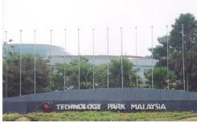
Photo 9.2: The Technology Park Malaysia in Bukit Jalil, … contains resource centres, innovation and incubator centres, R&D, ICT lots and multi-media centres.
(ii) Issues
Many of the older existing industrial areas especially Chan Sow Lin, Jinjang and the Old Klang Road are in a very dilapidated state and lack basic infrastructural facilities.
In Jinjang, some of the industrial areas are located in shop houses or residential areas and there are also many illegal industries. These areas contribute to traffic congestion, jeopardise public safety, constitute serious fire risks and create unhealthy conditions.
• Many of the older industrial areas in Kuala Lumpur are obsolete and lack basic facilities.
b) Facilities in Industrial Areas
(i) Existing Situation
According to the Kuala Lumpur Industrial Survey 1999, there were a number of inadequacies in existing industrial areas.
There is inadequate housing for workers in industrial areas except in Chan Sow Lin and there is also a lack of recreational facilities. Banking facilities such as automated teller machine services are generally not available in industrial areas. None of the industrial areas in Kuala Lumpur have any properly planned hygienic hawker or food centres and only 2.4 percent of industrial premises have workers’ canteens within their establishments. Only 26 percent of the industrial premises provide car and motorcycle parking facilities.
(ii) Issues
• Inadequate public facilities in industrial areas.
Public transportation services to most of the existing industrial areas in Kuala Lumpur are inadequate.
• Inadequate public transport services to industrial areas.
Loading and unloading facilities were available in only 24 percent of the factory premises.
• Insufficient loading and unloading facilities.

INDUSTRY
Section

9.3 OBJECTIVES
For Kuala Lumpur to become an International Commercial and Financial Centre, CHKL aims to:
• Promote the development of industries related to the K-Economy;
• Promote high-end industries employing highly skilled workers;
• Provide to all residents a wide range of employment and business opportunities; and
• Maintain a sectoral balance in industria development.
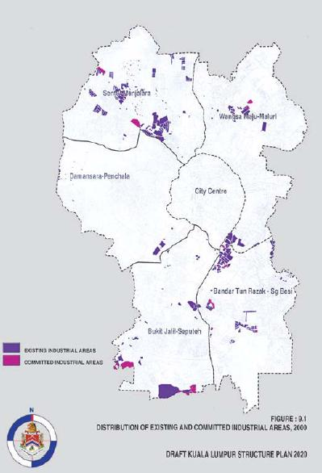
To create an efficient and equitable city structure for Kuala Lumpur, CHKL aims to:
• Achieve an optimum distribution of industrial areas in the City; and
• Ensure that industrial land use is integrated with road and public transportation networks.

INDUSTRY
Section

9.4 POLICIES AND PROPOSALS

9.4.1 Industrial Sector Development
a) Manufacturing Sector
The proximity of Kuala Lumpur to the MSC will have a profound effect on the types of industries that will develop in Kuala Lumpur in the future. There will be opportunities to develop high technology and knowledge-based industries that are auxiliary to or support enterprises in the MSC. Research and development centres associated with high technology industries will be encouraged in designated areas in the City.
CHKL shall encourage industries that have a high design and skills content. Such industries shall include those specialising in the manufacture of musical instruments, electronic toys, fashion, jewellery making and handicrafts. These kinds of industry have excellent export potential and could be well linked to commercial enterprises in the City. The new direction for industry in Kuala Lumpur shall rely on a plentiful skilled labour force. High technology skills training facilities are currently available in the Technology Park Malaysia and there are other institutes such as the German-Malaysian Institute offering specialist skills training. CHKL shall encourage the development of further high skills training facilities both within established institutions and in the new business and industrial parks.

Photo 9.3: CHKL shall encourage the development of further high skill training facilities ...
Policies:
IN 1: CHKL shall encourage the development of high technology and knowledge-based industries.
In order to maintain a sectoral balance in the economic base, the City will continue to maintain a small manufacturing presence specialising in high technology industries.
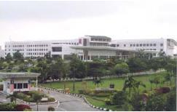
Photo 9.4: ... will continue to maintain a small manufacturing presence specialising in high technology industries.
IN 2: CHKL shall maintain a small manufacturing component related to high technology industries.
Manufacturing industries that are not compatible with Kuala Lumpur’s industrial strategy and objectives must relocate away from the City.
IN 3: CHKL shall ensure that there shall be no incompatible manufacturing enterprises in the City.
b) Service Industries
Automobile business parks shall be established in strategic locations, including a designated area in Chan Sow Lin, to enhance environmental management as well as provide efficient customer services. These parks shall provide ‘one-stop centre’ facilities for the operations of motor repair workshops, second-hand car sales and parking areas, showrooms, auto-parts and accessories shops, vehicle spraying workshops, vehicle services, vehicle refurbishment centres and provision for other related services that will enhance automobile businesses.
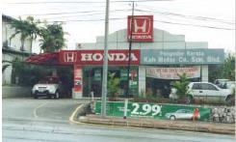
Photo 9.5: Automobile business parks shall be established in strategic locations ...
Policies:
IN 4: CHKL shall designate strategic locations as automobile business parks.
Compatible service industries should be encouraged at neighbourhood and district centres for the convenience of residents, together with other smallscale light industries that can provide employment opportunities for those living nearby. However, the Use Classes Rule shall be reviewed to ensure that polluting and hazardous industrial activities are not permitted in commercial areas.
IN 5: CHKL shall review the Use Classes Rule.
c) Inter-Industrial Linkages
Small and Medium Industries (SMIs) require support services through which they can develop effective networking and to enable them to draw from available resources such as capital sourcing, human resource development training facilities and information regarding regulations governing their operations. In addition, so as to ensure a healthy service industry that is able to serve the population effectively, support facilities to foster and strengthen customer-supplierproducer linkages for the service related industries should be provided.
Policies:
IN 6: CHKL shall coordinate with government agencies and the private sector to provide networking and support services for the growth of Small and Medium Industries.
d) Unrationalised Industries
Unrationalised and illegal industries are undesirable elements in the City and shall be phased out. However, many of these industries are light service industries that contribute to the economy of the City and need, therefore, to be accommodated in more suitable locations.
IN 7: CHKL shall designate areas to accommodate light service industries.
In areas where industrial establishments are close to river systems, the redevelopment process shall include efficient environmental control and management measures that avoid polluting the river systems. Policies relating to river pollution are covered in Chapter 15: Environment.

9.4.2 Industrial Area Development
a) Zone-Based Industrial Development
In order to regulate the expansion of industrial development, CHKL shall adopt a zonal approach by designating two distinct industrial zones separated by a central non-industrial zone (refer Figure 9.2).
The northern industrial zone comprises Jinjang, Bukit Maluri, Wangsa Maju, Sentul and Setapak. This zone is reasonably close to the Malaysian second car plant in Serendah and the proposed Proton City in the Bernam Valley. Support industries to cater for local needs and fabricated metal products are expected to be the major industries in this zone.
The southern industrial zone comprises Bukit Jalil, Bukit Indah, Bukit Anggerik, Seputeh, Bandar Tun Razak, Chan Sow Lin and Maluri. This zone is adjacent to the MSC and is also easily accessible to the KLIA. The MSC and the Technology Park Malaysia at Bukit Jalil provide opportunities for R&D cluster, support industries and industrial skills development.
Industrial development in both the southern and the northern industrial zones shall be encouraged to take advantage of current developments in their hinterland. No industries shall be encouraged in the central zone that comprises the City Centre, Damansara, Penchala and Ampang/U Thant. This will be the central spine of Kuala Lumpur that represents the ‘international zone’ and the commercial and financial centre of the City.
Policies:
IN 8: CHKL shall implement a zone-based industrial development strategy complementing prevailing sub-regional developments. Policies:
b) Industrial Area Infrastructure Development
Measures shall be implemented to provide all industrial areas with proper basic infrastructure, services and facilities including wider roads, improved loading and unloading facilities, better drainage systems, parking and public transport facilities, as well as suitable commercial enterprises, banking facilities, food courts and recreational areas.
Policies:
IN 9: CHKL shall ensure that all designated industrial areas are provided with adequate public facilities including parking for heavy goods vehicles.
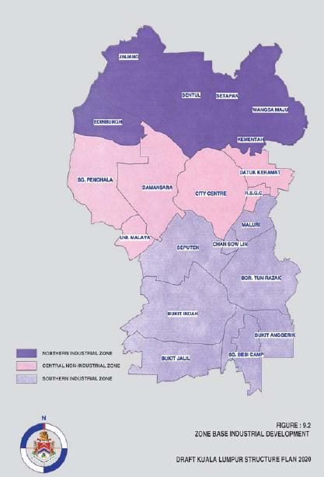
Photo 9.6: Measures shall be implemented to provide all industrial areas with proper basic infrastructure, service and facilities including wider roads, improved loading and unloading facilities ...
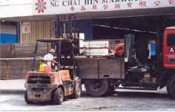
c) Industrial Development Close to Transit Stations
Transit oriented development is a cornerstone of the development strategy. Development policies shall aim to ensure that residential areas, services and commercial facilities shall, as far as is possible, have easy access to transit facilities. Where appropriate this strategy shall also include industrial areas particularly those where there is high employment. Feeder bus services in these industrial areas shall link to the railbased public transport system.
Policies:
IN 10: CHKL shall encourage the development of new industrial areas and the redevelopment of older industrial areas which are near to transit facilities.

INDUSTRY
Section

9.5 FUTURE REQUIREMENTS
Projected future requirements for industry forecast an overall increase in floor space with high technology and highly skilled clean industries gradually taking the place of the older manufacturing industries. The main areas of growth will be in Sentul-Menjalara and Bukit Jalil-Seputeh and the industrial component of the City Centre will be reduced to the minimum. Service industries that serve the population of Kuala Lumpur will be distributed evenly across the six strategic zones.
Table 9.2: Projected Industrial Requirement by Strategic Zone, 2020
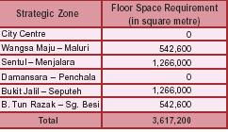

TRANSPORTATION
Section

10.1 Introduction
Comprehensive and efficient transportation system networks with good inter and intra urban linkages are essential enabling factors to ensure Kuala Lumpur’s position as an International Commercial and Financial Centre.
For the residents of Kuala Lumpur, the City must be able to provide an efficient and equitable city structure that, as far as possible, allows all members of the community equal accessibility to all areas and facilities so that everyone may enjoy the maximum benefits of city living.
The basic structure is now in place with a comprehensive road and rail network that has been built up since 1984, and the programme now for Kuala Lumpur will be to develop, refine and integrate this transportation system to serve the City and its population until 2020.

TRANSPORTATION
Section

10.2 EXISTING SITUATION AND ISSUES

10.2.1 General
a) Transport Modal Share
(i) Existing Situation
Between 1985 and 1997, the modal share of public transport decreased from 34.3 percent to 19.7 percent. and in particular bus transport, which is partly attributable to higher personal affluence leading to an increase in car ownership and also to deficiencies in the bus services. The increasing reliance on private transportation, in particular private cars, has created considerable pressure on the road network which has contributed to the problems of traffic congestion.
(ii) Issues
• Low public transport modal share resulting in high demand on road infrastructure and traffic congestion.
b) Travel Demand
(i) Existing Situation
Increased affluence and out migration from Kuala Lumpur have both contributed to the present traffic congestion problems in the City Centre. Between 1980 and 1997, the population of Kuala Lumpur maintained an annual growth rate of 1.1 percent while from 1985 to 1997 person trips by cars increased at an average annual growth rate of 4.2 percent in the Klang Valley Region.
It is also significant that, although the population of the City Centre accounts for only 3.3 percent of total population of the Klang Valley Region, approximately 19 percent of the 8.3 million person trips made daily within the Klang Valley Region are trips generated in the City Centre.
The high travel demand has been met in large part by private transportation in particular, private cars. As a consequence, there has been congestion and a serious deterioration of travel speed on major roads in many parts of Kuala Lumpur, especially in the City Centre, as well as in the east and south, due to major traffic routes operating at or above capacity during peak hours. Low vehicle occupancy has further aggravated the problem.
(ii) Issues
• High travel demand to and from the City Centre during peak hours.
c) Traffic Management
(i) Existing Situation
Traffic management measures are aimed at optimising the existing infrastructure to improve flow capacities and to be more responsive to traffic demand at different times of the day.
Various measures have been successfully implemented in Kuala Lumpur. The principal means of traffic control in the City presently comprises a computer based area traffic signal co-ordination system (SCATS/ITACA) that operates 130 intersections, supplemented by the traffic police during peak hours. Extension of the existing traffic control system together with an upgrading of the system’s capability is currently being implemented in phases.
Other traffic control measures which contribute to traffic management in Kuala Lumpur include the one way street system, reversible lanes to increase lane capacity during morning peak hours, exclusive bus/taxi lanes, penalties for illegal on street parking and regulations controlling heavy vehicle entry into the City Centre during peak hours.
Additional measures that relate to road safety are through the use of traffic signage, barriers, pavement line marking and pedestrian bridges. Driver awareness campaigns and strict provisions for the issuance of driving licenses are also relevant contributions to effective traffic management.
(ii) Issues
Although traffic management measures have done much to ease traffic flows particularly in the City Centre, they cannot continue to do so indefinitely if traffic demand on the roads continues to grow.
• Traffic management measures alone cannot effectively increase existing road capacity levels.
d) Transportation Institutional Framework
(i) Existing Situation
The institutional structure responsible for urban transportation within Malaysia and, more specifically, Kuala Lumpur is divided between federal departments and City Hall Kuala Lumpur (CHKL) (refer to Table 10.1).
The CHKL Urban Transport Department is entrusted with wide ranging coordination and administrative functions for the planning of urban transport in an effective manner. The federal government deals more with nationwide transportation plans, policy guidelines and matters concerning overall transport administration and planning.
Private sector involvement in the provision of transport infrastructure has expanded from the original role of bus and taxi transport operation to toll road construction and recently the implementation, operation and maintenance of the Light Rapid Transit (LRT) Projects. The Keretapi Tanah Melayu (KTM), the former national railway of Malaysia, was corporatised into a private entity as the Keretapi Tanah Melayu Berhad (KTMB), in 1992.
Table 10.1: Urban Transportation Responsibilities - Federal and Local Government Departments Federal Government / Major Urban Local Government Transport Departments
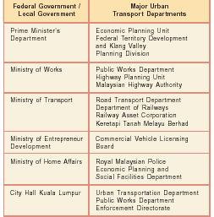
(ii) Issues
There is a degree of overlap and duplication in the functions of the various agencies responsible for Kuala Lumpur’s transportation network, which has led, in some instances, to conflicting policies or programmes.
This has made it more difficult to formulate policies for public and private transportation which are consistent.
• Inadequate coordination of policies concerning public transport and public/private transport modes.

10.2.2 Public Transport
a) Rail - Based Public Transport
(i) Existing Situation
Rail services have become a significant factor in public transport in Kuala Lumpur since the opening of the Light Rail Transit (LRT) System 1, Sistem Transit Aliran Ringan Sdn Bhd (STAR) in 1996 and subsequently the LRT System II or PUTRA in 1998. Together they provide approximately 50 kilometres of rail network with 40 stations.
In addition to the LRT, the People Mover Rapid Transit (PRT), a monorail system is under construction that will serve major commercial and office developments within the City Centre. The monorail’s 10-kilometre route with 10 stations will act as a downtown people mover operating on an elevated track.
The Express Rail Link (ERL), a dedicated high-speed rail system, has been completed between KL Sentral and Kuala Lumpur International Airport (KLIA). The ERL terminus at KL Sentral functions as a city airport terminal for KLIA. At KL Sentral station, an inter modal facility is being provided with KTMB Commuter, PRT and LRT System II, where users can transfer between the various modes to their desired destinations.
The upgrading of KTMB rail services and the operation of the KTM commuter added about 137 kilometres of rail services between Rawang - Seremban and between Sentul - Port Klang passing through 39 stations and halts. This service allows commuters to capture a significant portion of the long distance daily travel needs between Kuala Lumpur and the suburbs.
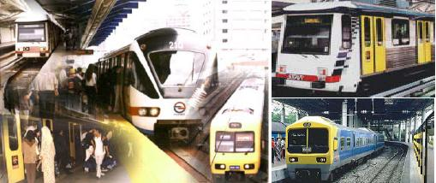
Photo 10.1: Rail services have become a significant factor in public transport in Kuala Lumpur ...
(ii) Issues
LRT and commuter rail usage has been encouraging since the LRT came into service. However, optimal usage has still to be achieved due to:
• Inadequate interchange facilities at stations including car and motor cycle parking and pedestrian linkages;
• Lack of integration between rail-based stations; and
• Poor support services including inadequate feeder bus frequency and service coverage.
Figure 10.1 indicates the relative accessibility of bus and rail-based public transport.
It is clear that rail-based public transport services are far less accessible than bus services and, consequently, their ability to service patrons in a single trip from origin to destination is very limited. The 2-kilometre radius coverage of the feeder buses that operate from stations is not enough to ensure sufficient accessibility.
• Poor accessibility to rail-based public transport.
Figure 10.1: Rail and Bus Accessibility in Kuala Lumpur
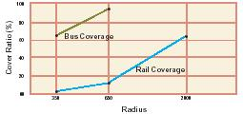
b) Bus Services
(i) Existing Situation
At present there are four major private companies operating about 15,000 bus trips per day. Each company operates about 30 routes, most of which are radial in nature, terminating at the City Centre.
Improvements to the bus network are being facilitated by CHKL providing exclusive bus/taxi lanes in the City Centre, and comfortable shelter/stop facilities. Together these improvements are intended to offer passengers a quick, comfortable and convenient transport option.
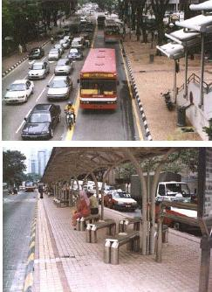
Photo 10.2: Improvements to the bus network are being facilitated by CHKL providing exclusive bus/taxi lanes in the City Centre, and comfortable shelter/stop facilities.
(ii) Issues
Despite the improvements to the bus system and road infrastructure, bus utilisation is low, primarily as a consequence of route duplication, unreliable service frequency, overcrowding during peak hours and the poor condition of buses.
• Under utilisation of bus services; and
• Unreliable and poor quality of services.
The existing main bus terminal is at Puduraya in the City Centre. The majority of inter urban buses and coaches terminate there, thus adding to traffic congestion and consequently, longer journey times for passengers.
• Central location of main bus terminal contributing to traffic congestion.
c) Taxis
(i) Existing Situation
Taxis are an important element of the public transport system offering a convenient form of alternative transport particularly outside peak hours. There are approximately 24,721 taxicabs licensed in Kuala Lumpur, run by 4,183 operators. A traffic classification survey carried out by Japan International Coorperation Agency (JICA) in 1997 indicated that taxis constituted 4 to 6 percent of the total number of vehicles passing through the City Centre.
(ii) Issues
There is no shortage of taxis but availability is frequently a problem at peak periods and during bad weather.
• Unreliable taxi services.

10.2.3 Private Transportation
a) Cars and Car Parking
(i) Existing Situation
Based on the Road Transport Department report, the ratio of registered cars and motorcycles in Kuala Lumpur was 985.7 per 1,000 populations in 2000. However, based on the Home Interview Survey carried out by JICA in 1998 the estimated possession ratio in vehicles represents approximately 211 cars per 1,000 population and 164 motorcycles per 1000 population. Private cars account for 56.6 percent of all motorised trips in Kuala Lumpur.
CHKL through the town planning approval process controls the number of car and motorcycle parking spaces to be provided for new development. However, at present parking charges are subjected to market forces and are not regulated.
In order to alleviate traffic congestion, CHKL has successfully implemented roadside parking restrictions on all major arterial roads in the built-up areas.
There are approximately 65,206 car parking spaces in the City Centre (refer to Figure 10.2). Office buildings record the highest utilisation of spaces averaging 71.0 percent, followed by retail premises (49.0 percent average) and mixed-use (47.0 percent average). Generally, car-parking provision in the City Centre is more than adequate.
(ii) Issues
Parking charges in the City Centre favour regular longterm parking with many car park operators offering cheap seasonal parking tickets. This, together with the flexibility afforded by private transport, encourages commuters to continue to use private transport into the City Centre.
• The low cost of long-term parking in the City Centre together with the abundance of parking spaces and the flexibility of movement associated with car transport, has made car transport the preferred means of travel in the City.
Outside the City Centre there is a shortage of car parking spaces in areas close to public transport and also in commercial shop lot developments where there are no multi-storey or underground car parks.
• Shortages of parking spaces outside the City Centre in locations which have reasonable access to public transport, and in commercial shop lot developments.
b) Motorcycles
(i) Existing Situation
Motorcycles account for approximately 23.0 percent of all road users in Kuala Lumpur. Principally used by the young and lower income groups, they provide a fast, flexible and economical means of transportation around the City.
About 52 percent of the total numbers of fatal and serious accidents in Kuala Lumpur involve motorcycles. Motor vehicles are the major source of urban air and noise pollution. Noise emission from motorcycles in the City Centre exceeds permissible noise limits (Malaysia Environmental Quality Report 1996, DOE).
(ii) Issues
• The accident rate involving motorcycles is higher than for all other forms of transport; and
• Motorcycles contribute significantly to noise and air pollution.

10.2.4 Road Infrastructure
(i) Existing Situation
Under the privatisation policy, the road building programme for the Klang Valley set out in the KLSP 1984, which comprised 23 new roads and 21 major road improvement projects, has mostly been completed together with some additional toll highways. The road network now in place has succeeded in its primary purposes of eliminating through traffic from the City Centre, reducing congestion on minor roads and efficiently dispersing traffic from the City Centre.
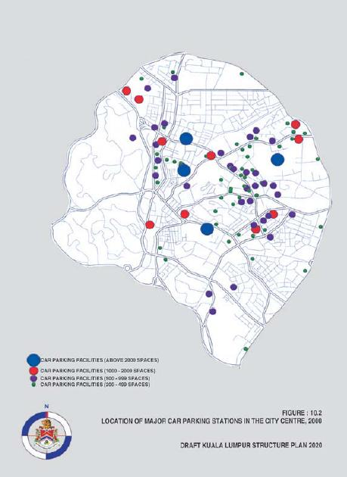
In addition there are a number of road building projects already under way, and some for which a concession agreement has already been signed, or for which approval in principle has been given (refer to Table 10.2).
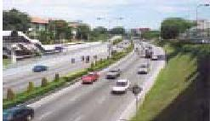
Photo 10.3: The road network now in place has succeeded in its primary purposes of eliminating through traffic from the City Centre ...
(ii) Issues
Discontinuities in the old city street layout have resulted in a lack of direct routes being available for traffic entering or leaving the City Centre, specifically from the south along Jalan Syed Putra and from the east along Jalan Kuching. Access to Bukit Bintang from these directions require through traffic to pass along narrow streets within the old city precinct.
• Constraints in expanding existing routes for traffic entering or leaving the City Centre.
Although the road-building programme is, to all intents and purposes, complete, there remain instances where connections between major roads or major and minor roads are incomplete. In addition, in some instances there is traffic back up at at-grade junctions which are unable to cope with the traffic flow. These factors cause traffic bottlenecks that lead to traffic congestion particularly at peak hours.
• Discontinuities in the road network; and
• Traffic back up at at-grade junctions.
Because no requirement has been made in privatisation agreements, major toll highways have been built without any specific provision for public transport or freight vehicles. The potential for maximising the utilisation of these highway routes for high-speed public transport connections to outlying areas has not been exploited.
• Lack of specific provision in toll highways for public transport or freight vehicles.
Major roads in Kuala Lumpur have not always fully observed road classification requirements. In addition, some roads have assumed functions for which they were not originally designed such as residential roads that have become trunk roads due to ill-considered road connections. These anomalies have presented difficulties in the design and management of the overall road network.
• Existing designation of major roads does not reflect actual usage.
Plot ratios for commercial spaces within the City Centre have progressively increased over the years and put increased pressure on the road network. Large-scale projects planned and committed will increase private vehicle travel demand even further.
• Increased pressure on the road network due to intensive and large-scale commercial developments.
Table 10.2: Existing Highway and Expressway Projects
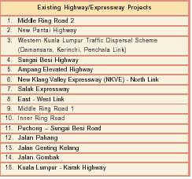

10.2.5 Non-Motorised Transport
a) Pedestrian
(i) Existing Situation
A pedestrian network is progressively being implemented in the City Centre. This will facilitate pedestrian and non-motorised vehicle movement at activity centres, connect transit stations and terminals for convenient inter-modal transfer, provide pedestrian malls and act as traffic restraint measures. The network will also help increase the utilisation of public transportation and reduce short vehicle trips.
The existing situation and issues relating to pedestrian movement are outlined in Chapter 14: Urban Design and Landscape.
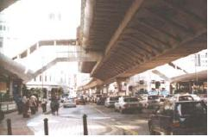
Photo 10.4: ... pedestrian and non-motorised vehicle movement at activity centres, connect transit stations and terminals for convenient inter-modal transfer ...
b) Bicycles
(i) Existing Situation
Cycle ways have, for some time, have been incorporated into new housing estates and recreational areas. Despite the relatively flat terrain of Kuala Lumpur, cycling as a convenient means of transport is under utilised partly due to local climatic conditions. There are also, however, some shortcomings in the existing cycle way network which contribute to the under utilisation of bicycles.
(ii) Issues
Opportunities exist for bicycle transport in providing connections to public transport services and short distance local travel. Other cities have utilized their roads, rail and open space corridors to create a comprehensive local area cycle way network.
• Cycle ways in housing estates suffer from under usage, misuse (illegal parking) and poor maintenance; and
• Lack of continuity in the cycle way networks.

10.2.6 Freight Transport
(i) Existing Situation
Lorry vehicular trip production is mainly focused in the industrial areas peripheral to the City Centre. Heavy lorry flows are concentrated more in external zones to the south and passing through the region on a north-south axis.
Within Kuala Lumpur there is some heavy goods vehicle (HGV) movement although this is prohibited during the morning and evening peak hours.
(ii) Issues
There are areas in the north and south of the City where the illegal parking of HGVs, construction vehicles and coaches in residential areas causes inconvenience to the residents.
• Illegal parking of heavy goods vehicles and construction vehicles in residential and commercial areas due to the lack of proper parking facilities and consequent enforcement difficulties.

TRANSPORTATION
Section

10.3 OBJECTIVES
To create an efficient and equitable city structure for Kuala Lumpur, CHKL aims to:
• Provide a comprehensive and integrated transportation system that caters for the needs of inter and intra-urban travel;
• Reverse the decline in public transport usage and to achieve a targeted public:private transport modal split of 60:40 by the year 2020;
• Optimise the road and rail transportation infrastructure so that it operates at its full capacity and maximum efficiency;
• Ensure that the overall configuration of land use is integrated with road and public transportation networks to optimise the development of land; and
• Ensure that all areas within the City enjoy the same high quality and standard of provision of public transport services.
To enhance the city living environment, CHKL aims to:
• Create a city that is highly accessible for all its occupants and users, in particular, one that is pedestrian and handicapped friendly.

TRANSPORTATION
Section

10.4 POLICIES AND PROPOSALS

10.4.1 General
a) Travel Demand Management
If current trends continue, motorised trips by car in 2020 are expected to be almost double those of 1997. Increasing road capacity by constructing new roads and widening existing roads do not, in the long run, resolve the situation, but simply postpone the problem until more roads need to be built. Most areas in the City, especially the City Centre, are now built up and land acquisition for road development is becoming increasingly difficult and expensive.
CHKL is, therefore, moving towards a Travel Demand Management strategy that aims to redirect movement patterns from private to public transport by integrating transport modes, extending and promoting public transport, and discouraging the use of private transport. The public transport system in the City must be competitive, convenient, user-friendly and accessible to all income groups.
Policies:
TT 1: CHKL shall determine Travel Demand Management measures to increase public transport usage and liase with the relevant authorities to ensure that these measures are implemented.
TT 2: CHKL shall implement a private vehicle restraint programme to improve traffic circulation in the City Centre by discouraging car travel to and from the City Centre during peak hours and enforcing measures to limit access to certain parts of the City.
b) Traffic Management System
In order to optimise the traffic management system now in place, the system needs to be upgraded to one that can monitor and control all aspects of traffic movement in the City.
Policies:
TT 3: CHKL shall enhance the traffic management system.
c) Transit Oriented Development
A principal objective of the transportation sector is the integration of land use with transportation and the development of a Transit Oriented Development Strategy.
This strategy, which is detailed in Chapter 6: Land use and Development Strategies, will promote intensified development along the rail network. Any planned extension to the rail network must, therefore, complement this policy by ensuring that rail stations serve designated urban centres.
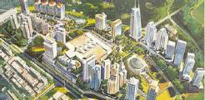
Photo 10.5: ... will promote intensified development along the rail network.
Policies:
TT 4: CHKL shall establish a Transit Planning Zone to facilitate intensification of transit oriented residential, commercial and mixed-use development around rail stations.

10.4.2 Public Transport
a) Public Transport Administration
The increased emphasis and capital expenditure on public transport requires complementary co-ordination between government departments and other related agencies. CHKL shall take pro-active measures in this respect.
Policies:
TT 5: CHKL shall coordinate the planning, development and operation of public transport and related private transport matters.
b) Public Transport Integration
The emphasis will be on providing an integrated, flexible, wide ranging and efficient public transport system orientated towards passenger accessibility and convenience. Central to this approach is the integration of public transport modes with each other and with private transport so that, with streamlined inter modal transfer facilities and integrated ticketing, passenger trips become as convenient and seamless as possible.
In order to avoid traffic congestion occurring on local streets, major bus/rail and park-and-ride interchange facilities will be located at the points of intersection of the rail stations and major roads. The recommended locations of these interchanges are shown in Figure 10.3.
Policies:
TT 6: CHKL shall ensure that public transport principally comprises a fully integrated system of bus transport and rail-based services with common ticketing and coordinated route scheduling, and major multi-modal interchanges located at strategic locations.
TT 7: CHKL shall ensure that multi-modal interchanges and terminals incorporate park-and-ride facilities and facilities for pedestrians and bicycles.
TT 8: CHKL shall coordinate with the relevant authorities to provide efficient feeder bus services to the rail-based public transport network.
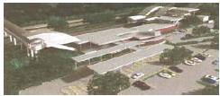
Photo 10.6: ... the integration of public transport modes ...
c) Rail-Based Public Transport
The rail network is the most efficient means of providing high capacity rapid public transport. Medium and longterm plans for the expansion of the rail network to outlying areas should be regularly examined for their feasibility.
The major growth areas in Kuala Lumpur are now well linked to the City Centre except those on the east-west axis. The feasibility of a new Damansara-Cheras LRT line linking growth areas in the east and west shall be investigated together with new rail links to serve district centres, comprehensive development areas and growth areas.
It is also proposed that the STAR LRT line from Sentul Timur station be extended northward towards Taman Wahyu and westward towards Kepong and another line be extended from Sri Petaling station westward to serve the area around Bukit Jalil.
A further extension to the PRT is proposed from KL Sentral station to the proposed district centre at Bukit Indah which will add a further 21.8 kilometres to the line.
Policies:
TT 9: CHKL shall prepare feasibility studies for future extensions to the rail network and coordinate with the relevant authorities with regard to implementation.
d) Bus Services
Buses will remain the principal form of public transport especially outside the City Centre for the foreseeable future. In order to encourage greater usage of bus services, it is essential that measures be undertaken to improve their reliability, coverage, comfort and convenience.
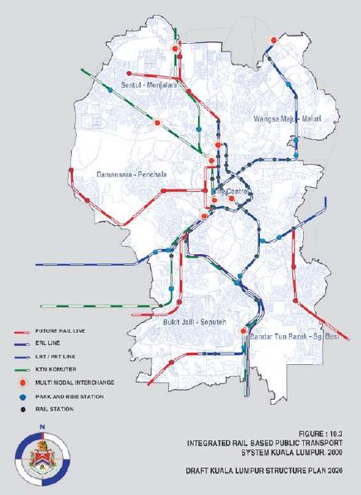
Policies:
TT 10: CHKL shall determine measures to improve bus services with maximum penetration into growth areas and all major employment and retail centres and coordinate with the relevant agencies and operators.
CHKL will also implement measures to create a network of bus terminals on the periphery of Kuala Lumpur for buses and coaches serving separate regional and interurban services. These terminals will be integrated with the rail system via multi-modal interchanges to enable easy access to the City Centre and other areas of the City. These terminals are located at Gombak (to serve
the east), Bandar Tasik Selatan (to serve the south), Jalan Ipoh (to serve the north) and Duta Station (to serve the west) (refer to Figure 10.4).
TT 11: CHKL shall implement a bus terminal network for inter and intra-urban bus services.
e) Cars and Car Parking
By controlling the supply and distribution of car parking facilities in Kuala Lumpur, CHKL can help to reinforce public transport and Travel Demand Management objectives by making private transport a less attractive proposition than public transport, especially within the City Centre. This can further be reinforced by controlling the cost of car parking in different parts of the City.
Policies:
TT 12: CHKL shall regulate the supply of parking facilities.
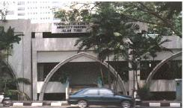
Photo 10.7: CHKL shall regulate the supply of parking facilities.
f) Taxis
In view of the vital role that taxis play in the business and commercial life of the City, it is important that significant improvements are made to the levels of service and reliability. In achieving better overall public transport services, taxis need to be expanded with innovative services into new markets.
Policies:
TT 13: CHKL shall coordinate with the relevant agencies to improve the reliability and availability of taxi services.
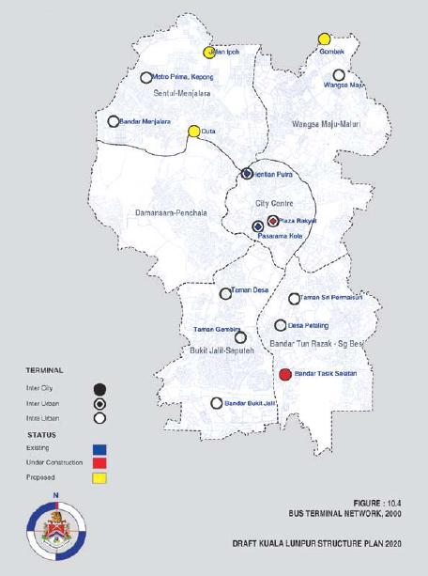

10.4.3 Private Transportation
a) Motorcycles
As Kuala Lumpur looks to a cleaner and safer living environment, the role of the motorcycle in transportation must be examined. A large percentage of motorcycle users are those that would benefit from a more comprehensive public transportation system. A longerterm view linked to the development of the public transportation system will look to encouraging motorcycle users to make greater use of public transport and limit motorcycle usage in the City Centre to only essential users.
In the short and medium term, measures to improve safety for motorcycle users shall be implemented and more rigorous enforcement of existing regulations shall be exercised.
Policies:
TT 14: CHKL shall coordinate with the relevant authorities and improve road infrastructure to enhance safety measures for motorcycle users.

10.4.4 Road Infrastructure
a) New Roads Development
The major road system currently in place together with those which are under construction or committed are considered sufficient to satisfy Kuala Lumpur’s needs to the year 2020. However, two new roads are proposed that are principally intended to improve traffic flow in and out from the City Centre. In view of the difficulty of increasing existing road capacities in the City Centre and the high cost associated with obtaining new corridors, an underground expressway is proposed beneath Jalan Raja Chulan connecting to the Middle Ring Road in the East.
An Inner City By-Pass Road is also proposed, part of which will be underground, to provide a direct link from Jalan Syed Putra in the south of the City Centre to Jalan Dang Wangi (refer to Figure 10.5 and Table 10.3).
Policies:
TT 15: CHKL shall determine a road development programme and coordinate with the relevant authorities regarding implementation.
In future the requirement, if any, for new roads must be examined in the context of CHKL’s general transportationpolicies. However, any new roads that may be deemed necessary should support CHKL’s policies to promote public transportation by making provision for high-occupancy vehicles and/or trunk bus routes. The reserves of these roads should be clearly demarcated to prevent urban encroachment on the right of way.
Privatisation bids on arterial roads must also conform to the network proposed in the Structure and Local Plans and not be conceived independently.
TT 16: CHKL shall ensure that proposed and committed major roads are considered in the broader context of public transport services, freight movement and impact upon the community and environment.
b) Improvements to the Existing Road Network
In order to complete the existing road network, increase its capacity and eradicate bottlenecks, a road network improvement programme must be carried out to upgrade existing roads to arterial roads, build missing linkages and improve interchanges (refer to Figure 10.5 and Table 10.3).
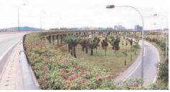
Photo 10.8: ... a road network improvement programme must be carried out to upgrade existing roads to arterial roads, build missing linkages and improve interchanges.
Policies:
TT 17: CHKL shall determine a road improvement programme and coordinate with the relevant authorities regarding implementation.
c) Hierarchy of Roads
In order to be able to better monitor and optimise usage of the existing road system, CHKL will undertake a review of the actual status of all existing roads and review the road hierarchy system. An improved road classification system shall be implemented.
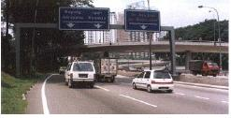
Photo 10.9: ... CHKL will undertake a review of the actual status of all existing roads and review the road hierarchy system.
TT 18: CHKL shall review the existing Road Hierarchy System and implement an improved road classification system.

10.4.5 Non-Motorised Transport
a) Pedestrian
Policies regarding pedestrianisation are covered in Chapter 14: Urban Design and Landscape. A pedestrian friendly environment will be created throughout the City with particular emphasis on the City Centre and other urban centres. Pedestrian networks in the City Centre will emphasise linking public transport facilities and will incorporate urban design elements. A proposed parkland PRT loop passing through the parkland sector in the western part of the City Centre shall connect to the existing PRT line and complement the pedestrian network. Special attention is to be given to areas around main transport interchanges to ensure that they incorporate facilities to make them fully accessible to the handicapped.
Policies:
TT 19: CHKL shall develop specific guidelines and standards to provide for the needs of the aged and handicapped to be applied to pedestrian networks, new public transport terminuses and stations as well as multi-modal interchanges.
b) Bicycles
Bicycles can and should continue to be encouraged as a healthy form of exercise and as an alternative means of private transportation for short journeys in residential and recreational areas.
Policies:
TT 20: CHKL shall improve the cycle way network and promote cycling activities in residential and recreational areas. Policies:
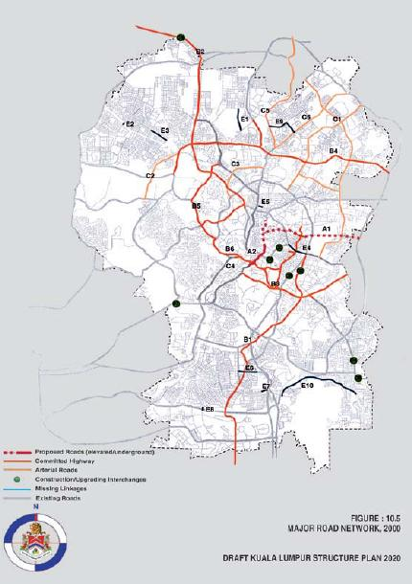

10.4.6 Freight Transport
Adequate lorry parks for the benefit of HGV owners residing in the City shall be provided so that they do not have to resort to illegally parking in commercial or residential areas. These lorry parks shall also include parking facilities for coaches and construction vehicles.
Policies:
TT 21: CHKL shall provide adequate parking and other ancillary facilities for heavy goods vehicles, coaches and construction vehicles in appropriate locations at the City perimeter.
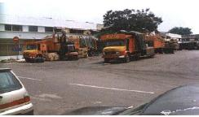
Photo 10.10: Adequate lorry parks for the benefit of HGV owners residing in the City ...

TRANSPORTATION
Section

10.5 Future Requirements

10.5.1 Integrated Public Transportation System
The complete rail network to the year 2020 including integrated park-and-ride stations and multi-modal interchanges are indicated in Figure 10.3.

10.5.2 Road Network
Ultimately Kuala Lumpur still needs a comprehensive road network in order to provide efficient and convenient road travel. The requirements for new roads and improvements to existing roads are indicated in Figure 10.5 and summarised in Table 10.3.
Table 10.3: New Roads Construction and Improvements to Existing Roads
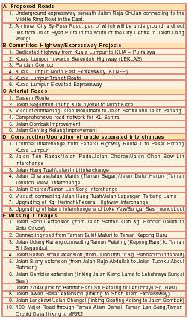
INFRASTRUCTURE AND UTILITIES
Section

11.1 Introduction
The quality of life of a city is always measured against the quality of its infrastructure and utility services and the general level of satisfaction of its citizens with such provisions and services. The efficient and reliable delivery of essential services is, therefore, a minimum expectation of a modern city. In order for Kuala Lumpur to achieve the status of a world-class city, its infrastructure and utilities must be of the highest quality, without any problems associated with interrupted supplies, shortages, the use of substandard equipment or materials or unsatisfactory services.
Although, in many cases, CHKL has no direct control over the adequacy of provision of infrastructure, utilities and services, any inadequacies reflect on the City as a whole and therefore indirectly on CHKL itself. To that extent CHKL must concern itself with the proper planning and coordination of these services to ensure that they meet the needs and expectations of the City’s population.
Information technology is now a global driving force in wealth creation and it is essential that modern cities incorporate comprehensive ICT networks in addition to the more traditional infrastructure requirements. Malaysia has taken a bold step in initiating the MSC a large part of which extends into the City Centre, and Kuala Lumpur must exploit the opportunities afforded by this initiative to make the it one of the most developed in the world in terms of ICT infrastructure.

INFRASTRUCTURE AND UTILITIES
Section

11.1 Introduction
The quality of life of a city is always measured against the quality of its infrastructure and utility services and the general level of satisfaction of its citizens with such provisions and services. The efficient and reliable delivery of essential services is, therefore, a minimum expectation of a modern city. In order for Kuala Lumpur to achieve the status of a world-class city, its infrastructure and utilities must be of the highest quality, without any problems associated with interrupted supplies, shortages, the use of substandard equipment or materials or unsatisfactory services.
Although, in many cases, CHKL has no direct control over the adequacy of provision of infrastructure, utilities and services, any inadequacies reflect on the City as a whole and therefore indirectly on CHKL itself. To that extent CHKL must concern itself with the proper planning and coordination of these services to ensure that they meet the needs and expectations of the City’s population.
Information technology is now a global driving force in wealth creation and it is essential that modern cities incorporate comprehensive ICT networks in addition to the more traditional infrastructure requirements. Malaysia has taken a bold step in initiating the MSC a large part of which extends into the City Centre, and Kuala Lumpur must exploit the opportunities afforded by this initiative to make the it one of the most developed in the world in terms of ICT infrastructure.

INFRASTRUCTURE AND UTILITIES
Section

11.2 EXISTING SITUATION AND ISSUES

11.2.1 General
(i) Existing Situation
Responsibility for the planning, capital works, operation and maintenance of almost all infrastructure and utilities in Kuala Lumpur lies with agencies independent of CHKL, most of which are also private corporations operating on a profit-making basis. CHKL has, therefore, little direct control over the quality of infrastructure delivery, performance and customer service.
(ii) Issues
A consequence of the lack of direct control over the provision and maintenance of utilities is that they have often been carried out in an uncoordinated manner.
• The installation and maintenance of utilities is carried out in an uncoordinated manner.

11.2.2 Storm Water Drainage and Flood Mitigation
(i) Existing Situation
The natural drainage system of Kuala Lumpur includes three primary rivers with a total length of 32.8 kilometres and eight other rivers with a combined length of 40.6 kilometres. The Federal Department of Irrigation and Drainage (DID) is primarily responsible for major capital works associated with the maintenance of the river system of Kuala Lumpur.
The CHKL Department of Drainage and River Management is responsible for the regular maintenance of the City’s rivers including de-silting and the operation of 15 rubbish traps. The department is also responsible for capital works, upgrading, structural repairs and maintenance of about 350 kilometres of minor rivers and trunk/monsoon drains. There are a total of 21 catchment
systems conveying storm water runoff from individual roadside drains, each catchment area generally covering a minimum of 40 hectares. The river system and the City’s drainage system, which consist of a total of 2,400 kilometres of reticulation drains, are indicated in Figure 11.1.
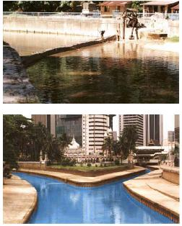
Photo 11.1: ... regular maintenance of the City’s rivers, including de-silting and the operation of 15 rubbish traps.
Frequent flash floods occurring after heavy downpours are a continuing problem for the City. Areas most susceptible to flash floods are low lying areas along Sungai Klang especially Datok Keramat, Jalan Yap Kwan Seng, Kampung Bharu, Jalan Dang Wangi and Jalan Tun Perak/Jalan Melaka in the City Centre. Flooding is partly attributed to silting of the rivers. The loading discharged into the rivers has made them shallower, thus decreasing their flow capacity. The disposal of garbage into the rivers by squatter settlements upstream also contributes to the clogging of the rivers.
However, flooding in the City cannot be resolved without consideration of the overall hydrological pattern of the Klang River basin, as it is estimated that over 70 percent of the volume of the rivers flowing through the City is contributed by upstream sources. A contributory factor leading to flash floods has been permanent structures within the river reserves which have reduced the rivers’ flow capacity.
The dynamic urban development of Kuala Lumpur and the Kuala Lumpur Metropolitan Region has resulted in changes in both the quantity and quality of the river water. The high proportion of hard surfaced areas greatly reduces the amount of water filtering through the soil, which further intensifies peak flows at discharge points.
(ii) Issues
• Frequent flash floods due to the heavy contribution of floodwaters from upstream catchments of Kuala Lumpur and the inadequacy of the primary rivers to contain floodwaters.
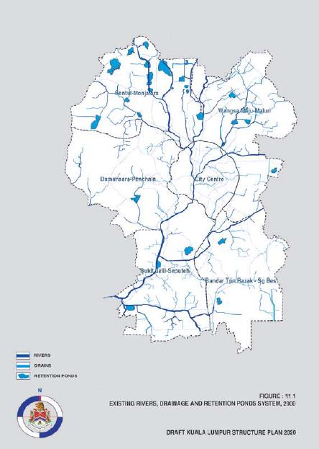

11.2.3 Telecommunications and Information Technology Systems
(i) Existing Situation
Malaysia is at the forefront of the world in providing a regulatory and infrastructural framework necessary to accommodate the rapidly converging communications and multimedia industries. This provision is in support of the MSC which has the potential to become a world information hub and a leading edge multimedia centre attracting world-class multimedia and information technology companies and professionals.
The Malaysian Communication and Multimedia Commission is the Federal regulatory agency responsible nationally for telecommunications services, by way of licenses granted to a wide range of network facilities providers, network services providers and network applications providers.
The telecommunications infrastructure in Kuala Lumpur has been comprehensively provided with fibre optic transmission networks within the City Centre. The provision of telecommunications infrastructure to Kuala Lumpur has to a large extent kept pace with rapid advances in technology, with increasing consumer demand for high-end services and with the growth in the number of residential and business users.
(ii) Issues
Despite the efforts of the agency responsible, there remain some difficulties in the provision of the ICT system infrastructure in some parts of the City and, as a consequence, full integration of the telecommunication network with the MSC has not been achieved.
• The development of the telecommunication network has not been fully integrated with the MSC network.

11.2.4 Water Supply
(i) Existing Situation
The Selangor Waterworks Department (JBAS) is responsible for the provision of the reticulated water supply to Kuala Lumpur (JBAS was corporatised on 15 March 2002 to ‘Perbadanan Urus Air Selangor Berhad’ or PUAS). The operation of all reservoirs and treatment plants is privatised or contracted out and water is sold by the treatment concessionaries to PUAS for distribution. The Bukit Nanas Treatment Plant is the sole water supply treatment plant in Kuala Lumpur and only provides sufficient water for 98 square kilometres of the City Centre. Kuala Lumpur’s water supply requirement is supplemented by four treatment plants in Selangor.
Much needed attention is currently being given to water supply planning for the State of Selangor and Kuala Lumpur, involving the development of new sources of supply and trunk distribution mains, water treatment works and the replacement of outdated plant and pipelines within the distribution network.
(ii) Issues
Attention has previously focused on supply capacity, and there have been some shortcomings in the quality of provision. There is widespread dissatisfaction with the performance of the water supply system in terms of the poor quality of water and low water pressure in hilly areas and the older parts of the City due to aging pipelines.
• Water quality is not at a satisfactory level; and
• Low water pressure in certain part of the City.

11.2.5 Sewerage Reticulation, Treatment and Effluent Discharge
(i) Existing Situation
The Federal Department of Sewerage Services is responsible for policy and performance audit matters relating to the development and operation of sewerage reticulation and treatment systems, including the arrangements by which private developers are required to construct sewerage facilities as part of the development infrastructure of any new project.
The Department of Environment is responsible for standards of effluent discharged from municipal sewerage treatment plants and all associated environmental matters.
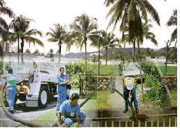
Photo 11.2: The Department of Environment is responsible for standards of effluent discharged ...
In 1994 the Federal Government appointed a concessionaire to design, implement and manage a unified sewerage scheme for Kuala Lumpur. The concessionaire has implemented a sewerage master plan which divides Kuala Lumpur into seven catchments, each of which has been provided with a regional waste treatment plant. The number of oxidation ponds and other small sewerage treatment plants is progressively being reduced as more catchments are being connected to the unified sewerage system. Ultimately, all sewerage flows will be directed to a single modern regional treatment facility. This will overcome the problem of incompatibility of land uses between sewerage treatment facilities and highly developed urban areas.
The distribution of the existing sewerage treatment plants and oxidation ponds in Kuala Lumpur is illustrated in Figure 11.2.
(ii) Issues
Approximately 70 percent of residents within Kuala Lumpur presently enjoy a reticulated sewerage service. However a significant proportion of developed areas remain unconnected to the centralised sewerage reticulation system particularly those, which are remote from the more densely urbanised areas.
• Significant numbers of areas in the City are still not connected to the centralised sewerage system.
The location of oxidation ponds close to housing has given rise to complaints.
• There is still a large number of oxidation ponds located close to residential dwellings.

11.2.6 Solid Waste Collection and Disposal
(i) Existing Situation
Since January 1997, a concessionaire has been responsible for solid domestic waste collection and disposal for the Central Region, comprising Kuala Lumpur and the States of Selangor, Pahang, Kelantan and Terengganu.
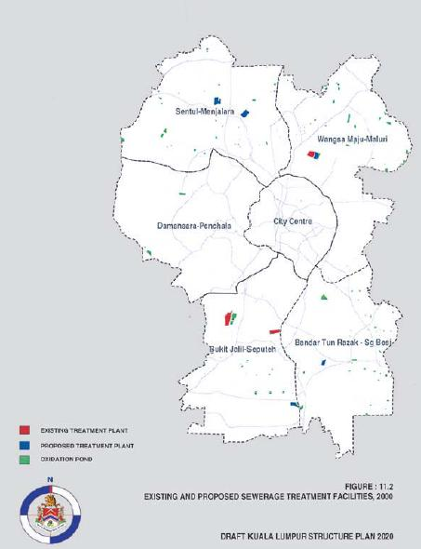
The responsibilities of the concessionaire include the provision of communal bins for public use, ensuring waste collection is carried out according to schedule, implementing an efficient and cost effective solid waste management system, educating the public on the proper handling and storage of waste and the development of an effective recycling programme to reduce waste.
Solid waste composition in 2000 was estimated at 40 percent domestic, 10 percent commercial, 5 percent institutional, 33 percent industrial, 10 percent construction and 2 percent municipal waste.
The 15 hectare Taman Beringin, Jinjang land fill site receives an average of 2,000 tonnes/day of solid waste, of which approximately 500 tonnes/day is sent out to an existing private landfill site at Air Hitam, Puchong in Selangor. Solid waste collection and disposal management in Kuala Lumpur has reached a critical stage because the Taman Beringin, Jinjang site has limited further capacity. Future planning involves the provision of a major transfer station at the Taman Beringin site, from where waste would be transported to the Air Hitam site for the recovery of recyclables and disposal of the remainder by landfill or incineration as appropriate.
The use of landfill sites for the disposal of solid waste is uneconomical in terms of land use and is environmentally undesirable. A 1500 tonnes per day incinerator is therefore planned to be built in Kg. Bohol, Puchong in the south of Kuala Lumpur. However, until a more permanent long-term solution can be found, it is anticipated that landfill sites will continue to be required. A new landfill site outside Kuala Lumpur has been identified which is estimated to have a 10-15 year lifespan. Figure 11.3 shows the distribution of the existing and proposed solid waste disposal sites.
(ii) Issues
There are programmes carried out by CHKL and the concessionaire to reduce waste disposal requirements through public participation in recycling. However, these programmes have not been effective in raising public awareness to a satisfactory level.
•· Waste recycling programmes have not yet been effective.
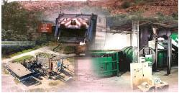
Photo 11.3: ... implementing an efficient and cost effective solid waste management system ...

11.2.7 Industrial and Clinical Wastes
(i) Existing Situation
A concessionaire operates Malaysia’s first integrated scheduled waste management service for the collection and disposal of industrial, chemical and toxic wastes. Its operations in Kuala Lumpur involve the collection of scheduled wastes at the waste generators’ premises, transportation, treatment and final disposal. The waste management system comprises local transfer stations,
a transportation network covering Peninsular Malaysia and a waste management centre at Bukit Nanas in Negeri Sembilan.
Another concessionaire is responsible for the collection and disposal of clinical wastes.
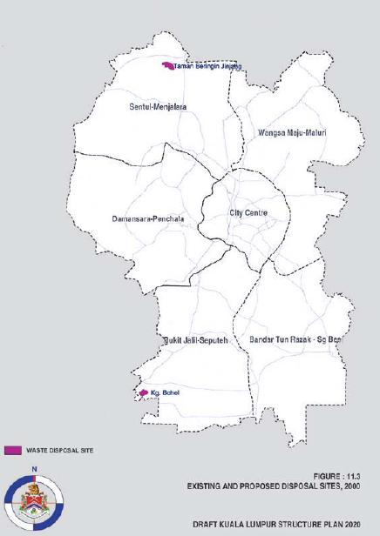

11.2.8 Electricity Supply
(i) Existing Situation
Tenaga Nasional Berhad (TNB) is responsible for electricity transmission and distribution for the whole country and is the country’s principal electricity producer, supplemented by five independent power producers that also deliver electricity to the national grid.
The national grid operates at 275kV and 132kV. High voltage power is delivered to Kuala Lumpur at 33kV and 11kV and reticulated through the City, predominantly underground, at 400V and 240V for domestic consumers. There are a total of 16 132kV and 78 33kV substations in Kuala Lumpur.
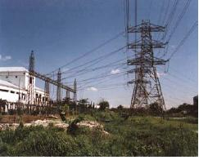
Photo 11.4: High voltage power is delivered to Kuala Lumpur at 33kV and 11kV ...
System augmentation programmes are presently in line with growth in consumer demand and outdated plant and equipment is being replaced to maintain performance and keep pace with technological advances.
(ii) Issues
Most of the electric transmission reserves run alongside developed neighbourhood areas and there are pressures to use these reserves for small-scale temporary development such as nurseries, storage and parking facilities.
• Pressure to use electric transmission reserves for small-scale temporary development.

11.2.9 Piped Gas Supply
(i) Existing Situation
In line with the national energy policy, Petronas Gas Berhad, which is the supplier of gas to Gas Malaysia, has expedited implementation of the Peninsular Gas Utilisation (PGU) project, which will transport gas from the east coast southwards to Johor Bahru and Singapore, with a pipeline branching north west at Segamat to the Klang Valley. The natural gas distribution network is being developed in phases based on demand.
Natural gas supplied to end users within the City is taken from a PGU transmission pipeline at a city gate station. As natural gas is odourless, an odourant agent is added to the gas at an odouriser station located immediately after the city gate station. Natural gas is then transported via feeder lines directly to medium and large end users or to a district station for distribution to small end users. At the end users premises, gas is further regulated and metered.
The development of feeder and distribution lines within Kuala Lumpur has commenced in accordance with a forward plan to the year 2005. Presently, the largest single user of natural gas in Kuala Lumpur is the KLCC, which utilises gas turbines to generate its entire electricity requirement and for the operation of a centralised cooling system. However the natural gas reticulation system coverage in industrial, commercial and residential sector in the City is still marginal.
(ii) Issues
• The natural gas reticulation system coverage in industrial, commercial and residential sector in the City is still marginal.

11.3 OBJECTIVES
To create the conditions necessary for a world-class living and working environment, CHKL aims to:
• Provide a clean and pleasant living environment supported by efficient infrastructure, utilities and services.
INFRASTRUCTURE AND UTILITIES
Section

11.4 POLICIES AND PROPOSALS

11.4.1 General
The improvement in the provision of infrastructure, utilities and waste disposal services is fundamental to the enhancement of the quality of life of the City’s population. Programmes must be initiated to address all aspects of provision including quality of service, maintenance, adequacy of availability of distribution and reliability. Public feedback is the most effective means of evaluating the adequacy of infrastructure, utilities and waste disposal services and procedures must also, therefore, be introduced to facilitate such feedback and involve the public more actively in the improvement of the living environment. Public complaints will be monitored and CHKL shall liase with utilities concessionaires on regular maintenance, repair and servicing.
CHKL’s role as an overall co-coordinator of infrastructure capital and maintenance works, service connection and GIS database will be important. The regulatory framework within which the independent infrastructure agencies operate needs to be reviewed in order to increase their accountability to the community.
Policies:
UT 1: CHKL shall, in coordination with the appropriate authorities and agencies, enhance the provision of infrastructure, utilities and waste disposal services and ensure that they are reliable and sufficient to meet the needs of people.
In order to ensure that infrastructure, utilities and waste disposal services are provided in a timely and coordinated manner, it is important that the agencies concerned plan for their future development in accordance with the City’s projected planning requirements. To facilitate this process and enable the relevant agencies to more accurately predict future requirements, a common land use and demographic database will be prepared.
UT 2: CHKL shall, in coordination with the appropriate authorities and agencies, ensure that infrastructure, utilities and waste disposal services development plans complement the City’s planned requirements.

11.4.2 Storm Water Drainage and Flood Mitigation
A long-term programme to reducing flooding is being implemented through the provision of flood retention facilities. In addition, other more radical solutions should be investigated such as flood bypass aqueducts to channel floodwater from upstream without passing through the City Centre.
Policies:
UT 3: CHKL shall, in coordination with Department of Irrigation and Drainage, take measures to mitigate flash floods.
Former tin mining ponds will be converted to be full-scale flood retention facilities and will also be developed for recreational purposes.
UT 4: CHKL shall identify, gazette and utilise former mining ponds as flood retention and recreation facilities.
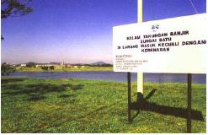
Photo 11.5: Former tin mining ponds will be converted to be full scale flood retention facilities.

11.4.3 Telecommunications and Information Technology System
The availability of high capacity state-of-the-art telecommunications and information systems infrastructure is critical in developing Kuala Lumpur as a financial and commercial centre able to compete technologically with the corporate drawing power of other regional and international centres in the Asia Pacific region. The provision of telecommunications infrastructure in Kuala Lumpur has, to a large extent, kept pace with advances in technology. However, the pace of change is very rapid and it is necessary to coordinate closely with the Malaysian Communication and Multimedia Commission so as to accelerate the provision of an integrated and up-to-date ICT infrastructure.
Policies:
UT 5: CHKL shall, in coordination with the relevant agencies, develop an integrated information communication technology infrastructure for the City as part of the Multimedia Super Corridor.

11.4.4 Water Supply
The unsatisfactory level of water quality and the low water pressure in certain parts of the City are not within the direct responsibility of CHKL. However in order to reduce demand on the water supply system, rainwater and wastewater recycling measures should be implemented.
Policies:
UT 6: CHKL shall implement measures to reduce water demand by encouraging users to install rainwater collection equipment and to recycle wastewater for non-drinking purposes.

11.4.5 Sewerage Reticulation, Treatment and Effluent Discharge
As Kuala Lumpur has become more urbanized, it is increasingly important to improve and extend the centralised sewerage system and eliminate the sewerage oxidation ponds in the City.
Policies:
UT 7: CHKL shall, in consultation with the Federal Department of Sewerage Services and with the co-operation of the sewerage concessionaire, ensure that the sewerage reticulation system is consolidated and oxidation ponds eliminated.
UT 8: CHKL shall require all new housing developments to be connected to the centralised sewerage system.
Lands made available for development from the elimination of oxidisation ponds and other upgrading works shall primarily be used for public purposes.
UT 9: CHKL shall ensure that lands made available from the upgrading of sewerage treatment plants be primarily used for public purposes.

11.4.6 Solid Waste Collection and Disposal
There is a need for a comprehensive solid waste management plan in order to achieve a balanced and sustainable living environment. An important part of this plan which will help to reduce the demand for solid waste disposal facilities, is the present strategy of reduce, recycle and reuse. However, measures must be introduced to improve the effectiveness of this programme.
Policies:
UT 10: CHKL shall, in coordination with the appropriate agencies, promote the strategy of reduce, recycle and reuse of waste products.

11.4.7 Industrial and Clinical Wastes
The centralised collection and disposal of chemical, toxic and clinical wastes is a relatively new development and it is important to ensure that operations are carried out safely and efficiently. Monitoring procedures should be sufficient to ensure that public confidence in these services is not jeopardized.
Policies:
UT 11: CHKL shall support the relevant agency to monitor the performance of the concessionaires involved in the disposal of chemical, toxic and clinical waste to
safeguard public health and public confidence.

11.4.8 Electricity Supply
Electricity generation and distribution capacity in the City is in line with the growth in consumer demand although there is still the need to maintain performance by keeping pace with technological advancements. Transmission reserves provide opportunity for temporary uses.
Policies:
UT 12: CHKL shall allow temporary development within electric transmission reserves in line with the guidelines of Tenaga Nasional Berhad.

11.4.9 Piped Gas Supply
It is desirable that natural gas is provided more extensively to industrial, commercial and residential users as it contributes less to the greenhouse effect and is therefore more environmentally friendly.
Policies:
UT 13: CHKL shall require flatted developments to be installed with gas piping reticulation for piped gas supply.
UT 14: CHKL shall encourage the inclusion of gas piping reticulation in other types of new housing development to allow for piped gas supply.

11.5 FUTURE REQUIREMENTS
The planning of infrastructure and utilities is currently undertaken by independent agencies each of who develop their own master plans and programmes. However, the master planning of infrastructure services should be coordinated according to CHKL’s projections, land use planning and future development. In this way, provision can be made for some land use requirements in respect of particular services such as major utility installation, common pipeline corridors and drainage or flood mitigation reserves.

Housing and Squatters
Section

12.1 Introduction
The residential population of a city is its most important resource and its greatest responsibility. The well being of Kuala Lumpur’s inhabitants is the overriding concern of the city authorities and for that reason; housing has always been an item high on its agenda.
The KLSP 1984 was aimed at ensuring that sufficient housing would be provided for all income groups in the City and that such housing was properly distributed so that its residents could be properly served in terms of infrastructure, utilities and community facilities. The strategy has, for the most part, been successfully implemented but, in line with the vision of A World-Class City, the emphasis will now focus on improving the quality of housing and the housing environment.
Improvements in the housing environment shall include enhancing comfort levels both within and outside housing developments, upgrading the provision of infrastructure, utilities and community facilities to the level of those enjoyed in other world-class cities, and improving the visual appearance of housing developments. Innovative designs, provision of the latest conveniences and facilities, variety of choice, quality of finish and attractiveness of layout, shall become priority concerns.
Much of the City’s older housing stock is in varying states of disrepair. Neglect, poor maintenance and poor construction have all contributed to declining visual amenity in various parts of the City. Upgrading and redevelopment programmes shall be initiated to improve the standards and environmental quality of existing housing stock whether private or public.

Housing and Squatters
Section

12.2 EXISTING SITUATION AND ISSUES

12.2.1 Housing Quality
a) Quality of the Housing Environment
(i) Existing situation
The quality of the housing environment has improved greatly in recent years in the newly developed housing areas such as Damansara, Bangsar, Wangsa Maju, Ampang and Taman Tun Dr Ismail.
However, many of the older private housing estates, for example Taman Setapak Jaya, Taman Kok Doh, Taman Bullion, Batu Housing Estate and Taman Sri Rampai, are still lacking in the provision of basic facilities and landscaped areas.
Social problems associated with very high-density living have led to vandalism and a lack of community concern over the upkeep of these areas which has in turn exacerbated environmental problems.
(ii) Issues
• Poor quality of external environment in older housing estates; and
• Social and environmental problems related to very high-density living.
The level of maintenance in some private developments, especially in private flatted housing, leaves much to be desired. Insufficient funds are directed towards essential maintenance and replacement leading to a loss of visual and environmental amenity.
• Poor maintenance of private flatted housing.
(ii) Issues
Space standards are still low when compared to other developed or developing countries and will certainly continue to be revised upwards as income levels increase.
• Space standards for low cost housing are low.
The standards of provision of facilities and utilities in low cost housing such as children’s playgrounds, reading rooms, community facilities and open space are inadequate to meet the needs of the residents.
• Under provision of public facilities within low cost housing areas.
b) Low Cost and Public Housing Standards
(i) Existing Situation
Basic standards in low cost housing are determined on a nation wide basis and are applied by CHKL, as elsewhere, with little deviation. Space standards for low cost housing have been recently revised from a minimum of 60 square metres to 65 square metres per unit. The maximum builtup area for low cost housing development is set at 70 percent leaving the remaining 30 percent for utilities and public facilities, while maximum densities have been set at 150 people per hectare.
Car parking provision for low cost housing has recently been revised based on one parking lot for every four housing units. This provision is not sufficient and create prominent problems on shortage of car parking spaces in these areas.
• Shortage of car parking spaces in low cost housing areas.
Maintenance procedures for public housing are reactive rather than preventive leading to wastage of resources and consequently higher maintenance costs. This problem is exacerbated as costs escalate when the buildings get older.
• High maintenance costs for public housing.
A major contributor to high maintenance costs in public housing is the use of cheap low quality materials and poor construction.
• Poor quality of construction and materials in low cost housing developments.
c) Temporary Housing: Squatters and Long
Houses
(i) Existing Situation
The squatter survey carried out in 1998 indicated that there were 197 squatter settlements in Kuala Lumpur occupying about 645 hectares. From 1992 to 1998 there was a reduction of about 32.4
percent in the squatter population (refer Figure 12.1). The reduction was largely due to intensive action taken by government agencies to build more low cost housing through privatisation and redevelopment programmes.
However, there are still some residual squatter settlements whose presence in the City is unacceptable for many reasons. They are characterised by unacceptable environmental conditions, high fire risks and a general lack of hygiene. In addition, many are located close to or along strategic routes or beside rivers thus marring the image of the City and causing river pollution.
Figure 12.1: Squatter, 1992-1998
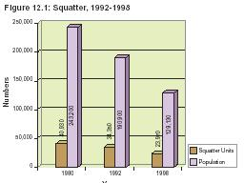
(ii) Issues
• The presence of squatter settlements in the City is unacceptable.
Long houses, such as those at Kerinchi, Cheras and Setapak, were originally provided in order to house people displaced by development projects until they could be rehoused in permanent accommodation. These temporary dwellings, some of which are now over 15 years old, lack basic facilities and are still in use as transit accommodation.
• Temporary houses are poor in quality and lack basic
d) Dilapidated Housing
(i) Existing Situation
About 5.5 percent of the existing housing stock was built in the sixties or seventies and much of it is dilapidated and in need of replacement. Apart from being in a very poor state of repair, these dilapidated housing areas lack basic facilities.
(ii) Issues
• Poor environmental condition of dilapidated housing.
The majority of dilapidated housing is located in the City Centre, for example Selangor Mansions and Malayan Mansion in Jalan Masjid India, Tuanku Abdul Rahman Flats in Jalan Tun Razak and Tan Cheng Lock Mansion and Selayang Flats in Chow Kit. Their continued existence in the City Centre is an uneconomical use of prime land and severely detracts from the image of the City.
• Many of the dilapidated housing areas especially low cost housing are located in strategic areas in the City Centre.
A number of houses in the Malay Reservation Areas, traditional kampungs and new villages are built on lands with multiple-ownership. These houses are often built without obtaining appropriate approvals and do not comply with planning or building standards. • Houses built on multiple-ownership lands frequently do not comply with planning standards. Much of the old government and institutional housing for public sector employees are dilapidated or located in flood prone areas and require replacement.
• Dilapidated state of older institutional housing.

12.2.2 Housing Provision by Type
a) Housing Stock
(i) Existing Situation
Between 1980 and 2000 the housing stock grew by an average of about 10,000 additional units per annum (refer Figure 12.2).
There is a slight overall shortfall in housing provision of 20,600 units if temporary housing is not taken into consideration.
Figure 12.2: Housing Growth in Kuala Lumpur, 1980-2000
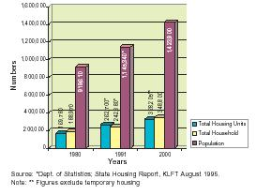
(ii) Issues
• Deficit in housing provision.
b) Housing Supply and Demand
(i) Existing Situation
Types of housing are divided into three broad categories, namely low cost, medium cost and high cost.
Medium and high cost housing is entirely produced by the private sector, while low cost housing is mainly provided from government housing programmes and from the 30 percent low cost housing quota imposed on private developers constructing new housing developments.
Table 12.1 shows a comparison between the existing housing supply by type and a projection of the effective housing requirement based on the relative household income levels of the City’s residential population.
Table 12.1: Existing and Required Housing, 2000
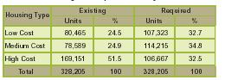
In 2000 there was a significant shortage of low and medium cost units and a corresponding oversupply of high cost units. The deficit in low cost housing will be offset by on-going low cost housing programmes which will make available a total of 56,953 units by the year 2005 (refer Table 12.2).
Table 12.2: Low Cost Housing Programme, 2000
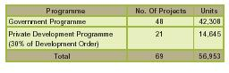
The shortfall in housing for the middle-income groups is especially of concern. Many of the people who fall into this category form a large part of the City’s workforce and are essential for the functioning of the its businesses and commerce.
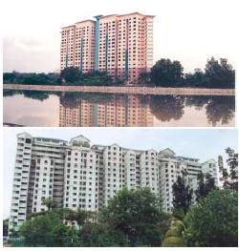
Photo 12.1: The deficit in low cost housing will be offset by on-going low cost housing programmes ...
There has already been significant out-migration of the middle-income population to more affordable housing outside the City boundary, which has contributed to increased traffic demand to and from the City Centre.
(ii) Issues
• Shortfall in the supply of medium cost housing.
c) Public Housing
(i) Existing Situation
Since about 8.1 percent of households are unable even to purchase low cost housing, CHKL supplies public housing for rental at subsidised rates. Currently there are 32,000 units of public housing in Kuala Lumpur.
(ii) Issues
• A significant percentage of the City’s population is unable to afford low cost housing.
d) Housing for Special Needs Groups
(i) Existing Situation
At present two homes for the aged have been built through private agencies and CHKL are planning to construct one more as well as two youth hostels, one in Gombak and the other in Chan Sow Lin. There is, however, a pressing need to provide more housing accommodation for special needs groups such as the physically disabled, the aged, single mothers and young single men.
(ii) Issue
• Inadequate provision of housing for special needs groups.
e) Housing for Public Sector Employees
(i) Existing Situation
The cost of private rental housing in Kuala Lumpur is very high in comparison with the rest of the country, and far exceeds housing allowances made available to public sector employees. Consequently many are obliged to rent substandard accommodation or to find alternative accommodation outside the City.
In order to provide for this housing need, 79,064 units of subsidised housing for public sector employees is provided by the government departments concerned. However, there is an insufficient amount of such housing to meet current needs.
(ii) Issues
• Lack of affordable accommodation for public sector employees.
Much of the housing for public sector employees is low density and the government land on which it is built is under-utilised.
• Under-utilisation of government land used for housing for public sector employees.

12.2.3 Distribution of Housing
a) Distribution of Housing by Type
(i) Existing Situation
Table 12.3 and Figure 12.3 indicate the distribution of housing types in the City. Housing is generally evenly distributed throughout the City with the notable exception of Damansara where there is no low cost housing and Bandar Tun Razak which contains a disproportionately high number of low cost housing units.
Table 12.3: Distribution Of Housing by Type, 2000
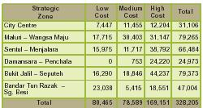
There are also 7,447 low cost housing units in the City Centre most of which are in a dilapidated state and which occupy land in prime areas. This issue is highlighted inparagraph 12.2.1d above.
(ii) Issues
• Uneven distribution of housing by type.
b) Housing in the City Centre
(i) Existing Situation
In parallel with the decline of the City Centre residential population, there has been a commensurate drop in residential land area from 523 hectares in 1980 to 288 hectares in 2000.
The decline in residential land use in the City Centre is due to the redevelopment of some of the older housing areas into offices and other commercial uses. In addition to the areas of dilapidated housing in the City Centre, there are many older, low density housing areas occupying land which has a high potential commercial value. Pressures will remain on these remaining pockets of residential land to convert to more profitable land use, which, in turn, could lead to a further reduction in the inner city residential population.
(ii) Issues
• Decreasing residential land use in the City Centre; and
• Pressure on remaining residential land in the City Centre to convert to commercial usage.
c) Housing along Major Roads
(i) Existing Situation
In certain areas of the City where housing has been built facing major roads, there is pressure to change the usage from residential to commercial. This kind of ribbon development is undesirable as it leads to uncontrolled commercial development that can adversely affect the City’s planned intentions.
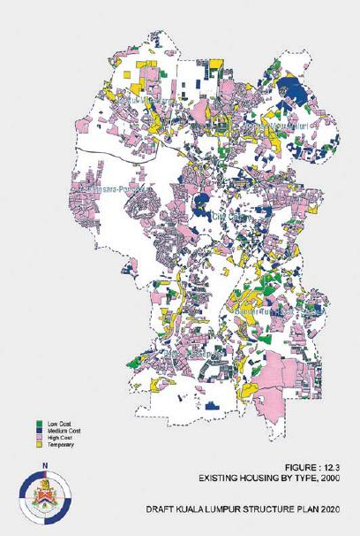
(ii) Issues
• Pressures for commercial development on housing areas facing major roads.
d) Housing Density
(i) Existing Situation
CDP 1040 and the Density Rules of 1985 determine housing densities. The density range used by the plan is between 4 persons per hectare (pph) to 162 pph and an average density of 24 pph is applied to all areas outside the original 93 square kilometre area of Kuala Lumpur.
Although they are now as ubiquitous as conventional housing, condominiums were a relatively new concept at the time that the original housing densities were determined. As a consequence of the growth in the number of condominium developments, densities in housing areas have increased and are no longer consistent.
(ii) Issues
• Current housing density guidelines are outdated.

Housing and Squatters
Section

12.3 OBJECTIVES
To enhance the City’s living environment, CHKL aims to:
• Improve the quality of housing and housing environment;
• Revitalise the City Centre by increasing the residential population; and
• Eradicate substandard housing.
For Kuala Lumpur to create an Efficient and Equitable City structure, CHKL aims to:
• Ensure sufficient housing to meet the demands of all income groups.

Housing and Squatters
Section

12.4 POLICIES AND PROPOSALS

12.4.1 Housing Quality
a) Quality of the Housing Environment
Good quality housing is a combination of many aspects of housing development. Design and layout, environmental responsiveness, the quality of workmanship and materials, the provision of utilities and facilities, landscaping, maintenance and upgrading, all play a part in the total housing environment. CHKL shall encourage and work with the private sector to raise overall standards of housing in all of these areas so as to produce housing of the highest quality.
The quality of the housing environment extends beyond the boundaries of individual residential developments. Careful attention should be paid to the external environment within private developments and also to the external appearance and environment immediately outside including the manner in which developments relate to their immediate surroundings. Housing developments should seek to be compatible with their surroundings, maintain connections, enhance the public spaces which they adjoin and optimise the spaces between developments. CHKL shall play an active role in ensuring that developers observe their responsibilities to the total city environment when planning housing developments.
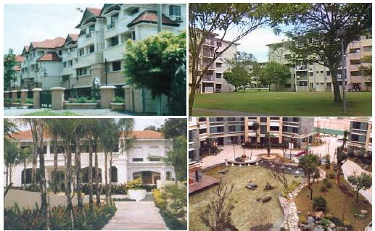
Photo 12.2: Design and layout, environmental responsiveness, the quality of workmanship and materials, the provision of utilities and facilities, landscaping, maintenance and upgrading, all play a part in the total housing environment.
Policies:
HO 1: CHKL shall encourage responsible parties in the housing sector to develop good quality housing and living environments.
The private sector shall be encouraged to investigate new forms of housing which can offer a wider choice of lifestyle. Entirely new concepts or hybrids could be developed that combine the attractions of different existing housing types.
HO 2: CHKL shall encourage the private sector to develop a wider choice of innovative housing.
Building owners and management corporations shall be educated in the benefits of regular maintenance and upgrading schedules. In the older housing areas which have fallen into disrepair, measures need to be initiated to upgrade them to acceptable standards.
HO 3: CHKL shall, together with responsible parties in the housing sector, develop and implement measures to upgrade the quality of existing old housing stock.
Where necessary, CHKL shall implement additional measures to improve the condition and external appearance of private flatted housing estates that do not meet minimum required standards.
HO 4: CHKL shall implement measures to ensure that all private flatted housing estates are properly maintained.
b) Low Cost and Public Housing
In view of the likelihood that minimum space standards for low cost housing shall continue to be improved, provision shall be made in the design of such developments to permit an increase in space standards without the need for costly redevelopment.
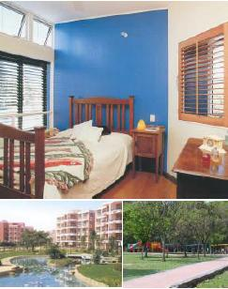
Photo 12.3: The standards of finishes and fittings in low cost housing developments shall be improved, as will the standards of provision of amenities and facilities such as play areas, car parking and public community facilities.
The standards of finishes and fittings in low cost housing developments shall be improved, as will the standards of provision of facilities such as play areas, car parking and public community facilities.
Policies:
HO 5: CHKL shall upgrade the minimum standards of low cost housing.
The external environment of low cost housing shall be improved by means of additional landscaping areas, improved standards of external finishes, provision of covered walkways as well as the repainting or, where required, retrofitting of existing facades.
HO 6: CHKL shall implement measures to improve the environmental quality of low cost housing
On-going regular maintenance, including preventive maintenance and periodic replacement of building elements and components, shall be properly budgeted for and comprehensive maintenance schedules devised for all public housing. Periodic upgrading to improve the standard of facilities in public housing estates shall also be planned and budgeted for.
HO 7: CHKL shall develop and implement maintenance and upgrading schedules for public housing.
CHKL will undertake an in depth and continuing review of materials, components and best practice standards used in the construction of public housing in order to reduce overall life cycle costs.
HO 8: CHKL shall review standards of construction, material and services for public housing.
c) Temporary Housing
Various programmes have been planned and implemented which are, at least in part, directed towards the elimination of squatter settlements in the City. Sufficient housing for the rehousing of squatters shall be in place before 2005.
Policies:
HO 9: CHKL shall eradicate all squatter settlements and long houses.
d) Dilapidated Housing
Appropriate action to improve or redevelop dilapidated housing areas shall be determined depending on the condition and location of the areas in question. CHKL will ensure that the owners of privately owned dilapidated housing areas take prompt and appropriate action to improve or redevelop their properties, and, where necessary, will become directly involved in the regeneration of such areas.
CHKL shall ensure that redevelopment of dilapidated housing areas in the City Centre incorporates a significant residential component.
Policies:
HO 10: CHKL shall encourage the improvement and redevelopment of dilapidated housing areas.
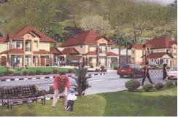
Photo 12.4: Appropriate action to improve or redevelop dilapidated housing areas ...

12.4.2 Housing Provision
a) General
The decision as to whether to live inside or outside the City boundary should be one of choice rather than necessity resulting from a shortage of appropriate housing. It remains, therefore, CHKL’s basic responsibility to ensure that there is an adequate mix of housing that meets the needs of its population and is commensurate with the City’s income distribution.
Policies:
HO 11: CHKL shall ensure that there is sufficient affordable housing available to meet the needs of the population.
b) Low and Medium Cost Housing
CHKL shall take appropriate measures so that more medium cost housing units are provided. Appropriate incentives shall be provided to the private sector that will make the construction of high density medium cost housing in areas close to transit terminals cost effective.
Policies:
HO 12: CHKL shall encourage the building of medium cost houses.
Low medium cost housing, defined as costing between RM43,000 and RM85,000 at 2002 prices shall make up 15 percent of future housing. Since the requirement of low cost housing in the City is adequately covered by planned or on going programmes, the 30 percent low costhousing quota provision will be revised to reduce the composition of low cost houses to 25 percent. The guidelines of the quota system shall also be revised so that in certain cases, where there is unlikely to be a demand for low or low medium cost housing in certain private housing developments, CHKL may permit developers to build their quota in appropriate locations elsewhere.
HO 13: CHKL shall review the conditions of the low cost housing quota placed upon private housing development.
c) Public Housing
As land costs and, therefore, housing costs continue to rise in Kuala Lumpur, there will continue to be a section of the population who are unable to afford low cost housing. At least in the foreseeable future, therefore, there shall be a need for CHKL to provide public housing for rental at subsidised rates.
Policies:
HO 14: CHKL shall continue to provide housing for rental at subsidised rates.
d) Housing for Special Needs Groups
CHKL shall liase with the relevant agencies and the private sector in order to assess the housing requirements of special needs groups such as the physically disabled, the aged and single mothers. Appropriate land or floor space shall be set aside for such housing and CHKL shall encourage the private sector to participate in their provision. Hostels to house unmarried
youths shall also be provided as required.
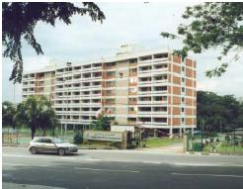
Photo 12.5: Hostels to house unmarried youths ...
Policies:
HO 15: CHKL shall, together with the relevant agencies and the private sector, ensure the adequate provision of housing for special needs groups.
e) Housing for Public Sector Employees
Sufficient land shall be allocated in convenient locations within the City to enable government agencies to provide affordable housing for their public sector employees. In addition, existing under- utilised government land used to house public sector employees shall be optimised to provide higher density housing.
Policies:
HO 16: CHKL shall, together with the relevant agencies and the private sector, ensure the adequate provision of affordable housing for public sector employees.
HO 17: CHKL shall encourage the redevelopment of under-utilised government land to provide high density housing for public sector employees.

12.4.3 Distribution of Housing
a) Distribution of Housing by Type
Housing shall be distributed by type throughout the City as evenly as possible and in a manner that is consistent with the development strategies. The strategic zone of City Centre, Damansara-Penchala and Bukit Jalil- Seputeh, of which the major parts are designated as International Zones, will have a preponderance of medium and high cost housing, although there will be some intensification of low cost housing in locations that do not conflict with the strategy. In the remaining strategic zones housing shall be evenly distributed by type so as to reflect a proper population balance.
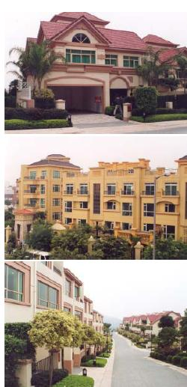
Photo 12.6: Housing shall be distributed by type throughout the City ...
Policies:
HO 18: CHKL shall ensure the proper distribution of housing units by type.
b) Housing in the City Centre
In order to attract more people to live in the City Centre, housing should be developed that capitalises on the opportunities offered by its unique location such as the availability of convenient public transport and proximity to the main business districts and shopping and entertainment centres. CHKL shall encourage the development of inner city housing by private developers. Mixed commercial and residential developments that contain a large quantum of medium and high cost housing shall be promoted with special emphasis on those near to transit terminals.
In line with the strategy to enhance the business, working and living environment of the City Centre, the quality of low cost houses and low cost housing environment in the City Centre shall be improved.
Policies:
HO 19: CHKL shall implement measures to increase the number of medium and high cost residential units in the City Centre.
HO 20: CHKL shall improve the quality of low cost houses and low cost housing environment in the City Centre.
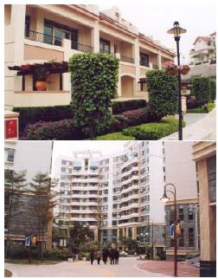
Photo 12.7: ... to increase the number of medium and high cost residential units in the City Centre.
c) Housing Density
Housing densities shall be reviewed to be consistent with the development strategies. Specifically, high-density residential and mixed residential/commercial development shall be encouraged near to rail terminals and low or medium densities determined for designated International Zones.
Low densities in specified high quality residential areas shall be maintained especially where these areas contribute to the green network. In other stable housing areas, existing densities will largely be retained.
Policies:
HO 22: CHKL shall discourage existing residential usage along major roads from changing to commercial usage except in certain designated areas. Policies:
HO 21: CHKL shall review housing densities to be consistent with the development strategies.
d) Existing Housing along Major Roads
In order to avoid the creation of uncontrolled ribbon development in a manner that conflicts with the development strategies, CHKL shall discourage the conversion of residential to commercial use along major roads except in certain designated areas where special circumstances warrant such a relaxation.
Photo 12.8: ... conversion of residential to commercial use along major roads ...
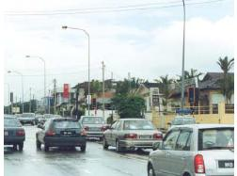
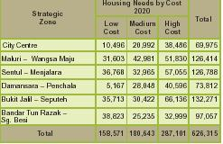

12.5 FUTURE REQUIREMENTS
Housing projections are based on the 2020 target population of 2.2 million. The distribution of housing reflects the strategies to increase the population of the City Centre and the preservation of Damansara-Penchala as a predominantly low density, high-class residential area in keeping with its status as an International Zone. In line with the overall strategy, housing shall be distributed evenly throughout the remaining four strategic zones.
Table 12.4: Total Housing Needs, 2020 Housing Needs by

