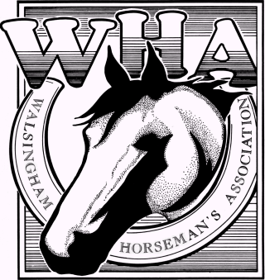
WAIVER & RELEASE
WARNING: Under Florida Law, an equine activity sponsor or equine professional is not liable for an injury to, or the death of, a participant in equine activities resulting from the inherent risks of equine activities.

I agree to abide by the WHA, Pinellas County show rules and understand that my privileges as an exhibitor and participant may be revoked if those rules are not followed.

I do hereby, for myself, my heirs, executors and assigns, waive, release and forever discharge any and all rights and claims for damages which I may have or hereinafter accrue against The Walsingham Horseman’s Assoc., it’s show managers, board members, members, officers, agents, volunteers, etc., and/or Pinellas County, it’s officers, agents, etc. for any damages which may be sustained by me in connection with my equestrian activities.

I have read & understand the above warning. I am in agreement with this release and waiver, which shall remain in effect for one year.

Date: ____________________ Exhibitor’s Name (Print): __________________________________

Exhibitor/Guardian Signature: ________________________________________________________
(Parent/Guardian must sign if participant is under 18)

Printed Name of Parent/Guardian: ______________________________________________________

-----------Cut Here-----------------------Cut Here-------------------------Cut Here-------------------------------

WAIVER & RELEASE
WARNING: Under Florida Law, an equine activity sponsor or equine professional is not liable for an injury to, or the death of, a participant in equine activities resulting from the inherent risks of equine activities.

I agree to abide by the WHA, Pinellas County show rules and understand that my privileges as an exhibitor and participant may be revoked if those rules are not followed.

I do hereby, for myself, my heirs, executors and assigns, waive, release and forever discharge any and all rights and claims for damages which I may have or hereinafter accrue against The Walsingham Horseman’s Assoc., it’s show managers, board members, members, officers, agents, volunteers, etc., and/or Pinellas County, it’s officers, agents, etc. for any damages which may be sustained by me in connection with my equestrian activities.

I have read & understand the above warning. I am in agreement with this release and waiver, which shall remain in effect for one year.

Date: ____________________ Exhibitor’s Name (Print): __________________________________

Exhibitor/Guardian Signature: ________________________________________________________
(Parent/Guardian must sign if participant is under 18)

Printed Name of Parent/Guardian: ______________________________________________________

