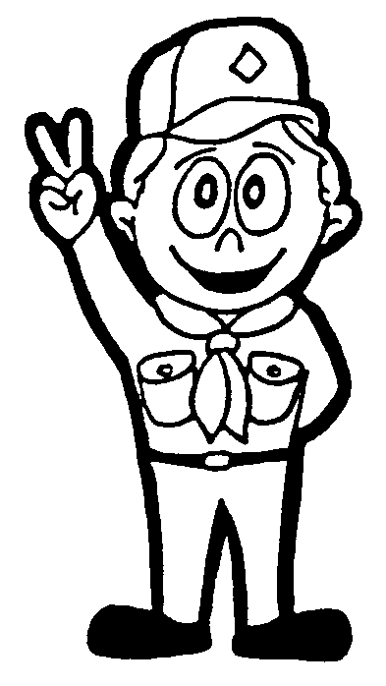

Brewster Pack 1
RULES AND REGULATIONS

- Uniforms must be worn to all Pack Meetings, unless otherwise stated. Uniforms should be worn to all Den meetings, unless otherwise stated by the Den Leaders Inspections may be made.

- Cubs are expected to attend all Pack Meetings, with at least 1 adult family member. These meetings are a very important part of the Cub Scout program, and should be viewed as such. Parents are expected to control their children at Pack Meetings and other functions. Families may bring siblings or other relatives to Pack meetings, as long as they do not disrupt the meeting.

- During Pack meetings all Cubs and siblings MUST remain in the Cafeteria. Cubs and siblings must be
accompanied to the restrooms by an adult. We have had problems in the past with children playing in the
halls and disturbing other groups using the school. If we do not abide by this rule, we are subject to losing
our privilege of being here.

- Cubs and siblings are not permitted to play with school equipment in the Cafeteria. They are also not permitted to climb on tables or counter tops. We are responsible for leaving the room as we found it.

- If parents cannot attend the Pack meetings, they must at least enter the cafeteria to drop off and pick up their Cubs. No child will be allowed to wait or play in the parking lot.

- We are all VOLUNTEERS in the Cub Scouting program. We are NOT BABY-SITTERS. Our leaders should be treated with the same respect as the teachers in this school are. We expect your boys to follow our rules and regulations to the best of their ability. If a Cub proves to be a disciplinary problem, as determined by the Den leaders, and Cubmaster, his parents will notified. If the problem cannot be resolved, the Cub will be asked to drop out.

- At least 2 leaders, or 1 leader and another Parent, must be present at all Cub group activities, ie: Pack meetings, Den meetings, and outings. This is a rule set by the Boy Scouts of America. It is designed for the safety of the boys, as well as the adults.

- It is the policy of the Boy Scouts of America that the use of alcoholic beverages and controlled substances are not to be permitted at any activities involving participation of youth members. Leaders and Parents are strongly encouraged not to use tobacco products in any form nor allow their use at scouting activities.

Cub Scout __________________________________________________

Parent ____________________________________________________

Please sign and return to your Den Leader

