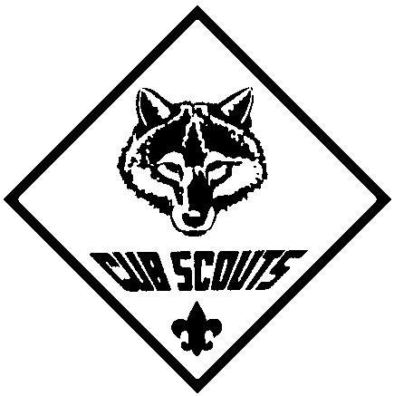
BREWSTER PACK 1
WE MAKE IT FUN
BREWSTER PACK 1
WE MAKE IT FUN
BREWSTER PACK 1 T-SHIRT ORDER FORM
PLEASE MAKE CHECKS PAYABLE TO BREWSTER PACK 1

Cub Scout’s Name: ______________________ Cub Parent’s Name _________________________
Den #_______ Phone #: ( ) _______ -_______

All shirts are Royal Blue with our Pack 1 logo in Gold. We will be purchasing these shirts in a bulk order. All Youth Shirts run small. Go for the larger size, the boys will be wearing them for several years. All orders forms must be in by the November Pack Meeting.

Youth Hanes Beefy-T $9.00 ea. M ____L ___ Adult S (fits 12/14)_____ Total $_______
100% Cotton

-------------------------------------------------------------------------------------------------------------------------------------
Adult Hanes Beefy-T $9.00 ea. S____ M____ L____ XL____ Total $_______
100%Cotton. 2X ($11.00/ea)____ 3X ($12.00/ea)____
-------------------------------------------------------------------------------------------------------------------------------------

Adult Golf Shirts $11.75 ea. S____ M____ L____ XL____ Total $_______
Red Eagle 100% Cotton 2X ($13.75/ea)____ 3X ($14.75/ea)____
-------------------------------------------------------------------------------------------------------------------------------------

Youth Sweatshirts $13.50 ea. M (fits 6/8)____L (fits 8/10)___ Adult S (fits 12/14)_____ Total $_______
FTL 90% Cotton
-------------------------------------------------------------------------------------------------------------------------------------
Adult Sweatshirts $14.50 ea. S____ M____ L____ XL____ Total $_______
FTL 90% Cotton 2X ($16.50/ea) ____ 3X($17.50/ea) ____

TOTAL ORDER $__________

