k | 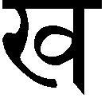kh | 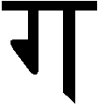g | 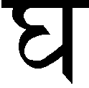gh | 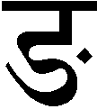ng
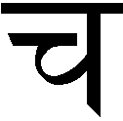c | 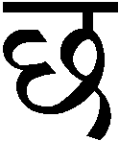ch | 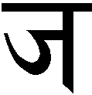j | 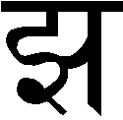jh | 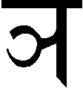ny
t’ | 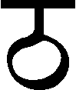th’ | 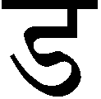d’ | dh’ | 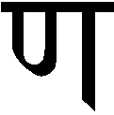nn
t | 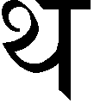th | d | dh | 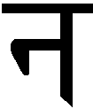n
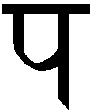p | 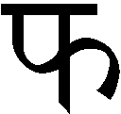ph | b | 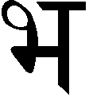bh | 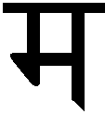m
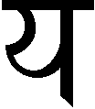y | r | 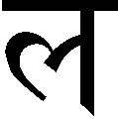l | v
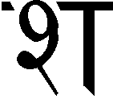sh | sh | s | 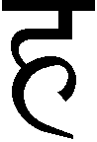h
•  -n | -n | 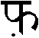  f | 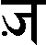  z

 | initial  short vowels | initial  long vowels | short vowels | long vowels | examples
a | 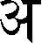  a |   – |  | – | pa | 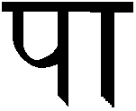  p–
i | 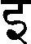  i | 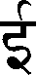  – |   i |   – | 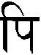  pi | 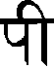  p–
u | 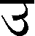  u | 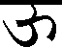  – | u | – | 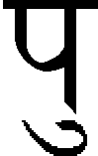  pu | 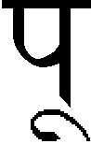  p–
e | e |   – | e | – | 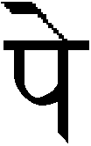  pe | 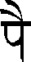  p–
o | 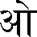  o | 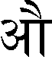  – |   o | – | 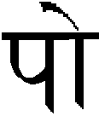  po | 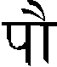  p–
ri | 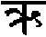  ri |  |  |  | pri

k | + | y | = | 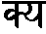  ky | k | + | sh | = |   ksh | kh | + | y | = | 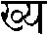  khy
g | + | v | = | 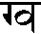  gv | gh | + | b | = | 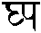  ghp | c | + | c | = | 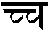  cc
ch | + | y | = | 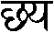  chy | j | + | j | = | 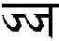  jj | t’ | + | t’ | = | 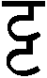  t’t’
t’ | + | r | = | t’r | t’h | + | t’h | = | 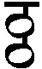  t’ht’h | d’ | + | d’ | = | 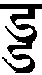  d’d’
nn | + | t’ | = | nnt’ | t | + | k | = | 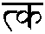  tk | t | + | t | = | 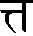  tt
t | + | r | = | 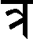  tr | d | + | d | = | dd | d | + | dh | = |   ddh
d | + | m | = | 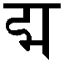  dm | d | + | y | = |   dy | d | + | v | = |   dv
dh | + | v | = | 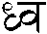  dhv | n | + | th | = | 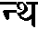  nth | p | + | p | = | 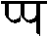  pp
ph | + | y | = | 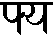  phy | b | + | d | = | 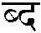  bd | b | + | r | = | br
bh | + | y | = | 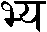  bhy | m | + | n | = | 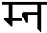  mn | r | + | m | = | rm
r | + | u | = | 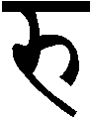  ru | r | + | – | = | 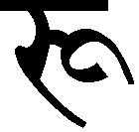  r– | l | + | m | = | 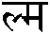  lm
v | + | k | = | 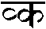  vk | sh | + | y | = | 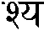  sy | sh | + | r | = | 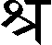  shr
sh | + | t’ | = |   sht’ | s | + | k | = | 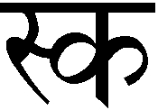  sk | h | + | m | = | 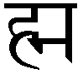  hm

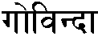  Govind– | 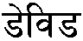  D’evid’ (David) | 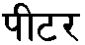  P–t’ar (Peter) | 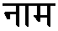  n–m (name) | 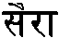  S–r– (Sarah)
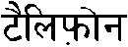  t’–lifon (telephone) | 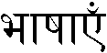  bh–sh–en (languages) | 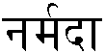  Narmad– | 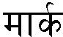  M–rk | 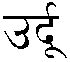  Urd–
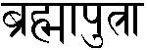  Brahm–putr– | 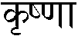  Krishnn– | 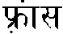  Fr–ns (France) | 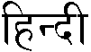  Hind– | 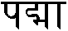  Padm–

