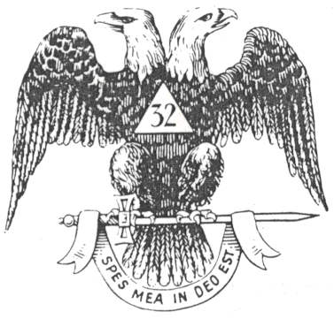
PRIDE of the MEDITERRANEAN CONSISTORY #350

Valley of Italy

“Strength in Numbers”

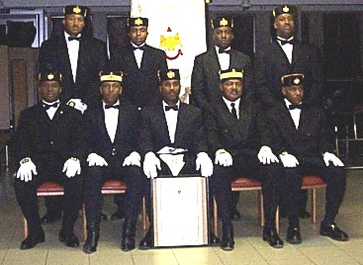

Pictured: Seated L – R:1LT Johnnie Gatlin, GIG Stephen Tavares, CIC Rodney Tremble, GIG Alfred Meyers, 2LT Jarret Frederick
Standing L – R: KOSA Muhammad Bilal, Prince Keith Donnell Allen, Prince Giovanni Robinson, Prince Reggie Brown

Not Pitcured: GIG Hess, GIG Jones, GIG Kenner, GIG Washington, Past CIC Harris, Past CIC Brown, Prince Benjamin, Burgess, Prince Campbell, Prince Carpenter, Prince Carrion, Prince Clark, Prince Davis, Prince Dennison, Prince Devine, Prince Dillard, Prince Dunn, Prince Felton, Prince Fikes, Prince C. Green, Prince D. Green, Prince Gutierrez, Prince Hall, Prince Harrison, Prince Heard, Prince Howard, Prince Jackson, Prince James, Prince Koch, Prince Luther, Prince Mayes, Prince Mitchell, Prince McCleod, Prince McKay, Prince Morris, Prince Odrick, Prince Palmer, Prince Patrick, Prince Prytula, Prince Stewart, Prince Sumrall, Prince Taylor, Prince Webb, Prince Washington, Prince Whitlock, Prince Yancey

