Essay Title

Britain's Practical Revolutionaries: Syndicalism in Theory and Practice, 1910-1920

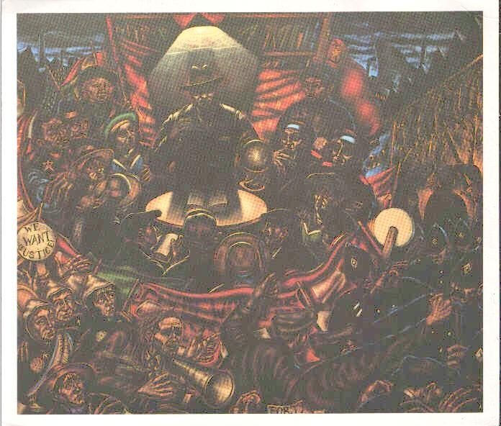

My name William L. Whitehead

My dept. History/Politics

Course tutor’s name Dr. Sue Pryce

Official module title Politics Dissertation - B

Word count 10,873

Date of submission May 2000

