The Second Political Party System (1828-1860). Presidential Elections.

1824—Andrew Jackson (Tenn.—Dem.), John Quincy Adams (Mass.—Natl Rep.).
1828—Andrew Jackson (Tenn.—Dem.), John Quincy Adams (Mass.—Natl Rep.).
1832—Andrew Jackson (Tenn.—Dem.), Henry Clay (Ky.—Whig), William Wirt (Md.—Anti-Masonic).
1836—Martin Van Buren (N.Y.—Dem.), William Henry Harrison (Ohio—Whig.).
1840—Martin Van Buren (N.Y.—Dem.), William Henry Harrison (Ohio—Whig, with John Tyler Va.—Dem), James G. Birney (Ky.—Liberty.).
1844—James Knox Polk (Tenn.—Dem.), Henry Clay (Ky.—Whig), James G. Birney (Ky.—Liberty.).
1848—Lewis Cass (Mich.—Dem.), Zachary Taylor (La.—Whig), Martin Van Buren (N.Y.—Free Soil), Gerrit Smith (N.Y.—Liberty League.).
1852—Franklin Pierce (N.H.—Dem.), Winfield Scott (La.—Whig), John P. Hale (N.H.—Free Dem.).
1856—James Buchanan (Pa.—Dem.), Millard Fillmore (Pa.—American), John C. Fremont (Ca.—Republican).

Dominant Political Party. Democratic. Leadership base. The Cotton South and infrastructuring linking it to the Transatlantic Industrial Revolution. Ideology. Opportunity, mobility, agrarian paternalism, Indian extermination or removal.
Major Oppositional Political Party. National Republicans, later called Whigs. Leadership base. Northeastern mercantile interest, allied to western interest in “development.” Ideological Variant. commercialism, manufactures
Major Issues. Domestic—Government fosters business through the establishment of banks and chartering companies. National Republican/Whig proposal of an “American system” involving use of protective tariffs to foster development of infrastructure. Democrats denounce “monopoly” of banks and chartered companies (favoring different companies), oppose tariffs, etc. Foreign—Democrats priority on militant expansionism as “Manifest Destiny,” even over constitutional restraints.
Major unaddressed questions. Slavery; Capitalism, Secret societies. Insurgent currents. Local Libertymen, Workingmen, Loco-foco, Antirenter, Nativism

Interim. Presidential Elections.1860—Stephen A. Douglas (Ill.—Dem), John C. Breckenridge (Ky.), John Bell (Ky.), Abraham Lincoln (Ill.—Rep.). 1864—George C. McClellan (N.J.), Abraham Lincoln (Ill.—Rep.).

Figures.

Charles G. Finney
Daniel Webster (Mass.—Whig)
Denmark Vesey
Frederick Douglas
George Henry Evans
Henry Clay (Ky.—Whig)
Henry David Thoreau
Horace Greeley
John C. Calhoun (S.C.—Dem.)
John Commerford
John Ross
Nat Turner
P.T. Barnum
Ralph Waldo Emerson
Thomas Hart Benton (Mo.—Dem.)
William Lloyd Garrison
William Walker
Winfield Scott

Political Issues.

Supreme Court Decision Gibbons v. Ogden (1824) defines the regulation of commerce as a Federal responsibility.
Maysville Road Bill and veto (1830)
Veto of charter of the Second Bank of the U.S. (1832)
Specie Circular Act (1836) responds to inflation by requiring the use of gold or silver to purchase public lands.
National Banking Bill (1841), Whig measure vetoed by Tyler

Succession of Sectional clashes.

Missouri Compromise (1820-21)
The "Tariff of Abominations" (1828).
South Carolina's Nullification Proclamation (1832)
Force Bill (1833)
Liberator (1831) and American Anti-Slavery Society (1833)
Congressional “Gag Rule” (1836)
Murder of Elijah Lovejoy at Alton, Illinois (1837).
Methodist Episcopal and Baptist churches split (1844-45)
Compromise of 1850
Kansas-Nebraska Act (1854)
Dred Scott decision (1857)

Foreign Policy & “Manifest Destiny”.

First American community in Texas (1822)
Monroe Doctrine (1823)
Mexican independence from Spain (1824)
Worcester v. Georgia (1832) [Cherokee case]
Texas War for Independence (1835-37)
Patriot War in Canada (1837-38), US future ambitions settled with the Webster-Ashburton Treaty (1842)
Philadelphia Bible Riots (1844).
Statehood for Texas postponed (1837-1844)
Oregon boundary with British Canada settled (1846)
War with Mexico (1846-48)
The Bear Flag Republic (1846)
Mormons establish state of Deseret (1847).
Treaty of Guadalupe Hidalgo (1848)
“Gold Rush” in California (1849)
Gadsden Purchase (1853)
Ostend Manifesto (1854).
Filibusterers Nicaragua (1854), reintroduces slavery there. (1854)

Note. You are expected to know more than is on this sheet, specifically, the significance of these items. When asked, you should know generally why each of these items is here (the who, what, when, where, of context).

Population. Est. 1776.—3 million in 13 colonies. 1830.—13 million in 28 states and territories. 1840.—17 million in 30 states. 1850.—23 million in 36 states and territories. 1860.—31 million in 33 states and territories. 2000.—281 million.

States. The original 13 states: Delaware, Pennsylvania, New Jersey, Georgia, Connecticut, Massachusetts, Maryland, South Carolina, New Hampshire, Virginia, New York, North Carolina, Rhode Island. States admitted before 1824: Vermont, Kentucky , Tennessee, Ohio, Louisiana, Indiana, Mississippi, Illinois, Alabama, Maine, Missouri. States admitted 1824-1861:

25. Arkansas (1836).
26. Michigan (1837).
27. Florida (1845).
28. Texas (1845).
29. Iowa (1846).
30. Wisconsin (1848).
31. California (1850).
32. Minnesota (1858).
33. Oregon (1859).
34. Kansas (1861).

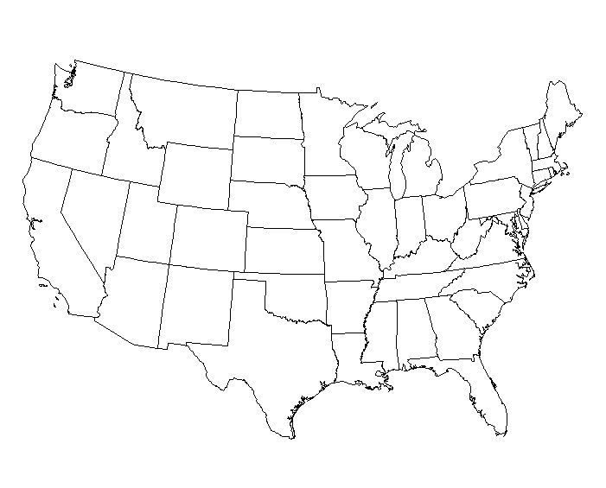

Economic.

Factory system
Erie Canal (1825)
Baltimore & Ohio Railroad charter (1828)
McCormick reaper (1834)
Panic of 1837
Second Bank of the U.S. failed (1839).
Samuel F. B. Morse patents telegraph (1844)
Erie Railroad completed to the west (1851)
Pennsylvania Railroad united Philadelphia to Pittsburgh (1852)
New York Central Railroad consolidates (1853)

Technical, Medical, Communicationss.

Worldwide cholera epidemic hit the U.S. (1832, 1849).
New York Sun (1833 first penny press
James Gordon Bennett New York Herald (1835)
Horace Greeley New York Tribune (1841)
W.T.G. Morton anesthesia in surgery (1846).

Social Reform.

Female Moral Reform Societies (1820-50)
Slave rebellion in S.C. (1822)
New Harmony (1824) in Indiana.
American Temperance Society (1826)
Mechanics' Union of Trade Associations (1827) at Philadelphia, launching an independent Workingmen's party (1828).
“Agrarian” radicalism demanding periodic equal divisions of property, inspires organization of New York’s Workingmen’s Party (1829)
Slave rebellion in Virginia (1831).
General and National Trades’ Unions (1833-37)
Equal Rights Party or “Locofocos” (1835-36)
New England Non-Resistance Society (1838).
“Anti-Rent War” (1839)
Washington Temperance Society (1840).
Brook Farm Community (1841)
Dorothea Dix begins exposing prison conditions (1841)
National Reform Association founded (1844)
Women's rights convention at Seneca Falls (1848)Young Men's Christian Association [YMCA] opens (1851)
New York Children's Aid Society (1853)

Cultural, Educational & Intellectual.

Lyceum movement (1826).
“Second Great Awakening” (1830-31 starts)
Spiritualism
P.T. Barnum’s American Museum (1841)
Transcendentalism in New England (1840s)

