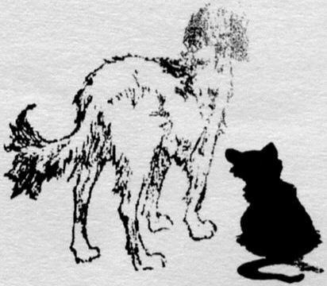
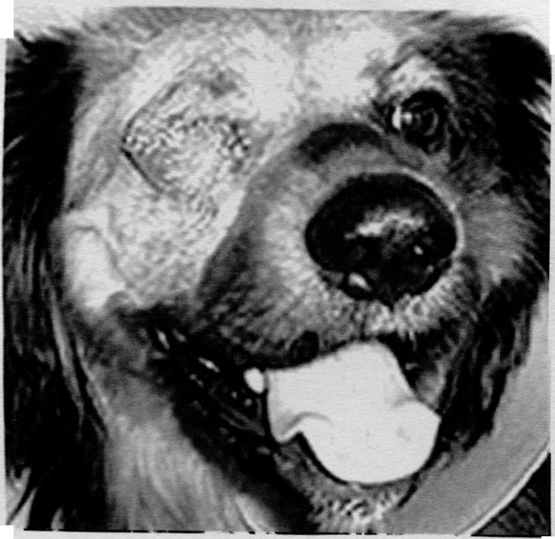
Summer 2006
TLC Paw Prints
Dedicated to Our Animal Friends and to Those Who so Dearly Love Them
Bertha's Legacy made Sullivan's Saga possible
One dog's tragedy helps another dog
survive, and so it was in Sullivan's case.
We have encountered a slim percentage
of animals that are in such severe
physical condition that they are beyond
saving Bertha was one of those tragic
cases.
For those of you not familiar with
Bertha's story we will take the time to
briefly fill you in.
Many years ago a stray pitbull type
dog was brought to us, such a sweet
gentle dog, that we named Bertha.
By all outward appearances Bertha
seemed ready to give birth any day.
We took her into the vet for a
thorough examination, and that is
when we were told, she wasn't
pregnant. The reason she appeared to
be pregnant, was that she had a very
advanced stage of heartworm, which
was causing her body to fill up with
fluids. The veterinarian that had
diagnosed her condition said the
kindest and most humane thing we
could do for her at this point, was to
have her put to sleep we did so
with a very heavy heart. And
although she is gone, Bertha will
never be forgotten. In memory of
that wonderful dog, we established the
Bertha Fund, to be used for animals in
need of more extensive medical care ....
Sullivan was one of them.
It was through internet intervention
that Sullivan ended up at TLC. Fulton
County Humane Society and three other
shelters, all located in very rural areas,
where the adoption rate is low. We help
them out, on a if space available basis.
They email us when they are overloaded
and need help, then we check the
pictures of the cats and dogs they have
via the internet. There are many
adoptable animals in these shelters but
they often would not have a chance, if
someone did not intercede on their
behalf ... Sullivan was one them.
Sullivan stole our hearts the first time
we saw his picture. We were told that
Sullivan was a stray, but once you got
to know him you just knew he was not
the type of dog that would wander off,
leaving the people he loved behind, he
was far too devoted for that. But now I
am getting ahead of myself, so let me
back up a little.
Sullivan had been abandoned with
nothing around but open fields,
without any available food or shelter.
to make matters worse, his right eye
had been injured leaving him visionless
on that side, further hindering his
plight.
It was apparent that Sullivan had
been wandering for quite a while, in
search of shelter. When he spotted an
old farm house, his hopes were
renewed that he would find refuge there
and something to eat. The woman
living there happened to look out her
window and spotted the dog trying to
make his way across the field toward
her house. But as she watched the
reddish brown dog, she noticed him
stop dead in his tracks, as three coyotes
surrounded him, and begin circling.
Having no way to ward off the attack,
she watched in horror, fearing the
worst. Under normal circumstances the
coyotes would have easily killed him,
but much to the woman's astonishment
and relief the coyotes just sniffed the
dog and slowly walked away. When the
coast was clear, the woman then rushed
out, and called the dog to her. His tail
began wagging as if he knew that the
woman had come to his aid. She gave
him food, shelter, and a name ....
Sullivan. He found refuge with the
woman for several days, but she knew
that she was unable to keep him, so she
brought him to Fulton County Animal
Control, in hopes his owners would claim
him or that he would be adopted.
Sullivan no longer had to fear the
dangers of coyotes, starvation or the
elements, he had an entirely new set of
concerns. Sullivan was given a
thorough check up by a local
veterinarian upon arriving at the animal
control facility. It was conclusive that
his right eye was in bad shape and
needed to be removed strike one.
The blood test he was given revealed
he had heartworm strike two. After
finding out about his physical problems
Sullivan's chances for adoption were
nil. The volunteers at Fulton County
Humane Society had done their best to
save Sullivan, but with adoptions poor,
and their kennel space full, Sullivan
was now facing strike three, as his name
was put on the euthanasia list.
We knew taking Sullivan would
be a big expense with the medical care he
required, but with the money that had
been donated to the Bertha Fund, we
knew we could cover his medical bills.
At this point, money was not the issue,
our main concern was if we put him
through the discomfort of the surgery and
heartworm treatment, would we be able
to find him a home. We looked at his
picture one more time, and knew we had
to go ahead with our plan to bring
Sullivan to TLC.
Sullivan was on borrowed time, and it
took a great deal of team effort to get
him transported to TLC. We want to
continued on page 4


Page 2
T.L.C. Paw Prints
Donations have been made in
loving memory of the following
animal lovers:
AL PAVLIK JR by Mary Simons
JONATHAN CORNWELL by Dad and
Mom (Bart and LIouann
Cornewell
FRANK CICALA by the Cicala Family
RICHARD NOVAK by Daniel and Karen
Lyvers
ANDREW GORDON by Margaret Sabo
JIM MAHAR by Mary Ann Mahar
JIM MIKOTA by Jim Roll
JIM MIKOTA by Kathy, PJ and Pal
Przybyla
JIM MIKOTA by Vivian Slaby
JIM MIKOTA by Judy Kunkel
JIM MIKOTA by Mildred Tesar
JIM MIKOTA by Irene Szczesniak
JIM MIKOTA by Bob and Mary Harazin
JIM MIKOTA by the Lodge Friendship,
No.66.C.S.A.
JIM MIKOTA by Fred and Marilyn
Birkhaug
ED GAWDZCK by Cheryl Reichold
FRANCIE TUCEK and her dog
SCHATZIE by Cheryl Reichold
ANDREW F. MALETICH, SR. by Rite
Way Tile & Carpet Co., Inc.
JOHN and BERNICE ADELMANN by
Michelle Agnes
CHARLEY MATHENY by Mary E.
Simons
ANDY BOROIAN by H. Boroian
LAWRENCE RUTTLE by Linda Silk
JOHN and BERNICE ADELMAN by
MicheIle Agnes
JIM and SHIRLEY PEDERSON by
Madelyn, Michelle, Oscar and
Susan Pederson
LOUISE ROWE by Virginia Eichholz
LOUISE ROWE and her dog BEAU by
David Armbrust
CLIFFORD BESSETT by Mara Glonz
BOB MARTWICK by Sharon Wilson
TONY BLANCO by Joy Blanco
HELENE OLTMAN by Jim and Linda
Palmer
EVELYN CROWE by Mr. and Mrs.
Ronald Kandalec
EVELYN CROWE by Susan Mankoski
EVELYN CROWE by Dawn Ferrarini
EVELYN CROWE by Richard and
Kristine Cardosi
EVELYN CROWE by Robert Ritholz
EVELYN CROWE by Patrick and Mary
Beth Welsh
EVELYN CROWE by Michael and Eileen
Mazva
EVELYN CROWE by Kathy and Terry
Finkelmeier
EVELYN CROWE by Phillip and Carolyn
Boch
EVELYN CROWE by the Cardosi Family
EVELYN CROWE by Billy Crowe
EVELYN CROWE by John and Mary Jane
Bucchel
BETTY WOODS by the Homer Seniors
BARB FREEMAN and her dogs OZZIE
and MAGGIE by Rich and
Shirley Sudantas
BARB FREEMAN and her dogs OZZIE
and MAGGIE by Kim Hardt
and Family
BARB FREEMAN and her dogs OZZIE
and MAGGIE by Dan and
Deanna Troike and Family
BARB. FREEMAN and her dogs OZZIE
and MAGGIE by Richard
Sudantas, Jr. and Family
LAWRENCE D. RUTTLE by Dr. and
Mrs. Joseph Gavron
LAWRENCE D. RUTTLE by Mr. and
Mrs. Jerry Sobczak
LAWRENCE D. RUTTLE by Mr. and
Mrs. Greg Zibell
Donations made in Loving
Memory of the following Pets:
PEACHES by Mrs. L. Stemmons
TONY by Gina Clark
MYSTIC 1,2,and 3 by Marilyn Harmon
BUTCH and LACY by Harriet Layfield
The BALZEKAS CATS by Darlene
Balzekas
KATY by Barbara Johnson
BOGIE and SAM by Cindy Swapa
CAT and BILL by Maxine Shirtino
SCRUFFY by Patricia Browne
BUCKY PARADAY by Sheri Paraday
ZIPPER by F. Knaack
KIPPI and MUFFIN by Joyce Kleinatis
The PAJKOS IRISH SETTERS by
Nancy Gannon
TIGGER by Mae Sala
SPANKY by Julie Alvarado
DREYFUSS by Vivian Slaby
BABE and RUFFLES by Janice Lane
SHANE and LASSIE by Valerie Moore
BOBBI (dog) SWARTZ by Wayne and
Marilyn Molitor
FLUFFY by Noreece Nemecek
BLU FRIEND by Karen Keefe
PONGO by Bernice Duehr
COY by Sue Uetz
PUDDY, PIT, KELLY, TIKI, SOOTY
by Cheryl Reichold
BLACKIE by Mr. and Mrs. D. Mauthe
TANYA by Rosemarie Cashman
BLU FRIEND by Karen Keefe
LEROY by Joy Melka
OSCAR MC GIVNEY by Catherine
Herman
MARK HOWARD (cat) by Nancy
Howard
FOR ALL of OUR PETS John and
Shirley Hiddleston ~
BUDDY-DOG by LuAnn Volanti
The TAZ by Robbin Fredericksen
"SAM" JANICKI by Mr. and Mrs.
Jezyk
TANYA by Rosemarie Cashman
ALL of OUR PETS by Patricia Nowak
GIZMO by AI Schroeder
QUINCY by Pat Ryan
MALI and MISSY by Carolyn Vincent
GIZMO by Sandra and Michael
Montagano
Donations have been made to
honor those people and pets
that bring happiness to our lives
HOLLY HEADLUND by Albert J. Sowa
In Honor of JOY BLANCO'S
Birthday by Mr. and Mrs.
Pataleo
ALL the TLC ANIMALS by Ralph
and Marsha Rusiecki
PEANUTS by Rita Bezalla
CHERYL REICHOLD by Greg
Reichold
KATHY PRZYBYLA and PAL VIP
by Jerry Przybyla
MAGGIE MAY by Richard Jarek
SUGAR SILVESTRI by Donald and
Diane Silvestri
LOIS CARBERRY by Florence
Forchione
FLUFFY by Emily C. Ullrich
STAFF, VOLUNTEERS and
ANIMALS at TLC by Elmira
Binkowski
ANNIE COLEMAN's 78th birthday
by Susie and Bruce Moore,
Pebbles and Sparkles
CHEWIE by Al Schroeder

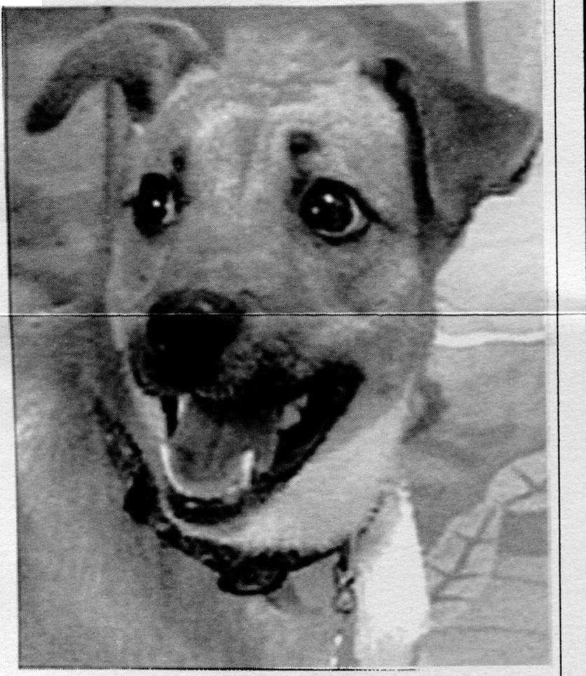
Page 3
Brownie'sHappy Ending
When we came to TLC with our two year old daughter, a few
weeks ago, we were amazed at the great dogs they had. We
looked at several larger dogs, as we had thought that we
wanted a larger dog for not only a companion but also as
protection.
Well, that was
history when
we saw
Brownie.
Brownie is a 2
year old
terrier/shelty
Mix that
weighs only 22
pounds, but has
the heart and
spirit of a lion.
He was
transported to
TLC by a
shelter in
Indiana.
We took Brownie out to the play area and decided then and
there that he was the one we wanted. We brought him home
that day and could not have been happier. He has fit in very
nicely with our family, and we just love him. Thanks TLC.
From the Oops Department
Our apologies for not listing Janice Lane as having
donated the Breadmaker for the raffle. Another mistake
made was on how we listed the first prize for the.raffle. It
should have read a stay for four (instead of saying a stay
for two) at the Eagle Ridge Resort and Spa in Galena, that
was donated by Complete Plumbing. With deadlines to
meet and the commotion at the shelter sometimes it is
hard to keep it all together. If we have make any mistakes,
please let us know, we would rather correct our errors
than have any hard feelings.
As far as deadlines go, we want you to note, if there is
anything special you wish to see printed in the newsletter
in regard to a memorial or to honor a person or pet, we
must have the information in our hands at least three
months in advance. By the time the newsletter is written,
printed, and mailed out, we are looking at a minimum of
two months to get that done. We try to get all requests in
as soon as possible but we do need some leeway time
wise. Thanks for being so understanding.
T.L.C. Paw Prints
A Note of thanks
It is easy enough for any of us to say we would never give up
any of our pets, myself included. More than 85% of the
reasons we hear are circumstances the majority of us hard core
animal lovers could cope with. But then there are those folks
with circumstances beyond their control that had to make that
heart wrenching decision. It might be due to a terminal
illness, seriously sick child, loss of their home, and other
reason I pray I never have to face. We received the following
thank you note for being able to help in just such a situation.
I am writing to thank you for your kindness toward me.
Last month I brought in Kiwi and Bear. When I walked
through the door barely able to speak through my tears I was
received with warmth and caring. I cannot tell you how much I
appreciated all the help I received from your staff. Giving
up my beloved friends into someone else's care was one of the
hardest things I've ever done. Knowing that I was leaving
them in the hands of such caring people made it a bit easier.
Thank you for giving me their numbers and telling me that I
could call anytime to check on them. I found however that I
was too choked up to speak every time I tried. I did check
your website and saw that Kiwi and Bear were quickly
adopted.
Until my attempts of re-homing failed and I started to find a
shelter or rescue to take Kiwi and Bear to, I had no idea of the
extent of the homeless animal population problem. I am still
shocked that so many animals are euthanized every day
because facilities simply have no room available. I am very
thankful for the work that your shelter does on behalf of these
wonderful animals. Please accept my donation as a thank-you
for your kindness toward Kiwi and Bear, and me and thank
you for the work you do.

In appreciation
Katrina ( we with held the last name for confidentiality)
-.
Notice to Our Supporters:
Another group calling itself "TLC" is now operating in our
area. Although we applaud all efforts on behalf of the
animals, we want our supporters to know that this new
group is not affiliated in any way with the Tender Loving
Care Animal Shelter, and has not pledged any funds raised
to us. If you are unsure about a fundraising event, please
call the shelter or check our website to see if we are
sponsoring it.

T.L.C. Paw Prints
continued from page I
Page 4
SulIivan's Saga
.
thank everyone who had a hand in his rescue, including Jaimee Steele
ftom Astoria, Karen Klinedinst and Nancy and Larry the wonderful
couple from St. Charles that made the long trip there and back to
bring Sullivan to us. When Sullivan arrived at TLC, it felt as if we
were greeting a long lost friend. We let him settle in for a few days,
before having his eye surgery and the heartworm treatment done.
Even though all went well, seeing "Sully" for the first time after
surgery tugged at our hearts. His right eye had been bandaged, and
he wore a big Elizabethan collar which made him seem even more
helpless. His heartworm had been treated and in a few days his
bandages were removed. Sullivan was now ready for the next saga of his story… Sully was ready for adoption.
Sandi O'Brien our webmistress put Sully’s.picture and story on
TLC's website also sending it to several local papers in hopes of
finding him a home. His story created quite a stir, evoking a great
deal of emotion with those who read about his plight. Sully had now
become a local celebrity with quite a following, including a very nice
family that had followed Sully's saga, from the beginning. The
family had made contributions to help with his medical care and
checked on him almost every day to see how he was doing. They
asked repeatedly if we would consider them for adopting Sully.
Seeing how loving they were with him, we said yes. His new family
emailed us daily updating us on Sully's progress. He adjusted quickly
to his new family, but something seemed to be missing, they felt Sully
was not as happy as he had been at TLC. Through numerous emails,
and many tearful days, the family decided it might be in Sullivan's
best interests if they returned him TLC. They felt Sully seemed
happier and livelier at the shelter, and that their life style was too
sedate for him. It is true Sully liked to watch the comings and goings
at TLC, much like someone who likes to sit on a bench watching
people go by. They were very saddened, but because of their love for
Sullivan they did what they felt would be best for him. As sad as they
were they were happy for the role they played in Sullivan's saga ....
his saga continues.
Perhaps it was his destiny as Sully is living at TLC (which makes a
"certain someone" who had fallen in love him very happy). He is
very content playing the roll as "our good will ambassador", and has
many friends stopping by to see him, including Judy Kunkel also a
TLC VIP member. Judy plans on taking Sullivan to school so he can
earn his Canine Good Citizenship Certificate, and become part of our
VIP program since he has such a loving, calm demeanor. Sullivan
has had quite a past and now a very bright future.
The Bertha Fund has helped more animals than you can imagine,
and Sullivan is just one of them. Thanks to everyone who has
contributed to the "Bertha Fund" and realize the important part it
plays, in the lives of the animals at TLC.
We want your dirty car!
Why: For TLC Animal Shelter's Annual Car
wash which benefits homeless animals at TLC
Where: at the Animal Care Clinic of Homer
Glen 13061 West 143rd Street Homer Glen
When: Sunday July 9th from 10:00 until 3:00
Price: $5.00 now that's a deal!
Photo contest deadline
extended until August 31st!
You still have time to enter
see enclosed entry form

Garage Sale raises cash for the Critters
Thanks to Annie Coleman for the weeks of work she put in on the garage sale and for the use of her garage for the sale. Annie had great volunteers helping her including Donna Holous, Judy Kunkel, Connie Bylsma, Kathy Przybyla and Mary Ann Lukas. The sale raised a total of$1,401.30 Thank you!
Walkathon loads of fun!
Sorry to make you wait to hear how the walkathon went,
but frankly we just ran out of space! We will update you in the next issue of Pawprints. For now check out
the pictures up on the website
www.tlcanimalshelter.org

ADOPTION HOURS

.
11 :00 a.m. until 4:00 p.m.
Tuesday through Saturday
Please call for an appointment for incoming animals as cage space is at a
premium. We try to get all animals in as soon as we
possibly can, with emergency cases receiving priority.
TLC PAW PRINTS
ALL DONATIONS ARE TAX-DEDUCTIBLE
PUBLISHED QUARTERLY BY THE T .L.C. ANIMAL SHELTER
13016 WEST 151ST STREET
HOMER GLEN, ILLINOIS, 60491
(708) 301-1594

