
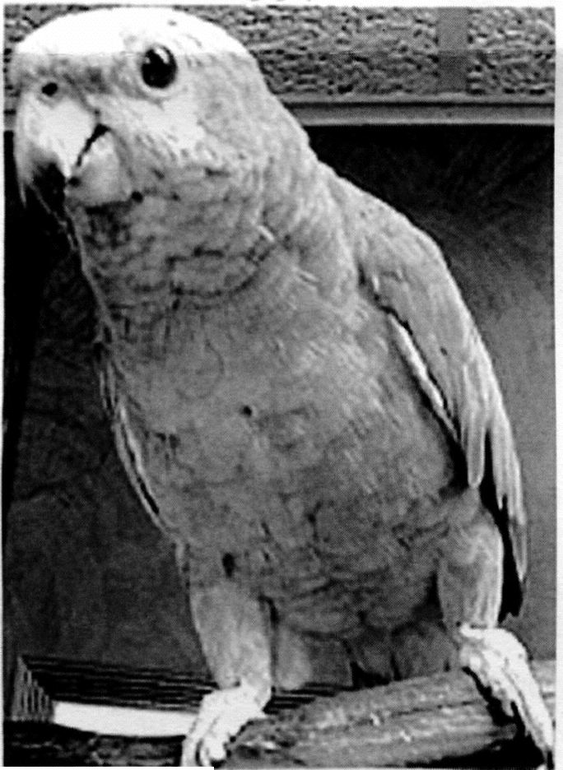
Shorty's Shelter News
Shelter News from Shorty's point of View
"Okay guys, I have to leave for a little while, and while I'm gone I really wish everyone would stay out of the office."
"Awwwww do we have to?" "We were just going to sit here and listen to Merlin tell us about his flight tales." "Please, please please!"
"If you guys promise to sit there an not touch anything on my desk I guess that would be okay Sam." " I just ask one favor, please don't touch anything on"my desk." "I have very important paperwork on my desk that needs to get done today and I have it all sorted out bills here, thank you's I need to do, and some of the newsletter over there, and I don't want to make any mistakes." "It's hard enough to get these things done, when it is like working in a three ring circus every day. No wonder I make mistakes." "I'd challenge anyone, to do my job for a week and see if you make any mistakes." "No wonder I've had to add an Oops department to the
newsletter sigh.”
Uhoh sounds like you need a chill pill! Don't worry get out of the office for a while, it might do you some good. I'll keep on eye on things for you, so you have nothing to worry about.
"Hmmmm famous last words." "I wouldn't leave at all if I didn't have to."
No problem, I'll hold down the fort
while you're gone.
"I'm counting on you Shorty." Remember, I don't want anyone touching anything on my desk! "
Nothing to worry about, and no need
to rush I have it all under control.
"Okay, but I'm holding you to that
Shorty."
" Hey guys now that we're here by ourselves, instead of me telling you about my aeronautics expertise, how would you like it if I put on a little air show for you?"
"That sounds like fun Merlin, we
would love to watch you!"
That might not be a good idea, I promised we would leave her desk alone.
"I'm not going to touch anything on
Shorty's left holding the bag
the desk, Shorty, so just get comfortable and watch the show."
I guess that won't be a problem, go ahead Merlin, show us what you can do.
"I'm ready for take off, now watch me go!" Whoosh "I'll start off with a simple loop around the room." Whoosh whoosh
"Oh Merlin that was great!" "I wish
I could do that."
"That's nothing guys, watch this!"

"Now I'll do a figure eight." Whoosh
"That was super Merlin."
"Now I'll build up a little more
speed." Whoooosh!"
"Merlin!"
"I know, hold the applause, I have more to show you." "You haven't seen my dive bomb yet." "I can fly up to the ceiling and nose dive directly over the desk, level out and never touch it, just watch me!" WHOOSH WHOOSH WHOOSH
MERLIN STOP! Look at the desk, all the papers are scattered all over the room!
"But I didn't touch the desk?"
You didn't have to, with the air
current from your wings when you accelerated, it created such a stir, it was
as if someone turned the fan on high! Look at this mess! All her important papers are scattered across the room, how am I going to explain this?
"I don't know Shorty, but you better think of something fast, because she's back already and she's headed this way."
Merlin where are you going?
"I'm just doing what my namesake
Merlin would do in this situation." Which is?
"Disappear!"
Oh no now what am I going to do?
"That's okay Shorty, I'll be by your side." "Anyway just tell her exactly what happened it was all perfectly innocent. "
Thanks Sam for sticking by my side.
I guess it's time to face the music.
"Shorty!" "It looks like a tornado hit
my desk!" "What went on here?"
Let me explain.
"This better be good., Shorty"
Well Merlin decided instead of
telling us about his flight experience he would put on an air show instead.
"How could Merlin have done this
when he is sitting in his cage?
Come on Merlin tell her how this
happened.
SQUACK SCREECH SCREECH
UGH! When you want Merlin to talk he won't and the rest of the time
you can't get him to be quiet! I can see we're not getting anywhere this way. I'm sorry I didn't mean to have this happen, it was just an accident. I can honestly say though that none of us ever touched your desk, it was more of an airflow problem shall we say.
"Shorty, you take the cake."
What cake, I didn't take any cake. I didn't even see any cake, but now that you mention it, I am starting to get hungry and cake sure sounds good to me.
" Shorty there are times you leave
me completely speechless."
Good! Then you won't say any
more about all this mess.
"Shorty! "
Ugho gotta run!
Love,
Shorty


Shorty's Shelter News
It takes a whole lot of digging, a good deal
of time and a great deal of nurturing to get the plants ready for the sale. Just ask
Sandi O'Brien who raised all the tomato
and pepper plants from seed. Also ask the
folks who dug up plants from their yard to
donate to the sale. Trying to keep
them perky and not have them look
wilty the day of the sale is quite a
job in itself. Thanks to the
following green thumbers for their
efforts: Gerry Pajkos, Carol
Migalski, Barb Griffen, Deb
Haslinger, Rebecca Better, Kathy
Reinhardt, Bobbie Sullivan and
Phyllis Sullivan, Rosemary Webster,
Clare Ann Paskiet, Linda Davis,
Annie Coleman, Parnell and Sandi
O'Brien, and Members ofT.O.P.S
2248, for giving those plants they
donated, lots of extra TLC so they
looked good for the sale.
A couple of months prior to the
sale Sandi was busy sending out mail
and then making follow up calls to
area garden centers requesting
donations of plant materials and items for
the garden. The response was
overwhelming and we wish to thank the
following garden centers for their
generosity: Dahl Landscaping/Ida's
Garden Paradise, Homer Glen, Hinsdale
Nurseries, Willowbrook, Reliable
Nurseries, Lockport, The Fields on Caton
Farm Road, Crest Hill, Doede Landscape
Nurseries, New Lenox, Green Glen
Garden Center, Joliet, Smith Bros. Garden
Center, Frankfort, Alsip Home and
Nursery Superstore, Ludwigs, Lemont,
Sid's Greenhouse, Bolingbrook and Sid's
Greenhouse and Garden Center in Palos
Hills.
This year a bake sale was added to
the event and really went over well. We want
to thank the following bakers who
conjured up some delicious goodies
Michele Chalifoux, Joni Futterer, Carol
Migalski, Mercedes Kane, Michele
Capriotti, Laura Williams. Judy Kunkel,
Kathy Przybyla, Rosemary Webster, Ethel
Rodriguez, Brandy Gergesz, Mary Ann

Plant Sale a Bloomin'
Success...
----------
Lukas, Annie Coleman, Rebecca Betten, Barb Chwierut, Janina Nalis, Janice Faikus, and Sandi O'Brien.
The Country Cafe was a nice addition to this years event. It gave people a chance to sit and relax, have a cup of coffee and something to eat, while enjoying the company of other animal lovers.
We also held a raffle, and among the
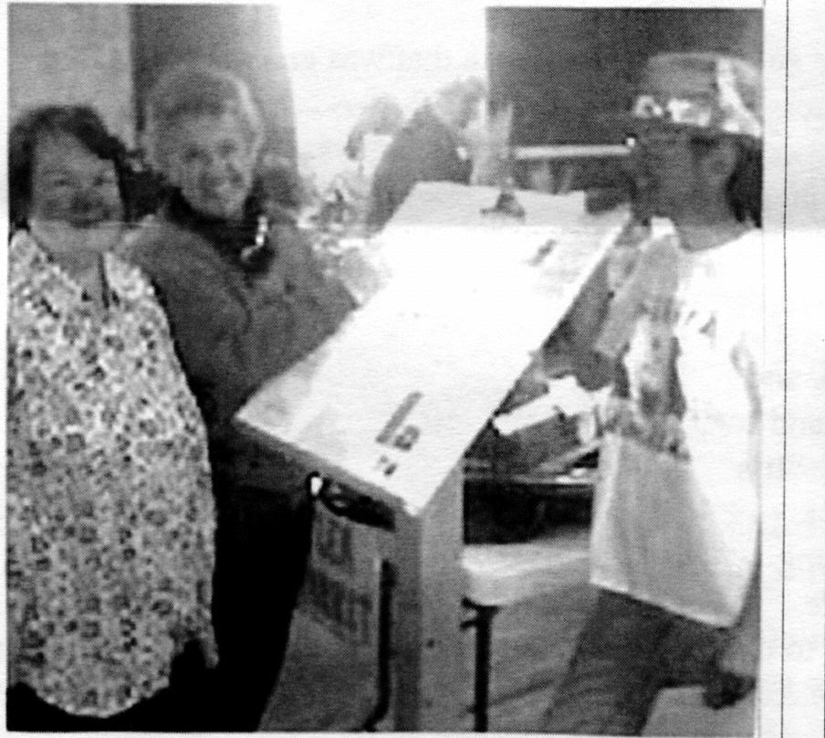

(left to right) Lottie Johnson, Clare Paskiel and Sandi O'Brien Checking the sign in sheet

prizes was a Tiffany Vase which was
donated by Valerie Sarafin of Lockport, a
Gardeners basket of goodies donated by
Rosemary Webster of Crestwood, and
several garden items donated by Darlene
Novak from Lowell, Michigan.
We had a great group of volunteers
helping Sandi on both days. On Friday
Leslye Ala, Annie Coleman, Michele
Chalifoux, Mary Ann Lukas, Kathy
Przybyla, and Connie Bylsma helped with
the set up and pricing, and the day of the
sale Janice Faikus, Parnell O'Brien,
Michelle Capriotti, Paula Bickel, Kathy
Przybyla, Connie Bylsma, Annie
Coleman, Michele Chalifoux, Clare Ann
Paskiet, Casey Carter and Keith Miller
were there to help out wherever needed.
We wish to extend a big thanks to
everyone who helped make the sale a
bloomin' success raising $2,800.00 more
than doubling last years sale!
If we did omit anyone's name then
please contact the oops department so
we can make a correction.

T.L.C. Wish List
These are just a few of the items that the shelter could use:
Home Depot or Menards Gift Cards ( this enables us to buy necessary items
for upkeep at the
shelter
39 cent Stamps
Kitty Litter ( no
scoopable please)
Little Ceasars Dog Food
Why this brand?
We have good luck getting puppies back on track eating when they've been ill and have little or no appetite, when we
fed them this brand. The pups relished the flavor, eating it quite readily over everything else we try
to tempt them with during a very critical period. Another plus was not encountering problems with diarrhea when we fed
the pups this brand.
Leashes
33 Gallon Rubber Maid
Garbage Cans
Scrubbing Bubbles
Bathroom
Cleaner
Cat Treats
Clorox Cleanup
*and our biggest need
presently is money to buy vaccines, wormers, and antibiotics for the animals


Shorty's Shelter News
Page 3
"And the Winners are:"
First Prize: A Fabulous stay for Four at the Eagle
Ridge Resort and Spa in Galena was won by Rosalie
Ducato, Naperville
2nd Prize: $500.00 cash won by Carol Vance, Homer Glen
3rd Prize: A Pet Stop Pet Fence Systems, was won by Paula Bickel, Orland Park
4th Prize: Mario Tricoci $227.00 Spa gift certificate was won by Terry Reitz,
Homer Glen
5th Prize: $200.00 Old Gold Jewelry Inc. Gift Certificate won by Dan Sedevic,
Chicago Ridge
6th Prize: $200.00 won by William Yucaitis, Homer Glen
7th Prize: Old Gold Jewelry $150.00 gift certificate won by Martin Johan, Mokena
8th Prize: $150.00 of Veterinary Service at Animal Clinic of New Lenox, won
by Louise Ardolino, Joliet
9th Prize: Milwaukee Heavy Duty Sawzall won by Gail Sweiteer, Lombard
10th Prize: Nutritionist Automatic Breadmaker won by Deb Rosendahl, Lemont
11th Prize: Avon Gift basket with $125.00 worth of Avon Products won by
Linda Youdal, Justice
12th Prize: Bakers Suite Mixer/Kitchen Aid Set and Cookbooks won by Don
Wessenhoff
13th Prize: $100.00 Jewel gift certificate won by Ron Pufahl
14th Prize: $100.00 gift certificate for Body Energetics Medical Rejuvenation
and Day Spa won by Terry Jacobs, New Lenox
15th Prize: $100.00 gas gift card for SpeedwaySuperAmerica won by Charles
Crocker, New Lenox
16th Prize: Ladies Gold Hoop Earrings won by Susan DeSanto, Lemont
17th Prize: Beautiful Bear and a $50.00 gift certificate for Bears and Borders
won by Gary Kruger, Lemont
And a big round of applause for the 5 top sellers:
Selling $530.00 in chances Keith Miller and he wins the protech portable
DVD player
2nd place winning the $100.00 gift certificate to the Bonfire Restaurant is Elizabeth
Herman selling $520.00
3rd place Patty Robinson won the Memorex Ultra Slim Progressive Scan DVD Player
4th Place: Barb Neitzke won the $100.00 gift certificate for a cosmetic laser treatment by Dr.
Daniel Clark
5th place Candace Kent won the two $25.00 Hollywood Blvd gift certificates
CONGRATULATIONS to all the winners!
1 think Patty Robinson summed it up best for most people, who bought and sold chances. "I didn't try to sell the most chances to win a prize, 1 did it to help the animals."
The biggest winners of this years raffle were the cats and dogs that the money raised will help, and we want to thank you one and all.
Hurry home before the ice cream melts!
This is so typical. On a
hot summer day, we stop
at the store for ice cream,
jump in the car, and turn
on the air conditioning in
an attempt to hurry home
before the ice cream
starts to melt. Why is it
such care is taken with
a carton of icecream,and
yet some people don't
have the common sense t
o use the same care with
their children and pets?
Each year we hear the same tragic story of young children and pets dying in cars that have turned into virtual ovens without any way to escape the deadly heat. Their answer to the tragedy, " we were only gone a few minutes," a few minutes that turned deadly. Even with the windows cracked that is not adequate relief as the heat inside the vehicle soars.
Only a few minutes they say, hmmmm, maybe they should try sitting in their car on a hot summer day and see how fast they scramble out of it as the temperature becomes more than they can stand. Then they should imagine themselves as a poor little tyke or pet, literally trapped in the vehicle because they cannot open the door to get out.
It's a no brainer!

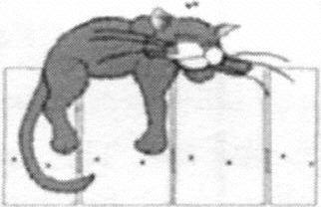

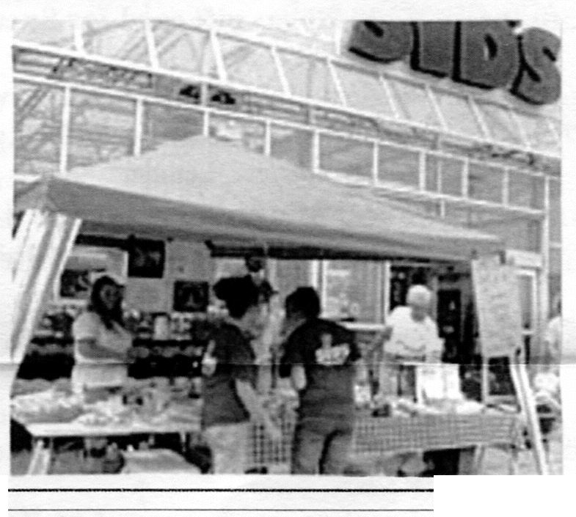
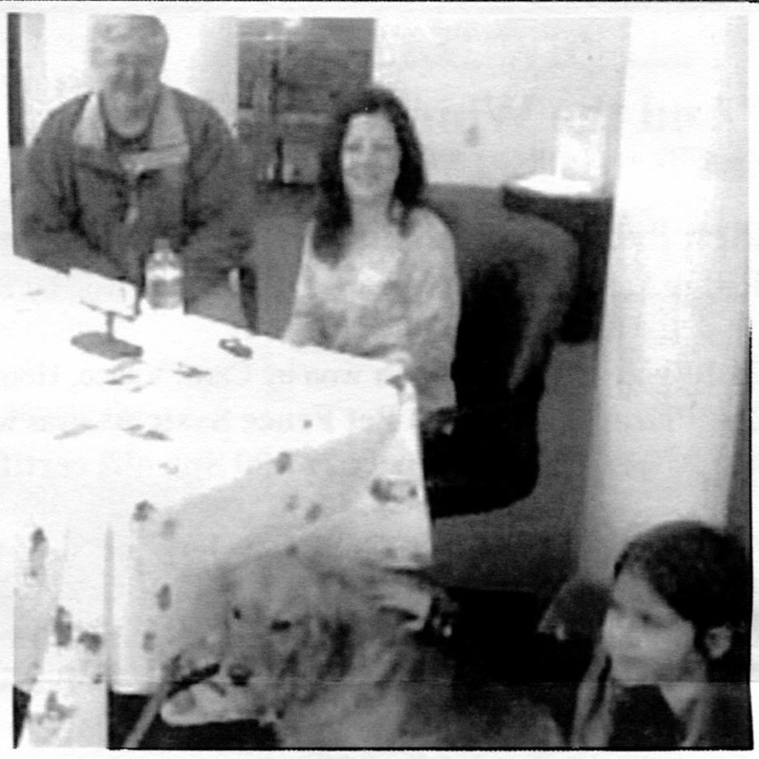

Shorty's Shelter News
Upcoming Events
Don't get caught napping and
miss......
* July 9th TLC Annual Car Wash being held at Animal Care Clinic of Homer Glen
* July 22nd VIP Picnic being held at the shelter 1:30 until 3:00
* August 31st Photo Contest
Deadline extended
so get those pictures in!
* September 15th Tentative Texas Hold Em' Fundraiser to be held at the VFW Hall in Lockport. If you are interested please call the shelter for further information 708-301-1594
* September 23rd 9:30 a.m. Tentative date for VIP meeting at the shelter
* November 11th TLC's Annual Craft Show and Bake Sale to be held at the Homer Township Hall in Lockport
* February 10th 2007 TLC's Annual Candlelight
Cosmic Bowl
* There are a great many events in the offing so please watch this spot for updates.
TLC Volunteers were
Busy with various
events
including:
representing TLC at
the Charter One, Will/Cook Branch's
Dog Days Event
held in May. Sandi O'Brien
took the 9:00 to 11:00 shift and brought Sullivan along while Paula Bickel took the
11:00 unitl 1:00 shift with her K-9 buddy, Zoey and her
,
neighbor Kelli Picman. It
was a great chance for people
to learn more about TLC and
all of the wonderful animals awaiting homes. Thanks again Sandi, Paula, Kelli
(L to R) Parnell O'Brien, Paula, Kelli & Zoey
TLC volunteers held their first HAVE a HEART bake
sale at Sid's Home and Garden Showplace
A big thanks to Theresa the manager Sid's Bolingbrook Store for allowing us to hold the bake sale there and also to the following people for baking: Rosemary Webster, Joni Futterer, Michele Chalifoux, Brandy Gergescz, Janice Faikus, Sandi O'Brien, Joaan Pavlik, Judy Kunkel, Annie Coleman, Connie Bylsma, Gerry Pajkos
Joan Wick, Jackie Connelly,
Renee Gillespie, and Ethel
Rodriguez. A special thanks to
Joan WIck, Donna Holous,
Michele Chalifoux, Annie
Coleman and Sandi O'Brien, that
tried to keep the frosting from
melting in the heat, while doing a
great job selling, raising over
$300.00 designated to be used for
.
the Bertha Fund, to help animals in
need of more extensive medical
care.
ADOPTION HOURS
11:00 a.m. until 4:00 p.m. Tuesday through Saturday
Please call for an appointment for incoming animals as cage space is at a premium.
We try to get all animals in as soon as we possibly can,
with emergency cases receiving priority.
Shorty's Shelter News
TLC Paw Prints Publication
Subscription rate donation of $10.00 per year
,J
! 13016 West 151st Street
Homer Glen, Illinois, 60491
(708) 301-1594


Wanted: great pictures of your pets for TLC's first ever Photo Contest!
12 winners will be chosen by you to star in the 2007 TLC Favorite Pets Calendar.
Don't miss out! Enter your favorite pet photo in our photo contest to benefit TLC Animal Shelter. The winners will be featured in the 2007 TLC Favorite Pets Calendar. Each winning entry will receive a calendar and be invited to "pawtograph" calendars at the Shelter's Christmas Craft Show in November.
Send an original photo of your pet with a $10.00 entry fee by August 31, 2006 using the enclosed return envelope or you may submit a high resolution digital image to the TLC website. The entry fee may be mailed in or sent through PayPal:- You may enter as many times as you like, but each entry must be accompanied by a $10.00 entry fee and a separate entry fonn"
Photos will be judged by popular vote on-line and at the shelter from September 1 through October 15. We request a minimum $1.00 donation per vote. More infonnation will be posted in August. Winners will be announced on October 31. Besides being featured in the TLC calendar if your pet is a winner, you will also get a free calendar and some other special prizes.
Contest Rules:
*No Professional photos may be entered
*Photos may be in color or black and white no larger than 8" x 10"
*Photos must feature at least one or more pet (or other animal) and be the camera work of the entrant or the
entrants family.
*Photos will not be returned and become the property of the TLC Animal Shelter
*TLC reserves the right to reject any photo it considers inappropriate.
* If done over the internet the electronic images must be emailed as a 300 dpi.jpeg file attachment no more
than 1 mb in size, and the entry fonn must be included as a text body _
* Employees and family members of employees of TLC are not eligible to win
Photo Contest Entry Form
Your name: Pet's Name:
Address:
City: State: Zip:
If my pets photos is selected, I agree to use it in the 2007 TLC Favorite Pets Calendar, proceeds to benefit
the TLC Animal Shelter. Signed: Date:Write a brief biography about your pet (you may attach an extra page if needed)

