
USS Hopewell Association
PO BOx 681 EastRochester, NY 14445
585 381-9538

USS Hopewell Ships Store Order Form
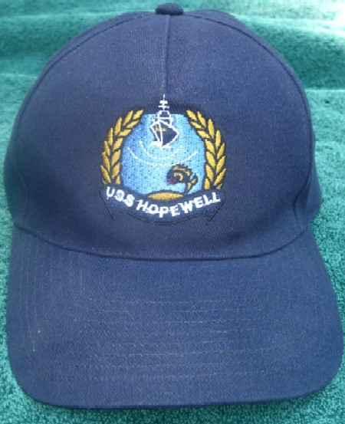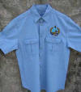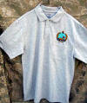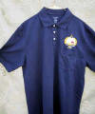
Cap Denim Shirt Gray Navy

Please send me __ ballcaps @ 14.00 =
Shirt ____ 36.00 =
Size ____ Color(s) ___
Shipping 3.50
---------------
Membership biannual $ 25.00
---------------
Total Check payable to USS Hopewell Association
======

Name _________________________
Shipping Address ________________
City/State/Zip ________________

Phone ________________________

E-Mail ________________________

Thank You

Mail to USS Hopewell Association
PO Box 681
East Rochester, NY 14445

