54th Annual
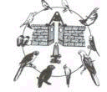

National Cage Bird Show
November 15⁻16, 2002

Sponsored by 

Santa Clara Convention Center ● Santa Clara, California

Santa Clara C
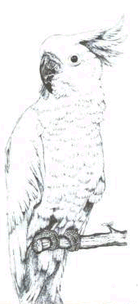
Come to the “Westminster ” of Bird Shows
– 54th Annual National Cage Bird Show –

First Time in Northern California

Don’t Miss This Once In A Lifetime Opportunity

Santa Clara Convention Center

5001 Great America Parkway, Santa Clara, California
See Thousands of Beautiful & Rare Exotic Birds All
Competing for the Coveted Best Bird in Show Award

● 19 Divisions – Beautiful Parrots, Lovebirds & Cockatiels
● Fancy Canaries, Exotic Finches & Canary Song Competitions
● Junior Division – (Grades 6-12) $1,000 1st Place Scholarship
● Show Breeders Bird Sales Room, Commercial Vendors
● Educational Seminars, Specialty Club Meetings
● Awards Presentation & Banquet
● Free Parking
● Open to the Public Fri.-Sat., Nov. 15-16, 8am - 5pm
● $7/adults, $2/ages 3-12

For More Information Contact Al Seminario 408/978-8118
Visit Our Website At http://www.geocities.com/scvcebc/

Hosted For the First Time By:
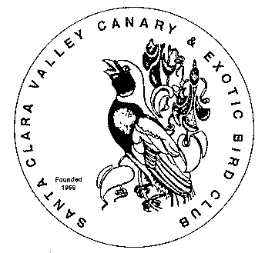

Santa Clara Valley Canary & Exotic Bird Club
www.geocities.com/scvcebc/

