Santa Clara Valley Canary & Exotic Bird Club
47th Annual Cage Bird Show
Saturday, December 12, 2009
10:00 am to 4 pm judging, public viewing, birds for sale
Temple Emanu-El
1010 University Ave., San Jose, CA

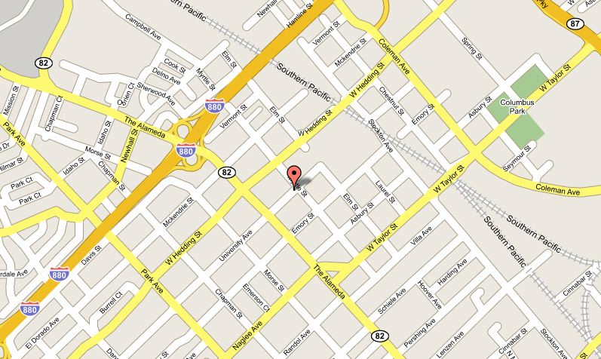
Open to the public, free parking (some street space restricted, read the signs)
There will be many birds of various colors, songs, and shapes, such as Color, Type and Song Canaries, Finches, Budgerigars, and Cockatiels.
These lovely birds are being judged by the best judges from around the U.S.
http://santaclarabirdclub.org/show/
A $3 donation per adult and $1 per child is requested for admittance.
The club goal is to educate the public, and this show gives everyone a chance to see the top quality birds in the area being judged by the very best judges.

