A Place to Return to…….Mana Young 2003

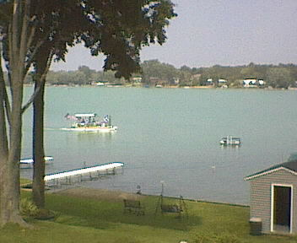

Give me the breezes and the crickets
I breathe in that air…full of the fresh moss and mulberry trees
Gentle water soft and sweet
The boats swishing against the piers…
I walk along my dreams…paddle through my fears
And rest on the beach
With butterflies flapping their wings on my body

My love for my childhood and my parents
Who brought me the heaven of a childhood dream

The sailboat…the motor boat…the canoes…
Fishing and baby ducks
Ice skating, playing on the snowy banks
In Eskimo caves…sleeping in the dens of deer

My parents gave me heaven
A place to return to in fear and pain
They gave me the greatest childhood ever….

