TRIP TO AUSTRALIA

Tuesday, September 14, 1999
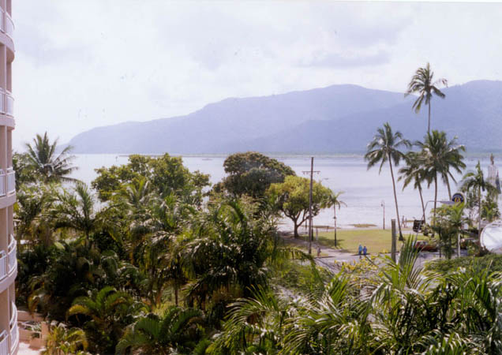
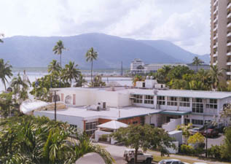
Our view from our room looked very enticing, so after discovering that Australian water is very soft, we managed to get rinsed off enough to head downstairs to the complimentary breakfast buffet. About the buffet, let me just say, “I could definitely get use to eating like this!” Craig and the girls enjoyed feasting on eggs and pancakes with a variety of toppings, while I on the other hand, tried a little bit of everything! My personal favorite was scrambled cheese eggs with marinated mushrooms on the side. I also enjoyed a wonderful warm pasta stirfry with way too many ingredients to describe. I was doing pretty well until I found the peach and raspberry filled pastries! Oh my gosh, were those good! And washed down with hot English tea was just too much! We weren’t sure whether to go on a tour yet so we opted to go see the local sites and get our bearings straight. The day was gorgeous with temperatures in the high 70’s to lower 80’s. They measure temperature in Celsius, so the easiest way to convert is to double the Celsius and add 32.
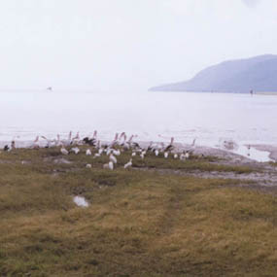
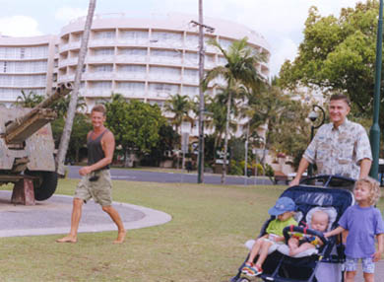
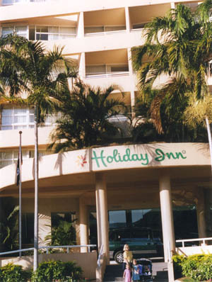
Poor Megan, after sleeping on her bee-stung eye all night, had an extremely swollen black eye. It just broke my heart to see my beautiful little girl with this huge black eye that she could barely open. The funny thing is that the day before we left, I was cleaning out my email and had just read about this exact thing happening to my baby cousin. His eye reacted in the same way as Megan’s, so because we had the information about what to do for it from her doctor, we had taken lots of Benadryl with us to Australia. Thanks Martha!
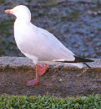We took off around the corner of the Holiday Inn so that we could stroll along the Esplanade. This is a long grassy area with a sidewalk that goes right along the beach. This beach, however, is only for birds since it is basically all mud. It is a birdwatcher paradise since you can really get a good close look at cranes and herons. I also got my first look at the very unique looking black and white magpie. This is a really cool looking bird. Besides the birdwatchers you see a lot of hippies living out of their vans. I kid you not, when I tell you that it is very common to go barefoot in Cairns. Except for a few restaurants that have signs about that, along with one-strap sandals and flip flops, we found most people were without shoes (and clothes at nearby beaches we were told).
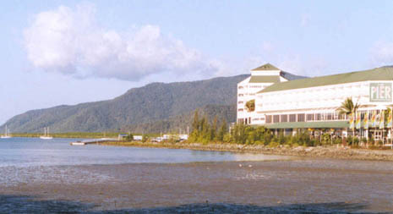
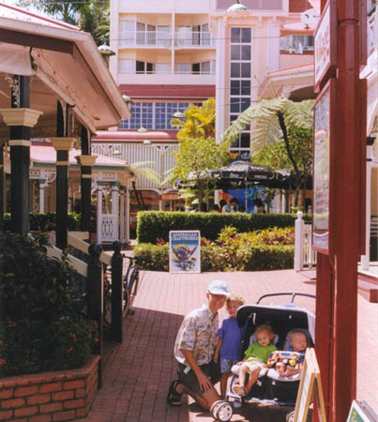
Despite this, Cairns is very clean with lots of toilets that are kept clean at all times. Some of the places we went to were boomerang shops (to get unique gifts), The Pier (which is a huge mall on the water’s edge where all the boats take off), and the RH night markets (which open at 4:30pm). This is a huge area with lots of vendors and a food court. Australia is famous for its opals, so you can find places to buy them absolutely everywhere. There were lots of ramps to help us get around with our double stroller and one thing that struck us as odd was the traffic lights. They make a clicking noise when it is time to walk across. We ate at an interesting pub called The Fox and Firkin so that we could try some Australian beer. By the way, when you see XXXX printed on large signs everywhere, it refers to the beer – not adult movies. Secondly, “light” beer in Australia refers to alcohol content, not calories. For those of you who like galleries, there are a lot of them. My favorite was the Reef Gallery inside the Pier Mall. I think I liked every artist they had on display. And that’s saying a lot!
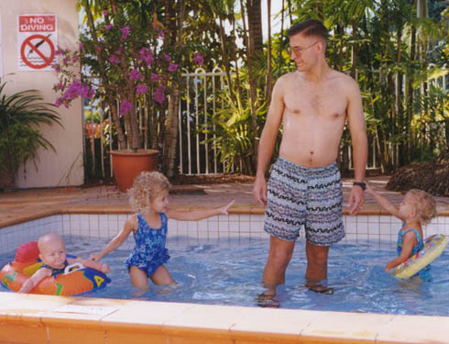
After so much walking, we headed back to the hotel for a dip in the pool. It was a little too cold for me so I chatted with a wonderful elderly lady named Jean who was from Scotland but now resided in Melbourne. After that, we took off for a local Chinese restaurant where they actually had bugs on the menu! We were exhausted from such a long day of walking so we only stayed out a little while longer in the cool breezy weather to enjoy the night markets.

