TRIP TO AUSTRALIA

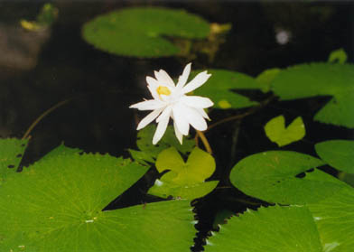
Thursday, September, 16, 1999
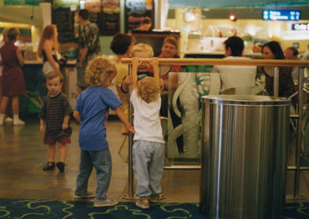
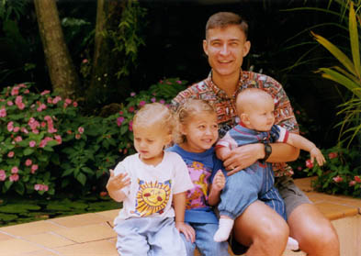
After a long shower trying to get the soap off, we headed back down to that fabulous buffet I mentioned earlier. After breakfast, we posed the kids outside in the beautiful little courtyard at the Holiday Inn before heading to the airport. We had a very pleasant wait at the Ansett terminal at the Cairns airport. Once again the girls kept themselves entertained with two little boys (Jake and Daussy from Australia). We decided that we could not take a family vacation to Australia without visiting Sydney. So, we were off for a week there before heading back to Cairns. The flight over was very pleasant. Unlike American airlines, you have more legroom, free headphones, and gift bags for the kids. The planes are nice and it feels more like you are sitting in business class then economy. And the food is good, if not a little on the interesting side. Sydney is only about a three and a half-hour flight from Cairns.

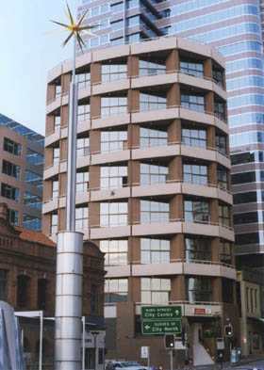
We didn’t go, but were told that Aires Rock is only a three-hour flight from Cairns. For those of you interested, I was told that Aires Rock is a spectacular site but that the red dust absolutely covers you from head to toe. This was an interesting vacation to pack for because while we had similar weather as Guam in Cairns--tropical but milder and less humid, Sydney was just entering spring, so we had to prepare for much colder temperatures. The day we arrived we were able to get away with pants and short sleeves and were still very comfortable. Our first impression of Sydney on the bus ride to the hotel was not the greatest. The weather wasn’t bad but the cloudy sky didn’t help. And you don’t go through the best parts of town to get to the downtown areas either. I’m not sure exactly what we expected Sydney to be like, but having lived in New York City, I have to say it closely resembles it (but a little cleaner). The bus (called a coach) dropped us off on a corner in downtown and it took us a while to figure out where our hotel entrance was. We were not thrilled to discover that it was located up about 15, very elevated, stairs with no ramp or elevator. So, with a ton of luggage and three kids, we started climbing. We were staying at the Metro Suites Hotel, on Sussex, which is also an apartment complex.
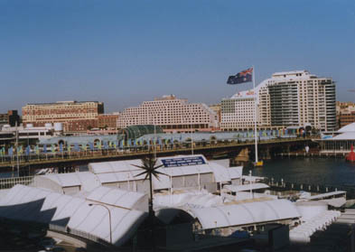
Unfortunately, they catered a little more to their regular tenants than to hotel guests. It worked out fine though because it was a roomy loft with a full kitchen. We had a queen-size bed upstairs with a bathroom equipped with a washer and dryer, and a double size pull out couch downstairs. This ran us about $80.00 US a night for the nine days we were planning to say in Sydney. The stairs scared us a little but luckily the girls were experienced stair climbers from when we lived in South Dakota. And you couldn’t beat the floor to ceiling window that sported a great view of Darling Harbour! From our balcony, we could clearly see the Sydney Aquarium, the National Maritime Museum, and the Harbourside Shopping Center. I was thrilled to see that we were so close to many of Sydney’s main attractions since most of them we would be walking to.

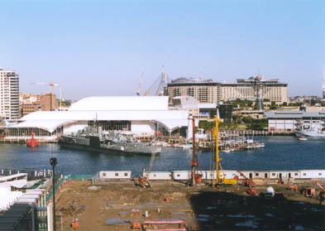
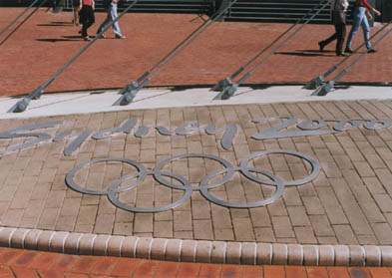
One thing that was also noticeable was the construction everywhere for the 2000 Olympic games to be held in Sydney. Some of the events would be held at Darling Harbour (most at Homebush Bay) but most of the work was for more apartment complexes, parking lots, and better walkways. As our family got settled in, I went in search of a grocery store to stock the refrigerator. The closest one was about three blocks away at COLES and down an escalator. Needless to say, I’m glad I didn’t have the kids and the stroller with me! Sydney is very different than Cairns. Much more metropolitan with the general population wearing black or suits (felt like we were in the movie Matrix). They have great organization. Like having a guard in Coles at the base of the escalator telling you which way to go so that you don’t interfere with the people checking out. You might think that their grocery stores would sell a lot of American products but they don’t. This made my quick trip to the store for basics a little longer that I expected. Luckily everything is in English but I did have to ask for help locating things a few times. Especially when it came to choosing milk. Cows milk was not the norm. The people I encountered were courteous but did not come across as extremely laid back and friendly as the people in Cairns. Coles had more health conscience food and even had its own liquor section. With so many wine vineyards in Australia you have a large selection of wines, and beer too for that matter. But remember that if you're buying beer, light refers to less alcohol, not less calories. I am not sure but alcohol seems to cost more. It’s hard to tell since you get about $1.50 for our dollar. Make sure, though, that you have plenty of Australian money because they don’t take American currency. It’s not hard to find currency exchange places but it’s a little inconvenient if you run out. By the time I dodged traffic coming from a different direction and more clicking traffic signals, I was glad to be going “home” for the night. I was a bit cold since I’m no longer used to the weather cooler than 80 degrees.

