Hello everyone,
I’ve now been about a month in California. I’m working one day per week in Roseville, which is not a very interesting place, and in Berkeley the rest of the time. Berkeley is an interesting place, and I thought I’d send you some photos from there.

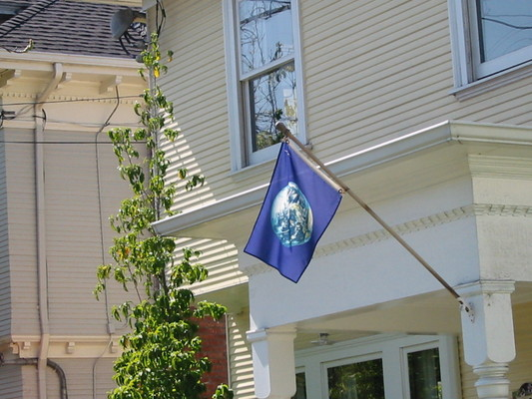
In other US cities they fly the Stars’n’Stripes. Yay Berkeley!

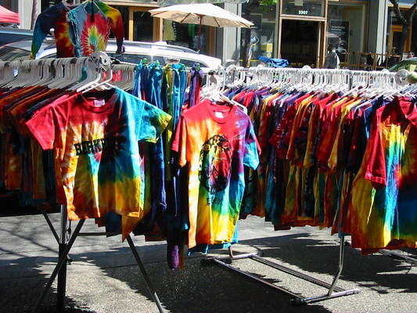
It’s bright + sunny just about every day, with beautiful light. People dress brightly too.

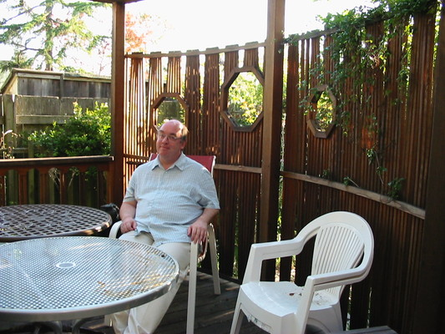
Jeremy and I are staying in an apartment near campus with a communal gazebo. Here’s Jeremy in the gazebo.
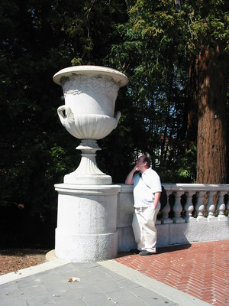
Jeremy is working at the Maths Sciences Research Institute, part of Berkeley University. Here he is thinking mock-mathematical thoughts in a mock-classical part of the campus.

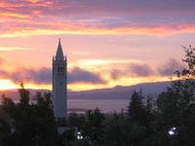
My office is quite close to this Campanile, which is in the centre of the campus. It was inspired by the one in St Mark’s Square in Venice. The sunset in this photo is typical. (Photo from virtualtourist.com).

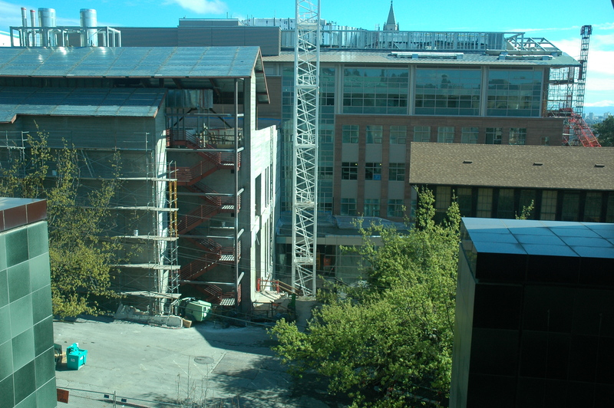

I’m a Visiting Industrial Fellow at CITRIS, the Center for Information Technology Research in the Interests of Society. When I arrived at Berkeley I went to CITRIS – and discovered it was a building site. (Photo from citris-uc.org)
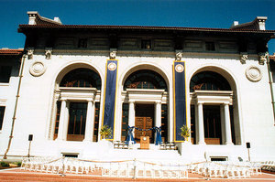
Luckily I eventually found out that until the new building is finished, CITRIS is in this building, the Hearst Mining Building. To get to my office, you go in the main door, up a grand marble staircase, and it’s right ahead of you. (Photo from citris-uc.org).

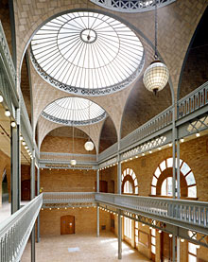
This is what the building looks like inside. (Photo from citris-uc.org.)

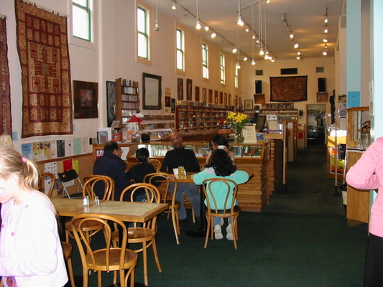
The first time I went to Berkeley good cafés were rare in England, and cafés in bookshops unheard of. I wanted to LIVE in a Berkeley café. Berkeley cafés are still especially good. This one is in a classical CD shop.
The book parts of the bookshops are wonderful too.

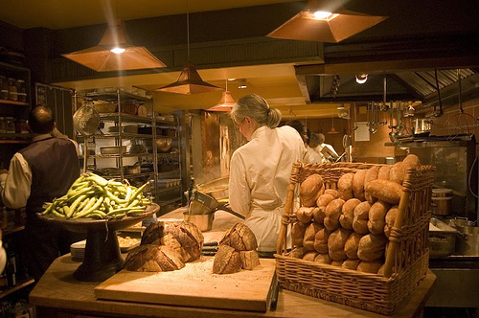
Berkeley is stuffed with gourmet restaurants and shops. This is the kitchen of Chez Panisse – yes, it’s as good as people say. (Photo by ulterior epicure on Flickr).

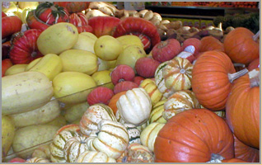
This picture is from our local supermarket (berkeleybowl.com), which is the foodiest supermarket I’ve ever seen: I had no idea there were seven different kinds of aubergine.

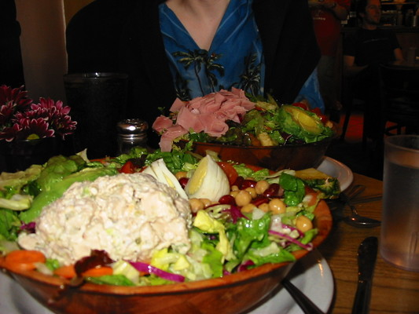

Jeremy and I are currently on a diet (we delayed starting it till the day after we went to Chez Panisse). This has prevented me so far from diving headfirst into the gourmet patisserie, but how can you eat moderately in a place where if you order a salad, they give you something bigger than your head?

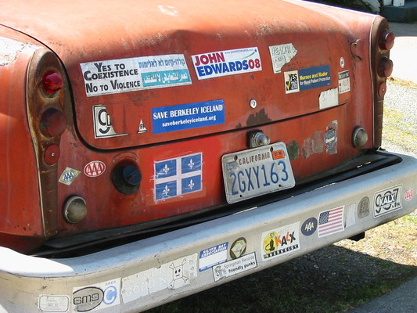
If a Berkeley car carries one bumper sticker it usually carries many, with lefty slogans. This lovely rusting old banger is endorsing John Edwards, a presidential candidate who talked a lot about global warming. I doubt that this car is helping to reduce global warming, unless - as seems possible - its owner doesn’t use it any more for transport, just for displaying stickers.

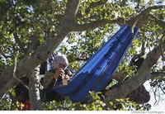
When I arrived in Berkeley this chap, known as “Fresh”, was living up a tree in the middle of campus as a protest. (He wanted the Regents of the University of California to be elected rather than appointed.) Fresh stayed up the tree for several weeks before eventually coming down. A very, very bored University policeman guarded the tree day and night. Every so often people held meditation circles round the tree. (Photo from Kurt Rogers and the San Francisco Chronicle).


Another bumper sticker. (Image from NorthernSun.com).

More Berkeley bumper slogans:

WHY DO WE KILL PEOPLE WHO KILL PEOPLE
TO TEACH THEM THAT KILLING PEOPLE IS WRONG?

LIFE IS BEAUTIFUL
YOU ARE BEAUTIFUL
HAVE A GREAT DAY

HATRED IS NOT A FAMILY VALUE

WHY DID THEY HAVE TO PUT OUR OIL
UNDER THEIR SOIL?



I’ve started thinking I ought to acquire a few extreme right-wing opinions, just for a bit of balance.

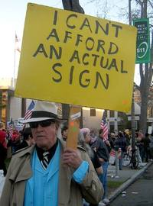

Marches are common in Berkeley too. (Photo from zombietime.com)

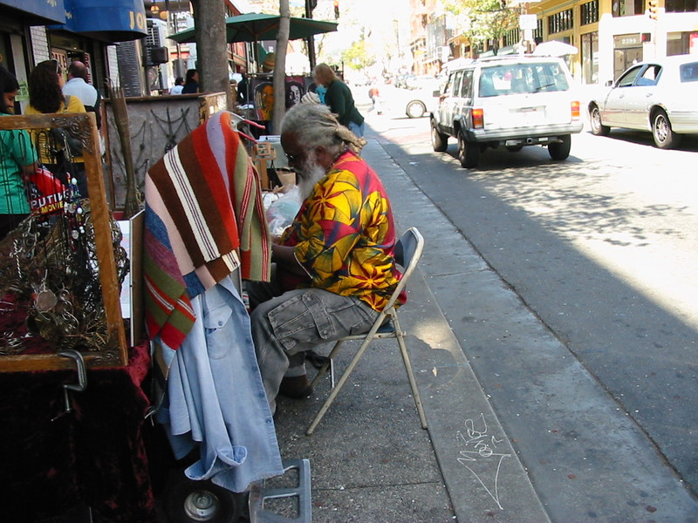

To end with, here’s a typical Berkeley resident. When I return to England in June I may look like this.

Love, Miranda.

