SDR PROMOTIONS PRESENT
DARK SUNDAY
‘A NIGHT OF NUMAN’
SUNDAY JULY 16th 6pm -2am
@ THE HATCHET INN
(FUNCTION ROOM -2 am Subject to licence)
27 FROGMORE ST, BRISTOL,BS1 5NA. 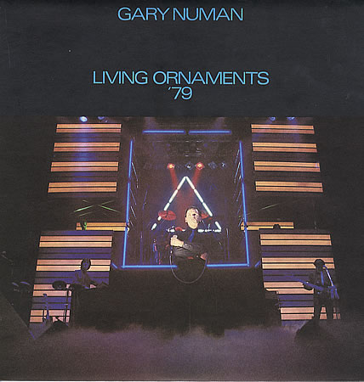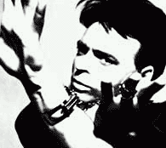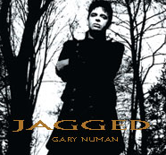

SDR Promotions/Steve Davis brought you the Mega Numan Discos in E1 & Cheltenham ‘95-97. FOLLOWING THE JAGGED TOUR Return with this unique NUMAN CELEBRATION ‘DARK SUNDAY’…
A night featuring superb dedicated Numan sets & the best in electro with a custom light show recreating that classic NUMAN concert feel - WITH DJ Steve Davis & Guests.
Tickets £4.50 (Advance Only - Pay: S Davis)
E: numan.darksunday06@yahoo.co.uk
T: 07788 423355/01452 550744
DARK SUNDAY IS NOT ENDORSED BY GARY NUMAN. IT IS A FAN EVENT THAT IS IN THE FORM OF A DISCO . ENTRY BY ADVANCE TICKET PURCHASE ONLY.DJ’S AND LIVE ACTS MAY BE ADDED TO THE BILL. THE EVENT WILL RUN UNTIL 1AM WITH 2AM EXTENSION APPLIED FOR …FOR LATEST INFO EMAIL numan.darksunday06@yahoo.co.uk

