Nightmare
No official taxonomy

The nightmare is a newly awakened specie that has been seen very few times by some people who assert it was flying and ridden by someone. No one is yet sure of what credit to give to such visions, but the few photos that have been taken by a civilian and exanimated by the Dunkelzahn's Institute of Magical Research prove them to be right and not falsified.
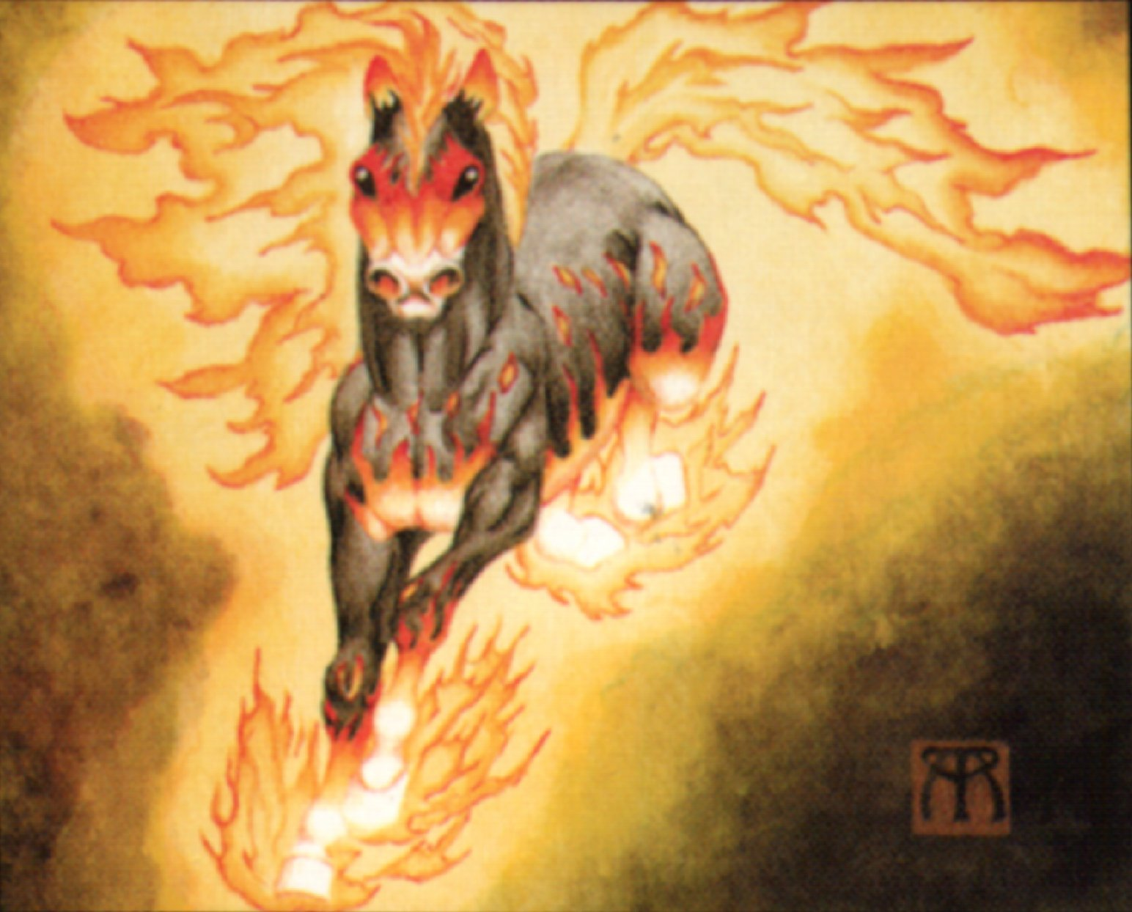

Magic capability : innate

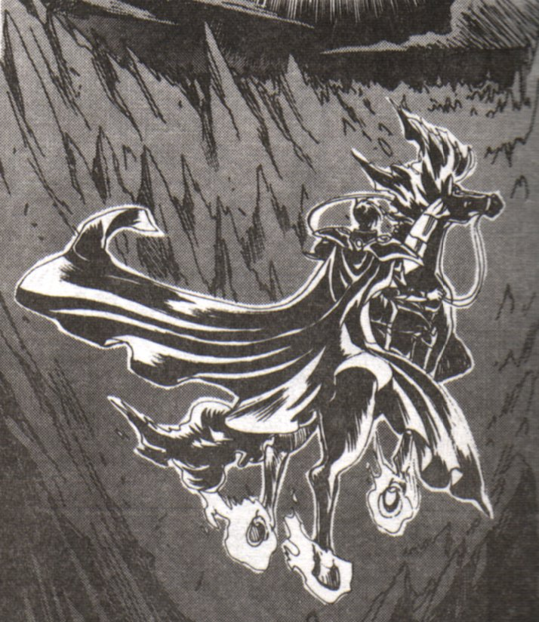
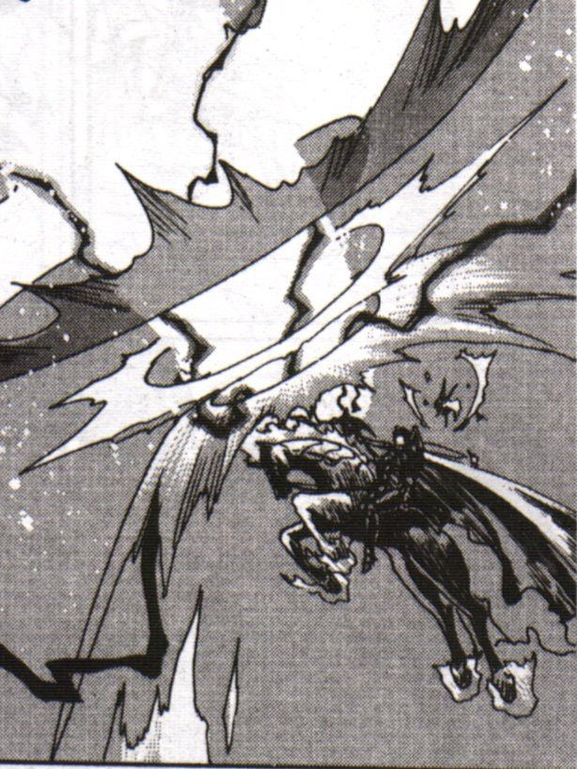

>>>>>[Hey, Patterson's getting that one outta his own nightmares or what ? Such a specie couldn't exist. It would burn every land it goes on, and so could never feed self. I don't buy it.]<<<<<
-Sera-Sera (05:43:19/12-26-54)

>>>>>[I wouldn't be so sure if I were you. These creatures have a long history, and who said they had to find their food ?]<<<<<
-Kayura (**:**:**/12-12-1559)

>>>>>[A long time ago, they were magically created to serve as combat horses. Their powers were not the only use, because they were so impressive, and their riders quickly well know as battle lords, that everyone flew as soon as they saw one leading an army]<<<<<
-DTP (12:12:59/12-26-54)

>>>>>[Hey, who are these two illuminated ? A long time ago ? 43 years ago, magic wasn't here, how could these beasts have a "long history", and be used as "combat horses" ? Today's combat horses are panzers, and I doubt anyone coming to a desert war with this creature would impress anyone. The only surprised would fire a missile at it fearing unknown magic, and it's down. End of story.]<<<<<
-Rat Dancer (03:26:51/12-28-54)

>>>>>[You should not be so sure of yourself and what you can know about magic. Especially magic this old]<<<<<
-The Laughing Man (15:54:03/12-29-54)

>>>>>[And what about the Thundermare ? Not seen yet ? ]<<<<<
-Wordsmyth (20:12:45/12-31-54)

Co Q S Ch I W E R Attacks

Nightmare 10 5×6 8 - 3/5 4 6 5 5G

Powers : Search, Flame aura (special), Fear, Flame projection, Magical resistance, Magical guard, Immunity to fire, Shadow cope.
Weaknesses : None

Note : The Quickness modifier while flying is 8.
The Flame aura is uncontrollable and is always active on tail, mane and hooves, increasing to legs and parts of the body if angry or in a great battle.

Note to the GM : This creature is a great one to make the mount of you big evil magician boy in a campaign or scenario. Especially if your evil magician is a 4th world one…

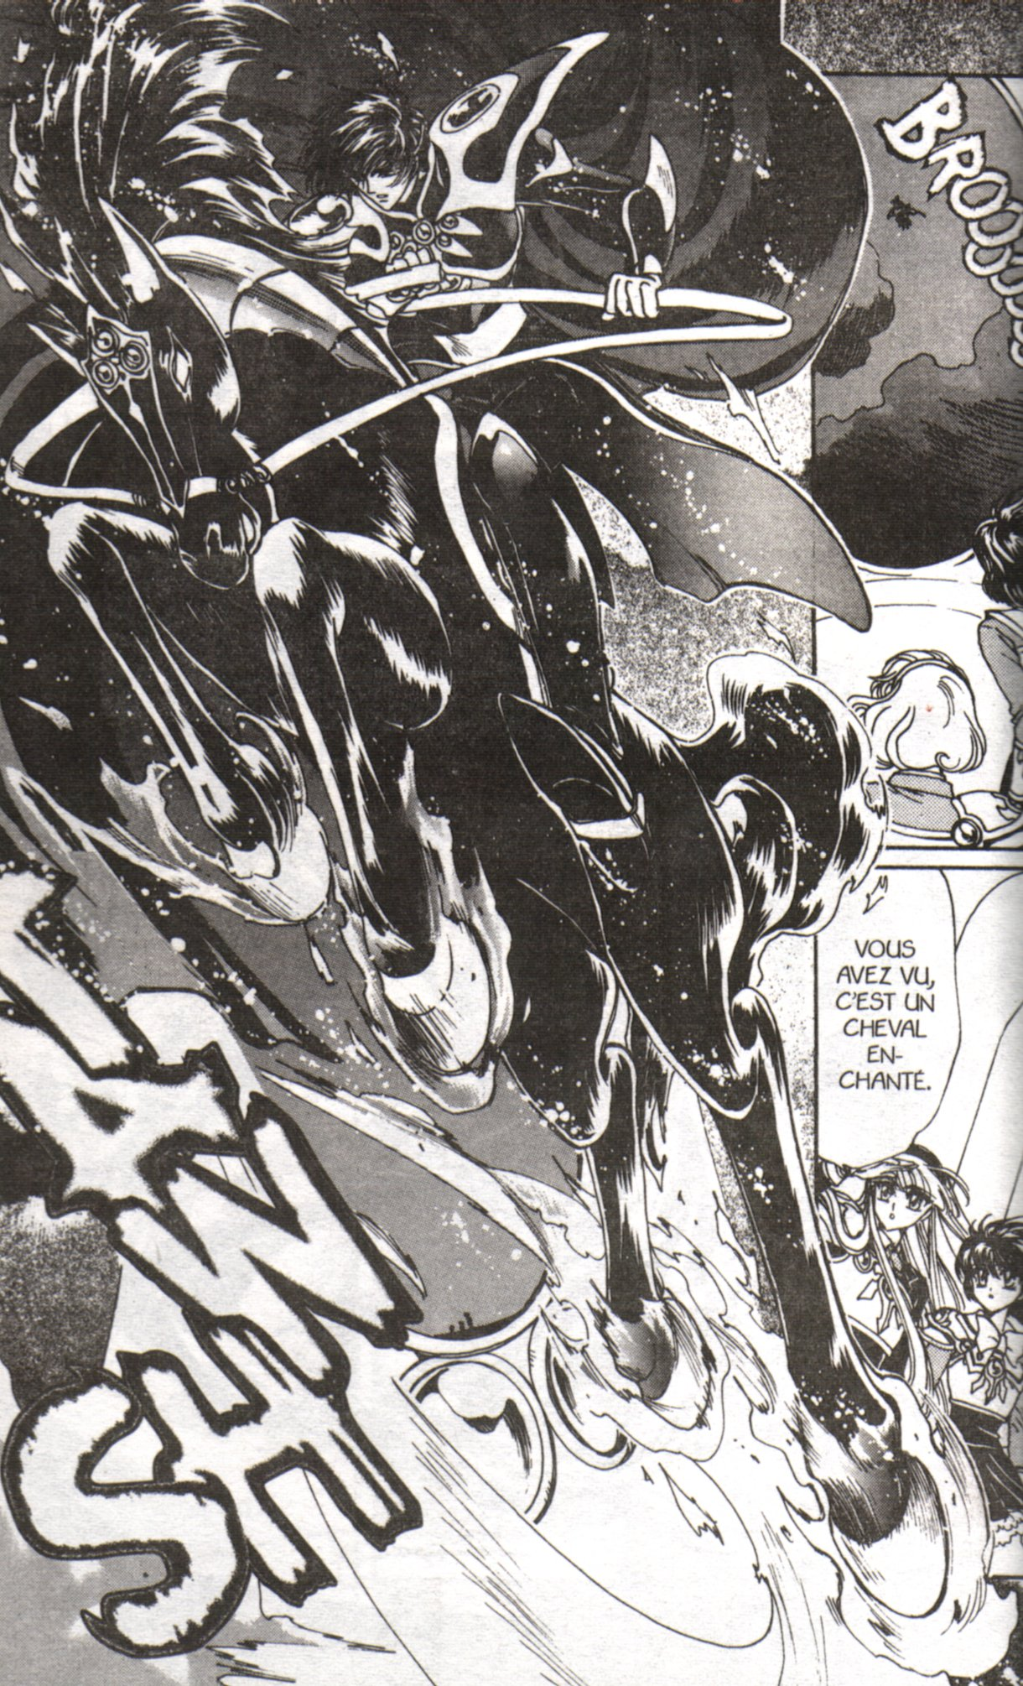
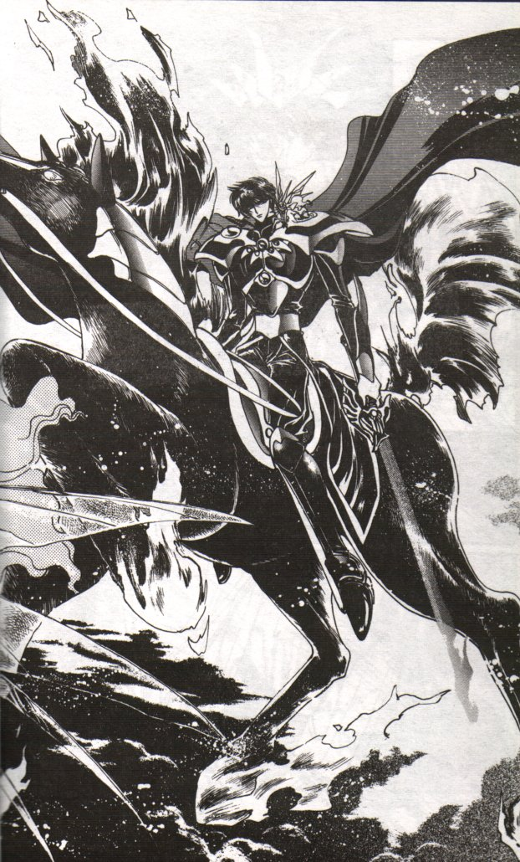

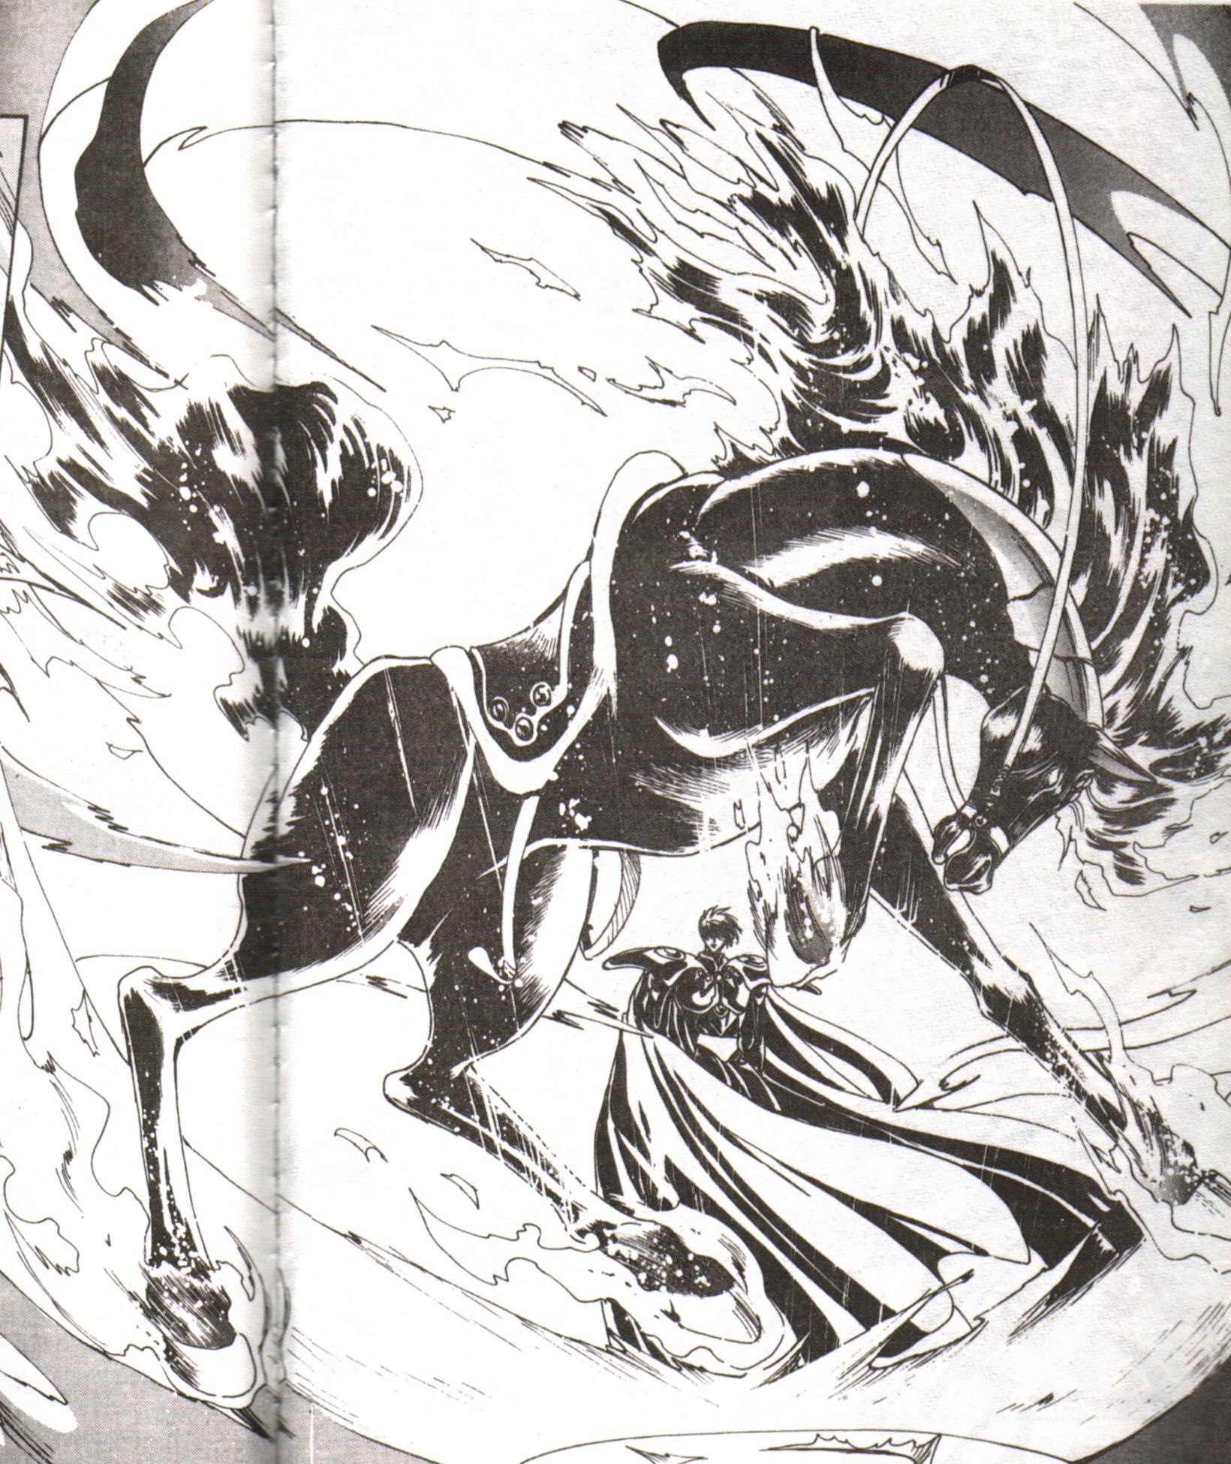

This document is intended for personal use. The black and white images are © CLAMP. Used without authorization. The color image is © Wizards of the Coast and © Melissa Benson. Used without authorization. All rights reserved to their respective owners.

Kor-Skarn (homepage http://www.geocities.com/TimesSquare/Corridor/5488/). E-mail at Vehuia@yahoo.com. Posted on 28/04/99

