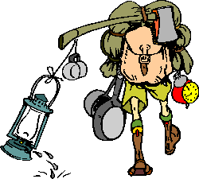
CHECK LIST OF SUMMER CAMP CLOTHING AND EQUIPMENT
Official Camp Uniforms

Uniform
Neckerchief Slide & Neckerchief
1 Scout Belt

Other Clothing

Bathing trunks, shower shoes, and sun block
Underwear, socks (lots and lots of socks)
Outdoor shoes, & change of shoes (if your doing canoeing bring shoes that will get wet and yucky)
Sleep wear
Sweater, sweat shirt & pants
T-shirts (T-shirts with camp insignia may be purchased at Camp Trading post)
Poncho or raincoat
Pair long pants
Warm Jacket
Supplies for days change of clothes.

Equipment

Heavy blankets or sleeping bag, pillow, laundry bag
Scout Knife (if applies)
Compass
Bath towels
Toilet articles - soap, toothbrush, toothpaste, etc.
Scout Handbook (if applies)
Flashlight & extra batteries
Paper and pencil
Canteen or water bottle
Hat

Optional Personal Equipment

Camera & film
Fishing tackle-bait
Backpack or book bag
Bible or prayer book
Pocket knife (no sheath knives permitted in camp)
Medicine in original container - inhalers if needed by boy or adult
Clothes line
Battery lanterns

