Dr. Martin’s Monoplane

"Resolved That Man Will Fly"

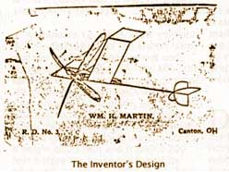
Mr. Martin joined a debating society at Brush College, near Canton. When asked to suggest a subject for debate he proposed. "Resolved that man will fly." Everyone laughed. No one else would take the affirmative. Not discouraged, Mr. Martin debated alone against three on the negative. He won against the three. The study he put into the debate gave him an inspiration and belief in the possibilities of flying that never weakened.

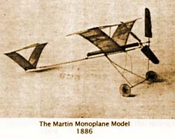
On April 22, 1900, Mr. Martin appeared before the New York Aeronautic Society and demonstrated a small
model of his plane which made several flights powered by rubber bands. It is believed that this may have been the first demonstration of a practical miniature flying model and the forerunner of a sport that has become a favorite with boys throughout the world.

Meanwhile he became a successful and up-to-date farmer. He adopted the latest agricultural methods and was the owner of the first grain reaper and binder used in Plain Township. He acquired half of the farm (62 acres) that belonged to John Pontius, his father-in-law, on the Harrisburg Road. His farm home was the hip-shaped building, still standing, which was sold to Herman J. Moore in 1945, and was later purchased by Blaine M. Davidson. Holtz, was second cousin to Mrs. Grover Cleveland. By the second marriage there were three children...James H., Charles C., and Eudora (who died in August, 1998 at the age of 94).

During William H. Martin's long continued aeronautical experiments, others about the country began similar experiments. On December 17, 1903, Orville Wright made the first successful flight in a heavier than air mechanically propelled biplane, rising from the base of Kill Devil Hill four miles south of Kitty Hawk, N.C. He flew 120 feet in 12 seconds in a 27 mile an hour wind. The fourth flight the same day was made by Wilbur Wright...a distance of 852 feet in 59 seconds. Their plane was patented May 22, 1906

Martin's experimenting reached the stage of a patent on a toy flying machine January 3, 1908. But he could not find a manufacturer. The toy never went into production. Later that year, Mr. Martin built his full-sized monoplane. He struck out boldly from the biplane designs in use by other inventors and adopted the monoplane from, with balancing wings forming a "V" below the main wing to give stability and safety. The materials used were light wood and English broadcloth.

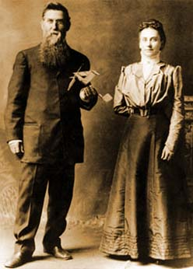
After his first wife died, William married Almina Pontius Martin, who was an enthusiastic supporter of her husband's flying projects. The plane was completed just at the turn of the year. It had sled runners in place of wheels, and the builder had to wait for a fall of snow before testing it.

On January 12, 1909, snow covered the fields back of the Martin farm, and the device was hauled out and taken to the top of a hill. Old Billy, the farm horse, was hitched to the front of the plane by a long rope. Mr. Martin took his seat in the plane, son George whistled to Billy. The horse started down the hill pulling the plane behind him. It rose from the ground, reached a height of 25 feet and traveled 200 feet before the horse slackened its pace and the plane settled gently back to earth.

Mrs. Martin then took her seat in the plane and made several successful flights, being the first woman ever to fly in a heavier than air machine. Another son, Charles C. Martin, (who was still living when this article was first published in 1952) also went up and said that it came down like a feather. When he shut his eyes, he didn't know when it struck snow.

Mr. Martin's experiments had been kept secret, but the trial flights could not be hidden. Neighbors flocked to the field to see for the first time in their lives a human being sustained in the air by a heavier than air machine. Cousin Glenn L. Martin had not yet built the first plane in California. The U.S. Army had not yet purchased its first airplane. In fact, the first test flight by Orville Wright before Army officials was not made until the following July, at which President Taft was a spectator.

Canton's aeronautical interest in 1908 and 1909 was still completely absorbed in the balloon flights of the Aero Club to witness which Orville Wright paid a visit to Canton, January 23, 1909.

It was thus at an extremely early period of airplane pioneering, that William H. Martin made his first flights. A photographer came out to take pictures of the flights but became so excited that he failed to operate his photographic apparatus properly and all the plates were ruined!

During successive days more than 100 flights were made. All the members of the family, including the pet dog enjoyed the novel experience. One day one of the sled runners struck a bare spot on the ground and swerved the plane against a fence, damaging it slightly. The flights were suspended for a time.
William H. Martin had his eye on more than the local scene and wanted to get his plane demonstrated in the East, but was handicapped by lack of funds. William A. Hoberdier, who, with his brother, L.A. Hoberdier operated Lyric Amusement Co. of Canton, is credited with having helped finance trips to New York in the Spring of 1909.

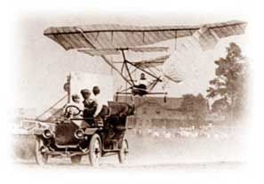
In May 1909, Mr. Martin returned to New York...this time with his wife. Mr. and Mrs. Martin demonstrated their plane successfully at the Hudson-Fulton Celebration which sponsored an air meet in Morris Park, N.Y. under the auspices of the New York Aeronautic Society. A New York newspaper gave this account of the exhibition:

"George Thompson, an ex-jockey, traveled around the old Morris Park race track twice yesterday in the Martin aeroplane, just arrived from Canton, Ohio. The aeroplane is bereft of motor so the motive power was supplied by an automobile. The flying machine was hitched to the motor car by a rope about 150 feet long and towed around the mile long track at a speed of 30 miles an hour. The following is an account of a flight witnessed by a reporter present at Morris Park...

"When going against the wind the monoplane rose to a height of between 15 and 75 feet, depending on the speed of the car. Whenever the automobile increased its speed the aircraft would receive such momentum that it would attempt to dash ahead of its guide.

"The Martin aeroplane is one of the most curious contrivances...among the 14 machines at Morris Park. It is 30 feet wide and about 30 feet long. Instead of consisting of the usual rigid planes top and bottom (biplane), it has one wide top plane and two planes inclined toward the bottom in the shape of a "V." These planes (monoplanes) constitute what is known as the dihedral principle and give the apparatus stability while in flight.

"It is mounted on small wheels for starting purposes and carries a rear rudder practically of the same construction as the main plane. The elevating is done by means of a plane in front.

"Yesterday's experiments were the first that Mr. Martin has made in New York. He did not fly in the contrivance himself because he wanted to see how it would act above the track in Morris Park...

""While the machine was in flight yesterday with Thompson aboard, it gave good indications of maintaining its equilibrium while going at high speed.

"As it swooped around the track behind Oral A. Parker's automobile it swayed from side to side. (The driver of the car was, at times driving faster than Mr. Martin had intended.) The airplane narrowly missed collision with an obstructing tree, but it showed very clearly that it would always right itself before coming to the upsetting point."
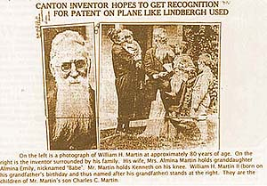
In the Sunday Repository of June 5, 1927, a feature story gave another slant on the Morris Park Exhibition as told by Mr. Martin, relating an accident that might have been fatal to the inventor.

"The wind was high that day, so high that I would not allow my wife to fly. Other men who were scheduled to perform refused to go up and the crowds began to grow impatient. When 50,000 people grow impatient, something has to be done, so I finally agreed to fly myself. The plane swept along like a bird until we reached the end of one of the grandstands when a terrific gale of wind struck it.

"Had the rope held, I would have been safe, for my machine is so constructed that it cannot nose dive, but the rope broke, and we started down. I had two chances, either to land on the fence or guide the machine through the rails, which were fairly wide apart. "I chose the latter. For a moment it seemed we would be dashed to pieces, but my plane responded to my efforts to guide it and we crashed through the opening and stopped. I escaped without a scratch." The disc landing wheels used on his plane were an invention of Mr. Martin's, which, however, he never had patented. His plane was one of the few actually to get into the air at Morris Park.

Another milestone was established September 21, 1909, when Mr. Martin's eight-year-old granddaughter, Blanche Martin, made several solo flights in the machine, thus demonstrating its safety. Her hops were 75 feet in length, and it was the first time a child of such age had ever taken to the air in a "heavier than air" machine. Blanche became Mrs. Chester Roth on Waynesburg Road (as of the date of the Sunday Repository article).

Mr. Martin sought to obtain a motor for his plane and wrote to F.S. Lahm, noted Canton balloonist, then living in Paris. In a letter from Paris, dated March 15, 1909, Mr. Lahm told him that the only successful motor then on the market was exorbitantly priced and advised that a smaller one was to be produced soon. Some used motors were obtainable, but were unreliable.

In 1936 Dennis R. Smith, when returning from a marble tournament, stopped in at the Smithsonian Institution and saw the Martin plane on display beside Lindbergh's Spirit of St. Louis.

When he returned to Canton he met William H. Martin on the street and reported seeing his plane at the Smithsonian. Mr. Martin, then an old man of 81, with long white whiskers, and gentle and quiet spoken in manner, had the happiest moment of his life when he knew that his contributions to air pioneering had been memorialized by the preservation of his machine. His patent had run out in 1926, and he took additional satisfaction in knowing that the invention which he had patented was free for the use of all mankind.

When he died, Mr. Martin's funeral had to be postponed, as international travelers wished to pay their respects to this gentleman who had the courage to stay with his convictions...

"Resolved that man will fly." And indeed he did, and so do we because of our aeronautical pioneers.

William H. Martin's funeral caravan stretched for five miles...

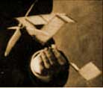
A copy of the patent drawing of Dr. Martin’s Monoplane is attached as a .pdf file.

