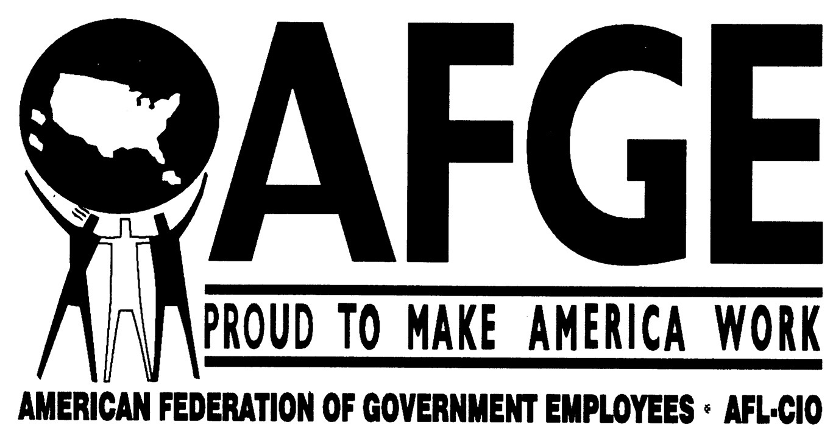 | THE TOMTOM
 | June-July 2004 | AFGE Local 3403 News/ADF Bargaining Unit | Vol. 3, No. 3

ADF BARGAINING UNIT NEWS

Alternate Dispute Resolution (ADR) ON ISSUES RAISED IN SETTLEMENT AGREEMENT

After Federal Labor Relations Authority (FLRA) facilitated negotiations between ADF Management and the Union on April 20, 2004, a settlement agreement was reached on the issues that gave rise to the Union’s Unfair Labor Practice (ULP) [see TomTom, Volume 3, No. 2). The negotiated agreement:
- Increases non-core work hours in a given work day to include 7 AM to 9:30 AM and 4PM to 7 PM.
- Expands the time within which an employee can make up missed time, from the same work-day to the same work-week (exclusive of core hours);
- Enables employees to access their vehicles (B2) and Metro (B3) beyond the 7 PM office closure; and
- Exempts Bargaining Unit (BU) members from sitting at the front desk, after hours, to “monitor” employee’s signing out.

The agreement provides for more equitable working conditions where employees are no longer penalized for absences, while not compensated for time made up or limited by unreasonable time bands. As one employee said, “Thank God there’s the Union.”

Draft Policy Revisions
Management presented the Union with drafts of new manual sections for review and comment. The new manual sections, elaborated by ADF contractor, GRA, included:
- Procedures for Providing Reasonable Accommodation for Individuals with Disabilities;
- EEO Processing Complaints of Contract Employees; Incentive Awards Program;
- Workplace Harassment and Hostile Work Environment;
- Merit Promotion;
- EEO Policy and Procedures; and Performance Appraisal System.
The new sections are a result of negotiations between the Union and Management during the Collective Bargaining Agreement (CBA) in which and submission of manual sections was in keeping with discussions between the Union and Management during CBA negotiations.

ADF Labor-Management Committee goes to Impasse Panel

An article that would have engendered a more cooperative working environment between ADF Labor and Management was refused by ADF president, Nate Fields.

The article, which would have established a Labor-Management Committee, was negotiated by the Union and Management teams during CBA negotiations. After reviewing the negotiated article, however, Mr. Fields overrode the recommendations of his own negotiation team and refused to ratify it. His rationale is that ADF is small and doesn’t need yet another structure or committee. The rationale, however, doesn’t make sense because:
- Such committees are proven to promote open communication between management and employees, enhance the quality of service, improve morale, and avoid misunderstandings;
- Though no longer mandated by law, Labor-Management Committees exist for almost every functioning government agency, including USAID, State Department, HUD, Veteran’s Administration, to name a few.
- Statistics indicate that ongoing and open discussions between Labor and Management reduce conflict, incidences of formal grievances, Unfair Labor Practices, and discrimination suits.

The Union does not understand why improved communications and understanding between Labor and Management would not be desirable to ADF Management.
After several attempts to reach an amenable solution failed, the article was forwarded to the FLRA Impasses Panel. The Panel resolves disputes between Federal agencies and unions arising from negotiations over conditions of employment under the Federal Service Labor-Management Relations Statute.

Representatives from ADF Management and from the ADF BU attended a facilitated meeting at the Panel’s headquarters on June 7th. No decision was reached at that meeting, however with the Panel’s assistance, the Parties have since exchanged counter-proposals (see attached). The Union’s counter-proposal represents an effort to address Mr. Fields’ aversion to what he refers to as “creating another structure” that would engender open and transparent interaction.

The Union has yet to receive a response to its latest proposal.

OTHER UNION NOTES:
THUMBS UP:
June 9, 2004
Labor to publish job competition paperwork By Amelia Gruber

The Labor Department is making decisions in small-scale job competitions less mysterious by publishing the data used to compare the cost of keeping work in-house with the cost of contracting it out.

Late last month, Labor officials began posting electronic versions of cost comparison forms on Federal Business Opportunities, an online listing of available government contracts, alongside entries announcing the outcomes of streamlined job contests. The forms open the Labor Department's cost projections, a key ingredient of the smaller contests, to public scrutiny.

Under the Office of Management and Budget's May 2003 version of Circular A-76, the guidelines on competitive sourcing, agencies must make cost streamlined comparison forms available to the public upon request, but do not have to publish them. Federal employee unions and industry groups have said they typically have difficulty getting their hands on the forms, and have complained that streamlined contests lack transparency. Full story: http://www.govexec.com/dailyfed/0604/060804a1.htm

AFGE Local 3403
(202) 673-3916 x 113
afgevp@yahoo.com

Local 3403 President – Carter Kimsey (NSF)
Local 3403/ADF Bargaining Unit Vice President – Rabihah Mateen
Communications Committee: Janice C. Hennix ■ Thad Kaminski ■

THUMBS UP:
June 16, 2004
Two union-backed outsourcing measures added to Senate Defense bill By Jason Peckenpaugh.

Legislation to give civil servants new rights to challenge government outsourcing decisions inched closer to law yesterday when the Senate attached it to the fiscal 2005 Defense authorization bill.

The legislation, sponsored by Sens. Susan Collins, R-Maine, and Carl Levin, D-Mich., would let federal workers appeal the outcome of public-private job competitions to the General Accounting OfficeGÇöa right currently enjoyed only by contractors.

In separate action, the Senate added an amendment from Sens. Edward Kennedy, D-Mass., and Saxby Chambliss, R-Ga., to the Defense bill that would make it easier for the Pentagon to shift work from contractors back to government employees. The provision is seen as a Senate counterpart to the Langevin-Cooper amendment that was added to the House version of the Defense bill last month.

"This amendment expands competition, which is good for both the government and the private sector," said Chambliss.
Full story: http://www.govexec.com/dailyfed/0604/061504p1.htm
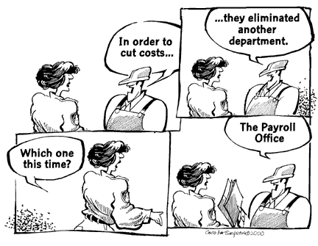

The TomTom welcomes your views and comments. Send them to afgevp@yahoo.com

This edition of The TomTom can also be found on our Website, www.geocities.com/afgevp.
Feel free to visit the Local’s site, as well as sign up for our Listserve. But PLEASE READ RESPONSIBLY ON YOUR PERSONAL TIME.

