Group: Grand Chapter of Arkansas
Title: Pages

Year 2009 - 2010
Please return this form with measurements and payment to the following address by August 15, 2009 for guaranteed delivery.

Creative Touch
Ship by: November 15th 2009
817 Terra Bella Drive
Please call us for a FREE catalog for your chapter or individual!
1-800-622-4272
www.fashionwise.com

Milpitas, CA 95035-4546

Phone: (408)-942-0696 Toll Free: (800)-622-4272

Fax: (408)-946-3821

Website: www.fashionwise.com Attn: Kimi

E-mail: CreativeTouch@fashionwise.com
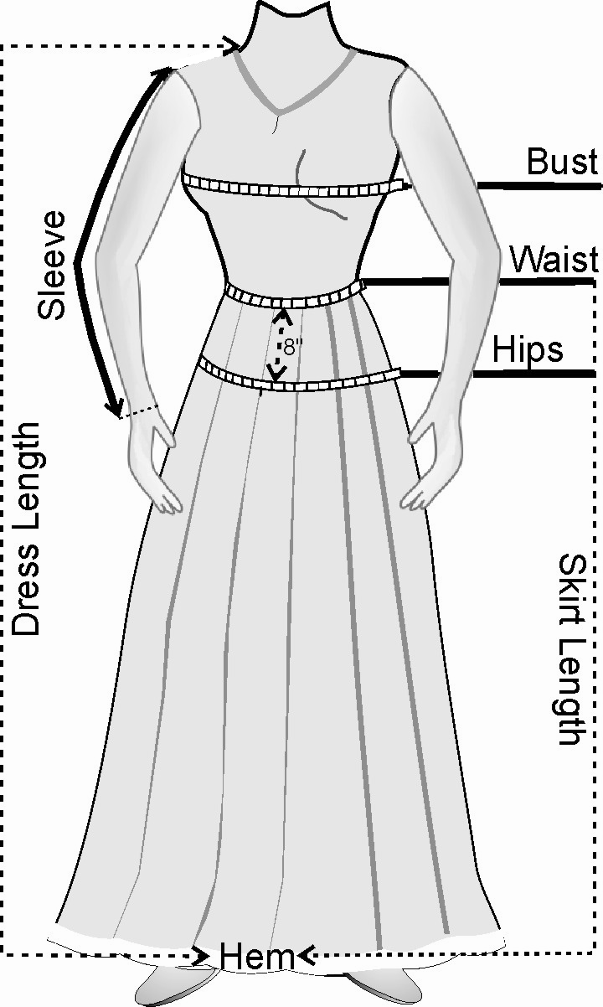

STYLE:
Top: T358 – White w/ Purple stars _
(Beaded star top, elbow sleeves, zipper in the back)
Skirt: SK204 – Purple __________________________
(Georgette satin, Half circle, elastic waist, washable)

YOUR MEASUREMENTS:
Note: Put the tape measure around the fullest part of your bust, waist and hips.
Measurements should be body-measurements not the garment measurements.

Bust (inches): ______________________________________
(Not the bra size):
DO NOT ADD EXTRA TO YOUR MEASUREMENTS
Waist (inches): _____________________________________

Hips (inches): ______________________________________

Skirt length (inches): ________________________________
(From top of the waist band to hem)
Height: ____________________________________________

Usual size you wear: _________________________________

YOUR INFORMATION:

Name: ______________________________________________________________________________

Street or P.O. Box Address: _____________________________________________________
(Street address preferred)
City: _______________________________State: _______________ Zip: ________________________

Home Phone: (________)- ___________________Daytime phone: (________)- ___________________

E-mail Address: ____________________________________________
(include E-mail to receive package tracking information)

AMOUNT DUE
Top & Skirt: _$150/set (including one time shipping) Amount Enclosed: .
NOTE: Size 18 (XXL) to Size 24 (3X) will require additional $10.00 for the set. Size 26 (4X) and over requires $20.00
Any changes in measurement after shipping can be replaced with extra cost.

Paid by (Check one): O Check (Enclosed check or money order with this form)
O Visa/MasterCard only (please complete the information below)

Charge Card #:________________________________ Exp. Date:_________ Signature:______________________

