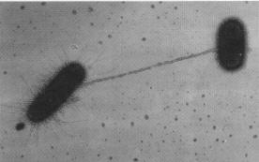
The Wild World Of
Bacteria
© C. Brinton
The Wild, Wild World of Bacteria

Hunter and Hunted

The bacterial world is one of hunter and hunted

Vampirococcus
Bdellovibrio

Bacterial Movement

Some bacteria stay still
Some are moved by other forces
Some move themselves

So how do bacteria move?

One of the methods is by a ‘tail’



The direction of spin controls the direction of travel

Bacteria with flagella at many sites have a more complex movement

Microbiologists call this a ‘biased random walk’

It is powered by an electric motor

Other methods of movement:

Gliding

Gas vesicles

Bacterial Senses

Wide array of senses

Light
Can destroy some bacteria
Vital for photosynthesis

Chemicals
Food
Poisons

Water ‘purity’
Magnetic fields

Electric currents

Temperature

Oxygen

No bacteria are known that uses all of these senses.
.

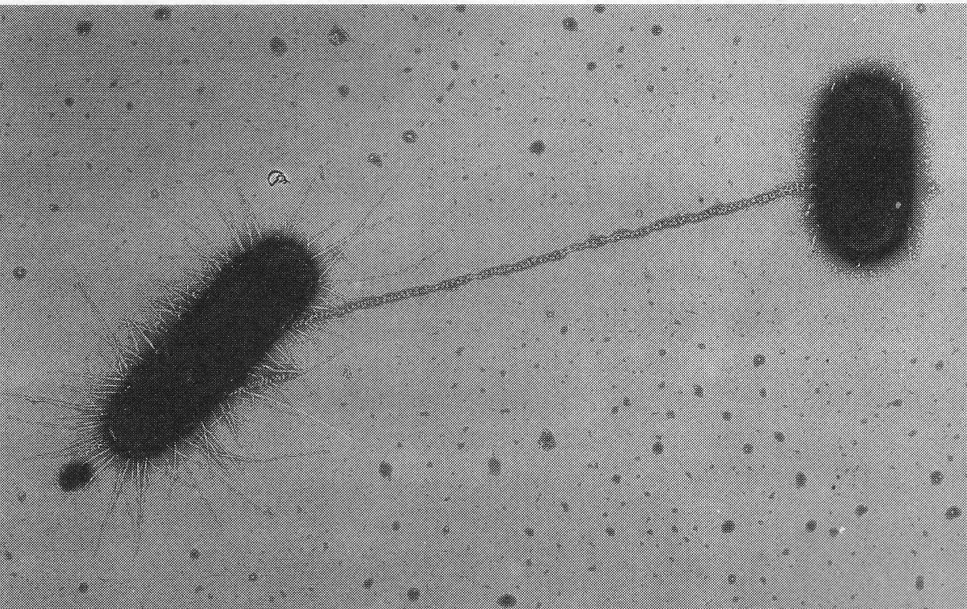
Sex and Reproduction
© C. Brinton

Bacteria reproduce by splitting into two new bacteria (see below)

They have no sexes as normally understood

Bacteria do have a mechanism for passing DNA to each other in a special form called a plasmid.

Plasmids are circles of DNA:
- They are reproduced when the cell divides.
- Each new cell receives at least one of the plasmids.
- They often contain useful genes

Plasmid transfer is one of the methods by which antibiotic resistance spreads

So how do the bacteria make this transfer?

Several methods exist

The one considered uses a pilus (a long straight tube)

Formation of this tube is caused by the f plasmid
(‘f’ for fertility).
f +
f -
Pilus

Can contact bacteria that do not have the f plasmid

A copy of the f plasmid then travels from the f+ bacterium to the f- bacterium – the f- becomes f+

Takes about two minutes

Cannot contact bacteria that already have f plasmid

Sometimes all of the f+ bacterium’s genes are transferred and not just the plasmid

Immortality and Hibernation
. Many microbiologists think that a bacterium will not die unless it is killed

Many bacteria have evolved survival mechanisms to allow them to withstand adverse environmental changes and starvation.

Endospores

Myxospores

Summary

Some bacteria can actively swim

There are several methods for doing this including a corkscrew-like tail

Bacteria can have many senses including:
Chemicals, Light, Temperature, and Water Purity

Some bacteria can pass genes to each other

‘Conjugation’

Bacteria may be immortal

Some have very efficient survival mechanisms

Endospores

Myxospores

Bacteria are incredible organisms, solving fantastic problems in packages far to small to be seen with the naked eye. They are not just causes of disease – most exist in their own wild world without ever directly affecting us.

