GPS+GLONASS Technology at
Chuquicamata Mine, Chile

Héctor Contreras, Geocom S.A.

BIOGRAPHY

Héctor Contreras is the Engineering Manager of Geocom S.A. in Chile. He is a Civil Engineer and holds an MS degree from The Ohio State University. He is a lecturer in Satellite Geodesy at the University of Santiago of Chile. For the past 10 years he has concentrated on the applications of satellite positioning for surveying and navigation.

ABSTRACT

Chuquicamata mine is the largest open pit copper mine in the world. Located in the Atacama Desert in northern Chile, the driest desert in the world, at an altitude of 3000 meters, Chuquicamata mine has a 6km by 4km pit with a depth of 800 meters. Chuquicamata produced 650,000 tons of fine copper in 1997.

The engineers of Chuquicamata have been involved in studying the development of GPS technology in mining applications. They were testing GPS receivers from the very early stage of development, when there was too few GPS satellites to get satellite coverage inside the pit. So that problem was one of the main concerns about GPS.

Also, at that time there were only post-processing techniques, which in productive environments made the system inefficient.

Finally, when real time techniques and a full constellation of GPS satellites were developed, it was thought that the problems would be solved. But the depth of the pit did not allowed to have full spatial and time coverage. Mine operations can not be dependable on when there will be enough satellites to work: the job has to be done any time, anywhere in the mine.

Enough satellites to work accurately and effectively with GPS RTK means six or more satellites. Inside the pit and close to a wall there are few moments where this condition can be met. Secondly, it was noticed that double frequency GPS receivers are sensitive to loss of lock of the L2 signal in comparison with L1. In other words it is advantageous to add more observables adding more L1 signals from extra satellites instead of adding a weaker L2 signal from the same satellites.

When Ashtech developed a receiver, which can use all the satellites in view, GPS and GLONASS, there was a big interest in testing this technology in the Chuquicamata pit. Thanks to this scenario, Chuquicamata took the decision to incorporate to its surveying operations Ashtech GPS+GLONASS RTK receivers. This is the first step. Next step is to install GPS+GLONASS RTK in Drills and Shovels for machine control, where there is a more demanding solution yet.

To date, the system has been fully operational for more than six months, giving a very good solution today in surveying with a satellite positioning system in a mining environment like Chuquicamata.

Still an optimized performance is expected with a full GLONASS constellation.

INTRODUCTION

Mining is a very demanding activity, where most of the systems have to work 24 hours a day. GPS certainly can improve the efficiency of the operations, mainly in surveying and more recently in machine control. An open pit mine has some advantages and some disadvantages for using GPS technology. One of the advantages is that the mine operations are concentrated in a limited area. One of the disadvantages is that the high walls of the open pit limit the sky view.

In order to get real time centimeter level accuracy, it is necessary to use a differential technique or relative positioning usually mentioned as Real Time Kinematic (RTK) positioning or Carrier Differential GPS positioning (CDGPS). A base station is setup at a known point from where it has to send satellite carrier phase data through a radio modem. Any rover capable of processing differential carrier phase data can use a radio modem to capture the data sent by the base receiver, and so compute a precise centimeter level solution once ambiguities are solved.

Therefore, the satellite positioning system has to work in real time kinematic (RTK) and the more satellites available the better. For some years the best technology available was GPS dual frequency P-code receivers. This technology gives a fast, accurate and reliable solution, usually with a 6+ satellite window. But in practice it has two drawbacks in mining: satellite availability inside the pit, and lost of ambiguities due to multipath.

About a year ago it was possible to experiment combined GPS and GLONASS receivers in RTK mode with on the fly (OTF) ambiguity resolution. These receivers can use simultaneously both satellite systems increasing satellite availability. Besides, these receivers are single frequency, so there is another difference that had to be tested: its practical effects in solving ambiguities.

CHUQUICAMATA PROJECT

Chuquicamata engineers were testing extensively satellite positioning systems from the very beginning, deciding finally to incorporate the Ashtech GPS+GLONASS technology.

The first part of the project is to install a GPS+GLONASS RTK system for mine surveying, to be followed by machine control.

The main requirements are:

- Real time RTK.
- OTF ambiguity resolution.
- Full satellite coverage.
- Full radio coverage.
- Surveying in local mine coordinates.

To fulfill the above requirements, the complete system has the following components:

- 1 Base GG-RTK station.
- 1 fixed radio repeater.
- 1 mobile radio repeater.
- 4 Rover GG-RTK station.
- 4 Mine Surveyor software for the rovers.
- 1 GG-RTK spare.

The area of the mine was study to choose the optimum location for the base station and radio repeater, taking into account the following:

- Satellite coverage.
- Radio coverage.
- Power supply.
- Existing Facilities.
- Accessibility.

After decided the location of the base station and radio repeater, it took place the installation, which was made considering continuous operation.

The GPS+GLONASS base station can provide satellite information to any rover in and around the mine, as long as there is radio coverage in the particular area. These rovers can be of any type, i.e. surveying rovers or machine rovers, such as shovels and drills.

Then each rover was setup for RTK operations in local mine coordinates after measuring a set of local control points to get transformation parameters between WGS-84 coordinates and local mine coordinates.

RESULTS

The experience shows that GPS can increase productivity as well as decrease costs in mining surveying. But, GPS-only could be used only during some hours a day inside the pit of Chuquicamata, loosing its advantages over traditional surveying.

Using a combined GPS+GLONASS system, satellite availability is increased, getting in practice a mean of 7 GPS+GLONASS satellites in view at the bottom of the pit, enough to obtain real time precise positioning.

The maximum number of satellites in view at the bottom of the pit has been 12. A mean of 11 satellites is in view above a cutoff angle of 10º in the surface around the pit.

Figures 1 and 2 show a simulation of the satellite window and satellite geometry during 24 hours for GPS-only and for GPS+GLONASS. The cutoff angle used is 30º, i.e. satellites at a lower altitude are not considered, which is a fairly close representation of the environment at the Chuquicamata pit.

Satellite geometry is evaluated through a Dilution of Precision factor (DOP), which represents how disperse the satellites in view in the sky are.

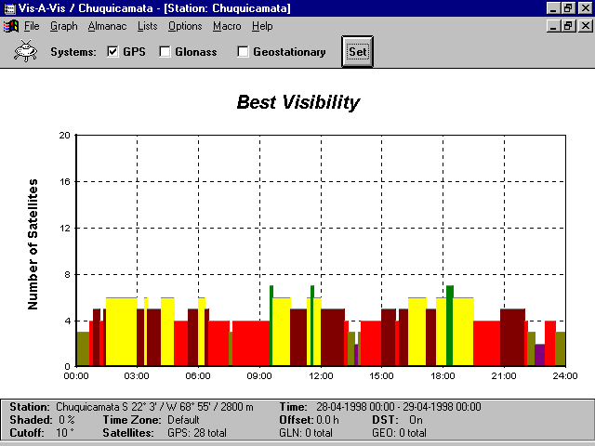
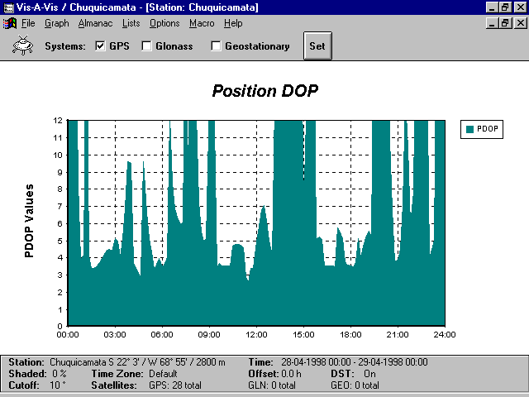

Figure 1. Satellite availability and geometry, GPS-only.

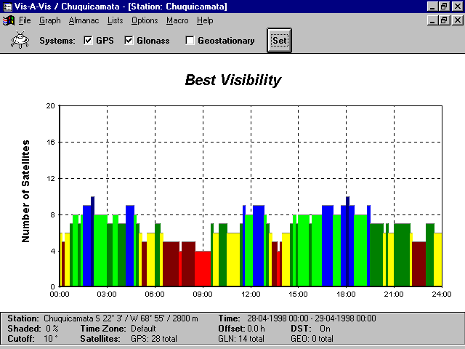
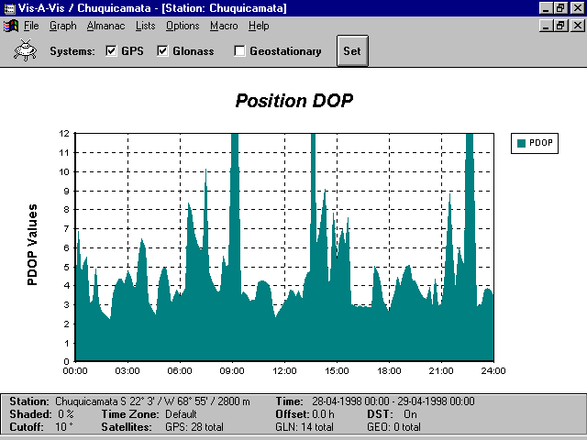

Figure 2. Satellite availability and geometry, GPS+GLONASS.

For a precise 3D positioning it is necessary to resolve the ambiguities. Ambiguity is the number of cycles of the carrier between satellite and receiver antenna. Once the ambiguities are solved, the accuracy of the carrier phase observation can be determined to a hundredth of a cycle, i.e. to a mm level considering L1 carrier cycle to be 19cm. Finally the resulting positioning can be estimated to a cm level. Five satellites in view are usually the minimum requirement to resolve the ambiguities. With 4 satellites in view it is possible to get a solution but usually it is going to be at the meter level.

Figure 1 shows the peformance of GPS-only. It can be seen that there are about 4 hours a day where there is no chance to obtain a 3D solution, since there are less than 4 satellites. For a precise (5 or more satellites) and reliable (PDOP less than 6) solution there are only some 7 hours a day.

In figure 2 GLONASS constellation of 14 satellites is added. Virtually a solution can be obtained all day long, while during about 16 hours a day the solution can be precise, increasing more than 2 times GPS-only availability.

It is interesting to observe that in an ideal situation for satellite window, where usually a 15º cutoff angle is applied, the addition of even a limited GLONASS constellation of 14 satellites, gives a precise solution 24 hours a day. Meanwhile GPS-only still has some satellite window problems during some hours a day.

This analysis was done from the report given by a planning module software from Ashtech Office Suite for Survey (AOSS), considering a 24 hours period for April 21, 1998, using almanac data from the same date. The GPS constellation consisted of 28 satellites, while GLONASS constellation had 14 satellites.

To date, the GPS+GLONASS system has been fully operational in Chuquicamata mine for more than six months, being used in the following tasks:

- Mine surveying.
- Drill design surveying.
- Shovel front surveying.
- Cut and fill operations.
- Stake out operations.
- Mapping.
- Mine navigation.

The only limitation that has been detected is the difficulty at some moments to solve ambiguities, which would be improved adding some extra satellites.

CONCLUSIONS

Now there is a promising solution: GPS+GLONASS System. Ashtech developed a receiver, which can use all the satellites in view, GPS and GLONASS, resulting in a tremendous increment in satellite availability. Besides, when there is a good GLONASS constellation, ambiguities are solved almost instantaneously, meaning that the GLONASS constellation plus the GPS constellation can provide accurate and fast RTK positioning almost everywhere, like deep mining pits, under tree canopy, in high density cities, where GPS-only has been always limited.

Now, comparing GPS+GLONASS single frequency technology with GPS-only dual frequency, the results found in practice are the following:

- Satellite availability is increased by a factor of 1.5.
- Positioning availability is increased by a factor of 2.
- Ambiguity resolution is faster close to the base station (usually 5km or less) and slower at about 5km or more.
- GPS+GLONASS ambiguities are maintained fixed under literally every condition, with a very good response to multipath environment. GPS-only ambiguities are easily lost due to any nearby obstruction.

REFERENCES

Van Diggelen, Frank (1997): GPS and GPS+GLONASS RTK. Proceedings of ION GPS-97, September 16-19, Kansas City, Missouri, 139-144.

Hall, T., Burke, B., Pratt, M., Misra, P.: Comparison of GPS and GPS+GLONASS Positioning Performance. Proceedings of ION GPS-97, September 16-19, Kansas City, Missouri, 1543-1550.

