DERIVADA UTILIZANDO A REGRA DO PRODUTO

1)
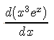

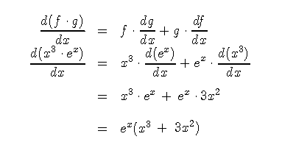

2)

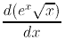

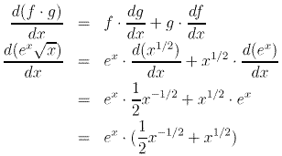
3)
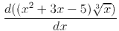

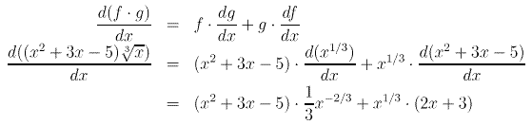

4)
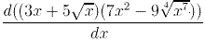

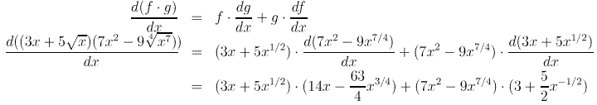

5)
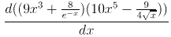

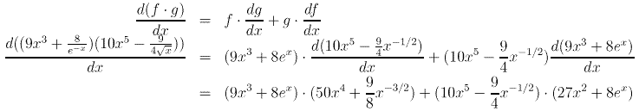

6)
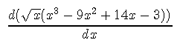

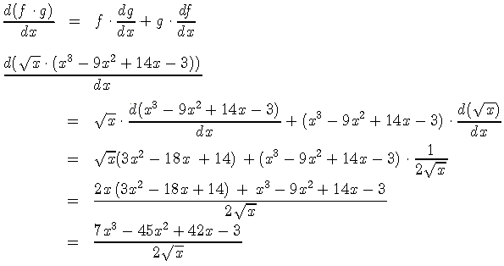

7)
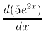

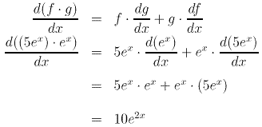

8)
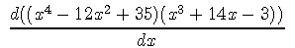

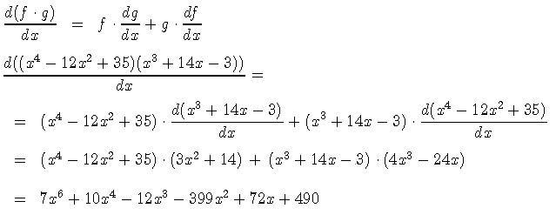
9)
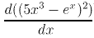

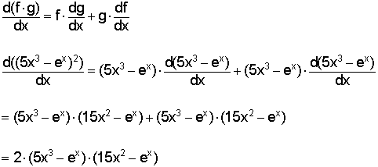

DERIVADA UTILIAZANDO A REGRA DO QUOCIENTE
10)
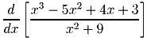
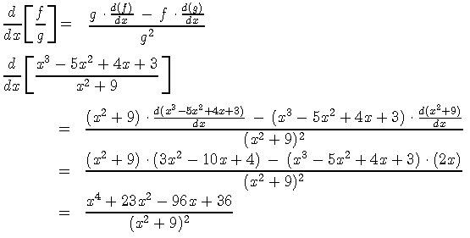
11)
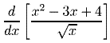

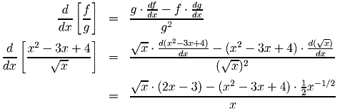

12)
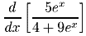

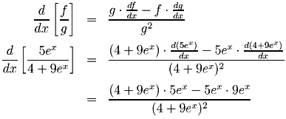

13)
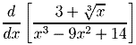

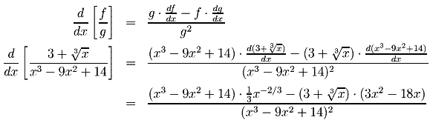

14)
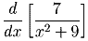

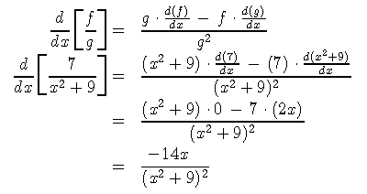

15)
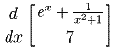

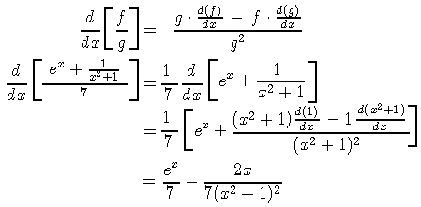

16)
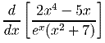

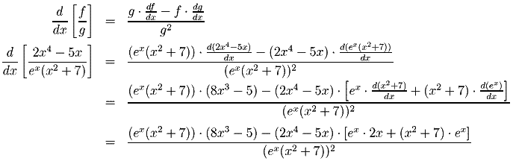

17)
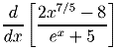

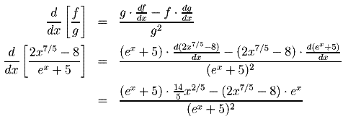

18)
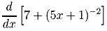

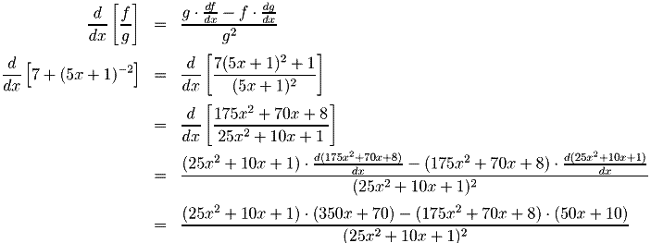
19)
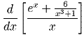

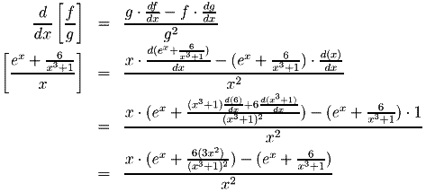

DERIVADA DE FUNÇÕES TRIGONOMÉTRICAS USANDO A REGRA DO PRODUTO

20)
Problem: Using the product rule, find the derivative of the function
Solution:
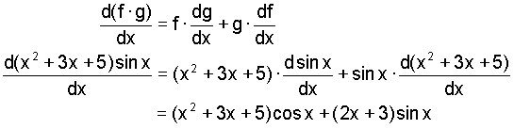

21)

Problem: Using the product rule, find the derivative of the function
Solution:
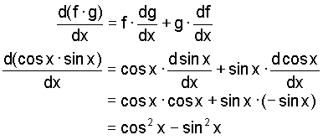

22)
Problem: Using the product rule, find the derivative of the function
Solution:
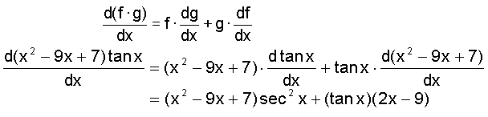

23)
Problem: Using the product rule, find the derivative of the function
Solution:
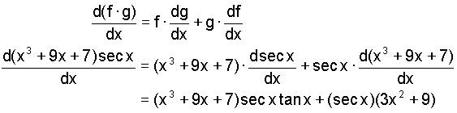

24)
Problem: Using the product rule, find the derivative of the function
Solution:
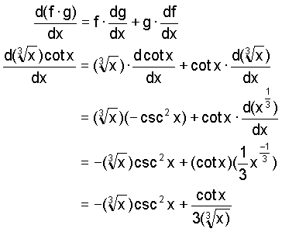
25)
Problem: Using the product rule, find the derivative of the function
Solution:
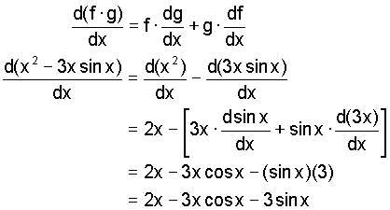
26)
Problem: Using the product rule, find the derivative of the function
Solution:
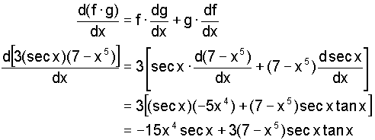

27)
Problem: Using the product rule, find the derivative of the function
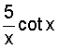
Solution:
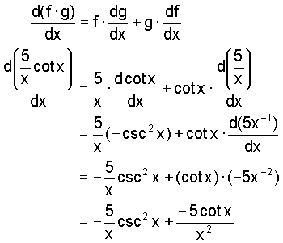
28)
Problem: Using the product rule, find the derivative of the function
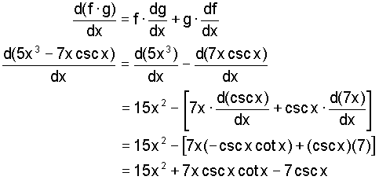
29)
Problem: Using the product rule, find the derivative of the function
Solution:
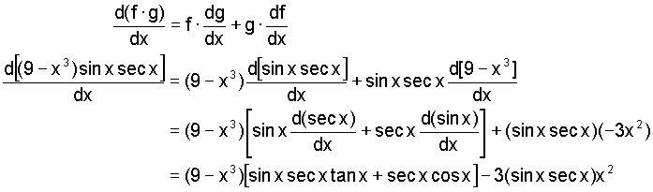

DERIVADA DE FUNÇÕES TRIGONOMÉTRICAS USANDO A REGRA DO QUOCIENTE
30)
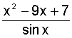
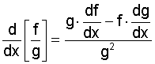
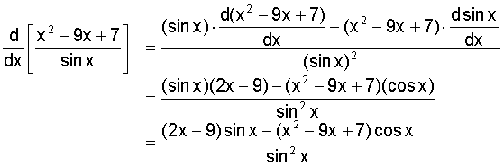
31)
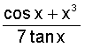
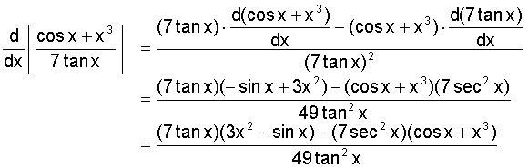

32)
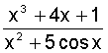

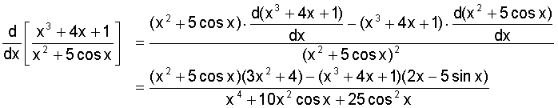

33)
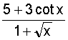

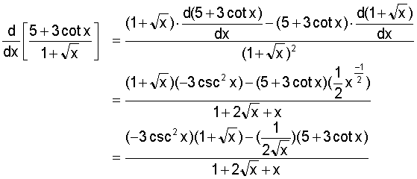

34)
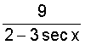

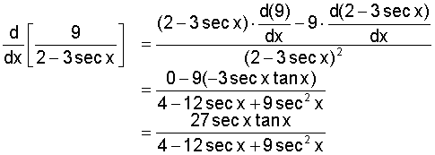
35)
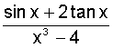

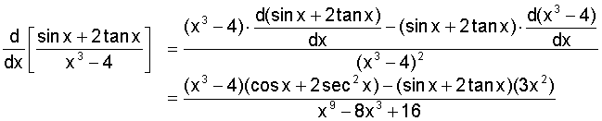

36)
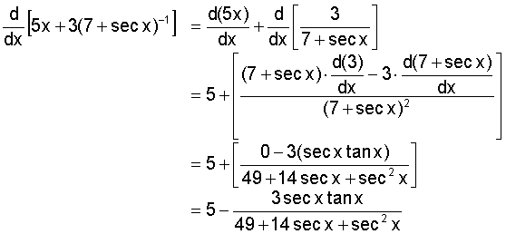
37)
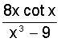
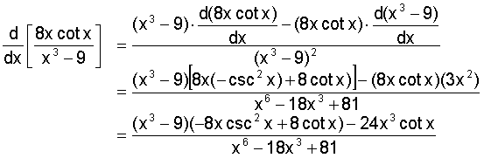

38)
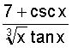
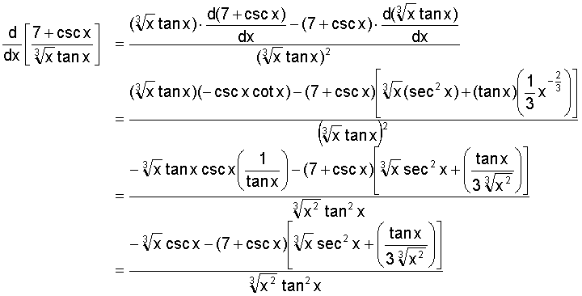

39)
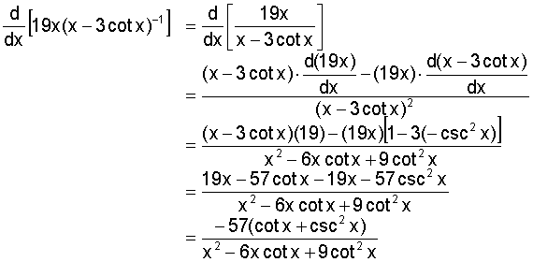
DERIVADAS USANDO A REGRA DA CADEIA
40)

41)
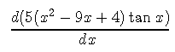

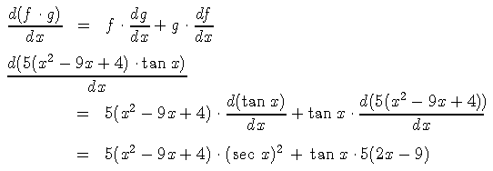

42)
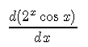

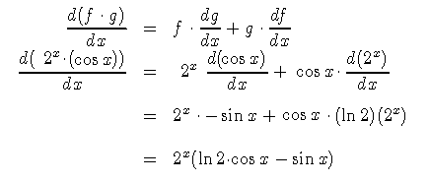

43)
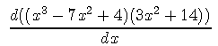

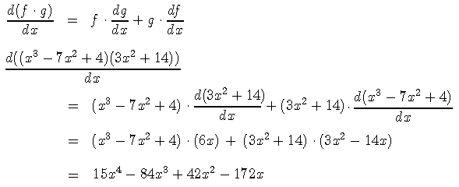

44)
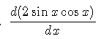

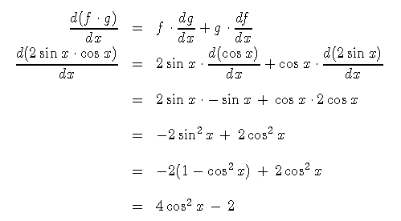

45)
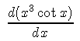

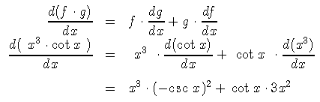

46)

47)
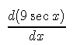

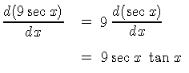

48)

49)
