Dressing the Part

One of our few requirements is that everyone attending our functions wear a reasonable attempt at Middle Ages-style clothing. The easiest garb to make is a T tunic and a pair of pants or a simple gown. This clothing was appropriate for everyday wear throughout much of the Middle Ages.

- Fabric: Cotton is best.
  - For a T tunic you need enough to go from mid-thigh over your shoulder and back down to mid-thigh, plus about a half yard. Depending on your size, this will probably be about 2 ½ yards to 3 ½ yards
  - For a gown, you need enough to go from the top of your foot, over your shoulder and back down to the floor, plus about a half yard. Depending on your size, this will probably be about 3 ½ yards to 4 ½ yards
- Thread which matches your fabric
- A loose fitting T- shirt to use as a pattern
- A pair of scissors
- A few pins
- You will need something to mark your fabric If you choose a dark color fabric, chalk will work. If you choose a light color use a fabric marking pen or a pencil
- A sewing machine, unless you want to hand sew
- An iron and ironing board

To make your garb follow these simple steps
- Wash your fabric in hot water with laundry soap and 1/2 cup vinegar to set the color and shrink the material. Dry it on the hottest heat allowed by the fabric
- Fold your fabric into fourths
- Iron your fabric
- Fold your T shirt in half lengthwise
- Lay your t shirt on the fabric and draw your patterns as shown in Figure A. As you draw, add at least an inch more than you think you need to make room for the seem
- Cut along your line
- Open up your cut tunic
- Fold neckline down 1/4 inch press flat
- Fold neckline down 1/4 inch a second time, press flat. This finishes the seam
- Sew along the neckline
- Fold your tunic in half so that it is inside out pin it, and sew along the sides
- You must now hem the sleeves and bottom hem line. To make a hem fold the very edge of the fabric up then over again Iron
- Pin and sew so that everything stays in place
- Clip the edges around the underarm close to the sewn line, be careful not to cut the threads.
- Turn your tunic right side out
- You are done

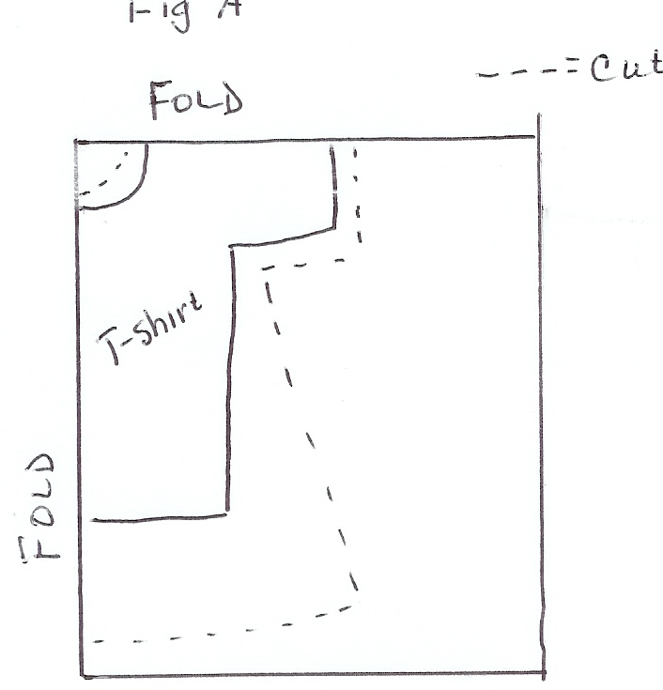Figure A

