Biscuit
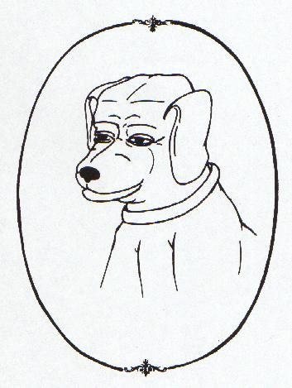

The Bomb Hunter
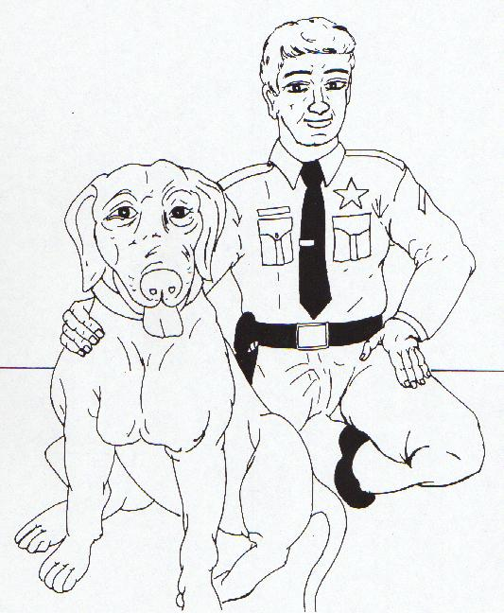
Hi! I’m Biscuit, and this is my partner, Deputy Chuck.
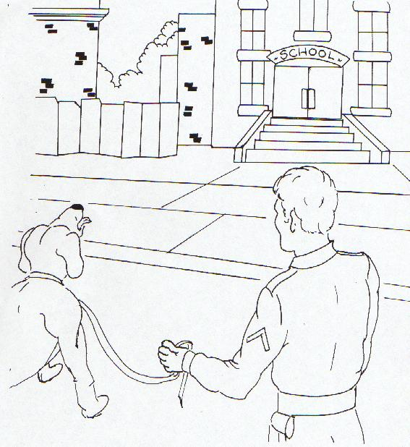
To become bomb hunters, we had to go to school!
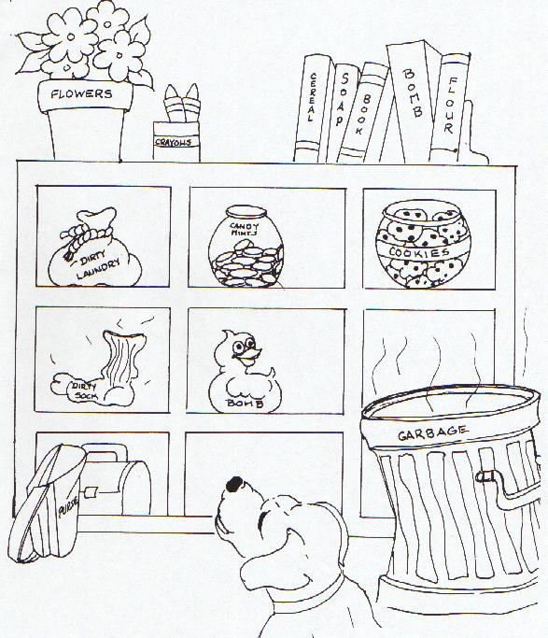
Learning to smell for chemicals that explode took a long time!
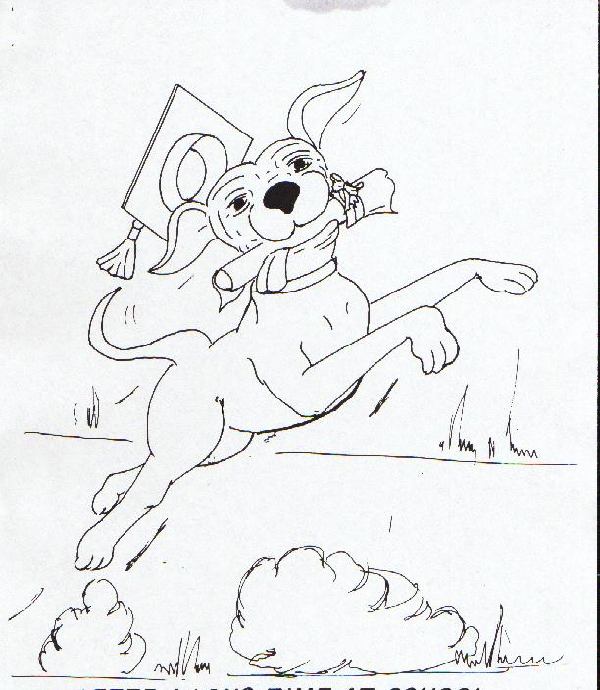
After a long time at school, I graduated!
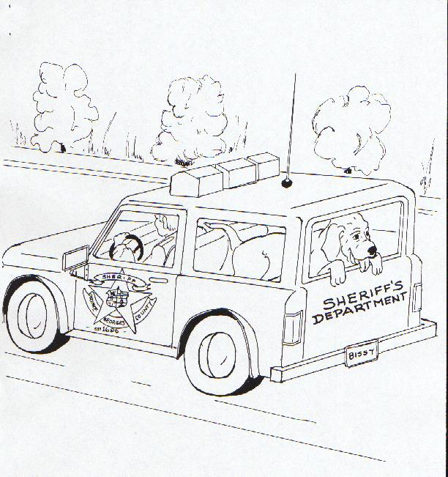
I like riding in the car. Going to work is fun!
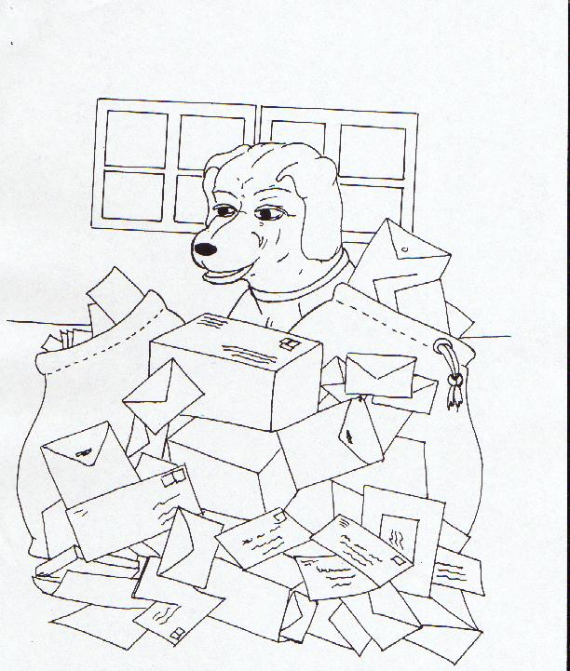
Each morning I check the mail for explosive devices.
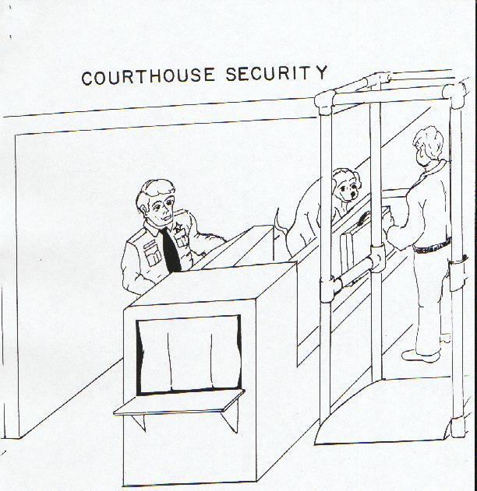
Another job I do is to sniff check briefcases before they enter the courthouse.
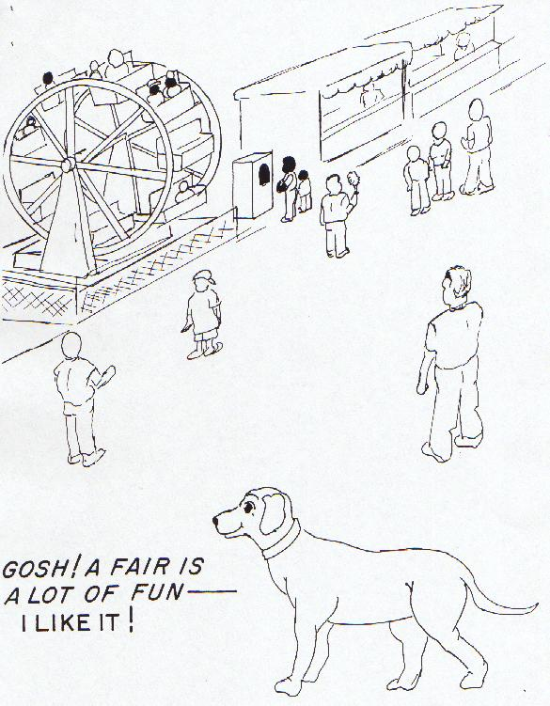
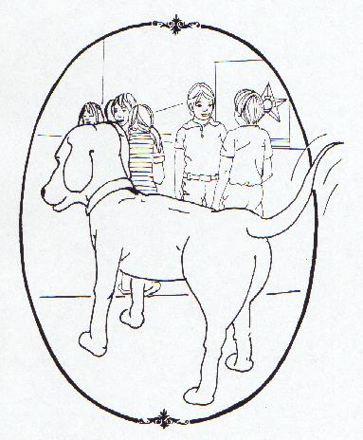

See you later!

