Chapter 13 MOTIVATION

Motivation is a psychological process that is defined as a will to do, the urge to achieve goals.

Many theories as to what motivates individuals.

CONTENT THEORY

MASLOW, Abraham- a hierarchy of needs

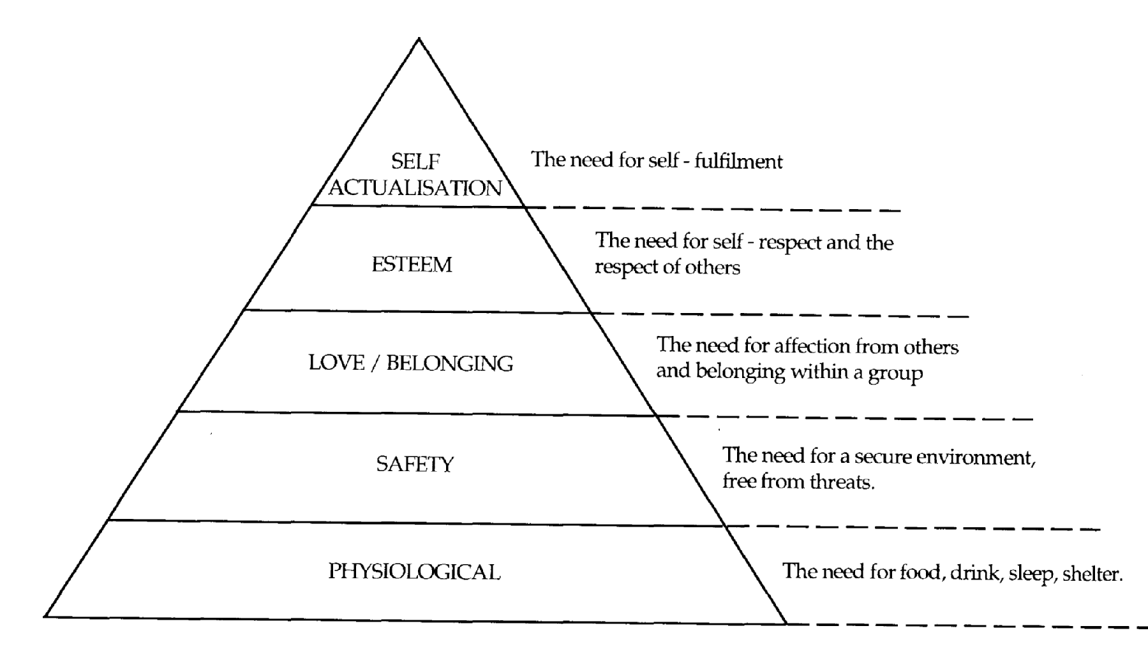

Maslow believed that people are never completely satisfied. By being aware of the needs of people means able to motivate them to work or to work harder.

HERZBERG, Frederick- preventive and growth needs

Motivation and maintenance.
Motivational needs are those which achieve satisfaction and fulfillment be being actively sought.

Maintenance needs are to avoid pain and dissatisfaction. (Hygiene factors.)

MOTIVATING FACTORS | HYGIENE FACTORS
Achievement  Recognition  Work itself  Responsibility  advancement | Company policy and administration  Technical aspect of supervision  Salary  Interpersonal relations  Working conditions

MCCLELAND’S ACHIEVEMENT MOTIVATION THEORY

3 Fundamental needs as motivators :
- achievement – the need to attain something which is related to a specific set of standards
- affiliation – the need to develop interpersonal relationships
- power- the need to influence

PROCESS THEORY

VICTOR VROOM – EXPECTANCY THEORY

People will be motivated to do things to reach a goal is they believe in the worth of that goal and if they can see what they can do will help them achieve it.
Perception that effort will lead to effective performance
Perception that effective performance will lead to rewards
Perception that attractive rewards are available
effort
Characteristic of individuals
Actual performance
Role perception
intrinsic
rewards
extrinsic

EQUITY THEORY

Adams’s equity theory focuses on people’s feeling on how fairly they have been treated in comparison with the treatment received by others.

When people sensed inequities in their work they will be motivated to remove the discomfort and restore a state of felt equity by:

- changing work inputs
- changing rewards received
- leaving the situation
- changing comparison points
- psychologically distorting the comparisons

MANAGERIAL BEHAVIOUR

McGregor, Douglas – traditional versus modern theories of management
Theory X and Theory Y

Theory X- more traditional. Assumption: people are inherently lazy, not ambitious, avoid responsibilities and work only when necessary.

Motivation must come from outside as it does not exist within. Consequently the type of motivation must be an appeal to greed or fear with constant supervision.

Theory Y– more modern. Assumptions are that work is natural to the individual and can provide enjoyment and satisfaction. People are self-directed if they are committed to the job and the direction in which it is going. People seek responsibility and creativity in a Theory Y atmosphere, because they relate their personal goals to their manager’s objectives. There is discussion, understanding and mutual agreement as to targets, which can only result in high efficiency and high productivity.

HANDY, Charles - MOTIVATIONAL CALCULUS

Each Person is motivated at a given time will depend upon a number of factors influencing that person at that time.

Each individual person has a specific motivation calculus in respect of every decision taken and this can be on a conscious or subconscious basis. Three factors:-

- Needs
- desired results
- Expenditure (E) factor

ARGYRIS, Chris – MATURITY/IMMATURITY THEORY

Personal development of people.

Infancy(immaturity) | Maturity
Infant passivity | Adult activity
Dependence | Relative independence
Limited behaviours | Many different behaviours
Erratic, shallow interest | Deeper and stronger interests
Short time perspective | Longer perspective
Subordinate family position | Equal or superior position
Lack of self awareness | Self awareness and self control
Directive style of management fosters immaturity and dependency whereas a more participative management styles fosters mature and active employees.

OUCHI’S THEORY Z

Management style and practice in different cultural setting. (Findings based on American-owned and Japanese-owned multinational companies).

Characteristic of Theory Z organization are:
- long term employment
- slow evaluation and promotion
- moderately specialized careers
- consensual decision making
- individual responsibility
- implicit informal control
- concern for employees
WAYS IN WHICH MANAGEMENT CAN MOTIVATE STAFF

- Role of management
  - Motivating staff to perform at the upper limit of performance
  - Coaching staff to develop ability and increase potential for high quality work
  - Clarifying and enforcing standards so that poor performers are given the opportunity to evaluate and discuss their performance.

- Employee’s behaviour-management must understand the way employees actually behave. 4 groups of people:
- rational-economical man
- social man
- self actualizing man
- complex man

- Participation-employees are involved in actions and decisions that affect them. By participating, there is a recognition of the value of staff and it provides a sense of accomplishment and “being needed”.

- Quality of work life (Davis and Cherns 1975) – to improve all aspect of work life especially job design, work environment, leadership attitudes, work planning and industrial relations.

- Job design-role definition ie defining what activities are carried out by a job holder.

Herzberg’s 3 avenue that management can follow in attempting to improve staff satisfaction and motivation:
    - Job enrichment
    - Job enlargement
    - Job rotation

REWARDS SYSTEM

Achievement of high performance may be through offering positive rewards and vice-versa.

Therefore it is important to identify opportunities for development and advancement and conduct regular performance reviews so that performance can be monitored.

MONEY AS A MOTIVATOR

Very powerful motivator.

MASLOW-pay is unique and it can satisfy all needs, directly in the case of lower level needs, indirectly for prestige of being a high salary earner.

McClelland-high need achievers view pay as performance feedback and a measure of goal accomplishment. Group bonuses are attractive to high-need achievers.

Herzberg- pay is normally view as a hygiene factor when it is view as a merit increase that give special recognition for a job well done.

Adam (Equity Theory)-pay is an object of social comparison and is a major reason for felt inequity.

V. Vroom (Expectancy Theory)- pay is only one of many works reward. When instrumentality and expectancy are high, pay can be a source of motivation.

Effects of money as a motivator

- money can buy, great purchasing power. Significance of money : power.
- Increasing differential between jobs creates feelings of a senior status in the person enjoying higher salary : status

Non-financial motivators
- participation
- quality of work life
- job design

FEEDBACK

Feedback is very important if motivation is to grow. The feedback should be clear and frequent.

