Email Subject Line:
Quality Custom Jewelry - We cut your production costs so you get more business

Email Body :

Jewelry Designers, Wholesalers & Volume Buyers :

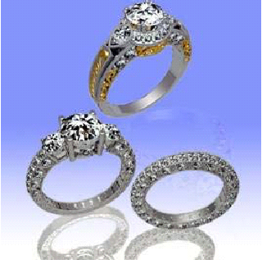

Did you know that you could save thousands of dollars while offering your customers hand-made, designer & custom jewelry ?

Get the creative edge and price advantage that will set your business apart !

Alexander Jewelry is a reputable manufacturer of designer jewelry.
We offer a jewelry production service to stores that:

> need to place large production orders
> create a new line of jewelry
> offer customized designs to their customers.

Now you can offer unique, quality jewelry pieces tailored to your customers’ needs and desires - all without having to invest in production facilities.

As an American company based in California, we understand the demands and quality issues of exquisite jewelry in the US market. We also have a production facility in China which allows us to offer competitive pricing on both custom fabrications and large production runs.

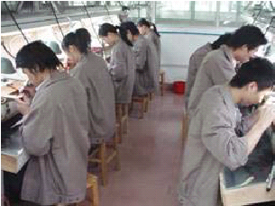

With Alexander, you can :

- Turn your designs from idea to reality WITHOUT investing in manufacturing facilities

- Expand your product line with innovative pieces

- Get exceptional savings on quality products

- Have access to our skilled craftsmen for sophisticated hand engraving or hand-crafted filigree

- Benefit from our initial minimum order quantity of 10 pieces.

Plus, we provide 3D rendering and real-time online tracking so you can keep track of everything from the design stage, all the way through production and delivery of the final product.

Let us help you be the jeweler that meets the most discerning customer’s designing whims and fantasies.

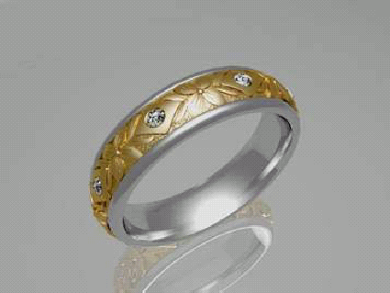

Please visit our site www.alexanderjewelry.com for more information. You can also reach us by phone or email. Our company representative will gladly answer any questions you have or provide you with a quote.

Ask us today how we can help increase your business and save you on production costs.

Yours truly,

Alex Tran

Alexander Jewelry
1111 Story Road Showroom 1063
San Jose, California 95122
toll-free: 800.917.2539
tel: (408) 920-0720
fax: (408) 904-7134
info@alexanderjewelry.com

Member of the Jewelers Board of Trade
Member of California’s Jewelers Association
Member of Jewelers of America

P.S. By outsourcing the mass production of your jewelry pieces with a reputable manufacturer such as Alexander, you benefit from our expert craftsmen while saving thousands of dollars as you won’t have to invest in manufacturing facilities. We are in the business of helping jewelers develop unique, quality product lines. Alexander offers amazing products and services so that you, in turn, can amaze your customers.

