INSERT HERE BUSINESS NAME OF BUYER/DESIGNER
INSERT THEIR ADDRESS

Dear Jewelry Designers, Wholesalers and Volume Buyers :

Did you know that you could save thousands of dollars while offering your customers hand-made, designer & custom jewelry ?

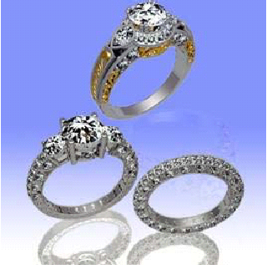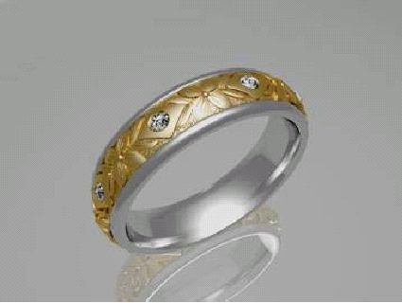

Understanding that the jewelry industry is highly competitive, we want to provide you with a creative edge and price advantage that will set your business apart. Now you can offer unique, quality jewelry pieces tailored to your customers’ needs and desires - all without having to invest in production facilities.

Please allow us to introduce ourselves. For over 10 years, our company Alexander Jewelry has thrived as a quality manufacturer of designer jewelry, specializing in 18K and platinum. We’re an American company based in California, so we understand the demands and quality issues of exquisite jewelry in the US market. In addition, we have a production facility in China which allows us to offer competitive pricing on both custom fabrications and large production runs.

With over 60 craftsmen in our company, Alexander has the ability to do mass production as well as hand-made jewelry pieces in larger quantities. We offer a jewelry production service to stores that:

- need to place large production orders
- create a new line of jewelry
- offer customized designs to their customers.

This means as a designer, wholesaler or volume buyer, you can:

- Turn your designs from an idea or sketch phase to production without having to invest in manufacturing facilities

- Expand your product line with innovative pieces

- Obtain exceptional savings on quality products

- Have access to our skilled craftsmen who can do sophisticated hand engraving or hand-crafted filigree

- Offer your customers jewelry of brilliant caliber, hand-crafted by our in-house artisans

- Benefit from our initial minimum order quantity of 10 pieces (most of our competitors require a minimum of 50).

Plus, we also provide 3D rendering and real-time online tracking so you can keep track of everything from the design stage, all the way through production and delivery of the final product.

To say it simply, we provide production services that are efficient and cost-effective. You save money while offering your customers quality products with an originality that is limited only by their imagination.

By providing your customers the option to buy unique designs, to have the pieces crafted to their specifications and to take advantage of competitive prices, you are setting your business apart as the jeweler who takes customer satisfaction one step further. Let us help you be the jeweler that meets the most discerning customer’s designing whims and fantasies.

We would like to invite you to visit our web site www.alexanderjewelry.com for more information on our mass production and custom manufacturing services. You can also email or call us, it will be a pleasure for our company representative to answer any questions you may have or provide you with a quote. Please don’t delay, contact us today and ask how we can help increase your business and save you on production costs.

Yours truly,

Name Here

Alexander Jewelry
1111 Story Road Showroom 1063
San Jose, California 95122
toll-free: 800.917.2539
tel: (408) 920-0720
fax: (408) 904-7134
info@alexanderjewelry.com

Member of the Jewelers Board of Trade
Member of California’s Jewelers Association
Member of Jewelers of America

P.S. By outsourcing the mass production of your jewelry pieces with a reputable manufacturer such as Alexander, you benefit from our high-caliber craftsmen while saving thousands of dollars as you won’t have to invest in manufacturing facilities. We are in the business of helping jewelers develop unique, quality product lines. Alexander offers amazing products & services so that you, in turn, can amaze your customers.

