Technical Co-ordinationits
PLANET has several "Technical Co-ordination Units" (TCUs) each focusing on a particular technological or application aspect, like the TCU on knowledge engineering for planning and scheduling.

Knowledge Engineering
Applying emerging software technologies to real problems often involves developing new methods which incorporate these technologies, and developing
tools and platforms to support the methods.
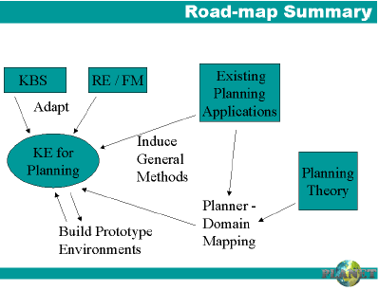
Whereas the area of “Software Engineering” originated from the need to provide a sound methodological base to the application of software, "Knowledge Engineering" has grown up as the area that provides methods to assist the implementation and maintenance of knowledge-based systems (KBS). Hence the field of knowledge engineering in AI planning deals with activities involved in implementing and maintaining the knowledge-based aspects of planning systems. This includes the acquisition, validation and verification, and maintenance of planning domain models (the latter are formalised, abstract models that an agent can use to make rational deductions about the application domain the model represents). It also includes the selection of appropriate planning machinery and its integration with the domain model to make up a planning application.
The Knowledge Engineering for Planning Technical Co-ordination Unit (KE TCU) of PLANET has been active for the past 3 years. It aims to identify and explore the current major problems involved in developing knowledgebased planning systems, and to examine the potential of future developments (such as the Semantic Web) to contribute to solutions of these problems. We also aim to synthesise related research and techniques from work in more general research areas into a relevant contribution to this area.
To achieve these aims the TCU is active in organising workshops and sponsoring cross-site visits in the subject. Further, we have created and are maintaining a Roadmap Document which summarises past work, and includes a collection of activities and problems that need to be tackled for the future. The Roadmap distinguishes Planning
from the more general field of KBS in that the knowledge elicited is largely knowledge about actions, and how objects are affected by actions. Also, the ultimate use of the planning domain model is to be part of a system involved in the synthetic task of plan construction (in contrast to classification or diagnosis tasks common in KBS). Our Roadmap examines topics inherited from these areas, and attempts to point out where we can learn from past work; it also contains other related research areas such as Machine Learning, KE Tools and Formal Methods. The diagram summarises the Roadmap's recommendations for future research. The community needs to adapt technologies and learn from related fields such as KBS, Requirements Engineering and Formal Methods. Research is needed to induce methods from existing experience with planning applications, to catalogue plannerdomain compatibility, and to build prototype environments for assisting in the process of KE.
Looking towards the future, we see the areas of knowledge sharing through the use of ontologies, and the development of the Semantic Net as very important to support KE in Planning. As more and more planning technology finds its way into applications, knowledge engineering issues are recognised
as crucial to an application's success. The KE
TCU therefore covers fundamental issues which are relevant to all of the application-oriented TCUs.
The current Roadmap, the associated working documents, and presentations from the workshops are available on the Knowledge Engineering TCU's web pages at:
http://www.planet-noe.org
[Technical Coordination Units]
Contact: Lee McCluskey
lee@zeus.hud.ac.uk

