Can You Tell What Possible Shape or Shapes I may Be?
Place an “X” in the most appropriate box below save and email me the result. ( dwilson16@nyc.rr.com )
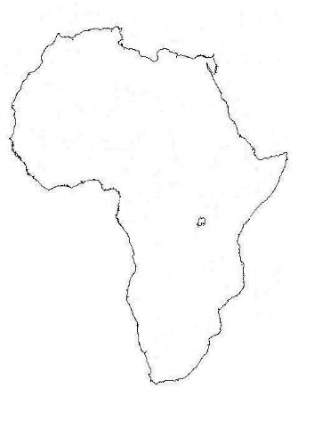 | 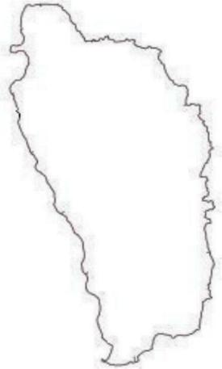
   | Africa |  | Human head |  | Horse’s head |  | All of the above
   | Dominica |  | Penguin |  | All of the above |  | None of the above
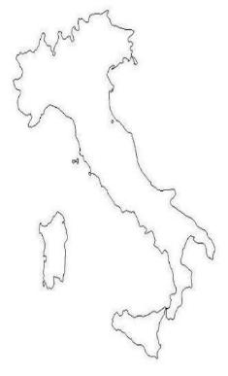 | 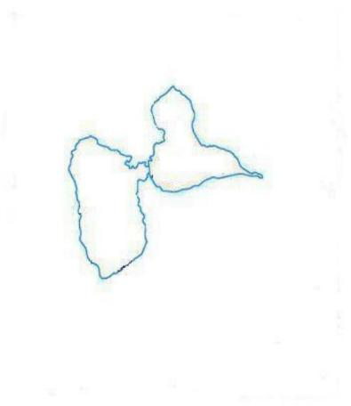
   | Italy |  | Boot |  | All of the above |  | None of the above
   | Guadeloupe |  | Butterfly |  | All of the above |  | None of the above

