Can You Tell What Possible Shape or Shapes I may Be?
Place an “X” in the most appropriate box below save. Then email me the results. ( dwilson16@nyc.rr.com )
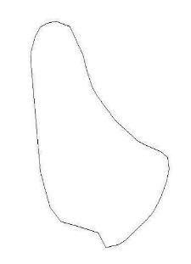 | 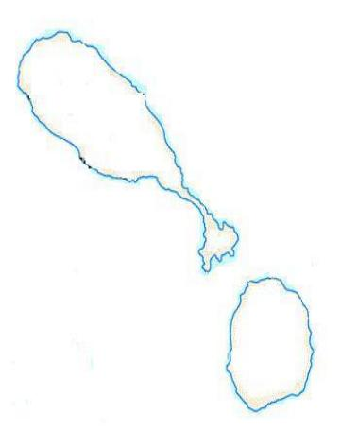
   | Barbados |  | Boxing glove |  | Ham |  | All of the above
   | St Kitts/Nevis |  | Club/Ball |  | Exclamation mark |  | All of the above
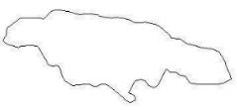 | 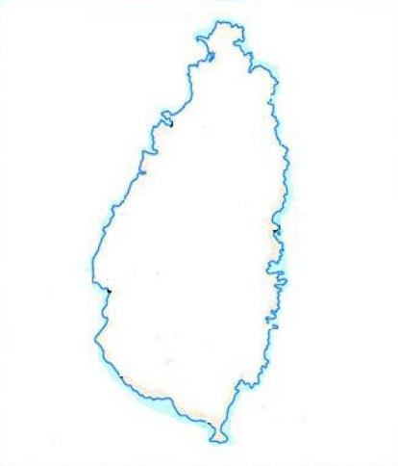
   | Jamaica |  | Sea Lion |  | All of the above |  | None of the above
   | St Lucia |  | Ham |  | All of the above |  | None of the above

