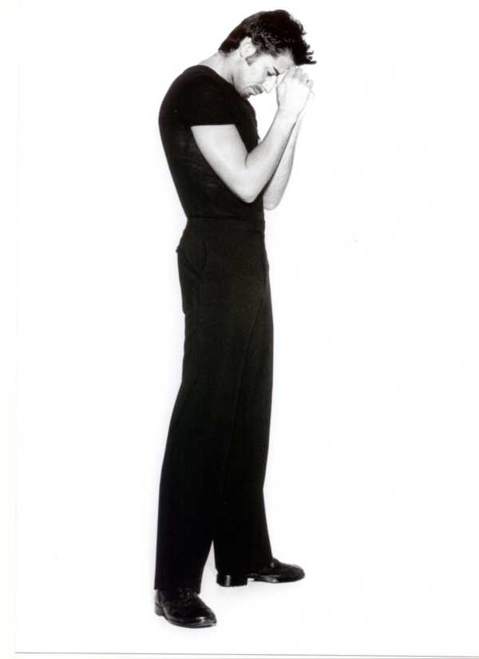
Sean Stephens
Auf der Ruhr 9 – 11
D – 50667 Köln
mobile: +49 / 174 / 2076355
home & fax: +49 / 221 / 250 89 02
webpage: www.sean-stephens.eu.tt
email: seanstephens_mail@yahoo.de

Height: | 1.80 meters
Hair: | Black
Eyes: | Brown
Vocal Range | Baritone
Equity Number | FOO125115

PROFESSIONAL EXPERIENCE
CHICAGO Swing Capitol Theatre, Düsseldorf
SATURDAY NIGHT FEVER Ensemble, Musical Dome, Köln
Fight Captain,
cover Double J.,
Joey, Chester
Ass. Resident Dir.
ROCKY HORROR PICTURE SHOW Phantom, cover Riff Raff Waxx Theatre, Düsseldorf
GAUDI Soloist Dancer, swing Musical Dome, Köln
BUGSY MALONE Laughing Boy , Her Majesty´s Theatre, London
cover Dandy Dann
DER MAGIER SALOME Magician Traumtheater Salome, Tour Germany
ZAUBERVOGEL Soloist Dancer Traumtheater Salome
MIDNIGHT FOLLIES Soloist Dancer Costa Cruise Lines & Williams Club, Milan - Italy
LES BALLETS ALZETAR Soloist Dancer Cannes, France
NIGHT OUT Soloist Dancer Casino Ruhl, Nice - France
ZYGO FOLLIES Soloist Dancer Zygo Parc, St. Isodore - France

FREELANCE
Apperance as Dancer at RTL Television “ DEUTSCHLAND SUCHT DEN SUPERSTAR”
Appeared as Dancer/Model for FORD MOTORS, MOSCHINO, C&A, “JUST ONE WORLD”, MARTIN MOSS, QUELLE, MERCEDES BENZ, CITROEN and the modern dance film BURNT.
VIDEO APPEARANCE in “ OOOHH ooohh (Talking About Love)” by Melanie Thornton.
* Various Appearances on Television as Dance and Actor.

EDUCATION
1986 - 1988 BUSH DAVIES THEATRE ART LTD. East Grinstead, England
1985 - 1986 SAINT LAURENT DANCE COLLEGE Wellington, England
1981 - 1985 REDROOFS THEATRE SCHOOL Maidenhead, England

SPECIAL SKILLS
Stage Combat
Tap Dancing
Languages: Fluent in English, French, German and Italian

TEACHING QUALIFICATIONS
Associate Member of Imperial Society of Teachers of Dancing, London - England:
A.I.S.T.D. Tap / A.I.S.T.D. Jazz (Modern)

