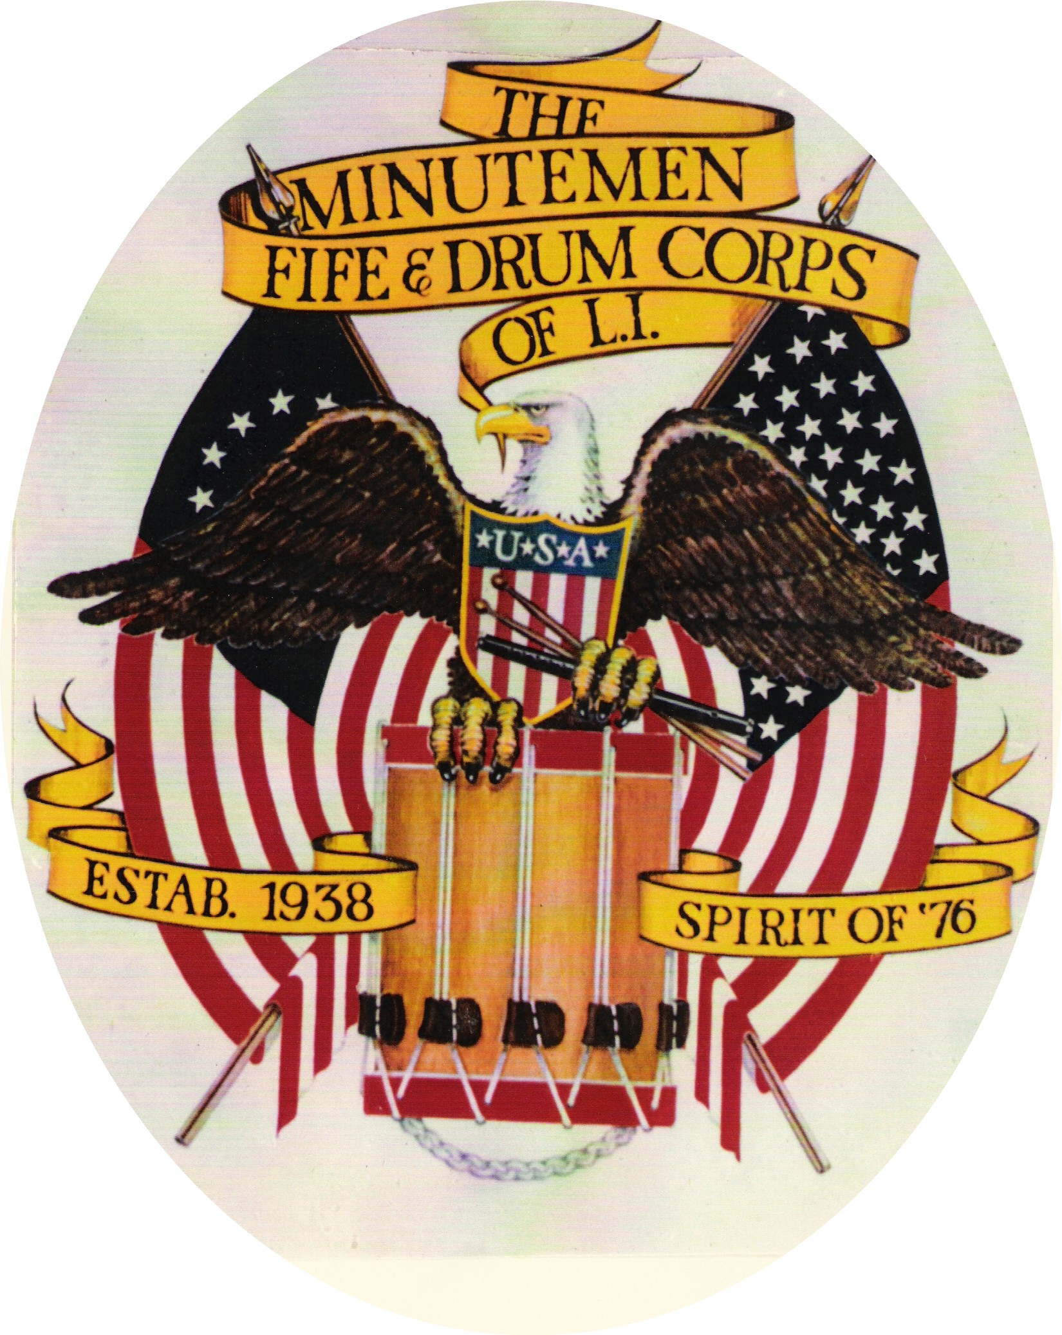
The Fifes and Drums of the Delaware Militia

