The sequence of events for the prototyping paradigm is illustrated in Figure 2-1.

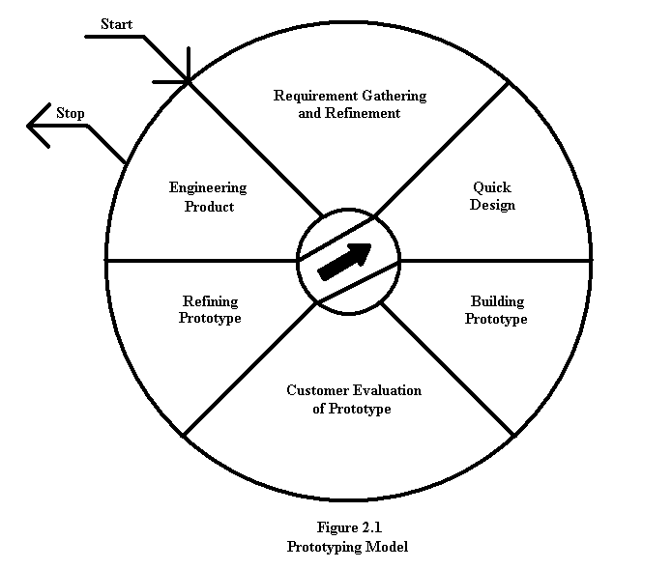
Figure 2 - 1
Prototyping Model

