2.0 Methodology of the Study

Upon gathering the required data, the proponents analyzed the data and chose a software development paradigm that will be best suited for the problem at hand.
The proponents narrowed their choices to the waterfall and prototyping paradigms. Between these two, the researchers decided to use the prototyping approach because prototyping does not only make the development process easier for the system analysts (especially for projects where end user requirements are hard to define) but also it has opened up the application development process to end users(See Figure 2 – 1 for the Prototyping Model). These developments are changing the roles of end users and information system specialists in the system development. Also, the proponents will implement a patch-up approach that will correct the prototype until the requirements are met.

The proponents in this study used evolutionary Prototyping. Evolutionary prototype develops an initial implementation, let the customer see it, and refine it. Most appropriate for systems where it is difficult or impossible to establish detailed system requirements. Mainly used in Artificial Intelligence or Expert System applications where since we don't understand how humans carry out tasks we cannot set out a specification of how the computer will do it. Evolutionary prototype evolves into final product and must therefore exhibit all quality attributes of final product.
Prototyping is composed of the following steps:

- Requirements Gathering and Refinement

In this stage the needed requirements are gathered and in subsequent iteration of the process are refined based on the officiating committee’s input.

During this phase the proponents performed the needed data by performing interviews of knowledgeable persons; questionnaires for other information needed and analyzed the documents of Quezon Convention Center.

- Quick Design

The design is developed to meet the requirements gathered during first step. In this phase conceptual model of the system is developed and analyzed.

The proponents conceptualized and studied how to construct the needed software, hardware, database design and architectural design of the system in this phase.

- Building Prototype

This step focuses on the construction of the software using a main application (programming language)

In this stage the proponents constructs the needed software using Visual Basic 6.0 for user interfaces and applications and Microsoft SQL Server 7.0 for the database. The proponents also construct a hardware prototype of a digital scoreboard containing the game time, shot clock and automated buzzer by constructing circuit diagrams and studying digital electronics.

- Customer Evaluation

During this stage the prototype has been submitted to the customer for system evaluation.

Although the proponents have not conducted this step yet, the proponents should submit the prototype to Quezon Convention Center for evaluation.

- Refining Prototype

In this phase repeating the earlier steps refines the prototype.

The proponents repeated the needed steps to improve the prototype. By refining, the proponents filter and improve the prototype by repeating it rather than doing it once. The proponent used evolutionary prototyping to develop an initial implementation and refines it to exhibit all quality attributes of final product.

- Engineering the Product

Upon completing the first five steps, the final product will be engineered using the information gained from the performance of the initial steps.

The proponents reengineered the product from the prototype by either reconstructing the product or using the patched up as the final product. The proponents may also construct additional features and applications for the software and hardware system as requested.

The sequence of events for the prototyping paradigm is illustrated in Figure 2-1.

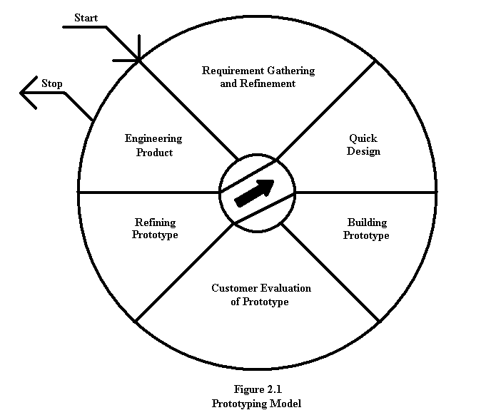
Figure 2 - 1
Prototyping Model

Methodologies that are not used in developing the system:

The proponents did not use throw–away prototyping in this study, because the objective of throw-away prototyping is to validate or derive the system requirements. Throw-away prototyping approach extends the requirements analysis process with the intention of reducing overall life cycle costs. Customers and end-users should resist the temptation to turn the throw-away prototyping into a delivered system that is put into use and it may not be obvious when to begin the design.

The proponents did not choose the waterfall model because it is used when the requirements, conceptual model, and design are considered stable, predictable, and certain. It is only appropriate when the simulation under development has predictable performance expectations, includes reused and previously accredited legacy components or federates, has pre-existing input data, experienced knowledgeable participants, and adequate documentation. Requirement stability and maturity are the most important in these factors of the waterfall model.

The proponents did not chose the spiral model because it is a combination of the two methods as far as rapid prototyping, the spiral model focuses on the analysis of risk at all phases of a programs creation by going through a number of iterations. The risk associated with that phase is analyzed and, if possible, reduced. One method used to analyze and reduce the risk is rapid prototyping, and a component of each phase is to determine the risk of reusing a prototype in the next phase of development. [BOEHM]

The proponents did not chose the RAD prototype because of its disadvantages like quality may be sacrificed for speed, time-consuming, may overlook software engineering principles, inconsistencies among system modules, non compliance with standards and lack system component reusability.

The proponents did not chose the JAD prototype because the proponents and the officiating committee of Quezon Convention Center will not work together in building, constructing and in the development of the product.

