 |  | 
 |  | Name:_____________________________
Printed for Goring District Guides |  | 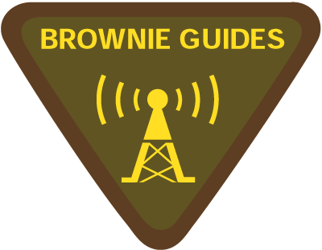
 |  | Name:_____________________________
Printed for Goring District Guides

Clause | Description | Date | Signed
1a | Listen to and tune a radio
1b | Write down details of conversations
2a | Spell your name in the phonetic alphabet
2b | Listen to words the tester spells
3 | Attend TDOTA
4 | Discuss how two way radios are useful
All passed

Clause | Description | Date | Signed
1a | Listen to and tune a radio
1b | Write down details of conversations
2a | Spell your name in the phonetic alphabet
2b | Listen to words the tester spells
3 | Attend TDOTA
4 | Discuss how two way radios are useful
All passed

