Phaze Paws
(Chronicles of the Cat)
by Linda Sabourin

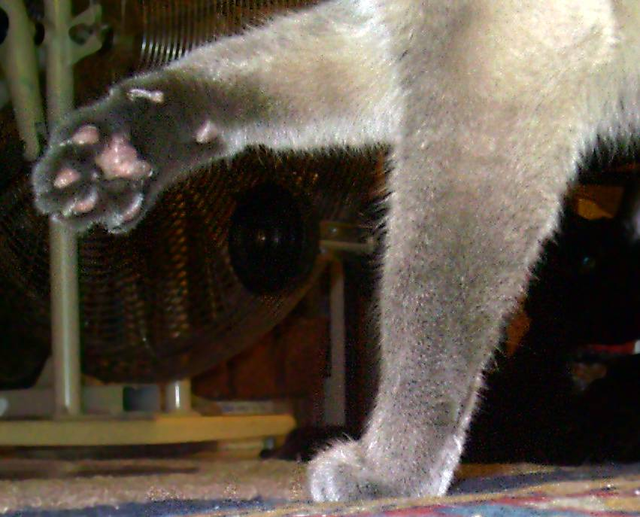

There’s somebody here! Somebody broke in! He doesn’t belong here! Mom’s not home! HELP!!! He’s doing something with the ceiling fan . . . oh, if only I could get to the phone! I must hide! Here – under the covers! He can’t see me so I am hiding!

Finally . . . I think he is leaving! Oh no! I hear footsteps coming toward the bed! I feel a hand patting my head! A voice is saying “See ya later, lump.” MOM!!!!!!!

Mom brought a man home tonight and I think he thinks he is going to stay. I don’t think so! I’ll chase him away! I’ll puke in his boots – yeah, that’ll do the trick! His boots! His ugly smelly boots! His really smelly boots . . . so nice and smelly . . . so smelly . . . on second thought, maybe I’ll let him stay . . . just for a day or two . . .
Mom really ticked me off today. I won’t say what she did – and I’m too dignified to say what I did – but she’s gonna have a little surprise when she pulls out the laundry basket . . .

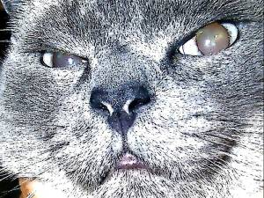

What do you mean, cardboard is not good for my digestive system?

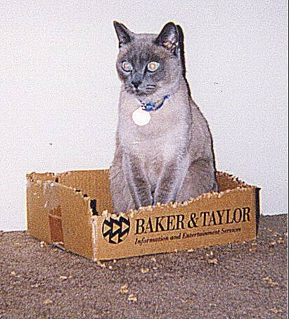
What IS this thing? It’s little and black and fuzzy and I think it thinks I’m its mother!!!!

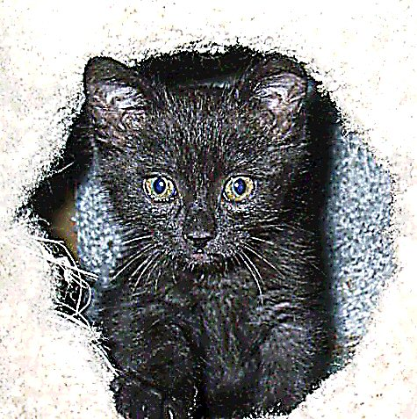
Do you know what it’s like sharing a litter box with two females?!?!?!?!? TWO!!

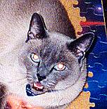

Mom thinks I am too skinny so she has started stuffing me with canned cat food (yum!).

Unfortunately, her ridiculous sense of “fairness” insists that Pest and Pest 2 shouldn’t be left out - and man, are they are getting fat!

I have decided I must rename them. Heretofore, they shall be known as Princess Lard-Ass and Lady Tubbs . . .

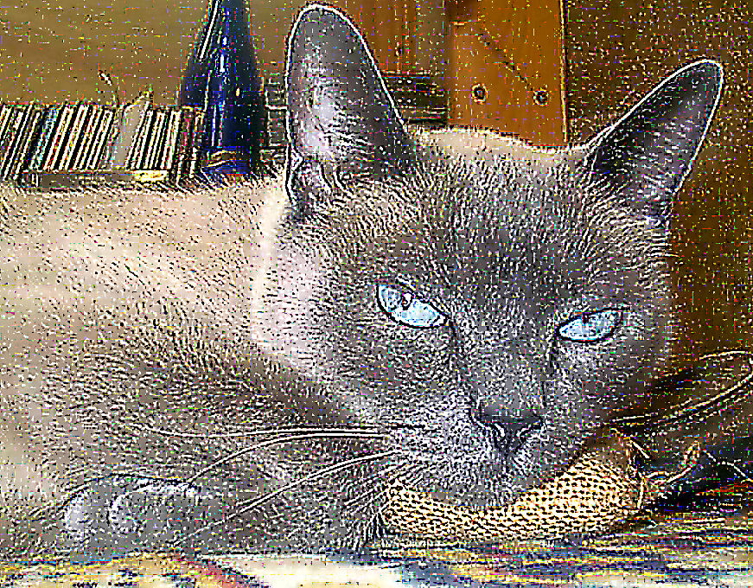
Huh? What’s this? Mom is spraying her hair ORANGE?!?!? And putting on orange eye shadow and lipstick! She’s wearing orange socks with pumpkin balls on them! That’s it – Mom has lost her mind . . . come on, Lard-Ass, come on, Tubbs – I got the box - we’re packing!

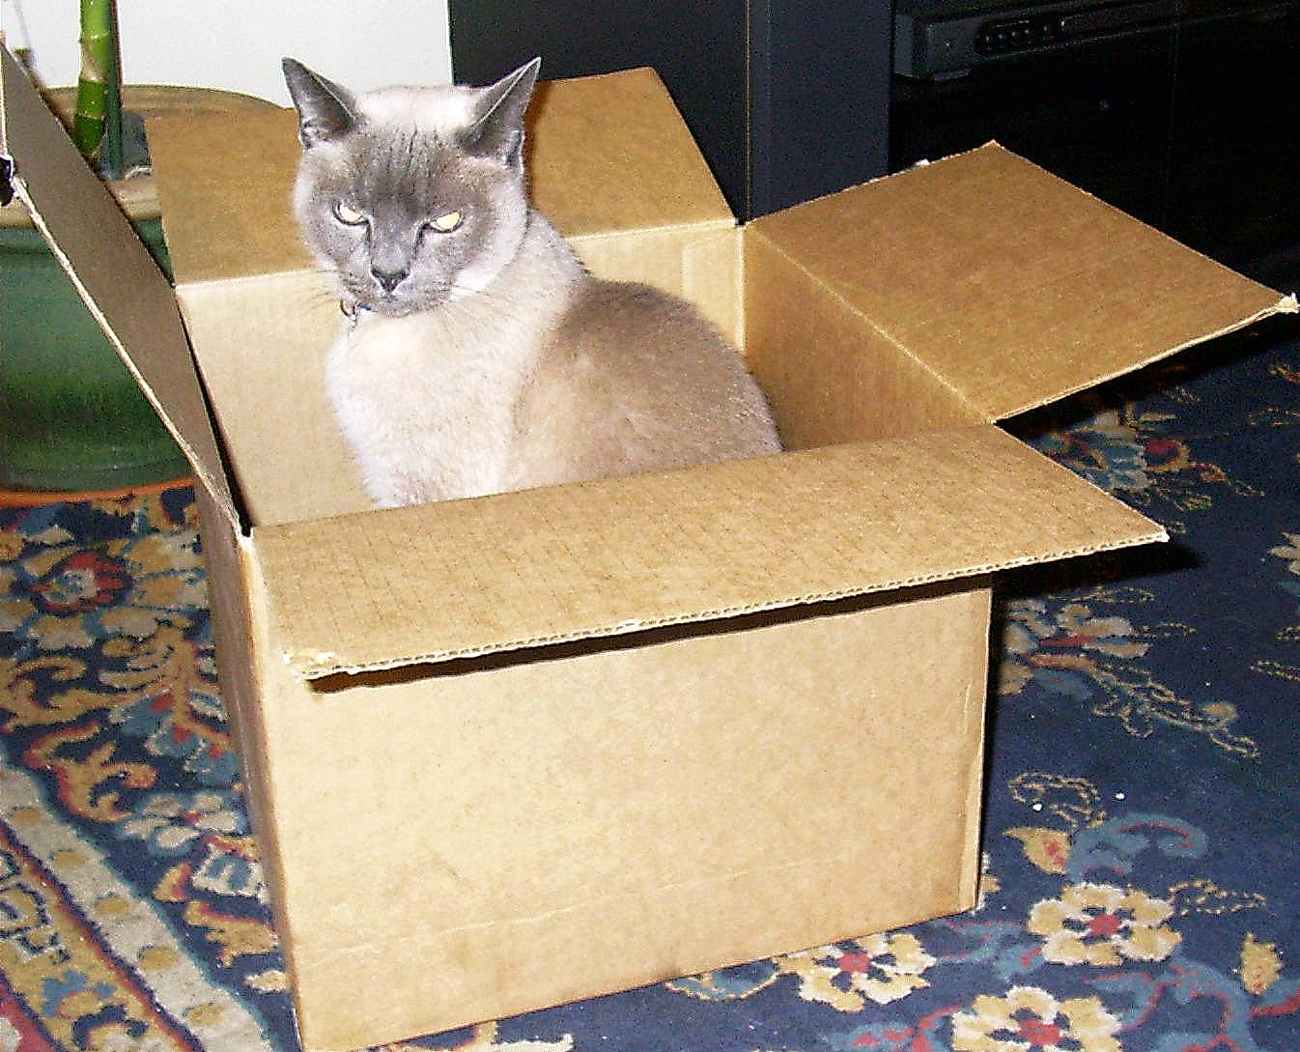

Tubbs attacked me! I think she kissed me! HELP!!! Cat crap in the litter box - I’ve been TUBBED!! My whiskers will never be the same again!!

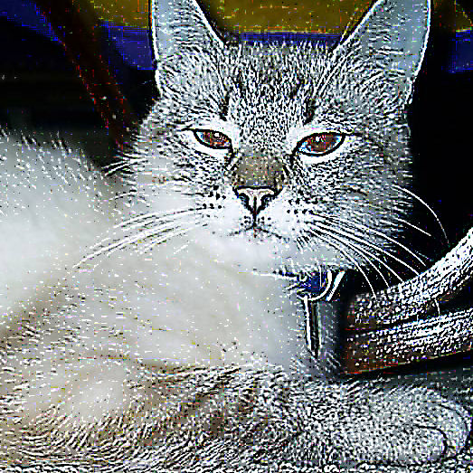
Mom is camera happy! There goes the darn flash again! I spend half my time walking around blind because Mom thinks I'm cute!

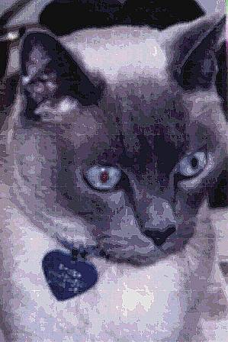
I am praying to the heater god. He has grown cold and unyielding. Please warm me, I beg of you. Please warm me . . . please warm me.

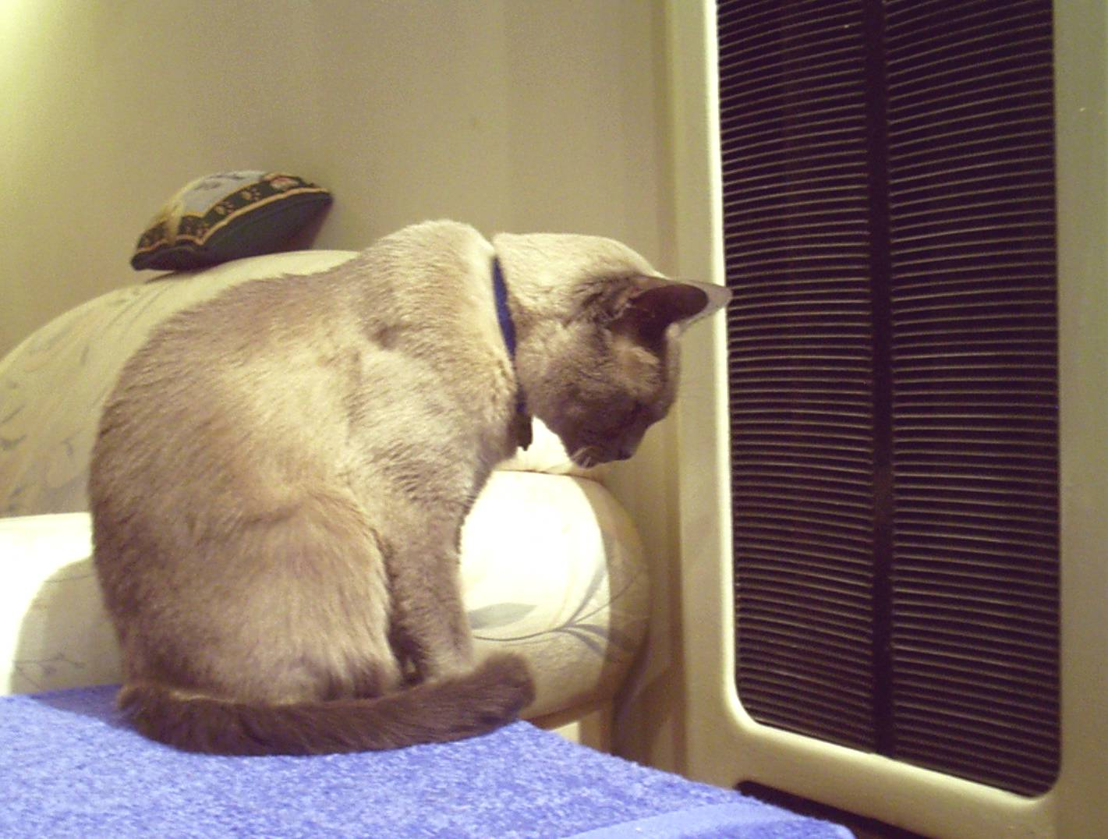
Christmas is here again – and here comes Mom with the camera. She wants nice pictures of all of us to put on the Christmas cards. Personally, I think Tubbs has the right idea . . .

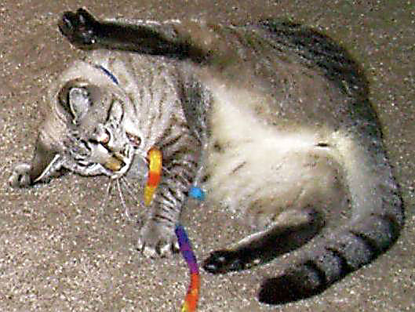

Dad! Dude! Enough with the male bonding! I love you too but can I please BREATHE now?!?!?!

Geez, I’m bonded already!

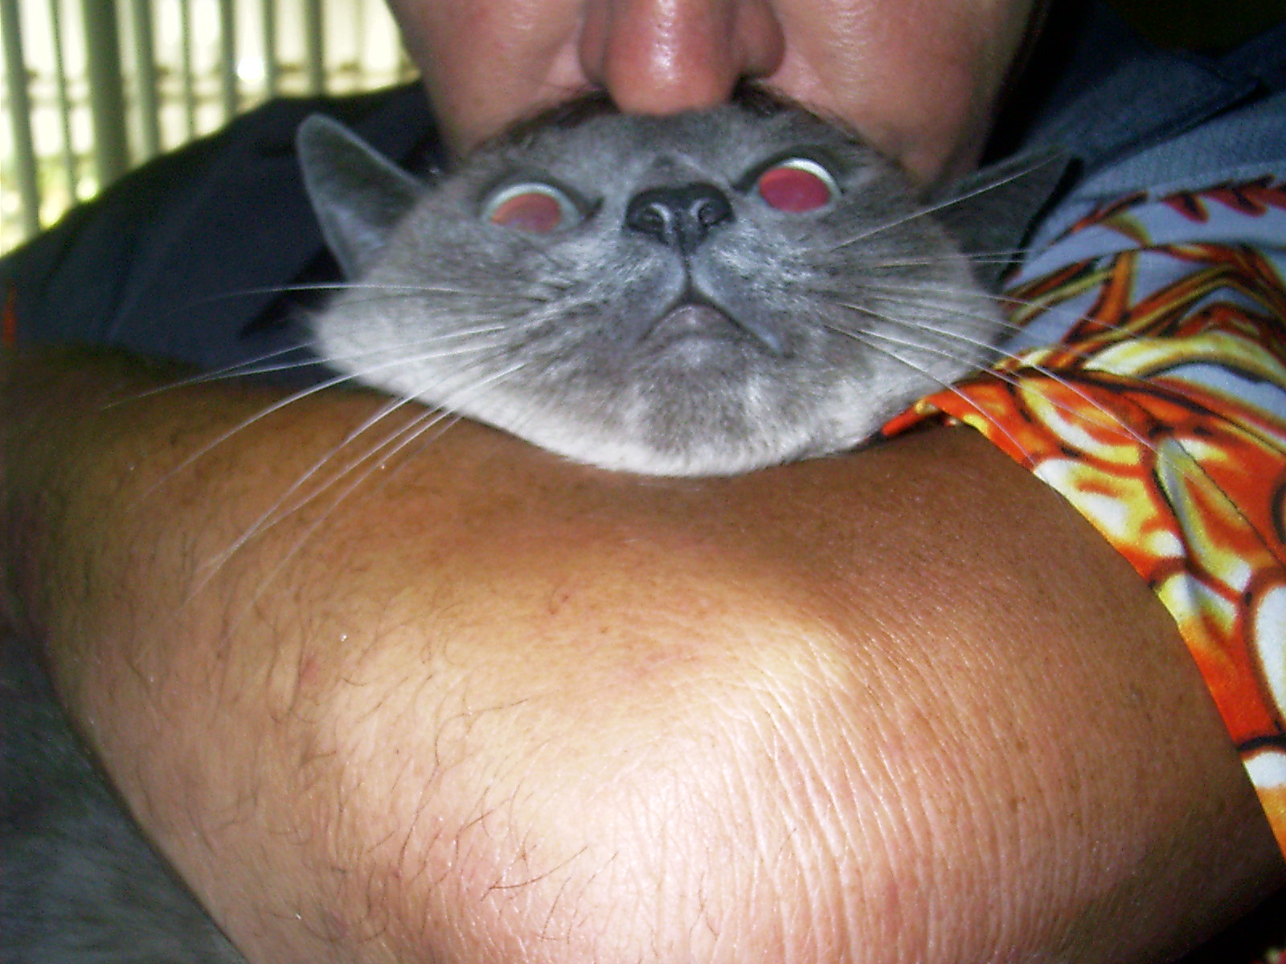
Lard-Ass has cramps again. The silly little nitwit has spent the last two days hacking up heaps of curly ribbon, elastic hair-ties and bits of wicker. If this keeps up, I am going to have to change her name to Garbage Gut . . .

And will ya look at that innocent “Who? Me?” look!

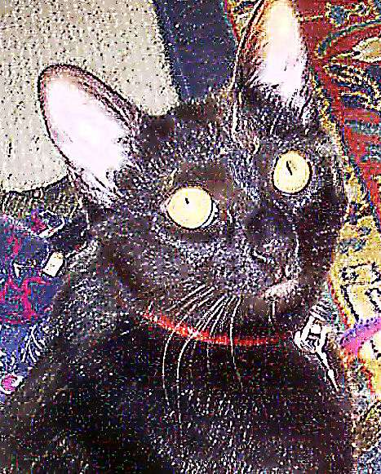
It’s been a bad week. My grandma is in the hospital. Mom and Dad went to stay with her and left us alone for FOUR DAYS!!! Do you have any idea what happens when you leave three cats alone with one cat box for four days? Little shitty paw prints . . . all over the house . . . .

My grandma went over the rainbow. Mom is sad.

Constipation and cat crap – now I am sad too. Mom says all four of Grandma’s cats have to come live with us. I know how to add - three cats plus four cats equals SEVEN cats! In this small apartment? I foresee wall-to-wall hairballs! We’re gonna need a cat box the size of a swimming pool! I may as well start packing now!
Whew! Crisis averted - we only had to take in one of Grandma’s orphans.

But you should see this dude - he’s huge! He’s hairy! He looks like Randy Moss with a tail! The Black Panther when he came out of the dryer! Oh, no, wait a minute, that was the Pink Panther, wasn’t it? I get confused . . .

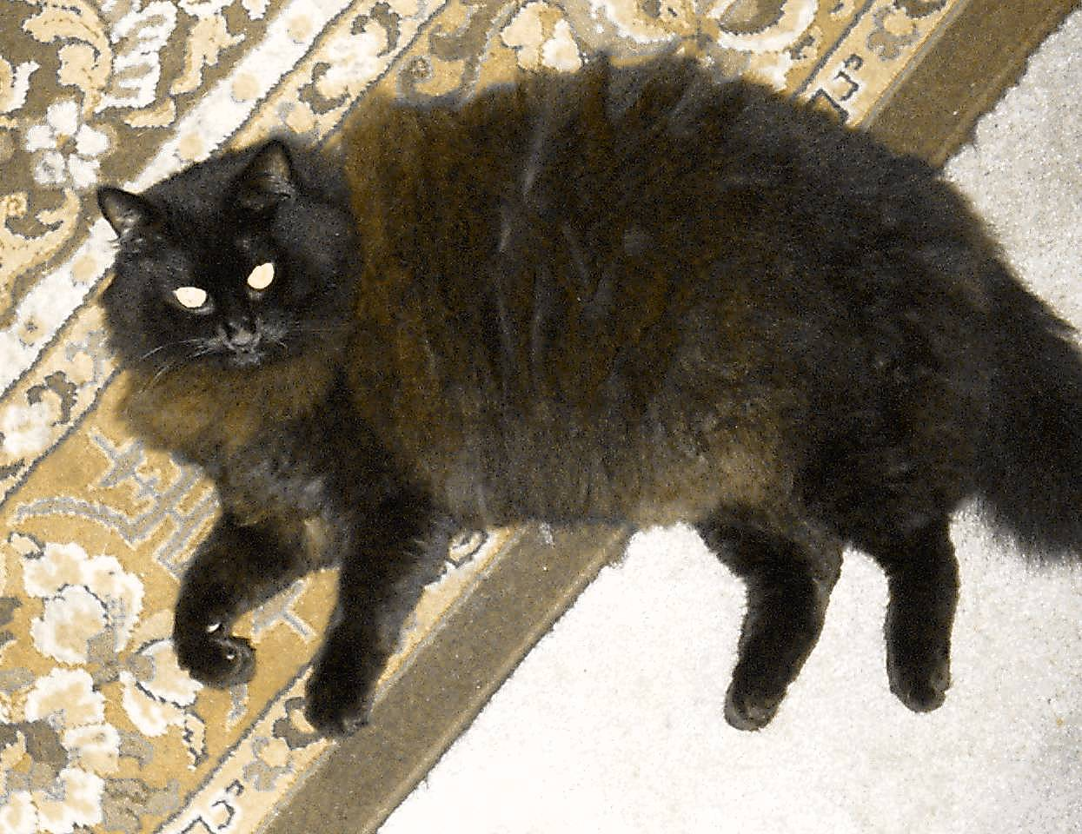
Mom and Dad tried to kill us today! It was horrible! One at a time, they took us . . . . I tried to hide in the farthest corner of the closet, behind the clothes, making myself as small as possible . . . but they found me!

They tortured us! They drenched us in foul-smelling flea spray and wrapped us in a blanket. Then they gave us a bath!

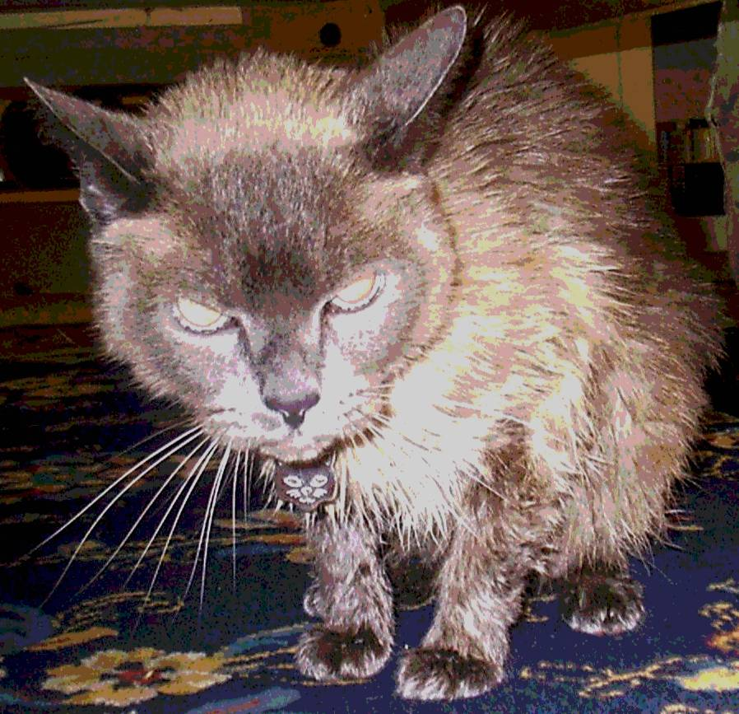

Murray – this is all YOUR fault!!!
Ah, now this ain’t right! I just heard a rumor that there is another one moving in!

I dream of the days when I was an only cat . . . a bachelor . . . ALONE . . . . one cat, one catbox . . . the way Tidy Cat and Nature meant it to be!

FIVE CATS?!?!?!

Somebody please . . . tell me it’s not true . . .

