Penarth Bowmen.

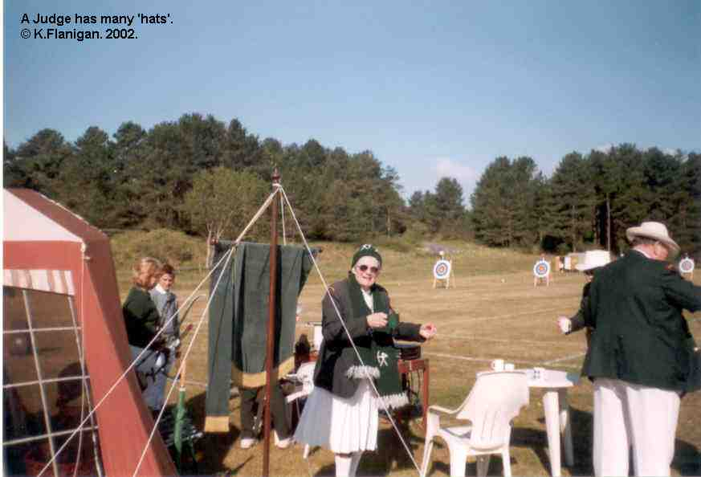
A Judge has many hats.

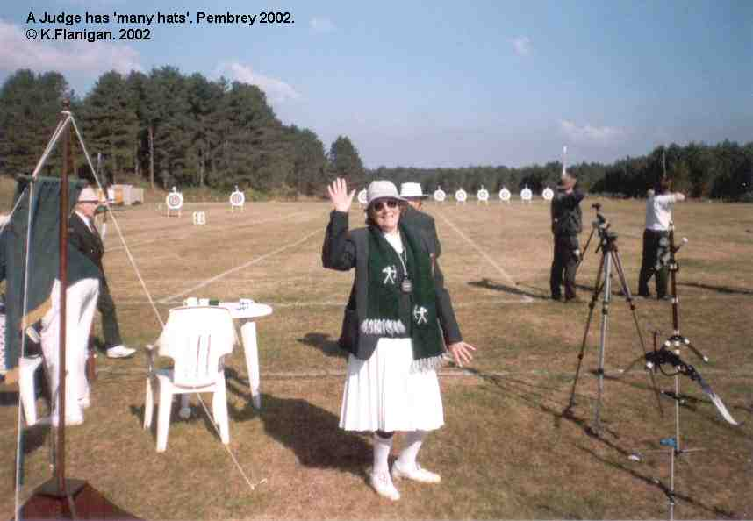
Where’s the Frog?

