Metaphors:
- “A dragfooted sheepdog, gray of muzzle, and with pale, blind old eyes”. “He ain’t no good to you, Candy. An’ he ain’t no good to himself. Whyn’t you shoot him Candy?” Why does this quote suit both Lennie and Candy’s dog? Why is it a metaphor for what George must do to Lennie?
- George often plays solitaire, or cards, in the bunkhouse. Why does he never ask Lennie to play cards with him? What might solitaire be a metaphor for? George does not ask Lennie and this is again a metaphor. By not asking Lennie he is suggesting something else – what is it?
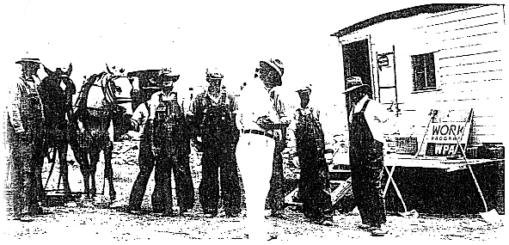
- The dead mouse and the dead puppy are both foreshadowing devices, but also metaphors. To foreshadow means to predict something that happens later in the book. What events do they foreshadow?
- What happens to the dead mouse and the dead puppy also, in a way, happens to George and Lennie’s dream. How is Lennie involved in both events? (i.e. he never intends to do something, or means anything, especially the things he loves or wants)
- Bad things come in threes; what is the last bad thing that happens? How does it seal both of their fates?

Characters:
- Describe the various emotions George feels towards Lennie during the novel and find quotations that chart this development. What are the main two emotions George feels towards Lennie? What would he do if Lennie was not around and why, ultimately, does he stick by him
- Why does Candy offer all of his money to George and Lennie? What does this suggest about his character? It could be said that he “clings to the dream like a drowning sailor to driftwood”. Explain the meaning of this phrase and why it applies to Curley. Describe his feelings by the end when he realises the dream is over.
- Describe Curley’s emotions and find four quotations that reflect his personality. Why does he take on Lennie in the fight scene?
- Why does Curley’s wife not have a name, when all the other male characters do? What does this suggest about the value of women in society at this time? How do the other workers on the farm see her? Find five quotes that illustrate their views. How does Curley’s wife view Lennie? What is her own version of the American dream?
- Crooks is frustrated by his helplessness – why is he helpless? Describe his character in detail? Why does he refuse to take part in their scheme? Why is Crooks the only one with any stability?
- What role does Slim play in the novel? Describe his manner and the way other characters view him. Find five quotations that describe his manner.

