Of Mice and Men Factsheet
Background to Of Mice and Men by John Steinbeck

John Steinbeck was born in Salinas, California in 1902. His most famous books were written in the 1930s and 1940s, and are set in California. They deal with the lives and problems of working people. Many of the characters in his books are immigrants from Mexico or from other parts of the United States who went to California looking for work or a better life.
John Steinbeck 1902 - 1968

The Setting of Of Mice and Men
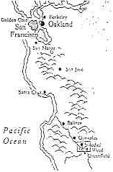
Of Mice and Men is set in the farmland of the Salinas valley, where John Steinbeck was born and which he knew all his life. Steinbeck's father owned land in the area, and as a young man Steinbeck had worked as a farm hand. The ranch in the story is near Soledad, which is south-east of Salinas on the Salinas river. Weed is nearby. The countryside described at the beginning of the book, and the ranch itself, would have been very familiar to John Steinbeck.
Map showing California south of San Francisco

Migrant Farm Workers
By the time that Of Mice and Men was published almost half of America's grain was harvested by huge combine harvesters. Five men could do what would have taken 350 men a few years earlier. George and Lennie are some of the last of the migrant farm workers. Huge numbers of men travelled the countryside between the 1880s and the early 1930s harvesting wheat. They earned $2.50 or $3.00 a day, plus food and very basic accommodation. During the 1930s, when there was very bad unemployment in the United States, agencies were set up under the New Deal to send farmworkers to where they were needed. George and Lennie got their works cards from Murray and Ready's, one of these agencies.
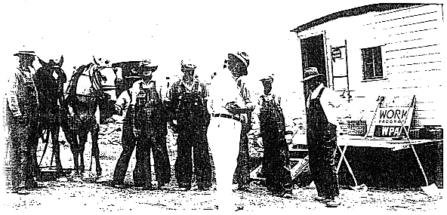
Farm workers getting work cards under a Government Scheme
The American Dream
From the 17th Century, when the first settlers arrived, immigrants dreamed of a better life in America. People went there to escape from persecution or poverty, and to make a new life for themselves or their families. They dreamed of making their fortunes in the goldfields. For many the dream became a nightmare. The horrors of slavery, of the American Civil War, the growth of towns with slums as bad as those in Europe, and the corruption of the American political system led to many shattered hopes. For the American society as a whole the dream ended with the Wall Street crash of 1929. This was the start of the Great Depression that would affect the whole world during the 1930s. However the dream survived for individuals. Thousands made their way west to California to escape from their farmlands in the mid-West. George and Lennie dreamt of their 'little house and a couple of acres'. The growing popularity of cinema was the last American Dream for many, Curley's wife was one: 'Coulda been in the movies, an' had nice clothes.'
Why Of Mice and Men?
The title of the novel comes from a poem by the Scottish poet Robert Burns (1759 - 96):
The best laid schemes o' mice and men
Gang aft agley [often go wrong]
And leave us nought but grief and pain
For promised joy!

