Analysing Images

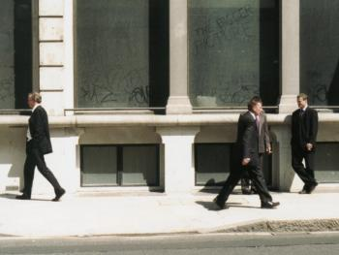

1. Pick any three contrasting photographs. Try to work out what the story behind each picture might be.

2. For each photograph you have chosen, crop the image a number of different ways so that its ‘meaning’ changes. Try to find two or three different ways of cropping each image. What does each one suggest to the viewer? Why?

3. Give each of your ‘versions’ a title or caption. Use these to help the viewer ‘interpret’ each cropping of your image.

4. Be prepared to show the ways you have cropped your images, and discuss the choices you have made with the group.

