“Welcome to my world...”

Below are some screen shots from David and Victoria Beckham’s “Beckingham Palace” website :

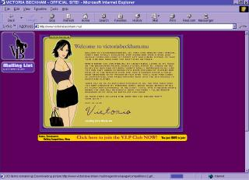
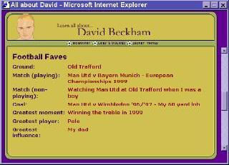

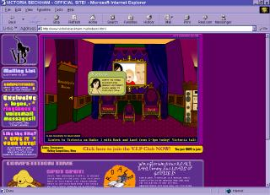
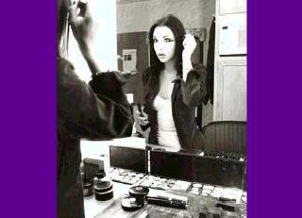

The Beckhams’ website is designed to show their fans what their ‘real’ lives are like. Pages include details of their likes and dislikes, information about their work and family, pop music and football.

Using the template below, plan your own ‘website’, either for yourself or for a celebrity who you admire. Use the first frame as a ‘home’ page, inviting the viewer into your ‘world’. The second page should be a biography, telling the viewer important facts about this person’s life. The third and fourth pages could tell the viewer about significant things the person has done, describe their greatest triumphs, or list their hopes for the future - it’s up to you.
Page 1
Welcome to __________’s Home Page!

Hi! My name is __________. Welcome to my

home page. Here you’ll find :

________________________________________

________________________________________

________________________________________

________________________________________

________________________________________

________________________________________

________________________________________

________________________________________
A picture of me..!

Page 2 Biography

Name : ___________ Age : _____________

Date of Birth : __________ Star Sign : __________

Occupation : _______________

Other details about me : ________________________

_________________________________________________

_________________________________________________

_________________________________________________

_________________________________________________

_________________________________________________

_________________________________________________

Page 3
Welcome to __________’s Web Page!

_____________________________

_____________________________

_____________________________

_____________________________

___________________________________________

___________________________________________

______________________________
Page 4
Welcome to __________’s Home Page!
___________________________________________

___________________________________________

___________________________________________

___________________________________________

______________________________

______________________________

______________________________

______________________________

A picture of ____________________________

A picture of ____________________________

